Built by Us: Strengthening Governance, Staffing, and Access at Your CIL

May 28, 2025

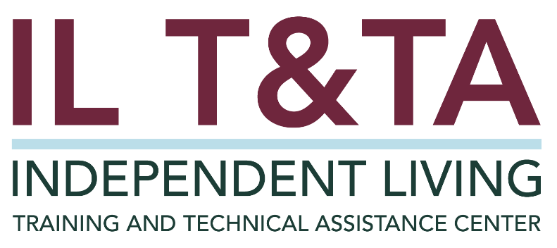

# Before We Begin

ASL & Spanish Interpreters are available and labeled.

Access Closed Captioning by clicking the CC button located at the bottom of your Zoom window.

Use Zoom's Raise Hand or Chat features to ask questions.

Remember to state your name and organization before speaking.

Message our IL T&TA team using the Chat feature if you have difficulties with today's call.

Please complete the survey at the end of today’s training.

# Agenda

* Welcome & Framing
* Practice in Action: Spotlight on IVCIL
* [CIL Evaluation Tool](https://acl.gov/sites/default/files/programs/2019-12/2%20CIL%20Eval%20Tool.pdf) as a Resource
* Peer Discussion & Shared Learning

# Learn & Share Format

* 20 minutes of spotlight content
* 40 minutes of peer discussion  
   Join in by unmuting or using the chat — your voice shapes this space!

# Key Takeaways:

* Understand the role of board structure and disability representation in CIL governance.
* Recognize inclusive staffing practices that reflect the IL philosophy.
* Explore strategies to ensure full access to services, information, and facilities for all individuals with significant disabilities.

# Overall Goal:

Let’s learn with and from each other!

# Presenters

**Sarah Stasik**

Executive Director

Illinois Valley Center for Independent Living

Spring Valley, Illinois

[Sstasik@ivcil.com](mailto:Sstasik@ivcil.com)

**Kate Webster**

Board President

Illinois Valley Center for Independent Living

Spring Valley, Illinois

[Socialservices@greenfieldhome.org](mailto:Socialservices@greenfieldhome.org)

IVCIL Logo: Illinois Valley Center for Independent Living Graphic features an icon of a person throwing their hand in the air. 

# Governing Board

* The CIL board must be the principal decision-making body - [29 U.S.C. § 796f4(c)(2)](https://uscode.house.gov/view.xhtml?req=granuleid%3AUSC-prelim-title29-chapter16-subchapter7&saved=L3ByZWxpbUB0aXRsZTI5L2NoYXB0ZXIxNi9zdWJjaGFwdGVyNy9wYXJ0QS9zdWJwYXJ0Mw%3D%3D%7CZ3JhbnVsZWlkOlVTQy1wcmVsaW0tdGl0bGUyOS1jaGFwdGVyMTYtc3ViY2hhcHRlcjctcGFydEEtc3VicGFydDM%3D%7C%7C%7C0%7Cfalse%7Cprelim&edition=prelim#:~:text=%C2%A7796f%E2%80%934.%20Standards%20and%20assurances%20for%20centers%20for%20independent%20living)
* Documented involvement in planning, budgeting, and program/fiscal oversight of the CIL
* Assurance that the CIL is meeting statutory standards and assurances in Section 725 of Rehab Act
* Recommended practices include having written roles, responsibilities, and a recruitment process

# Governing Board, con’t.

* A majority (51% or more) of board members must have [significant disabilities](https://www.ecfr.gov/current/title-45/subtitle-B/chapter-XIII/subchapter-C/part-1329)
* **An individual with a significant disability** means an individual with a severe physical or mental impairment whose ability to function independently in the family or community or whose ability to obtain, maintain, or advance in employment is substantially limited and for whom the delivery of independent living services will improve the ability to function, continue functioning, or move toward functioning independently in the family or community or to continue in employment, respectively - 29 U.S.C. § 705(21)(B))

[**Required in Rehab Act Sections 725(b)(1)(A) and 725(c)(2)**](https://uscode.house.gov/view.xhtml?req=granuleid:USC-prelim-title29-section796f-4&num=0&edition=prelim)

# CIL Employees

* Over 50% of all staff must be individuals with disabilities
* CILs must affirmatively recruit, promote, and retain staff with **significant disabilities** and track for compliance - [29 U.S.C. § 796f-4(c)(5)](https://uscode.house.gov/view.xhtml?req=granuleid%3AUSC-prelim-title29-chapter16-subchapter7&saved=L3ByZWxpbUB0aXRsZTI5L2NoYXB0ZXIxNi9zdWJjaGFwdGVyNy9wYXJ0QS9zdWJwYXJ0Mw%3D%3D%7CZ3JhbnVsZWlkOlVTQy1wcmVsaW0tdGl0bGUyOS1jaGFwdGVyMTYtc3ViY2hhcHRlcjctcGFydEEtc3VicGFydDM%3D%7C%7C%7C0%7Cfalse%7Cprelim&edition=prelim)
* At least 50% of decision-making roles must be held by individuals with disabilities
* CILs must be able to track and report staffing ratios

[**Required in Rehab Act Sections 725(b)(1)(A) and 725(c)(6)**](https://uscode.house.gov/view.xhtml?req=granuleid:USC-prelim-title29-section796f-4&num=0&edition=prelim)

# Self-Help and Self-Advocacy

* CILs must promote self-help and self-advocacy among individuals with significant disabilities
* Encouraging consumer control is essential to fulfilling the Independent Living philosophy

[**Required in Rehab Act Sections 725(b)(1)(B)**](https://uscode.house.gov/view.xhtml?req=granuleid:USC-prelim-title29-section796f-4&num=0&edition=prelim)

# Development of Peer Relationships and Peer Role Models

* CILs must support the development of peer relationships
* Peer role models help individuals with significant disabilities gain confidence and independence

[**Required in Rehab Act Section 725(b)(1)(C)**](https://uscode.house.gov/view.xhtml?req=granuleid:USC-prelim-title29-section796f-4&num=0&edition=prelim)

# Equal Access

* CILs must ensure equal access to all services, programs, facilities, and materials
* Access must be physical, programmatic, and communication-based
* Materials should be available in alternate formats and native languages when needed

[**Required in Rehab Act Section 725(b)(1)(D)**](https://uscode.house.gov/view.xhtml?req=granuleid:USC-prelim-title29-section796f-4&num=0&edition=prelim)

# Resources for Additional Guidance

* [Rehab Act: CIL Assurances and Standards](https://uscode.house.gov/view.xhtml?req=granuleid:USC-prelim-title29-section796f-4&num=0&edition=prelim)
* [CIL Evaluation Tool](https://acl.gov/sites/default/files/programs/2019-12/2%20CIL%20Eval%20Tool.pdf)
* [Compliance and Outcome Monitoring Protocol (COMP)](https://acl.gov/sites/default/files/programs/2019-12/1%20COMP_Guide.pdf)

# Learn & Share: Your Experience Matters

Recording has stopped – now it’s time to share.

This space is for real talk, peer learning, and practical problem-solving.

### Why the ‘Share’ Matters:

* Your lived experience helps others learn
* Real-world stories spark real-world solutions
* Together, we grow stronger as a IL network – one conversation at a time.

# Ways to Engage:

* Raise your hand to be spotlighted to speak
* Turn on your camera if you're comfortable
* Use the chat to share insights, questions, resources, or tools
* React, reflect, or build on what others say
* Share real challenges or successes from your CIL

**Let’s turn ideas into action — your voice is the most valuable part of this session.**

# Evaluation

Thank you for participating in today's Learn and Share.

Your feedback is important and helps us plan future training.

Please use the link in the chat to share your feedback.

[Evaluation Link](https://umt.co1.qualtrics.com/jfe/form/SV_246aAXbpobwuOY6):

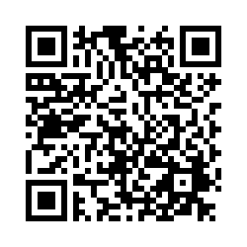

# How to Connect with Us!

## Website: <https://tinyurl.com/ILTTACenter>

Request training and / or technical assistance (expert help for your organization): fil out a form on our website to let us know how we can help.

Call**:** 406-243-5300 and someone will get back to you as soon as we can.

Sign-Up for Events & Announcements: Visit our website to sign up for updates about live training, group technical assistance, new publications, and other happenings around the Center.

# About the IL T& TA Center

The Independent Living Training and Technical Assistance Center (IL T&TA Center) is available to you through a contract with the US Department of Health and Human Services.

The IL T&TA Center provides expert training and technical assistance to CILs, SILCs, and DSEs.

The Center is operated by the University of Montana's **Rural Institute for Inclusive Communities**.



# IL T&TA Center Attribution

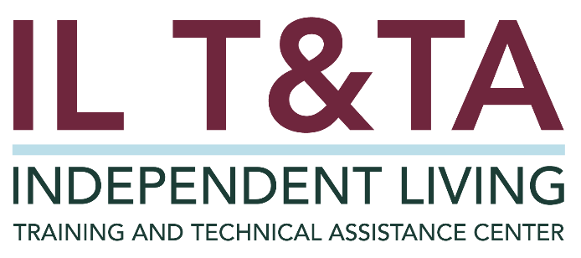

This project is on assignment through contract with the Administration on Disabilities, Administration for Community Living, Health and Human Services.