Unlocking Effective Workplans – Pro Tips and Real-World Application

June 11, 2025

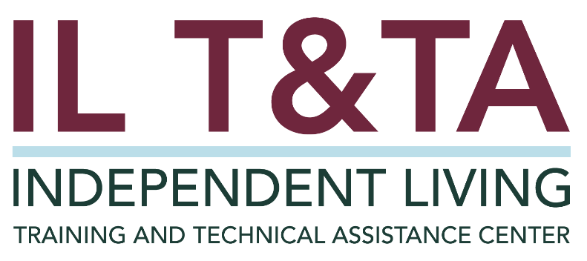

# Before We Begin

ASL & Spanish Interpreters are available and labeled.

Access Closed Captioning by clicking the CC button located at the bottom of your Zoom window.

Use Zoom's Raise Hand or Chat features to ask questions.

Remember to state your name and organization before speaking.

Message our IL T&TA team using the Chat feature if you have difficulties with today's call.

Please complete the survey at the end of today’s training.

# Agenda

* Welcome & Framing
* Practice in Action: Spotlight on LIFE, Inc.
* Peer Discussion & Shared Learning

# Learn & Share Format

* 20 minutes of spotlight content
* 40 minutes of peer discussion  
   Join in by unmuting or using the chat — your voice shapes this space!

# Key Takeaways:

* Optimize your workplan with essential strategies for success.
* Learn how well-crafted workplans support day-to-day activities and create greater impact.

# Overall Goal:

Let’s learn with and from each other!

# Presenters

**Neil Ligon**

Executive Director

Living Independence for Everyone (LIFE), Inc.

[Nligon@lifecil.com](mailto:Nligon@lifecil.com)

**Angel Denardi**

Associate Director

Living Independence for Everyone (LIFE), Inc.

[Adenardi@lifecil.com](mailto:Adenardi@lifecil.com)



# About LIFE, Inc.

**Background:**

* Located in Southeast Georgia
* Approximately 13 staff
* Serves 20 counties (two office locations)

**Awards:** GuideStar Gold Seal of Transparency 2024 from Candid – Exceeds best practices and industries standards across almost all areas.

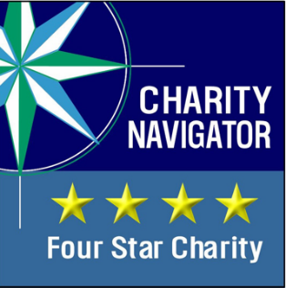

# Purposes of a Workplan & Why You Want One

* Align day-to-day work with long-term board vision
* Create staff buy-in
* Effective ways for Executive Director to delegate and monitor
* Provides leadership opportunities for staff
* Promote incremental change
* Meet funding and compliance requirements

# Key Compliance Requirement for CILs

“Establish clear priorities through annual and 3-year program and financial planning objectives for the center, including overall goals or a **mission** for the center, a **work plan** for achieving the goals or mission, specific objectives, service priorities, and types of services to be provided, and a description that shall demonstrate how the proposed activities of the applicant are consistent with the most recent **3- year State plan** under section 796 of this title.”

[**Required in Rehab Act Sections 29 U.S.C. § 796f-4(c)(4)**](https://uscode.house.gov/view.xhtml?hl=false&edition=prelim&req=granuleid%3AUSC-prelim-title29-section796f-4&f=treesort&num=0&saved=%7CKHRpdGxlOjI5IHNlY3Rpb246Nzk2IGVkaXRpb246cHJlbGltKSBPUiAoZ3JhbnVsZWlkOlVTQy1wcmVsaW0tdGl0bGUyOS1zZWN0aW9uNzk2KQ%3D%3D%7CdHJlZXNvcnQ%3D%7C%7C0%7Cfalse%7Cprelim)

# CIL Program Performance Report (Part 2) Instructions

#### SUBPART V – ANNUAL PROGRAM AND FINANCIAL PLANNING OBJECTIVES: Section 725(c)(4) of the Act

Section A – Work Plan for The Reporting Year

Item 1 – Achievements

Discuss the work plan’s proposed goals and objectives and the progress made in achieving them during the reporting year.

Item 2 – Challenges

Describe any substantial challenges or problems encountered by the CIL and the resolutions/attempted resolutions.

# CIL Program Performance Report (Part 2) Instructions, cont.

Item 3 – Comparison with Prior Reporting Year

As appropriate, compare the CIL’s activities in the reporting year with its activities in prior years, e.g., recent trends.

Section B – Work Plan for the Year Following the Reporting Year

Item 1 – Annual Work Plan

List the CIL’s annual work plan goals, objectives and action steps planned for the year following the reporting year.

Item 2 – SPIL Consistency

Explain how these work plan goals, objectives, and action steps are consistent with the approved SPIL.

# Workplan Essential #1

## Foundations of a workplan

# Workplan Essentials #2

## Identify Capacity

* What are we already doing?
* What are members of the staff interested in and currently capable of doing?
* What supports do the current community relationships offer?

# Workplan Essentials #3

## Setting Concrete Benchmarks

* Quantity measurements (ex. number of meetings).
* Identify specific timeframes (ex. quarterly).

# Workplan Essentials #4

## Monitoring for Accountability

* Delegate to team members.
* Establish open lines of communication.
* Schedule regular opportunities to share.
* Engage and encourage collective problem solving.

# Workplan in Action – Example

* **Mission**: “To promote independent living and advance community change for EVERYONE.”
* **Strategic Goal 1:** To advocate for equal access to services, programs, activities, resources and facilities.
* **Objective A:** Transportation – To identify consumers' unmet need with respect to transportation services in our service area and during crisis (ex. hurricane evacuation) and work to develop resources to address said need.
* **Sub-objective 1:** We will engage in both local and regional/national advocacy efforts to enhance funding for affordable, accessible transportation.

# Workplan in Action, cont.

* **Workplan Activity**: LIFE staff members will either attend or host at minimum a total of 10 meetings to discuss available accessible transportation options or development of new options. (G1, A., I.)
* **Connection to the SPIL Goal:** “2.1.1 – Georgian Independent Living Network (GILN) will attend local, regional, and state meetings to collaborate on transportation initiatives and remain abreast of transit options. (#of meets/trainings)”
* **Staff Responsible:** 
  + **President/Team Lead:** Staff #1
  + **Vice President/Assistant Lead**: Staff #2
  + **Team Members:** Staff #3, Staff #4

# Tools for Monitoring Your Workplan: Integrate in Staff Meetings

Monthly Staff Meeting Template:

* **CIL Suite:** Ensure data entry is accurate, thorough, and completed timely (weekly review).
* **Weekly Assignments:** Identify, execute, and report weekly tasks clearly and accurately, meeting deadline consistently.
* **Programmatic Oversight:** Regularly communicate progress clearly, set measurable goals, and consistently meet established deadlines.
* **Subject Matter Mastery:** Actively seek training opportunities, willingness to share knowledge with the team by presenting learnings quarterly.

# Tools for Monitoring Your Workplan; cont.

* **Relationship Building:** Track and report on new and ongoing relationships, clearly documenting purpose, outcomes, and next steps
* **Workplan:** Ensure alignment with strategic goals, accurately track progress, and regularly update for thoroughness and timeliness
  + Feedback from these meetings directly informs quarterly workplan adjustments/ pivots

Resources for Additional Guidance

* [Workplan Development for Centers for Independent Living](https://www.ilru.org/training/workplan-development-for-centers-for-independent-living-15-hours).
* [Outcome Measurement Toolkit](https://scholarworks.umt.edu/ruralinst_independent_living_community_participation/91/) – Research & Training Center (RTC) on Disability in Rural Communities.
* [“How to Use the Toolkit”](https://www.april-rural.org/conference/images/2023_Conference/RTC_ILRU_APRIL_Presentation_Deck.pdf) presentation.

# Learn & Share: Your Experience Matters

Recording has stopped – now it’s time to share.

## Ways to Engage:

* Raise your hand to be spotlighted to speak.
* Turn on your camera if you're comfortable.
* Use the chat to share insights, questions, resources, or tools.
* React, reflect, or build on what others say.
* Share real challenges or successes from your CIL.

**Let’s turn ideas into action — your voice is the most valuable part of this session.**

# Evaluation

Thank you for participating in today's Learn and Share.

Your feedback is important and helps us plan future training.

Please use the link in the chat to share your feedback.

[Evaluation Link](https://umt.co1.qualtrics.com/jfe/form/SV_4YDi5KU1hc8uxtI):

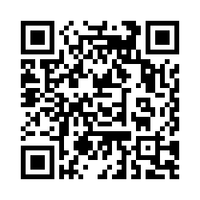

# How to Connect with Us!

## Website: <https://tinyurl.com/ILTTACenter>

Request training and / or technical assistance (expert help for your organization): fil out a form on our website to let us know how we can help.

Call**:** 406-243-5300 and someone will get back to you as soon as we can.

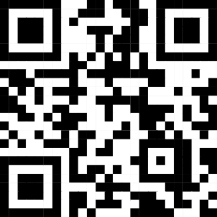Sign-Up for Events & Announcements: Visit our website to sign up for updates about live training, group technical assistance, new publications, and other happenings around the Center.

# About the IL T& TA Center

The Independent Living Training and Technical Assistance Center (IL T&TA Center) is available to you through a contract with the US Department of Health and Human Services.

The IL T&TA Center provides expert training and technical assistance to CILs, SILCs, and DSEs.

The Center is operated by the University of Montana's **Rural Institute for Inclusive Communities**.



# IL T&TA Center Attribution

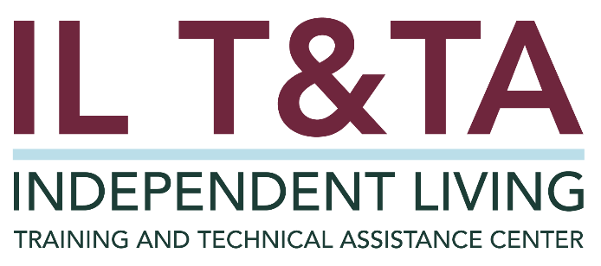

This project is on assignment through contract with the Administration on Disabilities, Administration for Community Living, Health and Human Services.