Future Ready: Strengthening Youth Initiatives at Your CIL
May 14, 2025
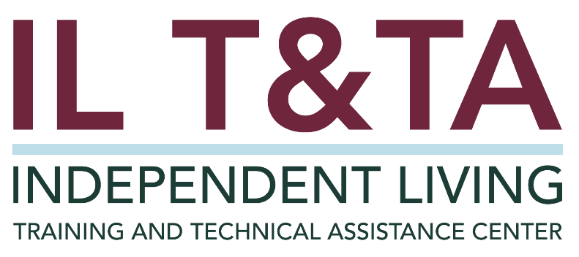

Before We Begin
ASL & Spanish Interpreters are available and labeled.
Access Closed Captioning by clicking the CC button located at the bottom of your Zoom window.
Use Zoom's Raise Hand or Chat features to ask questions.
Remember to state your name and organization before speaking.
Message our IL T&TA team using the Chat feature if you have difficulties with today's call.
Please complete the survey at the end of today’s training.

Presenters

Stephanie McDowell
Youth and Family Coordinator
Paraquad - Center for Independent Living
St. Louis, Missouri
Email: smcdowell@paraquad.org

The Independent Living T&TA Center

Transition: Youth & the Role of CILs
- Transition Services for Youth with Disabilities
- Rehabilitation Act of 1973, as amended, Sec. 7 (17) (E):
- “(iii) Facilitate the transition of youth who are individuals with significant disabilities, who were eligible for individualized education programs under section 614(d) of the Individuals with Disabilities Education Act (20 U.S.C. 1414(d)), and who have completed their secondary education or otherwise left school, to postsecondary life.”

What Does That Mean?
- Age – Youth aged 14 – 24.
- School– completion of participation in high school, ex. Diploma, graduation, left/dropped out, or exceeded age eligibility for IDEA services (22 y/o).
- IEP Eligibility – Must have been eligible for an IEP under IDEA.
- Significant Disability – defined as severe physical, mental, cognitive impairment substantially limiting major life activities or IL.
- Service – Explicitly supports the transition into postsecondary life.
  - Examples: Community living, further education/training, employment, etc.
Reporting Youth Transition Services
- Know the criteria.
- Document with purpose.
- State the transition goal (e.g. job, housing, college).
- Describe the specific steps taken.
- Note milestones (e.g. got SSI, enrolled in training, got driver’s license).
- Distinguish and report correctly.

Reporting Youth Transition Services

How the CIL PPR Defines Youth/Transition Services
Any service that develops skills specifically designed for youth with significant disabilities between the ages of 14 and 24 to promote self-awareness and esteem, develop advocacy and self-empowerment skills, and the exploration of career options, including the transition from school to post school activities such as postsecondary education, vocational training, employment, continuing and adult education, adult services, independent living, or community participation.

- A note about PPR instructions/definitions: The PPR instructions have not been revised to include the revised description youth transition services in the Rehab Act.
- Report According to PPR Instructions.
- Document and track according to the Rehab Act definition as well.
- Suggestion: Include your tracked youth transition services according to the Rehab Act definition of a core service in the narrative portion of your PPR.

Resources for Additional Guidance:
- PPR Instructions
- ACL FAQ on Youth Transition
- Rehab Act Definition of Youth Transition Services

Practice in Action: Paraquad’s Approach

Paraquad – Center for Independent Living



“The Youth Are Our Future”

Practice in Action: Paraquad’s Approach - Youth at the Center, Across the Center

Integrated Throughout the CIL
- At Paraquad, youth transition takes a village — it is embedded throughout the center.
- Transition is Not a Single Moment.
- Laying the foundation for independence.

Fueling Innovation Through Collaboration
- Paraquad partners with schools, Vocational Rehabilitation counselors, peer mentors, and youth-led groups.
- Food for Thought or Insights.
  - “Networking is the best way to build partnerships.”

Paraquad’s Approach - From Intake to Impact

Intake Procedures
Goal Setting
- Using a Facilitated Conversation to Help Set Goals and Steps
  - Example: “How Do I Get a Job; How Do I Write a Resume...”
- Use SMART Goals (Specific, Measurable, Attainable, Relevant, Time Bound).

Paraquad’s Approach - From Then to Now: Youth Stories

Story #1 - From Classroom to Community: Navigating the Shift Beyond High School

Story #2 - Owning the College Experience: Advocating for Accommodations and Academic Success

Story # 3 Empowered Independence: From College Graduate to Aspiring Advocate

Learn & Share: Your Experience Matters

Your Turn: Let’s Hear from You
- What Are You Seeing in the Field?
- Strategies, Struggles, and Solutions?
- Youth Transition – What's on Your Mind?

Evaluation
Thank you for participating in today's Learn and Share.
Your feedback is important and helps us plan future training.
Please use the link in the chat to share your feedback.

Evaluation Link: https://umt.co1.qualtrics.com/jfe/form/SV_8k0Qn2A05xRRjXE


How to Connect with Us!
Website: https://tinyurl.com/ILTTACenter
Request training and / or technical assistance (expert help for your organization): fill out a form on our website to let us know how we can help.
Call: 406-243-5300 and someone will get back to you as soon as we can.

Sign-Up for Events & Announcements:
Visit our website to sign up for updates about live training, group technical assistance, new publications, and other happenings around the Center.

About the IL T& TA Center
The Independent Living Training and Technical Assistance Center (IL T&TA Center) is available to you through a contract with the US Department of Health and Human Services.
The IL T&TA Center provides expert training and technical assistance to CILs, SILCs, and DSEs.
The Center is operated by the University of Montana's Rural Institute for Inclusive Communities.
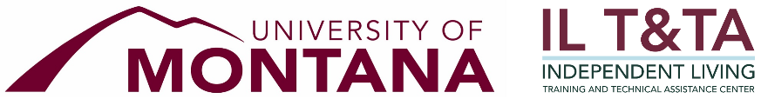

IL T&TA Center Attribution
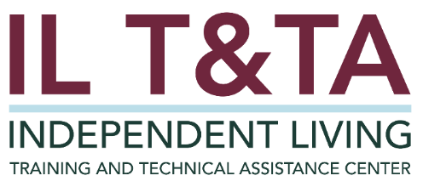

The IL T&TA Center, operated by the University of Montana’s Rural Institute for Inclusive Communities (RIIC), is funded by the Office of Independent Living Programs, Administration on Disabilities, Administration for Community Living (ACL) to provide expert information, support, and training tailored for Centers for Independent Living (CILs), Statewide Independent Living Councils (SILCs), and Designated State Entities (DSEs) across the country.

