SILC Connection – Assurances – Policies and Procedures
June 17, 2025
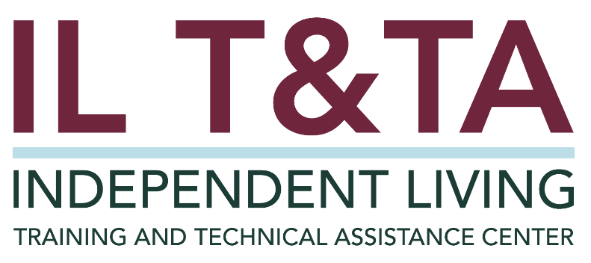

Before We Begin
ASL & Spanish Interpreters are available and labeled.
Access Closed Captioning by clicking the CC button located at the bottom of your Zoom window.
Use Zoom's Raise Hand or Chat features to ask questions.
Remember to state your name and organization before speaking.
Message our IL T&TA team using the Chat feature if you have difficulties with today's call.
Please complete the survey at the end of today's training.

Agenda
- Welcome & Framing
- Statewide Independent Living Council (SILC) Indicators of Minimum Compliance as a Resource
- Review of Policies and Procedures in Alignment with Indicators
- Peer Discussion & Shared Learning

Learn & Share Format
- 20 minutes of spotlight content
- 40 minutes of peer discussion
Join in by unmuting or using the chat — your voice shapes this space!

Key Takeaways:
- Understand the importance of assurances and indicators.
- Learn how to effectively review Policies and Procedures.
- Increase understanding of how the Board/Council need to approve the Policies and Procedures.

Overall Goal:
Let's learn with and from each other!

Presenters
Brooke Wilson
Executive Director
Oregon Statewide Independent Living Council
brooke.wilson@odhs.oregon.gov

Edward Mitchell
Executive Director
Statewide Independent Living Council of Tennessee
SILCDirector@silctn.org
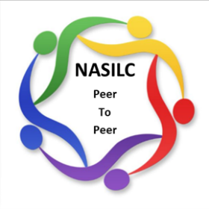
Mission: To provide resources to SILCs across the nation and promote collaboration with their partners to advance IL values and philosophy: www.nasilc.com.

SILC Indicators and Assurances
- ACL published indicators and assurances of minimum compliance for SILCs as required by the Rehabilitation Act in 2017.
- Why? "In order to ensure that all activities under this part are planned, conducted, administered, and evaluated in a manner consistent with the purposes of this chapter and the objective of carrying out activities to better serve individuals with disabilities and helping achieve the purposes of the Act (Rehab Act).

SILC Indicators of Minimum Compliance
There are six (6) indicators on the following topics:
- Policies and Procedures (today's focus)
- Appointment Process
- Training for Members
- Public Input on the SPIL
- Process for Monitoring, Reviewing and Evaluating the SPIL
- Resource Plan

SILC Assurances
There are eight (8) assurances on the following topics:
- Communicating Appointments to Appointing Authority
- SILC Membership Composition
- SILC Member Terms
- SILC Autonomy in Where it is Located
- SILC Use of DSE Staff
- Program Accessibility
- SILC Autonomy in Operations
- SILC Outreach to Underserved Populations for SPIL Development

Required Policies and Procedures on Member Recruitment
Indicator # 1 - SILC written policies and procedures must include:
- Member Recruitment - A method for recruiting members, reviewing applications, and regularly providing recommendations for eligible appointments to the appointing authority;
  - How are you recruiting new members?
  - What is the process for reviewing applications?
  - How often are you providing recommendations for new members?

Required Policies and Procedures on Disputes and Conflicts
Indicator # 1 - SILC written policies and procedures must include:
- Disputes and Conflicts of Interest - A method for identifying and resolving actual or potential disputes and conflicts of interest that are in compliance with State and federal law;
  - Do you have a conflict of interest policy? What is the procedure for disclosing the potential conflict?
  - Do you have a dispute resolution policy/procedure?
Who does this cover? Board, staff, the public?

Required Policies and Procedures on Public Meetings
Indicator # 1 - SILC written policies and procedures must include:
- Public Meetings - A process to hold public meetings and meet regularly as prescribed in 45 CFR 1329.15(a)(3);
  - What does 45 CFR 1329.15(a)(3) even say?
(The SILC shall meet regularly, and ensure that such meetings are open to the public and sufficient advance notice of such meetings is provided)
  - What does "regularly" mean for your SILC?

Required Policies and Procedures on Notice of Public Meetings
Indicator # 1 - SILC written policies and procedures must include:
- Advance Notice of Public Meetings - A process and timelines for advance notice to the public of SILC meetings in compliance with state and federal law and 45 CFR 1329.15(a)(3);
  - What does advance notice mean in your state?
  - Where should the notice be published? On your website? Social media?
  - Do you need a policy/procedure for emergency situations?

Required Policies and Procedures on Executive Sessions
Indicator # 1 - SILC written policies and procedures must include:
e. Executive Session Meetings A process and timeline for advance notice to the public for SILC "Executive Session" meetings, that are closed to the public, that follow applicable federal and State laws;
i. "Executive Session" meetings should be rare and only take place to discuss confidential SILC issues such as but not limited to staffing.
ii. Agendas for "Executive Session" meetings must be made available to the public, although personal identifiable information regarding SILC staff shall not be included;

Required Policies and Procedures on Accommodations for the Public
Indicator # 1 - SILC written policies and procedures must include:
f. Accommodations for Public Participation in SILC Meetings A process and timelines for the public to request reasonable accommodations to participate during a public Council meeting;
- What accommodations will be provided as standard practice?
- Does your timeline for requesting accommodations sync with your timeline for noticing the public meeting?

Required Policies and Procedures on the SPIL
Indicator # 1 - SILC written policies and procedures must include:
g. SPIL A method for developing, seeking and incorporating public input into, monitoring, reviewing and evaluating implementation of the State Plan as required in 45 CFR 1329.17; and
- How do your policies and procedures address the SILC's responsibilities of seeking public input into the SPIL?
  - Remember! Notice requirements are different for public input on the SPIL—30 days are required. Review 45 CFR 1329.17 for the whole list.

Required Policies and Procedures on Verifying CIL Eligibility to Sign the SPIL
Indicator # 1 - SILC written policies and procedures must include:
h. Verifying CIL Eligibility A process to verify centers for independent living are eligible to sign the State Plan in compliance with 45 CFR 1329.17(d)(2)(iii).

Required Policies and Procedures on Verifying CIL Eligibility to Sign the SPIL, cont.
What does 45 CFR 1329.17(d)(2)(iii) say?
"Not less than 51 percent of the directors of the CILs in the State. For purposes of this provision, if a legal entity that constitutes the "CIL" has multiple Part C grants considered as separate Centers for all other purposes, for SPIL signature purposes, it is only considered as one Center. CILs with service areas in more than one State that meet the other applicable requirements are eligible to participate in SPIL development and sign the SPIL in each of the relevant States."

Additional Recommendations:
- Consider virtual meetings, including committees, executive
- Review your financial policies – July SILC Connection topic
- Ensure accessibility – Website, social media, digital content, and paper

Resources for Additional Guidance
- Required in Rehab Act Sections 796d – Statewide Independent Living Councils
- Statewide Independent Living Council (SILC) Indicators
- Financial Policies – July SILC Connection topic
- eCFR :: 45 CFR Part 1329 -- State Independent Living Services and Centers for Independent Living

Process of Review
- How often should it be reviewed?
- By whom is it reviewed?
- Using simple language
- Ask one another for examples – We are all here to support one another.

Learn & Share: Your Experience Matters
Recording has stopped – now it's time to share.
Ways to Engage:
- Raise your hand to be spotlighted to speak
- Turn on your camera if you're comfortable
- Use the chat to share insights, questions, resources, or tools
- React, reflect, or build on what others say
- Share real challenges or successes from your CIL
Let's turn ideas into action — your voice is the most valuable part of this session.

Evaluation
Thank you for participating in today's Learn and Share.
Your feedback is important and helps us plan future training.
Please use the link in the chat to share your feedback.
Evaluation Link:


How to Connect with Us!

Website: https://tinyurl.com/ILTTACenter
Request training and / or technical assistance (expert help for your organization): fil out a form on our website to let us know how we can help.
Call: 406-243-5300 and someone will get back to you as soon as we can.

Sign-Up for Events & Announcements: Visit our website to sign up for updates about live training, group technical assistance, new publications, and other happenings around the Center.

About the IL T& TA Center
The Independent Living Training and Technical Assistance Center (IL T&TA Center) is available to you through a contract with the US Department of Health and Human Services.
The IL T&TA Center provides expert training and technical assistance to CILs, SILCs, and DSEs.
The Center is operated by the University of Montana's Rural Institute for Inclusive Communities.


IL T&TA Center Attribution

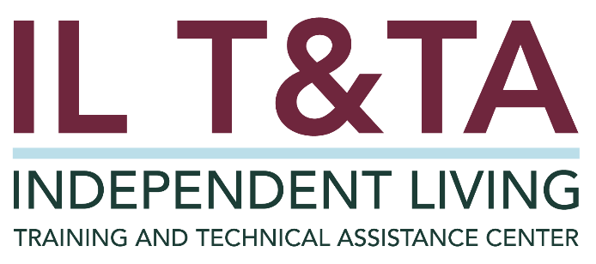
This project is on assignment through contract with the Administration on Disabilities, Administration for Community Living, Health and Human Services.

