Nursing Home? No Thanks! First Conversations for Community-Based Transition Services
June 25, 2025
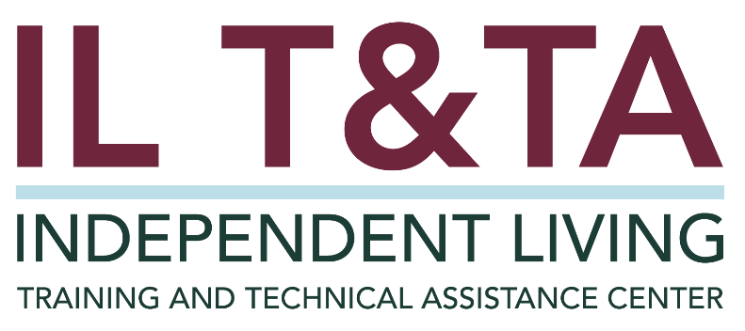

Before We Begin
ASL & Spanish Interpreters are available and labeled.
Access Closed Captioning by clicking the CC button located at the bottom of your Zoom window.
Use Zoom's Raise Hand or Chat features to ask questions.
Remember to state your name and organization before speaking.
Message our IL T&TA team using the Chat feature if you have difficulties with today's call.
Please complete the survey at the end of today's training.

Agenda
- Welcome & Framing
- Practice in Action: Spotlight on Greater New Haven – Center for Disability Rights (CDR)
- Peer Discussion & Shared Learning

Learn & Share Format
- 20 minutes of spotlight content
- 40 minutes of peer discussion
Join in by unmuting or using the chat — your voice shapes this space!

Key Takeaways:
- Starting the Conversation Strong
- Challenging Bias & Supporting Consumer-led Decisions
- Strategizing for Success

Overall Goal:
Let's learn with and from each other!

Presenters
Rick Famiglietti
Senior Advocate
Center for Disability Rights
Rick@cdr-ct.org

Tim Parkes
Money Follows the Person (MFP) - Program Manager
Center for Disability Rights
Tim@cdr-ct.org



About Center for Disability Rights (CDR)
Background:
- Located in Connecticut
- Approximately 11 staff, 6 dedicated to Money Follows the Person (MFP) subcontractor
  - 4 Transition Coordinators
  - 2 Housing Coordinators
- Serving New Haven County – total of 35 cities through two office locations
- CDR membership advocacy organization
CDR Successes:
- The CDR MFP team consistently exceeds quarterly program deliverables
- Each transition coordinator averages 10-15 nursing home transitions per year

Program Performance Report (PPR) Expectations for Reporting Core Transition Services
Centers for Independent Living (CILs) must report all transition activities as a core service, including:
- Consumer transitions out of institutions (today’s focus)
- Youth to postsecondary life

Nursing Home Transition (NHT) Services Definition Under the Rehabilitation Act
"(E) Independent Living Core Services – ...
(v) Services that –
(I) Facilitate the transition of individuals with significant disabilities from nursing homes and other institutions to home and community-based residences, with the requisite supports and services. This process may include providing services and supports that a consumer identifies are needed to move that person from an institutional setting to community based setting, including systems advocacy required for the individual
to move to a home of his or her choosing;

Nursing Home Transition (NHT) Services Definition Under the Rehabilitation Act, cont.
(II) Provide assistance to individuals with significant disabilities who are at risk of entering institutions so that the individuals may remain in the community. A determination of who is at risk of entering an institution should include self-identification by the individual as part of the intake or goal-setting process."

Defined within the Rehabilitation Act of 1973, as amended; 29 U.S.C. § 705(17)(E)(v)(I)-(II)

CIL Program Performance Report (PPR) – (Part 2) Instructions

SUBPART III – INDIVIDUAL SERVICES AND ACHIEVEMENTS: (Section 725(c)(8)(C) of the Act)

Section B – Independence and Community Integration

Item 1 – Goals Related to Increased Independence in a Significant Life Area:
J) Relocation from a Nursing Home or Institution – Goals related to relocation from nursing homes or other institutions to community-based living arrangements. This significant life area specifically pertains to consumers who live in a nursing home or institution, unlike the Community-Based Living life area, above, which includes any consumer regardless of his/her living situation prior to receiving IL services.

The Goal of Reporting NHT in the PPR
Purpose:
- Capture consumer outcomes tied to Independent Living (IL) services
- Quantify progress in significant life areas (e.g., housing, transportation, healthcare access)
- Report activities under the core services, Nursing Home Transition (NHT)

The Goal of Reporting NHT in the PPR, cont.
Why It Matters:
- Demonstrates the impact of IL services on real lives
- Shows how NHT supports community integration, not just discharge
- Meets federal expectations under 29 U.S.C. § 705(17)(E)(v)
- The only IL performance measure tracked in the Congressional Budget Justification
  - Expected outcome: An increase in the percentage of people successfully relocated from institutions to community-based living by CILs
  - Based on: Goals set vs. goals achieved

What Must Be Reported in the PPR for NHT?
The total number of consumers assisted with:
- Transitioning from institutions to community-based living (Including transitions still in progress as “Goals in Progress”)
Include:
- Number of consumers served
- Number of goals created, achieved or in-progress
- Consumer stories or examples – used for impact

What Must Be Reported in the PPR for NHT, cont.?
Best Practices on Using “Relocation from a Nursing Home or Institution” on the PPR
- Only use this category for institution-to-community transitions
- Do not combine with “Community-Based Living” (Helps to prevent underreporting NHT work)

What Does Doing This Mean? Why Nursing Home Transition Matters
- We help people with disabilities, who are our peers, transition out of institutions—such as nursing homes, hospitals, rehabilitation centers, mental health facilities, group homes, and other congregate settings—and return to homes in the community
- People with disabilities have a right to decide what supports they need — we listen and follow their lead
- The goal for people with disabilities is choice, freedom, and control over their lives
- Our role is to assist in removing barriers, not just providing services

Centering Independent Living in Nursing Home Transition (NHT)

Integration of NHT Process with overall Center
- Shifting away from "'medical model"' mindset
- Ensuring consumer control in the process
- Advocate for consumer-directed planning
- Encourage IL values: Self-direction, peer support, consumer control
- Collaboration with other CILs

"Nothing about me without me!"

Building Trust from the First Contact
- Meet the consumer first before interacting with the support team or facility staff
- The first meeting should be on the 'consumer's terms and schedule
- Build a rapport with the consumer
- Encourage the consumer to lead the conversation
- Be practical and transparent with the process
  - Explain the "why” behind the work
- Emphasize peer connection: “If I can, you can!”

Getting the Whole Story – Understanding Their Journey
- Gather background thoroughly
  - Ask open-ended questions:
    - “What brought you here?”
    - “What matters to you?”
    - “What do you need to live in your home and in the community?”

“Am I Ready?” – Challenging Barriers: A Consumer’s Right to Take Risks
External Barriers & Influences
- Staff (CIL staff/nursing facility staff/case coordinators/home health & home care agencies, etc.)
- Affordable and accessible housing
- Timelines & deadlines
- Family/support opposition
- Conservatorships/guardianship
Consumer’s Barriers
- Own self-doubts
- Fallacy of independence

Make It Theirs – Shared Planning & Responsibility

Who will do what?
- Clarify transition team and consumer’s role
- Develop the Independent Living Plan (ILP) through informed consumer choice
- Build a consumer-controlled “Circle of Support”
- Empower consumers to be involved to the extent of their ability – it's their transition

Key Components of Nursing Home Transition Support:
- Communication – it’s a team effort
- Independent Living Skills Training
  - Eligibility for self-directed personal care
  - Budgeting and benefits navigation
  - Medication & supply coordination
  - Transportation planning
- Secure Accessible and Affordable Housing
  - Accessibility & Safety Evaluations
  - Durable Medical Equipment (DME)
  - Home modifications coordination
- Shopping Support for Essential Supplies

Post-Transitions: Quality of Life Follow-Ups
Goal: Ensure the consumer is stable in the community
How: CDR’s MFP Program: support extends up to 365 days with check-ins at 3 days, 30 days, 60 days, 90 days
- Address any issues related to care, housing, or health
- Use a follow-up tool to evaluate quality of life and service needs
Additionally, CIL core services remain available as long as the consumer has active goals in place to support their continued transition and reintegration into the community

Real People, Real Shifts – Peer Stories of Transition
- Mark: 53-year-old adult returned to community living on their terms
- Judy: Long-term institutionalization due to traumatic brain injury (TBI) and her 8-year path to reclaimed independence.
- Ryan: From a 16-year-old living in a nursing home facility to living independently as an adult

Resources for Additional Guidance
- Transitions Out of Institutions: Administration of Community Living: Housing & Resource Center
- Choose, Get, Keep...Integrated Community Housing: ILRU and the IL-NET
- ABCs of Nursing Home Transition: An Orientation Manual for New Transition Facilitators: ILRU and the IL-NET

Learn & Share: Your Experience Matters
Recording has stopped – now it’s time to share.

Ways to Engage:
- Raise your hand to be spotlighted to speak
- Turn on your camera if you're comfortable
- Use the chat to share insights, questions, resources, or tools
- React, reflect, or build on what others say
- Share real challenges or successes from your CIL
Let’s turn ideas into action — your voice is the most valuable part of this session.

Evaluation
Thank you for participating in today's Learn and Share.

Your feedback is important and helps us plan future training.
Please use the link in the chat to share your feedback.
Evaluation Link:


How to Connect with Us!

Website: https://tinyurl.com/ILTTACenter
Request training and / or technical assistance (expert help for your organization): fill out a form on our website to let us know how we can help.
Call: 406-243-5300 and someone will get back to you as soon as we can.

Sign-Up for Events & Announcements: Visit our website to sign up for updates about live training, group technical assistance, new publications, and other happenings around the Center.

About the IL T& TA Center
The Independent Living Training and Technical Assistance Center (IL T&TA Center) is available to you through a contract with the US Department of Health and Human Services.
The IL T&TA Center provides expert training and technical assistance to CILs, SILCs, and DSEs.
The Center is operated by the University of Montana's Rural Institute for Inclusive Communities.


IL T&TA Center Attribution

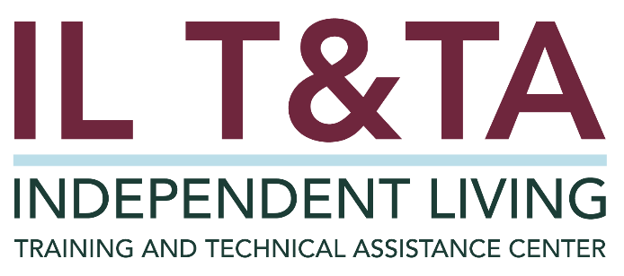
This project is on assignment through contract with the Administration on Disabilities, Administration for Community Living, Health and Human Services.

