SILC Connection- Fiscal Oversight

July 15, 2025

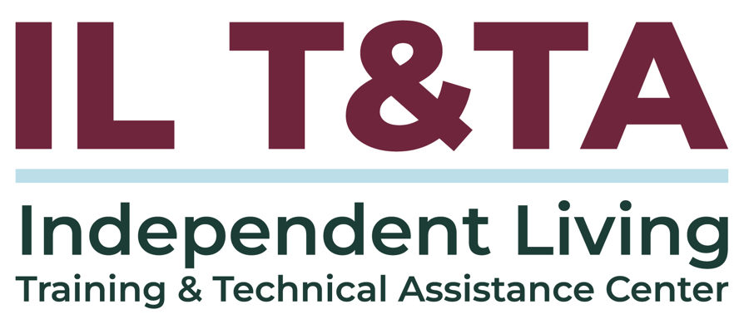
Before We Begin
ASL & Spanish Interpreters are available and labeled.
Access Closed Captioning by clicking the CC button located at the bottom of your Zoom window.
Use Zoom's Raise Hand or Chat features to ask questions.
Remember to state your name and organization before speaking.
Message our IL T&TA team using the Chat feature if you have difficulties with today's call.
Please complete the survey at the end of today's training.

Agenda
- Key Takeaways and Background
- Fiscal Oversight: Roles, Structures, and Practices
- Fiscal Management & Compliance: Internal Controls and Accountability
- Peer Discussion & Shared Learning

Learn & Share Format
- Short presentation (approximately 20 minutes)
- 40 minutes of peer discussion

Key Takeaways:
- Define the SILC's role in fiscal oversight, management, and compliance
- How do fiscal policy and procedures enhance governance

Overall Goal:
Let's learn with and from each other!

Presenters and Facilitators
Peer Presenter:
Jeremy Morris
Executive Director
Ohio State Intendent Living Council
Jmorris@ohiosilc.org
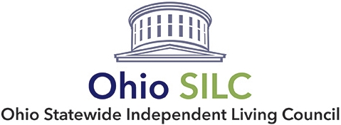
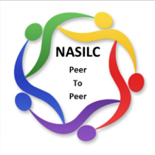
Facilitated by:
Brooke Wilson
Chair - Oregon Statewide Independent Living Council, NASILC (National Association of State Independent Living Councils)

Fiscal Oversight, Management, and Compliance
- Purpose
- Practice
- Structure
Common Financial Management: 2 CFR 200 (“Uniform Guidance”)

Fiscal Oversight - Purpose
- The State Independent Living Council (SILC) is a non-Federal entity that receives federal funding
- The SILC has the responsibility of administering the federal funds received
- The SILC must implement sound organization and management processes and practices to ensure proper and efficient administration of funding
- The SILC is the primary check and balance for the Executive Director and ensures that there is proper oversight

Fiscal Oversight – Practice
- The SILC Board has approved fiscal policies and procedures for the organization
- The policies and procedures are reviewed and updated periodically
- The SILC approves an annual operating budget and receives regular reports on the budget
- If nonprofit, SILC should review the annual 990
- Any audit report should be provided directly to the SILC Board and reviewed

Fiscal Oversight – Structure
- Some SILCs may have a finance committee, or another committee assigned to that responsibility
- There should be active board level involvement in fiscal oversight and review
- These tasks should include:
  - Review and develop annual budget
  - Review 990 or other reporting
  - Develop and review fiscal policy
  - Review and monitor policies that are implemented and followed
  - Review regular financial statements

Fiscal Management – Purpose
- Daily operations of the SILC are carried out through the consistent application of its approved policies and procedures
- Following the approved processes ensures compliance with funding rules and regulations
- It provides internal controls to protect:
  - The assets of the SILC
  - SILC members
  - SILC staff
- Allows the SILC to follow 2 CFR 200 (“Uniform Guidance”) which sets the standards for managing federal grant awards

Fiscal Management – Practice
- Specifically with federal funds, all costs must be reasonable, necessary, allowable, and allocable
- Policies and procedures should clearly demonstrate how compliance is maintained
- Cost and expenses are well documented and reviewed regularly
- Potential issues are identified early, documented, and addressed to prevent recurrence

Fiscal Management – Structure
- Separation of duties – have defined roles for SILC board and staff
- Engage external accounting services with experience with federal funds to strengthen financial oversight for compliance
- Reconcile bank, credit card, and other accounts monthly
  - Reviews should involve someone not signing or issuing checks

Fiscal Management – Structure, cont.
- Create approval processes for expenses and review documentation
- Collaborate with the Designated State Entity (DSE) to align fiscal procedures, ensure timely funding, and maintain SILC autonomy

Fiscal Management – DSE
Provides fiscal oversight without compromising SILC autonomy
Understanding the DSE’s Role:
- The Designated State Entity (DSE) receives, disburses, and accounts for Part B and I&E funds in accordance with the SPIL
- The DSE provides fiscal oversight, but must support the SILC’s autonomy and may not impose conditions that interfere with the SILC’s operations or decision-making

Fiscal Management – DSE, cont.
- Oversight includes ensuring expenditures are allowable, reasonable, and allocable under federal and state regulations (e.g., 2 CFR 200, 45 CFR 75, 45 CFR 1329)
- DSE fiscal control procedures must facilitate the SILC’s independence and implementation of its resource plan
- DSE fiscal procedures must recognize the SILC’s authority over its resource plan and facilitate—not delay—access to committed funds

Fiscal Compliance – Purpose
- Compliance with federal rules and regulations should be included into the management and oversight
- Having established policies that are regularly review and updated helps ensure alignment with regulations and rules
- Conflicts of interest are managed and disclosed properly

Fiscal Compliance – Practice
- SILC Board members are well informed about fiscal requirements and policies
- The SILC accurately reports financial information
- Established internal controls prevent misuse of money
- Expenses are documented and are reported properly
- The Designated State Entity (DSE) receives accurate financial invoicing consistent with any contract provisions

Fiscal Compliance – Structure
- SILC members review and approve reporting; financial statements are prepared in advance
  - Responsibilities should be distributed to prevent any one person from having unchecked authority over financial processes
- SILC Treasurer is actively involved in reviewing the banking information and reconciliations
- If the SILC has staff, there are limits to their purchasing and approval authority. All staff purchases are subject to review and may require board approval

Important Policy and Procedure Topics: Things to Consider
- Check Signing and Approval
- Purchasing Policies
- Travel Cost and Reimbursement
- Staff Time
- Credit/Debit Card access
- Bank Statements
- Cash/Check Receipts

For Check Signing and Approval
- Policies should indicate who can sign checks and the maximum limit, example:
  - SILC Director can sign a check for up to $1,000 without second approval if expense is in the approved budget
- Approval of Expenses for non-check payments
  - Electronic payments or credit card payments should follow similar processes to check payments for fidelity

For Check Signing and Approval, cont.
  - Approvals should be documented in some form: electronic system, signed forms, or other process
  - Nothing should be done based on verbal approval

For Purchasing
- Policies should indicate what types of purchases require a competitive bidding process (multiple bids)
- Have process to solicit proposals or bids, review the proposals, and select a contract or vendor.
- Specify exceptions to a competitive bid
- Know your state policies and contract requirements about any minority or women-owned business purchasing initiatives

For Travel cost and reimbursement
- Establish policies and procedures around travel related expenses and costs, such as:
  - Is per diem used for travel?
  - Are state travel rules applicable?
  - Is there a maximum mileage rate the state will reimburse?
  - What expenses and cost require receipts?
  - What timeframe can someone submit for reimbursement?
  - Are travel advances allowed?

For Staff Time
- What is used to document staff time and efforts?
  - There should be a process to document the amount of time spent working
- What records are maintained to justify after the fact?
- What is the approval process?

For Credit/Debit Card Access
- If the SILC has a credit/debit card, who has access to the card?
- Where is it kept when it is not in use?
- What process is set up to collect the documentation when the card is used?
- What is the process if the card is lost/stolen?
- How is the credit card statement reviewed?

For Bank Statements
- Bank statements should be reconciled regularly for all accounts
- Bank statements and reconciliations should be reviewed by an individual other than the one writing or signing checks
- Do you have statements that provide check images?
- Are the check images compared to the financial records to make sure that the records match the checks?

For Cash/Check Receipts
- How is it handled when the SILC receives payments?
  - Could be grant payment, donation, or any payment to the SILC
- How long before it must be deposited?
- Who can make a deposit?
- What records are maintained to show the receipt of money?
- Are checks marked “For Deposit Only” recorded?
- How do you ensure checks received are deposited and recorded?

Resources for Additional Guidance
- Common Financial Management: 2 CFR 200 (“Uniform Guidance”)
- SILC Policies and Procedures: A Solid Foundation for Management: ILRU and the IL-NET
- SILC Basics: ILRU and the IL-NET
- FAQ SILC Resource Plans: Located on Administration for Community Living for SILC & SPIL
- Guidebook for SILC Chairpersons, Members, and Administrators: ILRU and the IL-NET

Learn & Share: Your Experience Matters
Recording has stopped – now it’s time to share.

Ways to Engage:
- Raise your hand to be spotlighted to speak
- Turn on your camera if you're comfortable
- Use the chat to share insights, questions, resources, or tools
- React, reflect, or build on what others say
- Share real challenges or successes from your CIL
Let’s turn ideas into action — your voice is the most valuable part of this session.

Evaluation
Thank you for participating in today's Learn and Share.

Your feedback is important and helps us plan future training.
Please use the link in the chat to share your feedback.
Evaluation Link:


How to Connect with Us!

Website: https://tinyurl.com/ILTTACenter
Request training and / or technical assistance (expert help for your organization): fill out a form on our website to let us know how we can help.
Call: 406-243-5300 and someone will get back to you as soon as we can.
Sign-Up for Events & Announcements:

Visit our website to sign up for updates about live training, group technical assistance, new publications, and other happenings around the Center.

IL T&TA Center Attribution

This project is on assignment through contract with the Administration on Disabilities, Administration for Community Living, Health and Human Services.

About the IL T& TA Center
The Independent Living Training and Technical Assistance Center (IL T&TA Center) is available to you through a contract with the US Department of Health and Human Services.
The IL T&TA Center provides expert training and technical assistance to CILs, SILCs, and DSEs.
The Center is operated by the University of Montana's Rural Institute for Inclusive Communities.


