The Independent Living Philosophy
in Operations

July 9, 2025
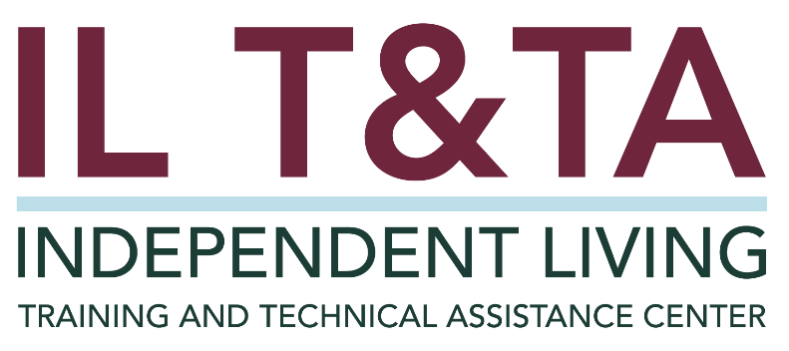

Before We Begin - Accessibility
- ASL & Spanish Interpreters are available and labeled.
- Access Closed Captioning by clicking the CC button located at the bottom of your Zoom window.
- Use Zoom's Raise Hand or Chat features to ask questions.
- Remember to state your name and organization before speaking.
- Message our IL T&TA team using the Chat feature if you have difficulties with today's call.
- Please complete the survey at the end of today's training.

Today’s Agenda –

Key Takeaways:
- Identify practical ways to apply the IL Philosophy throughout your organization
- Learn how to use the IL Philosophy to make well informed decisions

Learn & Share Format:
- 20 minutes of spotlight content
- 40 minutes of peer discussion

Overall Goal:
Let's learn with and from each other!

Presenters
Tyler Morris
Director of Training
Independent Living Training & Technical Assistance Center
tyler.morris@mso.umt.edu

Facilitated By:
Mary-Kate Wells
Director of Programs
National Council on Independent Living

What is the
Independent Living (IL) Philosophy ?

Rehabilitation Act of 1973
Title VII. Chapter 1. Part A. Section 701. Purpose.
The purpose of this chapter is to promote a philosophy of independent living, including a philosophy of consumer control, peer support, self-help, self-determination, equal access, and individual and system advocacy, in order to maximize the leadership, empowerment, independence, and productivity of individuals with disabilities, and the integration and full inclusion of individuals with disabilities into the mainstream of American society.

How IL Philosophy Shapes Our Work
The Independent Living Philosophy is more than a mission – it is a mindset that shapes how we work. It centers self-determination, consumer control, dignity, and inclusion.
Consumer voice is not symbolic – it is central to every decision we make.
Staff carry out the mission daily. The IL Philosophy guides how we communicate, problem-solve, and empower our consumers.

How IL Philosophy Shapes Our Work, cont.
The IL Philosophy means:
- Consumers shape services and lead their own goals
- Services reflect real needs, not assumptions
- Staff practices uphold independence, dignity, and choice
- Lived experience shapes services and priorities

What is Informed Decision Making?
Informed decision making, is a process of making a thoughtful, well-informed choice based on facts and information. It involves analyzing potential outcomes, benefits, and risks before deciding on the best option.
Informed decision making isn’t just about saying “yes” or “no” – it’s about every decision moving us forward with purpose.

What is Informed Decision Making?, cont.
What informed decision making is NOT:
- Reacting instead of reflecting
- Doing for instead of deciding with
- “We’ve always done it this way” thinking
- Quick fixes over long-term solutions
- Deciding without understanding the 'why'

Key Inputs for Decision Making
Key inputs are critical pieces of data, perspective, or guidance that helps ensure a decision is well-informed, aligned with the mission, and supportive of doing the right thing in real time.
Examples of Key Inputs:
- Consumer Feedback
- Workplace Values and Goals
- Team Insights and Lived Experience
- Policies and Procedures
- Clear Directives
- Critical Thinking & Reflection

Key Inputs for Decision Making, cont.

Reflection Note:
What inputs are critical to your decision making in your role?

Questions Asked by Highly Effective IL Teams
- Does this action support consumer control and dignity?
- Have I asked the consumer how they want to move forward?
- Are we creating access – or creating barriers?
- What perspectives are we missing that could impact our decisions?
- Did this process include people with lived experience?
- What did we learn, and how do we improve?
- How can I support you in making a confident next step?

Questions Asked by Highly Effective IL Teams, cont.
- Are we staying aligned with the values we’ve agreed matter most?
- Was this decision disability-led?

How does the IL Philosophy impact:
- Environment and Space
- Forms, Procedures, and Technology
- Communication and Service Delivery
- Team Culture and Interactions
- Policy and Practice

Environment & Space:
- Is the front entrance welcoming, accessible, and clearly marked?
- Are restrooms fully accessible (not just ADA compliant)
- Is there a quiet space for consumers who may be overwhelmed?
- Is there space for a wheelchair user to sit in the waiting room?

Forms, Procedures, and Technology:
- Are sign-in sheets clear, private, and respectful of personal information?
- Do forms avoid deficit-based language like “problems” or “limitations”?
- Can consumers choose how they receive information?
- Is the copy machine in a location that everyone can use it independently?
- Do consumers have access to technology and is that technology equipped with accessibility tools?

Communication & Service Delivery:
- Does our team first ask, “How would you like us to support you?”
- How does the person I’m speaking to know we are a disability-led organization?
- Is everyone who walks through our door greeted equally, regardless of communication style or appearance?
- Is feedback invited regularly and acted upon?
- Are communication supports clearly posted for consumers to know their options?

Team Culture:
- Are co-workers encouraged to ask questions with respect, not assumptions?
- Does our team interrupt or override consumer unintentionally?
- Are all team members – including janitorial staff, volunteers, and trainers – trained in the IL Philosophy?
- Do we assume competence and prioritize peer leadership?

Policy and Practice:
- Do hiring practices reflect a commitment to employing people with disabilities?
- Are transportation, lunch breaks, and meetings times planned with flexibility in mind?
- Are we applying universal design principles wherever possible?
- Are consumers ever required to “prove” disability or justify their decisions?
- Are we taking affirmative action to employ and advance in employment qualified individuals with significant disabilities?

Learn & Share: Your Experience Matters
Recording has stopped – now it’s time to share.

Ways to Engage:
- Raise your hand to be spotlighted to speak
- Turn on your camera if you're comfortable
- Use the chat to share insights, questions, resources, or tools
- React, reflect, or build on what others say
- Share real challenges or successes from your CIL
Let’s turn ideas into action — your voice is the most valuable part of this session.

Evaluation
Thank you for participating in today's Learn and Share.

Your feedback is important and helps us plan future training.

Please use the link in the chat to share your feedback.
Evaluation Link:


How to Connect with Us!

Website: https://tinyurl.com/ILTTACenter
Request training and / or technical assistance (expert help for your organization): fil out a form on our website to let us know how we can help.
Call: 406-243-5300 and someone will get back to you as soon as we can.

Sign-Up for Events & Announcements: Visit our website to sign up for updates about live training, group technical assistance, new publications, and other happenings around the Center.

IL T&TA Center Attribution

This project is on assignment through contract with the Administration on Disabilities, Administration for Community Living, Health and Human Services.

About the IL T& TA Center
The Independent Living Training and Technical Assistance Center (IL T&TA Center) is available to you through a contract with the US Department of Health and Human Services.
The IL T&TA Center provides expert training and technical assistance to CILs, SILCs, and DSEs.
The Center is operated by the University of Montana's Rural Institute for Inclusive Communities.



