Data as a Driver – Telling the Story of IL Impact (Part 1)
August 13, 2025

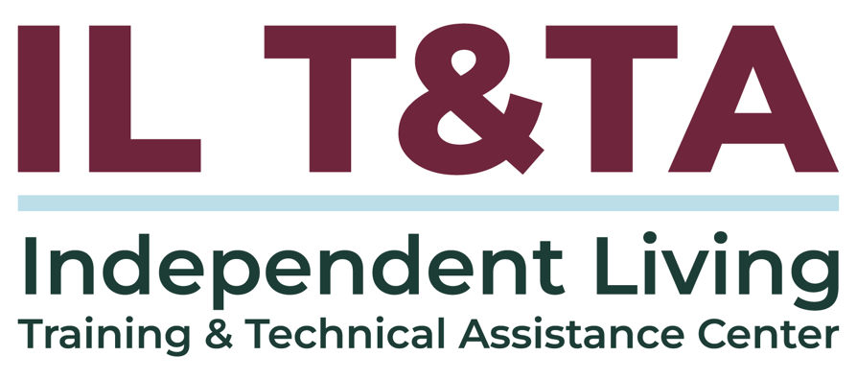
Before We Begin
ASL & Spanish Interpreters are available and labeled.
Access Closed Captioning by clicking the CC button located at the bottom of your Zoom window.
Use Zoom's Raise Hand or Chat features to ask questions.
Remember to state your name and organization before speaking.
Message our IL T&TA team using the Chat feature if you have difficulties with today's call.
Please complete the survey at the end of today's training.

Today’s Agenda –

Key Takeaways:
- Understand how internal data practices support quality improvement and mission alignment at CILs.
- Recognize simple strategies for using data to promote consumer control and guide organizational growth.

Learn & Share Format:
- Approx. 20 minutes of spotlight content
- 40 minutes of peer discussion

Overall Goal:
Let's learn with and from each other!

Presenters
Gerald Hay
Director of Independent Living Services
Independence First
ghay@independencefirst.org
Support: Eric Riskus
Independent Living Program Director
Midstate Independent Living Choices, Inc. eriskus@milc-inc.org

IL T&TA Center
Tyler Morris
Director of Training
Independent Living Training & Technical Assistance Center

Facilitators
Mary-Kate Wells
Director of Programs
National Council on Independent Living

Key Regulations
- 45 CFR § 1329.26 – Annual Performance Reports (PPR)
  - Data reported annually is the baseline, and this training encourages using that data internally for growth, strategy, and storytelling
- 45 CFR § 1329.5 – Indicators of Minimum Compliance for CILs
  - CILs must meet minimum indicators for: Independent Living goals, community activities, outreach to underserved populations
  - Training Point: Help CILs to go beyond the minimum by tracking deeper impact and equity

About Wisconsin Coalition of Independent Living Centers
All 72 counties in the state are served by one of the 8 CILs in the state, and management staff from each of the centers meet in-person (and virtually) on a bi-monthly basis
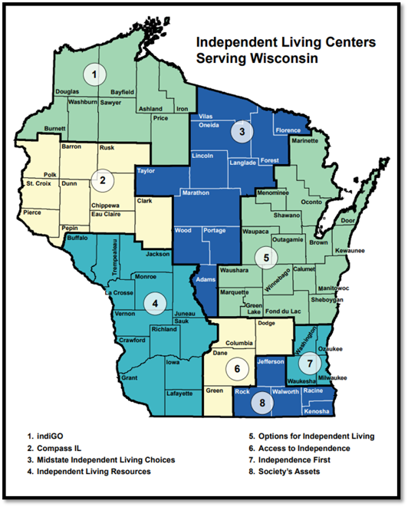

What Can Good Data Do?
Being able to collect and use good data can:
- Give a better understanding of the communities your Center serves
  - Who are our consumers?
- Allow for better tracking of Center activities
  - What exactly are we doing?

What Can Good Data Do (cont.)?
- Ensure state, federal and other granting source compliance
  - Compliance is just a minimum standard; good data can illuminate patterns that lead to the delivery of relevant, responsive services that empower consumers as they prefer
- Provide for better management and quality assurance
  - How do we maintain or grow positive momentum?
- Create opportunities to share your mission and help with advocacy initiatives

What is Good Data?
Good data should:
- Serve a purpose
  - Why are you collecting it? What do you need to do?
- Be accurate
  - Do you know the framing and how it was collected?
- Be clear
  - Can you understand what is presented?

What is Good Data (cont.)?
- Be consistent
  - Is it collected and/or pulled in the same way every time? Does staff know the how and why?
- Be findable
  - Is it accessible to the people who need it?
- Be usable!
  - Can you use it to answer a question, complete necessary reporting or build something with it?

Aligning Data and IL Values:
Where can good data take you?
- Towards better serving the underserved
- Towards better understanding your Center’s reach and impact
- Towards better management practices
- Towards improved legislative, funding and marketing actions (i.e. justification)
- Back to the beginning of Independent Living

Connection to IL Philosophy:
Independent Living Centers (ILCs) are consumer-controlled, community-based, cross-disability, nonresidential private non-profit agencies that are designed and operated within a local community by individuals with disabilities, and provide an array of independent living services.

Each one of these highlighted elements are essential to the core mission and successful functioning of a CIL and they can each be measured.

Tools to Tell the Story:
- Quality Standards and Indicators
- Program Performance Report for State Independent Living Services Program
- Compliance and Outcome Monitoring Protocol - CIL Evaluation Tool
- CIL Evaluation Tool - Self-Evaluation
- Peer Review tools like Wisconsin's QUILS (Quality Indicators for Independent Living Services)
- Survey tools like Survey Monkey or paper survey
- Your CIL's database or information management system

Where to Start?
Identify needs:
- PPR and other report feedback
- Satisfaction with current database
  - Usability
  - Organization of Information
  - Report Access
  - Staff ease of use, time demands and margins of error
  - Customization/Adaptability

Quality Assurance Measures:
- Determine what information you need, and what information your Center would like to have.
- Compliance is just the beginning. Start small then build out
  - Talk to other Centers!
- Integrate wherever possible
  - Using multiple data sources like Excel spreadsheets can introduce room for error, create double data entry and increased work load for staff, and lead to potential data loss (broken formatting, easy deletion etc.)

Quality Assurance Measures (cont.):
- Clearly define who is responsible for each step in the process
- Establish a pattern of regular reviews
  - E.g. monthly, quarterly, annual
- Create opportunities for feedback and discussion
  - What trends are we seeing?
  - What are we doing with the information we receive?
  - Where should we go next?

Staff Buy-in:
Staff should be involved during every step of the process including forward planning:
- Common Definitions of Terms
  - Make sure staff are familiar with all relevant service definitions and there is consistency
- Set Clear Data Entry Expectations and Practices
  - Create standard operating procedures (SOPs), visual guides and checklists to help guide existing staff and train new members of the team

Staff Buy-in (cont.):
- Regularly review data with staff not only for job performance, but also to set goals and seek input
- Share the results from reports like the PPR and show them how it is prepared
  - Ask for feedback!
- Create opportunities for feedback and discussion
  - Use this as an opportunity for staff development and succession planning

Takeaways:
- Identify your Center's needs before implementing a strategy or tool
  - Build a data framework that meets your Center's needs
- Any tool should meet the needs of the user and their role
  - Accessibility
  - Function
- Ensure staff is adequately trained and involved in forward planning
- Perform regular quality assurance and reporting checks

Takeaways (cont.):
- Ask "Why?
  - Are you seeing what you expect to see? If not, why not?
- Good data can strengthen your Center's ability to grow, adapt and successfully meet the needs of your community
- Quality assurance is continuous process
  - Plan, Do, Check, Act (PDCA)
  - Repeat!
- Share in all of your successes to tell the story of Independent Living

Resources for Additional Guidance:
- Section 7: Operational Excellence and Evaluation, ILRU
- Overview of Compliance and Outcome Monitoring Protocol (COMP), Administration of Community Living
- Top 10 Mistakes That Can Put Your CIL or SILC At Risk, ILRU
- Gathering, Analyzing, & Utilizing Data, ILRU

Coming Up Next – Part 2: Data as a Driver – Beyond the Numbers on August 27, 2025!

Learn & Share: Your Experience Matters
Recording has stopped – now it’s time to share.

Ways to Engage:
- Raise your hand to be spotlighted to speak
- Turn on your camera if you're comfortable
- Use the chat to share insights, questions, resources, or tools
- React, reflect, or build on what others say
- Share real challenges or successes from your CIL
Let’s turn ideas into action — your voice is the most valuable part of this session!

Evaluation
Thank you for participating in today's Learn and Share.

Your feedback is important and helps us plan future training.
Please use the link in the chat to share your feedback.
Evaluation Link:
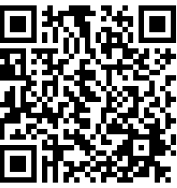

How to Connect with Us!

Website: https://tinyurl.com/ILTTACenter
Request training and / or technical assistance (expert help for your organization): fill out a form on our website to let us know how we can help.
Call: 406-243-5300 and someone will get back to you as soon as we can.
Sign-Up for Events & Announcements:
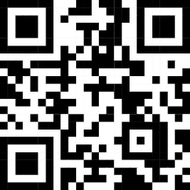
Visit our website to sign up for updates about live training, group technical assistance, new publications, and other happenings around the Center.

IL T&TA Center Attribution

This project is on assignment through contract with the Administration on Disabilities, Administration for Community Living, Health and Human Services.

About the IL T& TA Center
The Independent Living Training and Technical Assistance Center (IL T&TA Center) is available to you through a contract with the US Department of Health and Human Services.
The IL T&TA Center provides expert training and technical assistance to CILs, SILCs, and DSEs.
The Center is operated by the University of Montana's Rural Institute for Inclusive Communities.
