SILC Connection- Statewide Plan for Independent Living (SPIL) Amendments

August 19, 2025

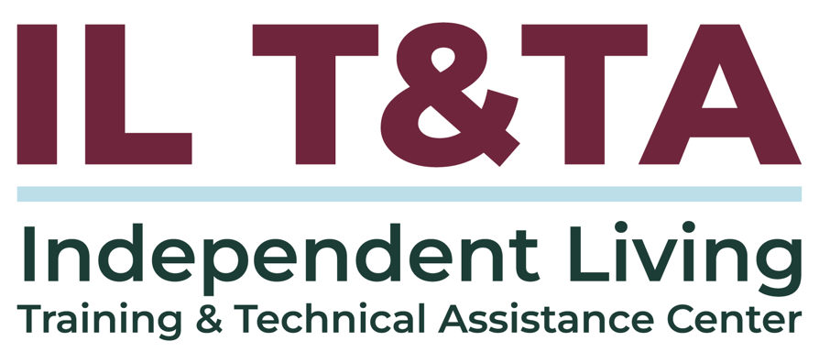
Before We Begin
ASL & Spanish Interpreters are available and labeled.
Access Closed Captioning by clicking the CC button located at the bottom of your Zoom window.
Use Zoom's Raise Hand or Chat features to ask questions.
Remember to state your name and organization before speaking.
Message our IL T&TA team using the Chat feature if you have difficulties with today's call.
Please complete the survey at the end of today's training.

Key Takeaways:
- Understand the purpose of Substantial and Technical SPIL amendments
- Understand the steps for submitting SPIL amendments

Learn & Share Format
- Short presentation (approximately 20 minutes)
- 40 minutes of peer discussion

Overall Goal:
Let's learn with and from each other!

Presenters and Facilitators
Peer Presenters:
Megan Kulwein
Executive Director
Kentucky Statewide Independent Living Council
Megan@kysilc.org

Mel Leviton
Executive Director
Idaho State Independent Living Council
Mel.Leviton@silc.idaho.gov

Facilitated by:
Brooke Wilson
Chair- NASILC (National Association of State Independent Living Councils)

SPIL Amendments
Detailed Information about SPIL Amendments can be found in the SPIL Instrument and Instructions (pages 7-8).
Two Ways to Start the Process: SPIL amendment may be initiated by the SILC and CILs and/or at the request of the ACL Administrator.
When An Amendment is Required: A SPIL amendment must be submitted to ACL/OILP whenever necessary to reflect any material change in State law, organization, policy, or agency operations that affects the administration of the SPIL (CFR 1329.17(c)), and for any substantial or material change desired, such as a change in the DSE.

SPIL Amendments (cont.)
Current SPIL Remains In Effect: The State will continue to operate under the existing SPIL during the period covered by the SPIL until the amendments are approved.
DSE Must Be Notified: The director of the DSE must be informed of, and provided with a copy of, all proposed SPIL amendments before submission to ACL/OILP and provided with the amended SPIL upon approval by ACL/OILP.
Two Types of Amendments:
- Substantial Amendment
- Technical Amendment

Substantial Amendments
Substantial amendments are significant changes to the SPIL. These may include, but are not limited to:
Changes in the:
- SPIL goals and objectives that impact the scope of services to individuals with significant disabilities;
- the designation of unserved or underserved areas and the priorities for serving them;
- the state’s priorities for funding new or existing centers;

Substantial Amendments (cont.)
- the distribution method (e.g., formula for distributing excess funds to centers); or
- the DSE to an entity NOT currently identified in the SPIL.

Technical Amendments
Technical amendments are technical changes to the SPIL that do not constitute a substantial and material change in information in, or operation of, the SPIL. These may include but are not limited to:
- Changing the entity responsible for achieving a SPIL objective (without changing the objective itself);
- DSE director or SILC chairperson (without changing the DSE); or
- Implementation dates.

SPIL Amendment Process
Step 1—Send a Request: Before amending the SPIL, States must send a SPIL Amendment Request, by e-mail, to their assigned Program Officer.
Step 2— ACL/OILP Determines Type of Amendment: The Program Officer will make a determination whether a technical amendment or a substantial amendment is required based upon the information presented in step 1.
- The Program Officer will make the determination within 30 days of official notice of intent to amend from the State.

Substantial Amendment Process
If the Program Officer has determined that a substantial amendment is required:
- Gather Input: The SILC must gather input from individuals with disabilities and other stakeholders in the state before drafting the SPIL amendment.
- Draft the Amendment: The SILC chairperson and the directors of the CILs in the state draft the amendment(s).
- Submit Draft: The SILC will submit the proposed amendment language to the Program Officer for review.

Substantial Amendment Process: (cont.)
- ACL/OILP Will Respond to Draft: Program Officer will confirm receipt of the proposed amendment and establish a deadline to respond to proposed language.
- SILC Hold Public Hearings: The SILC must hold public hearings to receive public comment on the amendment(s), identifying any revisions needed.

Substantial Amendment Process: (cont.)
- Sign & Submit Final: Submit the signed amendment to ACL/OILP for approval. The amendment must be signed by the SILC chair, and not less than 51 percent of the CIL directors in the state.
  - The DSE Director’s signature is required ONLY if the amendment includes changing the DSE or materially changing its duties/responsibilities.
- ACL/OILP Reviews & Approves: Program Officer reviews and approves or disapproves.

Technical Amendment Process:
If the Program officer has determined that a technical amendment is required:
- SILC & CILs Draft: The SILC chairperson and the directors of the CILs in the state draft the amendment(s).
- Submit Proposed Amendment: The SILC will submit the proposed amendment language to the Program Officer for review and respond to proposed language.
- Final Submitted to ACL/OILP: The SILC then submits the signed amendment to ACL for approval.

Resources for Additional Guidance
Instructions for State Plan for Independent Living (SPIL)
Office of Independent Living Programs Contact List

Learn & Share: Your Experience Matters
Recording has stopped – now it’s time to share.

Ways to Engage:
- Raise your hand to be spotlighted to speak
- Turn on your camera if you're comfortable
- Use the chat to share insights, questions, resources, or tools
- React, reflect, or build on what others say
- Share real challenges or successes from your CIL
Let’s turn ideas into action — your voice is the most valuable part of this session.

Evaluation
Thank you for participating in today's Learn and Share.

Your feedback is important and helps us plan future training.
Please use the link in the chat to share your feedback.
Evaluation Link:


How to Connect with Us!

Website: ILTTACenter.org
Request training and / or technical assistance (expert help for your organization): fill out a form on our website to let us know how we can help.
Call: 406-243-5300 and someone will get back to you as soon as we can.
Sign-Up for Events & Announcements:

Visit our website to sign up for updates about live training, group technical assistance, new publications, and other happenings around the Center.

IL T&TA Center Attribution

This project is on assignment through contract with the Administration on Disabilities, Administration for Community Living, Health and Human Services.

About the IL T& TA Center
The Independent Living Training and Technical Assistance Center (IL T&TA Center) is available to you through a contract with the US Department of Health and Human Services.
The IL T&TA Center provides expert training and technical assistance to CILs, SILCs, and DSEs.
The Center is operated by the University of Montana's Rural Institute for Inclusive Communities.


