Language Matters: Tools for Effective Communication in IL Services
August 21, 2025
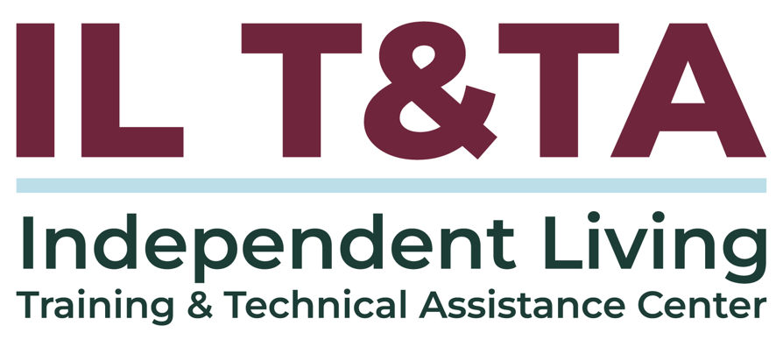

Before We Begin
ASL & Spanish Interpreters are available and labeled.
Access Closed Captioning by clicking the CC button located at the bottom of your Zoom window.
Use Zoom's Raise Hand or Chat features to ask questions.
Remember to state your name and organization before speaking.
Message our IL T&TA team using the Chat feature if you have difficulties with today's call.
Please complete the survey at the end of today's training.

Today’s Agenda –

Key Takeaways:
- Learn how Section 21 of the Rehabilitation Act supports access to IL for people from different language and cultural backgrounds.
- Understand key terms like “plain language,” “unserved,” and “underserved,” and how they apply to Independent Living work.
- Explore practical ways CILs can improve communication access for all consumers, including those with limited English proficiency or diverse communication needs.

Today’s Agenda (cont.) –

Format:
- Approx. 45 minutes of spotlight content
- 30 minutes of peer discussion

Overall Goal:
Let's learn with and from each other!

Facilitators
Mary-Kate Wells
Director of Programs

Technical Assistance
Tyler Morris
Director of Programs
Independent Living Training & Technical Assistance Center

What is “Section 21”?
Section 21 is not a standalone law — it’s a specific provision within the original Rehabilitation Act of 1973, codified at 29 U.S.C. § 718. It was added to strengthen outreach efforts to individuals from minority backgrounds, this may include those with limited English proficiency (LEP) and from culturally diverse or disadvantaged populations.

How Section 21 Shows Up in Independent Living (IL)
While Section 21 itself doesn’t prescribe specific regulatory steps, its requirements are embedded in some Independent Living regulations:
- 45 CFR § 1329.4 – Definitions: Defines “unserved and underserved populations” to include linguistic and cultural minorities.
- 45 CFR § 1329.10 – State Plan Requirements (SPIL): Requires IL State Plans to address outreach to LEP and minority groups.

How Section 21 Shows Up in IL (cont.)
- 29 U.S.C. § 796f-4. Standards and assurances for centers for independent living: Mandates that Centers for Independent Living must “promote equal access” for individuals from minority or disadvantaged backgrounds.

How Section 21 Shows Up in IL (cont.)

Outreach & Representation
- Prioritizing engagement with communities that have historically been excluded from IL services (e.g., racial/ethnic minorities, people with limited English proficiency, Deaf/DeafBlind communities, and Tribal communities).
- Recruiting and supporting staff, board members, and peer mentors who reflect the demographics of the service area.

How Section 21 Shows Up in IL (cont.)

Removing Communication Barriers
- Providing information in plain language, multiple languages, and accessible formats.
- Ensuring interpretation/translation, captioning, and assistive technology are available for all IL services.

Building Trust Through Cultural Competence
- Recognizing and respecting cultural norms and lived experiences.
- Training staff to address bias, build rapport, and tailor services to community needs.

How Section 21 Shows Up in IL (cont.)

Measuring and Responding to Gaps
- Using data to identify who is not being reached.
- Adjusting outreach strategies and service delivery to close gaps.

Key Terms to Know:
- Unserved and Underserved: include populations such as individuals from racial and ethnic minority backgrounds, disadvantaged individuals, individuals with limited English proficiency, and individuals from underserved geographic areas (rural or urban).
- Minority Group: Includes racial, ethnic, cultural, and language minorities, as well as people from other historically marginalized groups.
- Cultural Competence – The ability to interact effectively with people across different cultural and linguistic backgrounds.

Key Terms to Know: (cont.)
- Effective Communication: Ensuring that information is understood by the intended audience, including through interpreters, assistive technology, and plain language.
- Communication Preferences – Modes or formats a consumer identifies as most effective for them (e.g., ASL, LSM, AAC devices, large print, Braille, captioning).
- Plain Language: (Administration of Community Living: Communication Planning Tips) – Clear, direct communication that can be understood the first time read or heard.
- Language Access – The ability for people with limited English proficiency or different communication modes to fully understand and participate in services.

Key Terms to Know: (cont.)
- Limited English Proficiency (LEP)(US Commission on Civil Rights) –Describes individuals who: a. do not speak English as their primary language; and b. have a limited ability to read, write, speak, or understand English. Individuals with LEP may be competent in English for certain types of communication (e.g., speaking or understanding), but have limited proficiency in English in other areas (e.g., reading or writing)
  - An individual who is Deaf or Hard-of-Hearing (D/HOH) may also have limited proficiency in spoken or written English and may not be proficient in ASL or any other recognized sign language.

Presenters from Dayle McIntosh Center
Nelly Gomez
Lead Youth and Information Coordinator
ngomez@daylemc.org
Jet Hurley
Deaf Services Advocate
jhurley@daylemc.org
Lizette Martinez
Assistive Technology Coordinator
lmartinez@daylemc.org

Language Matters in Practice: Dayle McIntosh Center
Dayle McIntosh Center for the Disabled (DMC) was established in 1977.

Our mission statement is, “Access and equity, by and for, people with disabilities and older adults.”

DMC is 1 of 28 Centers for Independent Living in the State of California.
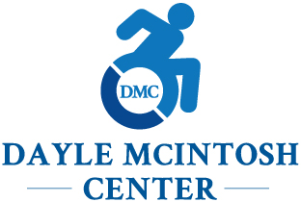

DMC’s Core Commitments to Access
Living the IL philosophy means making sure every person in every community can:
- Find you – Equal opportunity starts with visibility
- Understand you – Information is power when it’s accessible
- Use your services – True choice requires removing barriers
- Want to come back – Inclusion means feeling valued and respected
Consumer control and equal access drive each step

One Mission, Many Paths to Access
Dayle McIntosh Center (DMC) puts the IL philosophy and Section 21 into action — ensuring everyone can find us, understand us, use our services, and feel welcome
We’ll highlight our practices from:
- Deaf/Deaf-Hard of Hearing Program – Language and cultural access
- Youth Transitions Program (DMC Youth Connect) – Meeting young people where they are
- Assistive Technology - Tools that remove communication barriers and expand consumer choice
- Reception/I&R (Information & Referral) – Opening the door for all community members

Program in Action: Services for the Deaf
“The purpose of the Deaf Services Program is to empower d/Deaf persons with the needed tools, skills, and support to succeed. Our services are designed to promote effective communication and integration for deaf people living in a hearing world.”

Every service is delivered in the consumer’s preferred language and communication method—whether ASL, captioning, written English, or technology-supported access.

Services in Action: Services for the Deaf
Independent Living Skills Training – One-on-one or group sessions covering budgeting, communication strategies, daily living, technology use, driver’s license readiness, and social/soft skills.
Advocacy and Rights Protection – Support with addressing discrimination, benefits navigation, Social Security issues, workplace barriers, housing services, and securing interpreters or other accommodations.
Community Connection & Education – Peer support groups, quarterly workshops, and Deaf Sensitivity Trainings that strengthen cultural awareness and create inclusive spaces.

Services in Action: Services for the Deaf (cont.)
Communication Access Resources – Guidance on learning to read and write in English, knowing your rights, requesting sign language interpreters, and using tools like videophones, relay services, and other assistive technology to ensure equal participation.
Self-Advocacy Development – Building skills to confidently request communication access and navigate systems independently.

Access in Action: Services for the Deaf
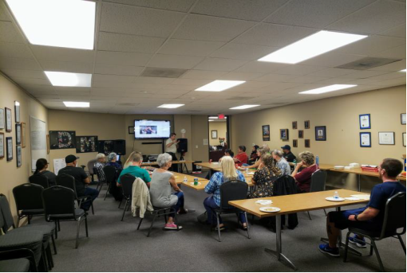
Dayle McIntosh Center Conference room hosting Deaf and Hard-of-Hearing consumers for a training.

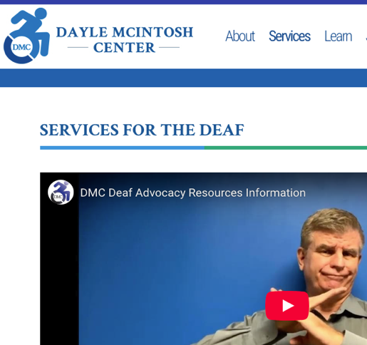
DMC’s website features ASL videos across key pages, giving Deaf and hard of hearing visitors essential information in their native language from the first click.

Program in Action: Youth Transitions (DMC Youth Connect)
“The purpose of DMC Youth Connect is to help youth with disabilities transition from school to adult life, gain independence, and connect with peers. The program offers skill-building, recreation, and mentoring—meeting youth where they are and helping them get where they want to be.”

We talk to each youth in the way they understand best—this could be American Sign Language (ASL), spoken English, or another language. Since Orange County has many different languages, we make sure all youth can be included and take part in the program.

Services in Action: DMC Youth Connect
Independent Living Plans – Goal-setting process that includes activities, timelines, and desired outcomes, with parent/guardian participation for minors.
Skill-Building & Education – Group sessions and school-based training on work readiness, safety, and navigating adult life.
Peer Connection – Social events, Youth Summer Academy, and mentoring from adults with disabilities.
Partnerships – Collaboration with schools, community organizations, and Peer-to-Peer Coast-to-Coast partnership with Able South Carolina to strengthen networks and reduce isolation.

Services in Action: DMC Youth Connect (cont.)
Language Access – Two (2) Youth Program staff are bilingual in Spanish, providing bilingual emails, materials, and support during intake, calls, groups, and check-ins. In addition, most downloadable resources on DMC’s website are available in both Spanish and English, ensuring access to preferred language.
Ongoing Support & Feedback – Youth may remain in the program until they age out or meet their goals, with post-program surveys to assess impact.

Access in Action: DMC Youth Connect
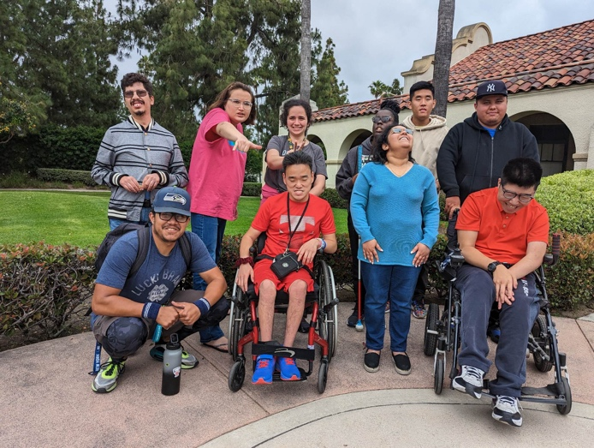

Dayle McIntosh Center Youth Connect
consumers posing for a group picture.

Program in Action: Reception/Information & Referral (I&R)
“The purpose of DMC’s information and referral is to ensure access to the information which will support people with disabilities and older adults have equal opportunities to lead their lives as they choose.”

Information & Referral is the starting point for many consumers’ IL journey. Whether the first contact is by phone, email, relay, or in person, staff ensure each person is welcomed, understood, and connected to the right resources – in their preferred communication method.

Services in Action: Information & Referral (I&R)
Direct Connection to Resources – Linking individuals with DMC services, community programs, housing, transportation, benefits support, and other disability-related resources.
Language Access from the Start – Two Spanish-speaking staff members and Spanish-speaking volunteers provide interpretation and support. Flyers, forms, and key materials are available in Spanish in the lobby, by email, and at events.
Multiple Access Points – Requests can be made by phone, email, text, video relay, mail, or in person with accommodations.

Services in Action: Information & Referral (I&R)(cont.)
Comprehensive Resource Database – Maintained by staff and linked to local and state resource systems to ensure accurate, timely referrals.
Follow-Up for Impact – Random follow-ups check whether the information provided met the person’s needs and improved independence or quality of life.
Empowerment Through Information – Clear, plain-language explanations so individuals can make informed decisions about their lives.

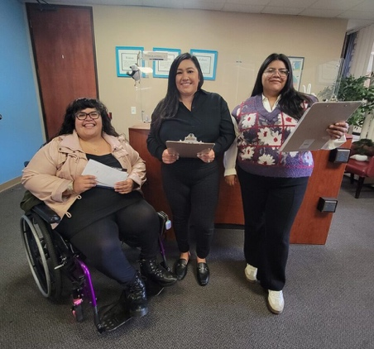
Access in Action: Information & Referral (I&R)

Three (3) Reception team members in the lobby of Dayle McIntosh Center

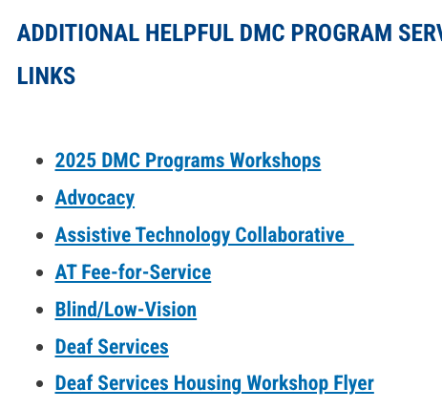
A snapshot of Information & Referral links on DMC’s website—making vital resources available online in accessible formats, so consumers have what they need from the very first visit.

Program in Action: Assistive Technology for Effective Communication
“The purpose of the Assistive Technology Program offered by the Dayle McIntosh Center (DMC) is to promote the use of equipment, software, devices, and applications that enhance full participation in the community and home for people with disabilities and older adults.”

DMC’s Assistive Technology Program promotes tools, devices, and software that make effective communication possible—both expressing ideas and receiving information. From AAC devices and adaptive listening systems to captioning tools and multilingual options, AT ensures that communication is accurate, inclusive, and truly understood in every direction.

Services in Action: Assistive Technology
AT Information & Referral – Guidance on devices and software that support communication, including speech-to-text apps, video relay services, captioning tools, and translation technology, along with funding resources to make them accessible to all.
Personalized AT Plans – One-on-one coordination to identify communication needs, test equipment, arrange trials, and provide training—ensuring every consumer has the tools to connect and choose in their preferred method, whether ASL, written English, or translated speech.

Services in Action: Assistive Technology (cont.)
Communication Access Tools – From captioning apps and real-time transcription to speech-generating devices and multilingual translation tools, AT ensures everyone can express themselves and receive information in a way that works for them.
Accessible Digital Resources – Online content and downloadable materials in English and Spanish, with compatibility for screen readers, magnification, and voice access tools.
AT Collaborative – A countywide partner network that meets regularly to share resources, explore innovations, and expand AT access for diverse communities in Orange County.

Access in Action: Assistive Technology

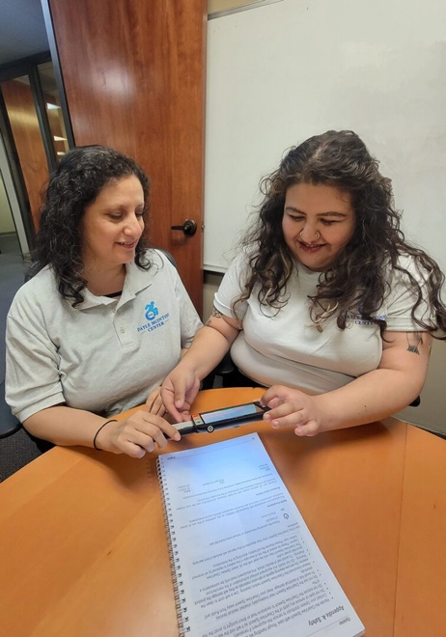
Two (2) DMC staff members explore a handheld magnifier together, demonstrating how assistive technology supports both expressing and receiving information—key to effective, inclusive communication.

Linking Services to Everyday Communication Practices
Highlighted DMC programs— Deaf Services Youth, I&R, and Assistive Technology—are powerful on their own.
- True access happens when the values behind those programs show up in every interaction – not just specialized programs.
Ensure every consumer can participate fully, no matter their language or communication needs, by:
- Using clear, plain language
- Respecting cultural and community context
- Offering multiple communication formats and tools
- Empowering consumers to choose and advocate for what works best for them

Questions to Guide Your Practice

How do we ensure plain language is consistently used across all programs?
DMC Examples:
- Deaf Services: Simple English or ASL video for emails/messages, translate ASL grammar structure, repeating things as needed.
- Youth Connect: Lesson plans, flyers, and posts in plain language.
- Posting of signs and materials in the languages people use in your community.

Questions to Guide Your Practice (cont.)

How do our policies and training prepare staff for communication access?
DMC Examples:
- Written language access procedures in Operations Manual.
- Onboarding and refresher trainings on interpreting, plain language, and cultural awareness.
- Contracts with multiple interpreting providers (spoken language & ASL).

Questions to Guide Your Practice (cont.)

How do we meet consumers where they are?
DMC Examples:
- Respect preferences for ASL (American Sign Language), SEE (Signed Exact English) , Cued Speech, tactile sign, and AAC (Augmentive & Alternative Communication).
- Plain language, ASL video, and bilingual formats for key info.
- Visual aids for lessons (e.g., DMV prep) and outreach.

Questions to Guide Your Practice (cont.)

How do we engage culturally and linguistically diverse communities?
DMC Examples:
- Bilingual reception and outreach materials.
- AAC devices with culturally relevant vocabulary (Spanish, Vietnamese).
- Partnerships with Deaf, Spanish-speaking, and youth-serving orgs.

Questions to Guide Your Practice (cont.)

How do we support self-advocacy for communication access?
DMC Examples:
- Teach how to request and follow up on interpreter needs.
- Provide interpreter agency resource lists.
- Encourage direct communication with providers and employers.

Questions to Guide Your Practice (cont.)

Are staff prepared for diverse communication preferences?
DMC Examples:
- Adaptations for American Sign Language (ASL), Signed Exact English (SEE), Pidgin Signed English (PSE), Oral, Cued Speech, tactile sign, and AAC.
- Using images and visual aids in ILS sessions (e.g., DMV prep).
- Matching interpreters to the consumer’s language (e.g., LSM, trilingual, Deaf interpreters).

Questions to Guide Your Practice (cont.)

Do our policies guide staff on interpreters, tech tools, and ADA compliance?
DMC Examples:
- Written procedures in Operations Manual.
- Onboarding and hands-on training.
- Contracted interpreting services (spoken & ASL) with ADA compliance for mode and timeliness.

Questions to Guide Your Practice (cont.)

How do we involve consumers—especially youth—in communication decisions?
DMC Examples:
- Ensuring youth’s own voice is heard over parents/support people.
- Checking in to confirm understanding.
- Honoring youth consent in family-involved situations.

Questions to Guide Your Practice (cont.)

How do we protect boundaries and dignity in communication?
DMC Examples:
- Avoid using children or untrained individuals as interpreters.
- Match interpreter’s mode/language to consumer’s needs.
- Use appropriate tech (VRS, VRI, captioning, voice-to-text) and know its limits.

Communication is the Gateway to Participation
Effective communication isn’t just about having the right tools—it’s about creating an environment where every consumer’s language, culture, and preferences are respected.
Every service, every interaction, every time.
Ask Yourself:
- How does our team make communication access part of daily practice, not just special requests?
- Where can we strengthen connections with culturally and linguistically diverse communities?
- What policies, training, or partnerships will make these changes sustainable?

Resources for Additional Guidance:
- Plain Language Resources:
  - Self Advocacy Resource and Technical Assistance Center (SARTAC)
  - Plain Language Action and Information Network (PLAIN)
  - Communication Planning Tips (Administration of Community Living)
- Effective Communication (Americans with Disabilities Act)
- Section 21 of Rehab Act: 29 USC § 718: Traditionally underserved populations
- Defining Diversity, Intersectionality, and Cultural Competence (ILRU)
- Disability, Diversity, and Intersectionality in CILs: Creating a Welcoming and Supportive CIL for Diverse Populations (ILRU)

Learn & Share: Your Experience Matters
Recording has stopped – now it’s time to share.

Ways to Engage:
- Raise your hand to be spotlighted to speak
- Turn on your camera if you're comfortable
- Use the chat to share insights, questions, resources, or tools
- React, reflect, or build on what others say
- Share real challenges or successes from your CIL
Let’s turn ideas into action — your voice is the most valuable part of this session!

Evaluation
Thank you for participating in today's Learn and Share.

Your feedback is important and helps us plan future training.
Please use the link in the chat to share your feedback.
Evaluation Link:
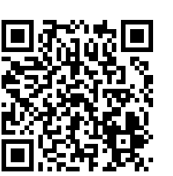

How to Connect with Us!

Website: https://tinyurl.com/ILTTACenter
Request training and / or technical assistance (expert help for your organization): fill out a form on our website to let us know how we can help.
Call: 406-243-5300 and someone will get back to you as soon as we can.
Sign-Up for Events & Announcements:

Visit our website to sign up for updates about live training, group technical assistance, new publications, and other happenings around the Center.

IL T&TA Center Attribution

This project is on assignment through contract with the Administration on Disabilities, Administration for Community Living, Health and Human Services.

About the IL T& TA Center
The Independent Living Training and Technical Assistance Center (IL T&TA Center) is available to you through a contract with the US Department of Health and Human Services.

The IL T&TA Center provides expert training and technical assistance to CILs, SILCs, and DSEs.

The Center is operated by the University of Montana's Rural Institute for Inclusive Communities.

