Data as a Driver – Telling the Story of IL Impact (Part 2)
August 27, 2025

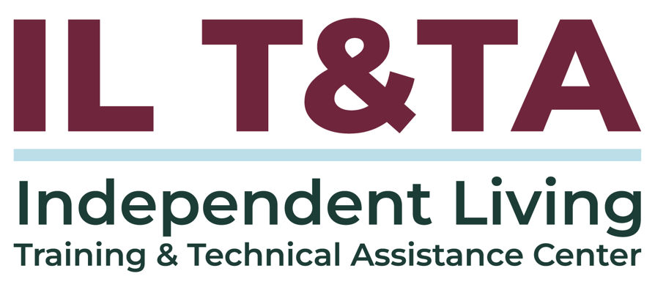

Before We Begin
- ASL & Spanish Interpreters are available and labeled.
- Access Closed Captioning by clicking the CC button located at the bottom of your Zoom window.
- Use Zoom's Raise Hand or Chat features to ask questions.
- Remember to state your name and organization before speaking.
- Message our IL T&TA team using the Chat feature if you have difficulties with today's call.
- Please complete the survey at the end of today's training.

Today’s Agenda –

Key Takeaways:
- Identify key types of data and how they show impact beyond service counts.
- Learn how to communicate your CIL’s impact using data-driven messaging that supports sustainability and outreach.

Learn & Share Format:
- Approx. 20 minutes of spotlight content
- 40 minutes of peer discussion

Overall Goal:
Let's learn with and from each other!

Key Regulations
- 45 CFR § 1329.6 – Annual Performance Reports (PPR)
  - Data reported annually is the baseline, and this training encourages using that data internally for growth, strategy, and storytelling
- 45 CFR § 1329.5 – Indicators of Minimum Compliance for CILs
  - CILs must meet minimum indicators for: Independent Living goals, community activities, outreach to underserved populations
  - Training Point: Help CILs to go beyond the minimum by tracking deeper impact and equity

Presenters
Eric Riskus
Independent Living Program Director
Midstate Independent Living Choices, Inc. eriskus@milc-inc.org
Support: Gerald Hay
Director of Independent Living Services
Independence First
ghay@independencefirst.org

About Wisconsin Coalition of Independent Living Centers
All 72 counties in the state are served by one of the 8 CILs in the state, and management staff from each of the centers meet in-person (and virtually) on a bi-monthly basis
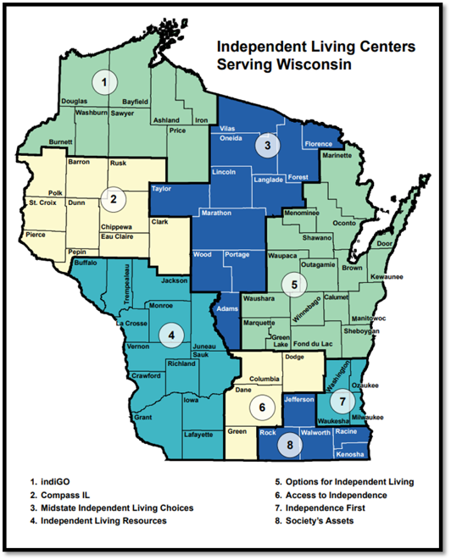

Data as a Driver: Part 1 Review
- Good data shows us who we serve and what's working.
- It keeps us on track with requirements and program goals.
- Good data is accurate, clear, consistent, findable, and usable.
- When used well, data helps us understand reach, measure impact, improve management, and drive advocacy.

From Counts to Impact: Part 2 – Building the Story

Key Terms to Know (Data 101)
Data – Simply: facts and information collected to help us understand something.
Quantitative Data – Numbers you can count or measure (e.g., # of consumers served).
Qualitative Data – Stories, quotes, or feedback that explain the “why” behind the numbers.
Metrics – Specific things we choose to track (e.g., employment outcomes, housing stability).
Indicators – Signs that tell us whether change is happening (e.g., more people voting, fewer barriers).
Outputs – What we did (workshops held, calls answered).
Baseline – The starting point before we begin measuring (e.g., “We started with 20 participants…”).

Key Terms Know (Data 101) (cont.)
Outcomes – What changed because of what we did (consumer got housing, returned to work).
Trends – Patterns over time (e.g., steady growth, seasonal dips).
Benchmark – A point of comparison or a goal (e.g., state average, federal targets).
Return on Investment (ROI) - A measure of what you get back compared to what you put in. In Independent Living, ROI goes beyond money—it shows how resources (funding, staff time, programs) translate into cost savings and real-life results like independence, employment, and community inclusion.

Where This Connects to the Program Performance Report (PPR)
The PPR isn’t just compliance—it’s a blueprint of IL impact.
It captures more than service counts:
- What consumers achieve
- Barriers removed
- Systems changed
Think of it as your impact framework—already built in!
Every data point you enter can also become part of your CIL’s story.

Telling the IL Story: Outputs, Outcomes, and Impact
Outputs (service counts): # of IL skills classes, # of consumers served.
Outcomes (changes for consumers): % of consumers achieving housing goals, % reporting increased independence.
Impact (broader community change): policy wins, increased accessibility in city services, partnerships formed.
Outputs tell what we did. Outcomes show what changed. Impact shows why it matters.

Midstate Independent Living Choices (MILC) - Data in Action

Where Every Hour Tells the Story: 100% Reporting in Action
- Staff’s time sheets MUST match what is entered:
  - Time Tracker – Administrative & in-office work
  - Individual Services – Direct time with consumers
  - Community Activities – Events, presentations, and CIL-wide initiatives

MILC - Data in Action (cont.)

What 100% Reporting Reveals
- Confirms accuracy and compliance through monthly reconciliation
- Aligns staff wages and fringe with the right grant funding sources
- Acts as a daily time study to reflect true service delivery
- Provides a clear, at-a-glance snapshot of how staff time supports consumers and community impact
Transforms raw data into
meaningful stories of impact

MILC - Data in Action (cont.)

From Tracking to Transformation
- Supports professional development instead of micromanagement
- Helps staff overcome the “I don’t have time” challenge
- Clarifies differences in caseload size and intensity
- Identifies needs and service gaps
- Builds compelling narratives for the Board and funders
- Transforms raw data into meaningful stories of impact

Combining Data Across Centers for Greater Impact
MILC collaborates with other Wisconsin CILs to use data for:
- Advocating for increased base funding: Data paints a clear picture of staffing needs and capacity gaps.
- Strengthening state-level advocacy: Tracking time with consumers in long-term care or waivers highlights the need for expanded support.
- Building peer support and coalition power: Sharing data across centers fosters strong relationships and a united voice.

Using Data to Spot Performance Clues
PPR can be a tool help explain shifts, track trends, and guide strategy
- Are open consumer numbers rising or falling?
  - Ask: Why is this happening?
Factors to explore:
- Community shifts (pandemic, referral changes, redundant services)
- Staffing (turnover, caseload size, performance, cost of living)
- Documentation (are services fully captured?)
- Logistics (travel)

Performance Case Study: Florence County, WI
Context:
- Population: 4,634 (824 with disabilities: 327 elderly, 497 non-elderly).
- Open Consumer Service Records: 2
- Outreach: Dining site presentation in Aurora (2023) – 23 participants.
Challenges Identified Through Data:
- 3.5 hours drive – reduces staff capacity by 7–8 appointments.
- Limited lodging (nearest hotels 20+ mins away).

Performance Case Study: Florence County, WI (cont.)
- Harsh winters, rural access barriers.
- Low reach (1–2 consumers served vs. 800 eligible).
Data-Driven Strategy:
- Plan overnight trips for concentrated outreach.
- Leverage other grants for travel/admin costs.
- Target outreach at Farmer’s Market + ADRC hubs.
- Integrate broadband access & age demographics into planning.

Performance Case Study: Florence County, WI (cont.)
Why It Matters:
- Shows how local data informs statewide advocacy.
- Demonstrates that data isn’t just compliance—it drives smarter use of resources and stronger funding arguments.

Performance Case Study: Florence County, WI (cont.)
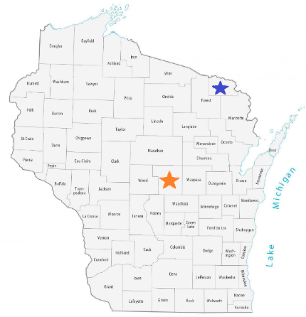

Wisconsin 2025 Baseline Funding Increase
How We Used Data to Receive Increased Funding
Data collected to strengthen case:
- # of people with disabilities, # of consumers, and # of frontline staff
- Drive time, service time, and travel barriers
- Impact data: surveys, goals reached, event attendance, success stories
Fiscal Argument:
- Cost of institutional care vs. independent living supports
- Return on Investment (ROI) Emphasized: funding IL saves Medicaid dollars

How Other CILs Can Apply This Approach?
- Track reach + impact consistently (counts + outcomes + stories)
- Highlight geographic barriers and service efficiency
- Collect consumer success stories that align with policy goals
- Use ROI language: show how IL funding saves taxpayer and Medicaid costs
- Frame for audience
  - Always ask “What will resonate?”

Data in Context: Speaking to Who’s Listening
Different audiences may prioritize different outcomes:
- Funders / Legislators – Emphasis on Return on Investment (ROI), cost savings, and efficiency.
- Community Partners – Look for collaboration opportunities and evidence of unmet needs.
- General Public / Media – Responds to clear narratives and community impact.

Data in Context: Speaking to Who’s Listening (cont.)
Common ground: Across all audiences, people want to know:
- What was done?
- What changed?
- Why does it matter?
Independent Living takeaway:
Use quantitative data (transitions, diversions from institutions) + qualitative stories to create a statewide impact narrative that resonates across audiences, regardless of their focus.

Data Tools to Consider:
Leverage data collection tools to increase funding potential, build partnerships, and demonstrate impact.
- Your Department of Health Services
- US Census Bureau
- Artificial Intelligence as a data helper:
  - AI Guide for Government (IT Modernization Centers of Excellence)
  - People + AI Guidebook

Resources for Additional Guidance:
- Section 7: Operational Excellence and Evaluation, ILRU
- Resources on Outcome Measures, ILRU
- Get to the Core of It: Best Practices in CIL Core Services -- Systems Advocacy, ILRU
- Gathering, Analyzing, & Utilizing Data, ILRU

Learn & Share: Your Experience Matters
Recording has stopped – now it’s time to share.

Ways to Engage:
- Raise your hand to be spotlighted to speak
- Turn on your camera if you're comfortable
- Use the chat to share insights, questions, resources, or tools
- React, reflect, or build on what others say
- Share real challenges or successes from your CIL
Let’s turn ideas into action — your voice is the most valuable part of this session!

Evaluation
Thank you for participating in today's Learn and Share.

Your feedback is important and helps us plan future training.
Please use the link in the chat to share your feedback.
Evaluation Link:
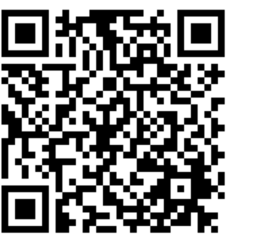

How to Connect with Us!

Website: https://tinyurl.com/ILTTACenter
Request training and / or technical assistance (expert help for your organization): fill out a form on our website to let us know how we can help.
Call: 406-243-5300 and someone will get back to you as soon as we can.
Sign-Up for Events & Announcements:

Visit our website to sign up for updates about live training, group technical assistance, new publications, and other happenings around the Center.

IL T&TA Center Attribution

This project is on assignment through contract with the Administration on Disabilities, Administration for Community Living, Health and Human Services.

About the IL T& TA Center
The Independent Living Training and Technical Assistance Center (IL T&TA Center) is available to you through a contract with the US Department of Health and Human Services.
The IL T&TA Center provides expert training and technical assistance to CILs, SILCs, and DSEs.
The Center is operated by the University of Montana's Rural Institute for Inclusive Communities.
