SILC Connection – Building a Common Framework: Working Together to Define and Report Data
September 16, 2025

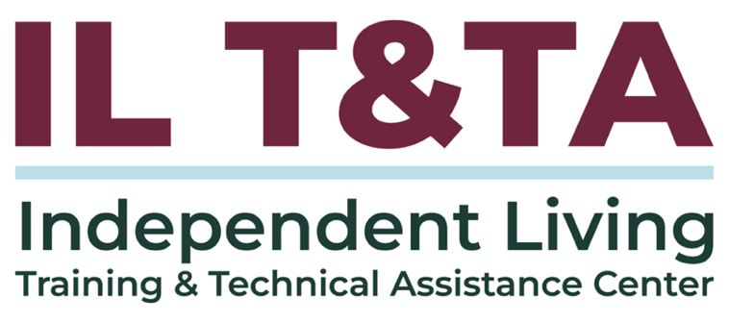

Before We Begin
ASL & Spanish Interpreters are available and labeled.
Access Closed Captioning by clicking the CC button located at the bottom of your Zoom window.
Use Zoom's Raise Hand or Chat features to ask questions.
Remember to state your name and organization before speaking.
Message our IL T&TA team using the Chat feature if you have difficulties with today's call.
Please complete the survey at the end of today's training.

Technical Assistance:
Why Data Matters in SILC Work (Regulatory Context):
- 45 CFR 1329.15(c)(5): SILCs must monitor, review, and evaluate SPIL implementation → Consistent data collection is the foundation for compliance and evaluation.
- 45 CFR 1329.17: SPILs must include measurable goals and timelines → Reliable reporting strengthens evaluation and highlights progress.
- Rehabilitation Act, Sec. 705 (29 U.S.C. §796): SILCs must be consumer-controlled → Data should reflect diverse voices and lived experience, especially from underserved populations.

Technical Assistance: (cont.)
- 45 CFR 1329.15(c)(6): SILCs must work with the DSE on joint resource planning → Sharing impact data in clear and persuasive ways helps secure resources and influence funding.
- SILC Indicators and Assurances for the Designated State Entities: Data must demonstrate outcomes, not just outputs → Turning numbers into stories makes the impact real for stakeholders.

Today’s Agenda –

Key Takeaways:

Apply strategies for consistent data collection and reporting to strengthen SPIL evaluation.

Develop strategies for sharing impact with stakeholders in a clear, accessible, and persuasive way.

Learn & Share Format:
- Approx. 20 minutes of spotlight content
- 40 minutes of peer discussion

Overall Goal:
Let's learn with and from each other!

Peer Presenters from Connecticut State Independent Living Council
Molly Cole
Executive Director
molly@ctsilc.org

Michele DuBois
Data Coordinator / Office Administrator
michele@ctsilc.org

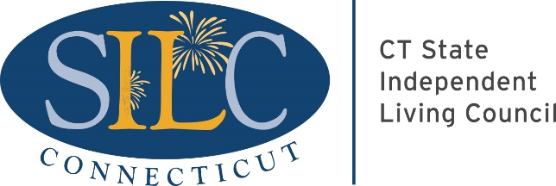

Connecticut’s IL Network
- Connecticut has five (5) Centers for Independent Living.
- All five centers use CILs First as their database.
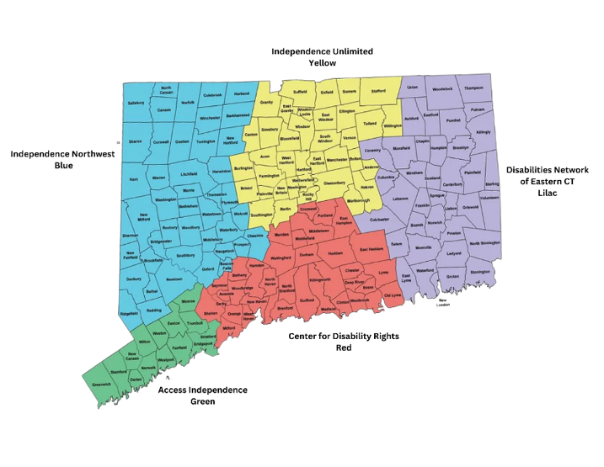

Early Collaboration: The Data Committee
- To address concerns about data, the SILC Director, CIL staff, and all five CILs began meeting monthly.
- The five CILs also met as the Connecticut Association of Centers for Independent Living (CACIL), with the SILC Director participating.
- CACIL prioritized increasing state funding for Independent Living and developed outreach materials and data to share with legislators.
- When the SILC reviewed aggregate data, they noticed discrepancies in definitions, raising concerns about accuracy and its effect on funding.

A Breakthrough Opportunity
- Ongoing discussions highlighted the urgent need for greater data consistency.
- The SILC Director explored possible solutions, but limited staffing made progress difficult.
- A breakthrough came when the DSE offered significant I&E funding and requested a proposal.
- Working with CACIL, the SILC Director developed and submitted a data project proposal, which the DSE approved.

Elements of the Data Project
- A statewide half-time Data Coordinator to oversee the initiative.
- A Data Coordinator at each CIL to train staff, manage data entry, and troubleshoot issues.
- Regular coordination meetings: bi-weekly/weekly among coordinators and monthly with the full committee.
- Coordinators collaborated to develop the scope of work and timelines.
- SILC established contracts with each CIL to offset coordinator costs.
- Each CIL provided quarterly summaries to the SILC Director on progress and activities.

Launching the Data Project:
- Month 1: Contracts finalized.
- Month 2: Statewide Coordinator hired.
- Month 4: First meeting convened.
- SILC Director and Data Coordinator secured access to CILs First.

Information Gathering & Trust Building
- The Statewide Data Coordinator visited each CIL to observe data practices.
- Focused on building trust while learning each center’s processes.
- Developed and signed a confidentiality agreement to ensure consumer privacy.
- With trust established, gained access to CIL data for statewide comparison.
- Identified differences in how definitions were interpreted across centers.
These findings highlighted the need to address several common challenges.

Challenges (and Why They are Common)
- Balancing data entry with other center duties.
- Immediate consumer needs often took priority over data entry.
- Software customizations varied across centers.
- Federal definitions left room for interpretation.
- Building comfort with data sharing required strong privacy protections.
- “Simple” issues often proved complex, showing consistency is an ongoing process.

Successes
- Established a statewide data coordination structure.
- Built trust through confidentiality and judgment-free collaboration.
- Made progress aligning definitions and practices across centers.
- Created openness: members shared data, spoke up, and supported one another.
- Individuals contributed their strengths, transforming into a true team.

Next Steps / Goals
- Continue regular meetings to sustain collaboration and consistency.
- Develop reference guides, onboarding materials, and staff training supports.
- Strengthen peer-to-peer support by leveraging each coordinator’s expertise.
- Focus on key areas still needing alignment in definitions and use of data.
- Use data to create a clear statewide picture of impact, needs, and funding priorities.

Long-Term Vision
- Maintain consistency through ongoing SILC–CIL collaboration.
- Monitor and adapt data practices as needs and circumstances change.
- Ensure new staff can step in with training and guidance already in place.
- Use consistent data to show the impact of Independent Living statewide.
- Highlight consumer needs to guide outreach, identify funding, and connect people with IL services.
- Leverage data to secure more resources and staff to meet community needs.

Moving Forward Together
Through collaboration, we can use data to show needs, bring in resources, and connect more people to Independent Living services.

Resources for Additional Guidance
- SILC Indicators and Assurances for the Designated State Entities (ILT&TA)
- Guidebook for SILC Chairpersons, Members, and Administrators (ILRU)
- High-Performance Measurement Framework for SILCS (ILRU)
- Strengthening Relationships Among CILs and the SILC: Building and Maintaining a Statewide Partnership (ILRU)

Learn & Share: Your Experience Matters
Recording has stopped – now it’s time to share.

Ways to Engage:
- Raise your hand to be spotlighted to speak
- Turn on your camera if you're comfortable
- Use the chat to share insights, questions, resources, or tools
- React, reflect, or build on what others say
- Share real challenges or successes from your CIL
Let’s turn ideas into action — your voice is the most valuable part of this session.

Evaluation
Thank you for participating in today's Learn and Share.
Your feedback is important and helps us plan future training.
Please use the link in the chat to share your feedback.
Evaluation Link:
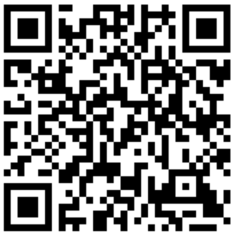

How to Connect with Us!

Website: https://tinyurl.com/ILTTACenter
Request training and / or technical assistance (expert help for your organization): fill out a form on our website to let us know how we can help.
Call: 406-243-5300 and someone will get back to you as soon as we can.
Sign-Up for Events & Announcements:
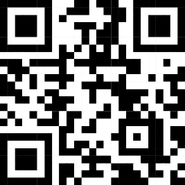
Visit our website to sign up for updates about live training, group technical assistance, new publications, and other happenings around the Center.

IL T&TA Center Attribution

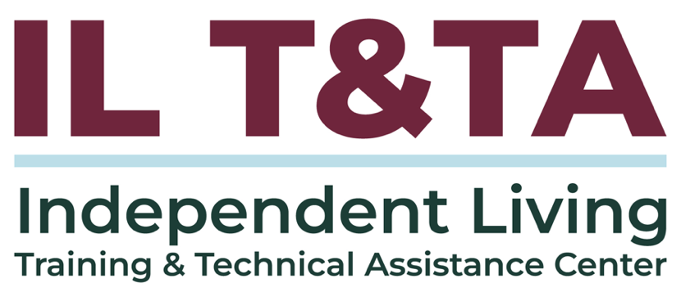
This project is on assignment through contract with the Administration on Disabilities, Administration for Community Living, Health and Human Services.

About the IL T& TA Center
The Independent Living Training and Technical Assistance Center (IL T&TA Center) is available to you through a contract with the US Department of Health and Human Services.
The IL T&TA Center provides expert training and technical assistance to CILs, SILCs, and DSEs.
The Center is operated by the University of Montana's Rural Institute for Inclusive Communities.
