Expanding Access: Identifying and Reaching Underserved Populations in Independent Living Services
September 18, 2025
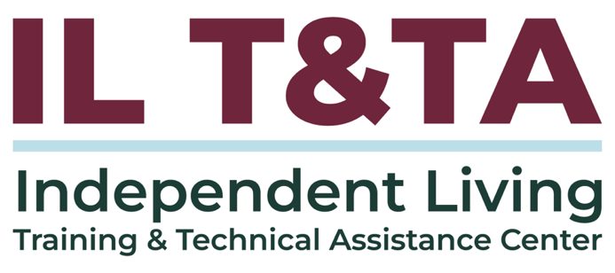

Before We Begin
- ASL & Spanish Interpreters are available and labeled.
- Access Closed Captioning by clicking the CC button located at the bottom of your Zoom window.
- Use Zoom's Raise Hand or Chat features to ask questions.
- Remember to state your name and organization before speaking.
- Message our IL T&TA team using the Chat feature if you have difficulties with today's call.
- Please complete the survey at the end of today's training.

Today’s Agenda –

Technical Foundation Review: Independent Living Training & Technical Assistance Center

Key Takeaways:
- Understand why outreach to underserved and unserved communities is critical to the mission of Independent Living and how it connects to CIL standards and assurances.
- Identify practical steps your CIL can take—including staff training and intentional outreach approaches—to expand access to Independent Living services.
- Explore proven strategies and real-world examples that show how CILs can successfully connect with underrepresented groups.

Today’s Agenda (cont.) –

Learn & Share Format:
- Approx. 45-60 minutes of spotlight content
- Goal of at least 30 minutes of peer discussion

Overall Goal:
- Let's learn with and from each other!

Facilitators
Mary-Kate Wells
Director of Programs
National Council on Independent Living

Technical Assistance
Tyler Morris
Director of Programs
Independent Living Training & Technical Assistance Center

Recap: What is “Section 21”?
Section 21 is not a standalone law — it’s a specific provision within the original Rehabilitation Act of 1973, codified at 29 U.S.C. § 718.
It was added to strengthen outreach efforts to individuals from minority backgrounds, which may include:
- From racial or ethnic minority groups
- From culturally diverse or disadvantaged backgrounds
- Limited English Proficiency (LEP) or non-English speakers
- Living in rural or underserved areas

How Section 21 Shows Up in Independent Living (IL)
45 CFR § 1329.4 – Definitions: Defines “unserved and underserved populations” to include linguistic and cultural minorities.
29 U.S.C. § 796f-4. Standards and assurances for centers for independent living
- Equal access for individuals with significant disabilities across all services and settings.
- CILs must provide cross-disability services, including to unserved/underserved groups.
- Aggressive outreach is required, especially to minority, rural, and urban populations.
- Staff must receive training on how to serve these communities.

Why Section 21 Matters?
Outreach, inclusion, and representation are statutory requirements — not optional.
Failure to demonstrate outreach in SPILs can result in ACL requiring revisions.
Without adequate outreach to unserved and underserved populations, CILs risk underreporting community needs — weakening credibility with funders and policymakers.
Section 21 is the reminder that Independent Living must start with a simple question: who is missing? It requires us to reshape outreach so unserved and underserved communities are not left out.

Peer Presenters from New York’s Harlem Independent Living Center (HILC):

Yaw Appiadu
Executive Director
yappiadu@hilc.org

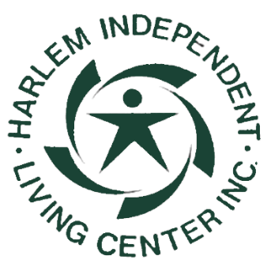

About Harlem ILC: Who We Serve
Harlem ILC’s service area is Upper Manhattan
  - Rooted in Central and East Harlem—densely populated neighborhoods that are historically Black and immigrant-rich.
Consumers from Black, Latin, and African communities, many of whom face overlapping barriers:
  - Poverty
  - Systemic inequities
  - Language access
A significant portion of the disabled community in Harlem have limited English proficiency (LEP), with many living in large public housing developments where access to disability services has historically been limited.
HILC: Who We Serve (cont.)
The Center’s staffing model mirrors the diversity of its community:
- Multilingual team members (English, Spanish, French, Twi, ASL), staff who are Deaf or Hard of Hearing, and staff with lived experience of disability and intersecting barriers.
Intentional approach: Harlem ILC doesn’t just serve its community—it is part of it.
- Program design and outreach deliberately center race, disability, and socioeconomic realities, ensuring access and culture is intertwined.
Outreach is most effective when staff demographics, lived experiences, and intentional approaches reflect the communities being served.

HILC’s Targeted Outreach
Outreach is Never Generic
Data-Driven: Review data from prior years of services to identify gaps in who is being served and where outreach is falling short.
Building Around Trusted Spaces: Faith-based orgs, tenant associations, cultural centers, clinics, local hospitals, and now legal services and re-entry networks.
- HILC Justice Partnerships: Recognizing the deep impact of poverty and the need for stronger law enforcement training on disability, HILC formed partnerships with Legal Aid, law practitioners, and human rights commissions to support people with

HILC’s Targeted Outreach (cont.)
disabilities facing incarceration or legal challenges.
- Gap Identified: People with disabilities impacted by the justice system have historically been underserved — HILC now provides I&R, benefits access, housing support, and a disability rights perspective.

From Outreach to Communication
- Outreach opens doors…
- But once inside, how you communicate matters.
- Harlem ILC emphasizes non-suppressive information (Plain Language): clear, transparent, peer-to-peer.
Effective outreach gets you in the room. Effective communication keeps trust in the room.

Building Trust Through Plain Language
Outreach is rooted in plain, clear, and consistent communication—meeting people where they are and explaining their rights in a way that builds trust.
- Transparent communication: Rights explained clearly, no jargon.
- Reduces intimidation: Shifts power dynamics, avoids system-level mistrust.
- Peer-to-Peer Approach: Consumers feel respected, not talked down to.
Empowered Consumer Control

From Philosophy to Practice: HILC Staff Training
The Independent Living philosophy only works if staff are prepared to carry it into daily practice.
- Community-Rooted Onboarding: Orientation covers Harlem’s demographics and service realities — Black, Latin, African, and LEP communities, many in public housing and facing systemic barriers.
- Neighborhood Strategies: Outreach is tailored to each community. Staff are better equipped to support a consumer when they understand where they live and can meet them at their level.
  - Example: In East Harlem, outreach is often led by Spanish-speaking staff to reflect the community.
From Philosophy to Practice: HILC Staff Training (cont.)
- Learning by Doing: A two-week onboarding for staff to get the lay of the land, such as attending community meetings, but is training is on-going.
- Origins of HILC: Established by the disability community itself — not one individual — in response to unmet needs. In the early years, Harlem residents leaving hospitals lacked transition supports and were often pushed into nursing homes.
- Living the Movement: Training connects staff to this history and the broader IL/disability rights movements, showing how today’s work continues that legacy.

Competence in Action: HILC’s Ongoing Training
At HILC, competence isn’t a checkbox — it’s a living practice.
- Competence as a Living Practice: Training never ends at HILC with semiannual refreshers sharpen skills in disability etiquette, outreach, and recognizing multiple barriers disabled people face — ensuring staff grow with the community.
- History as a Guide: Disability rights + civil rights history (e.g., Section 504 sit-ins, Black Panther Party advocacy) keep staff grounded in advocacy, not just services.

Competence in Action: HILC’s Ongoing Training
- Language in Practice: Staff openly discuss how disability is spoken about across cultures, what words carry stigma, and how to use language to build trust.
- Community Connection: Events like HILC’s End of Summer Connection Gathering give staff space to practice learning with consumers, not just about them.
- Responsive to the Field: Trainings are led by HILC’s Executive Director, Systems Advocate, and guest experts — and are continually updated based on challenges staff encounter in the community.

Opportunities Revealed Through HILC’s Outreach
- Peer-Led Support = Consumer Control: Many HILC staff have disabilities themselves, modeling the IL philosophy and strengthening trust.
- Outcomes-Oriented Work = Outreach that Changes Lives: Targeted support has led to housing placements and financial relief, proving that outreach leads to tangible results.
- Voter Engagement = Equity and Civic Inclusion: HILC extends outreach into civic spaces — ADA anniversary events and voter engagement bring disability rights into public life.

Opportunities Revealed Through HILC’s Outreach (cont.)
- Aging Populations = Addressing Underserved Groups: Nearly one-third of consumers are 60+, showing how IL services must also partner across aging and Medicaid systems.
- Funding Disparities = Why Advocacy Is Essential: Despite high need, HILC is one of the lowest-funded ILCs in New York, highlighting the importance of equitable resource distribution.
Reaching underserved groups isn’t abstract — it’s the daily practice of Independent Living: peers leading the way, outcomes that matter, civic participation, cross-system collaboration, and equity for all.

Let’s Hear From You!
Recording has paused.
Let’s take a moment to hear from you before moving to the next presenter.
Chat: One word to describe your CIL’s outreach training.
Chat/React: Drop an emoji showing how prepared your staff feel to serve diverse communities!
Chat/Raise Hand:
  - What training does your CIL currently offer (or need) to reach underserved/unserved communities?
  - For rural CILs: What unique training needs do you see?
  - Section 21 Focus: Which emphasis area is your biggest growth opportunity?

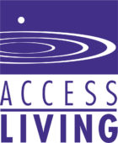
Peer Presenters from Chicago’s Access Living – Center for Independent Living:

Michelle Garcia
Manager of Organizing and Community Development
mgarcia@accessliving.org

Timothy Pagani
Senior Survivors of Gun Violence Program Coordinator
tpagani@accessliving.org

Stephanie Santana
Survivors of Gun Violence Program Coordinator
ssantana@accessliving.org

Access Living: Who We Are
Founded in 1980 as part of the Rehabilitation Institute of Chicago; became an independent nonprofit in 1987, bringing the Independent Living Movement to Illinois.
Mission: Ignites disability power and pride, provides critical services, and breaks down systemic barriers for a more inclusive society.
Diverse City, Diverse Communities: Serves one of the largest urban disability populations in the U.S., reflecting Chicago’s racial, cultural, and linguistic diversity.
Two Key Outreach Intiatives:
- Latine Outreach
- Survivors of Gun Violence

Latine Outreach in Action: Using Data to Identify Gaps
In 2004, Access Living compared census data vs. consumer data.
Found that only 4% of Access Living’s consumers were Latine — while 28% of Chicago’s population identified as Latine.
The numbers revealed serious underrepresentation — and entire communities left unserved — in CIL services.
Data became the first step in recognizing the need for intentional Latine outreach.

Latine Outreach in Action: Understanding the Gap
Used consumer satisfaction surveys to gather feedback from Latine consumers.
Held community meetings and conducted family interviews in majority-Latine neighborhoods.
Built partnerships with Latin-serving organizations across Chicago.
Learned:
- Latin consumers were less connected to government service pipelines, a key referral pathway to CILs.
- The concept of “Independent Living” didn’t always align with Latin family and cultural dynamics.

Latine Outreach in Action: Next Steps (Strategic Plan)
Access Living’s 2005–2009 Strategic Plan included a formal goal to improve Latin outreach.
This ensured board-level support and dedicated organizational resources.
Made Latin outreach a core priority, not a side project.
Institutional backing created the structure for accountability and sustainability.
Responded to a clear gap: Latin communities had historically been unserved/underserved by IL services in Chicago.

Latine Outreach in Action: Process to Implement the Program
Created a formal implementation plan with clear outcomes, activities, and staff roles.
Began as a pilot program to allow experimentation and learning.
Built trust by:
- Attending and hosting community events in majority-Latin neighborhoods.
- Offering workshops responsive to community needs.
- Providing immediate supports (e.g., donated DME, healthcare access).
Focused first on credibility and visibility before expanding services.

Latine Outreach in Action: Formation of Cambiando Vidas
In 2009, Access Living launched Cambiando Vidas (CV) — a group for community members and their families who are Latine and disabled.
CV provides a critical space for Latines with disabilities to come together, organize, and effect change.
Advocacy as a Core Service and in Action:
- Access to healthcare
- Public Charge
- CityKey ID
- Welcoming City Ordinance

Latine Outreach in Action: Formation of Cambiando Vidas (cont.)
Conducts Know Your Rights trainings in partnership with elected officials and Latine organizations.
Meetings are held in Spanish, with interpreters provided, ensuring accessibility and consumer control.

Latine Outreach in Action: Outreach Requires Internal Change
Having a targeted outreach effort is important — but it will not succeed without broader organizational shifts.
Access Living examined the demographics of staff and board, adding Latin representation to better match Chicago’s communities.
Nothing About Us, Without Us: CILs cannot serve underserved communities well if leadership does not reflect those communities.
True outreach is sustained when equity
is embedded inside the organization,
not just practiced outside it.

A Different Kind of Outreach…

Survivors of Gun Violence (SGV) Program:
SGV reaches survivors of gun violence — a population shaped by trauma and often missed by traditional disability services.
Newly Disabled Survivors: Many acquire disabilities suddenly due to shootings, with little support for transition or adjustment.
Multiple Barriers: Gun violence impacts communities of color most —survivors face trauma, stigma, poverty, systemic inequities, and isolation on top of disability.
Innovative in IL: Few CILs serve this population.

How the SGV Program Started
Began in 2022 as an 18-month research project to understand the needs of survivors newly disabled by shootings.
Held 150+ interviews, listening sessions, and surveys with survivors, families, and community stakeholders.
Findings published in Disabled Gun Violence Survivors in Chicago: An Initial Needs Survey (2023).
Data revealed major gaps in healthcare, housing, employment, and support systems.
Listening confirmed the need for a dedicated program to serve this underserved population.

SGV Program Components
Survivor Voice at the Center: Services shaped directly by feedback from interviews and listening sessions.
- Information & Referral (I&R): Guidance on disability rights, benefits, housing, and healthcare navigation.
- Advanced One-on-One Support: Intensive case support for survivors navigating trauma, new disability, and systemic barriers.
- Peer Support Groups: Safe spaces for survivors to connect, share experiences, and reduce isolation.
- Trainings & Community Education: Sessions for survivors, families, and community partners on disability rights, Independent Living, and trauma-informed care.

SGV Outreach in Action
Connecting with Internal Programs: Survivors are referred through Access Living’s existing services, ensuring SGV is part of the broader IL framework.
Pre-Existing Partnerships: Built on trusted external partners already engaged in the community, creating quick pathways to survivors.
New Relationships: Developed ties with organizations directly serving survivors of gun violence, expanding the network of referral sources.
Consumer Voice: Survivors themselves share information and bring others into the program — peer trust is central to outreach.

SGV Outreach in Action (cont.)
Coalitions & Advisory Councils: Access Living plays an active role in local and statewide advocacy tables, keeping survivor needs visible in policy spaces.
Broad Marketing: Increased visibility through radio, newspapers, TV news, billboards, and flyers to reach survivors where they live.

Strategies in Action: Identifying Underserved Communities
Awareness of Gaps: Notice what’s visible vs. missing in your community.
Ex: News stories cover shootings, but little about what happens to survivors afterward.
Consumer Interactions: Listen to what consumers tell you in other programs.
Ex: SGV survivors had limited awareness of trainings, funds, or support available to them.
Research & Surveys: Use listening sessions and survivor-led surveys to uncover barriers.
Ex: SGV used survivor-led listening sessions to identify gaps in services.

Strategies in Action: Identifying Underserved Communities (cont.)
Community Outreach: Go where people are to engage survivors directly.
Ex: Finding survivors was difficult at first — low engagement improved once Access Living connected through community members.
Pre-Existing Relationships: Build on trusted contacts.
Ex: Engagement grew when SGV leveraged nonprofits and hospitals already serving survivors.
Government & City Entities: Public institutions can help survivors connect.
Ex: Outreach expanded through partnerships with city agencies and schools.

Strategies in Action: Identifying Underserved Communities (cont.)
Partnership Power: Survivors were more likely to engage when outreach came through trusted organizations.
Independent Living: Values can take root anywhere survivors of disability exist, even in spaces of trauma and violence.
The deeper lesson: Underserved communities aren’t invisible — we must see them differently and reshape our outreach so they know Independent Living is for them, too.

The Spirit of Section 21
Section 21 calls us to see who’s missing and build new pathways for access.
Cambiando Vidas (CV): Created culturally grounded, language-accessible pathways for Latine communities.
Survivors of Gun Violence (SGV): Opened new pathways for survivors navigating trauma, stigma, and new disability.
One Lesson: Outreach has no single formula. The IL philosophy is always the same — listen, build trust, and reshape services so no one is left out.

Resources for Additional Guidance
- Administration for Community Living: Section 21 Program
- Section 21 of Rehab Act: 29 USC § 718: Traditionally underserved populations

Learn & Share: Your Experience Matters
Recording has stopped – now it’s time to share.

Ways to Engage:
- Raise your hand to be spotlighted to speak
- Turn on your camera if you're comfortable
- Use the chat to share insights, questions, resources, or tools
- React, reflect, or build on what others say
- Share real challenges or successes from your CIL
- Let’s turn ideas into action — your voice is the most valuable part of this session.

Evaluation
Thank you for participating in today's Learn and Share.
Your feedback is important and helps us plan future training.
Please use the link in the chat to share your feedback!
Evaluation Link:


How to Connect with Us!

Website: https://tinyurl.com/ILTTACenter
Request training and / or technical assistance (expert help for your organization): fill out a form on our website to let us know how we can help.
Call: 406-243-5300 and someone will get back to you as soon as we can.

Sign-Up for Events & Announcements:
Visit our website to sign up for updates about live training, group technical assistance, new publications, and other happenings around the Center.

IL T&TA Center Attribution

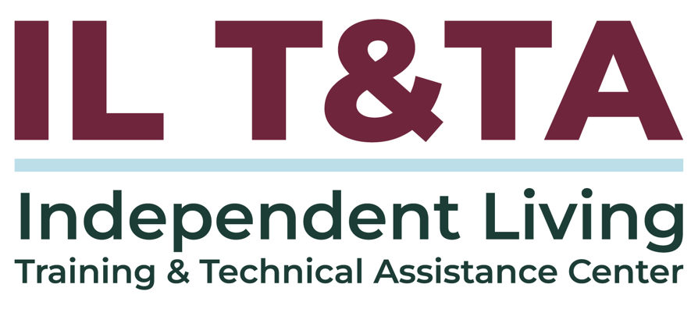
This project is on assignment through contract with the Administration on Disabilities, Administration for Community Living, Health and Human Services.

About the IL T& TA Center
The Independent Living Training and Technical Assistance Center (IL T&TA Center) is available to you through a contract with the US Department of Health and Human Services.
The IL T&TA Center provides expert training and technical assistance to CILs, SILCs, and DSEs.
The Center is operated by the University of Montana's Rural Institute for Inclusive Communities.
