SILC Connection – Network Relations with the Designated State Entity (DSE)
September 2, 2025

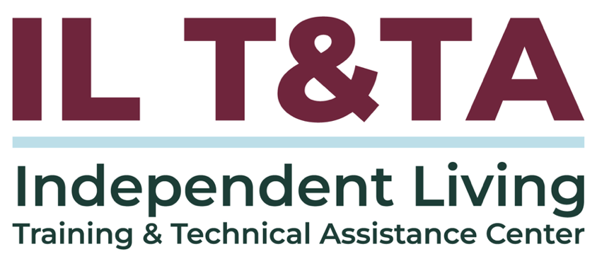

Before We Begin
ASL & Spanish Interpreters are available and labeled.
Access Closed Captioning by clicking the CC button located at the bottom of your Zoom window.
Use Zoom's Raise Hand or Chat features to ask questions.
Remember to state your name and organization before speaking.
Message our IL T&TA team using the Chat feature if you have difficulties with today's call.
Please complete the survey at the end of today's training.

Technical Assistance

Why State Independent Living Council (SILC)-Designated State Entity (DSE) Autonomy Matters

1329 Subpart B
The SILC shall not be established as an entity within a State agency, including the DSE. The SILC shall be independent of and autonomous from the DSE and all other State agencies.
No conditions or requirements may be included in the SILC's resource plan that may compromise the independence of the SILC.
The SILC is responsible for the proper expenditure of funds and use of resources that it receives under the resource plan.

Technical Instruction Components (TA Team), con’t.
1. Statutory Authority (45 CFR Part 1329)
- Independence mandates (SILC cannot be part of DSE) – § 1329.14
- Defined roles of DSE – § 1329.12
- SILC’s duties, authorities, and joint resource planning with DSE – § 1329.15
2. SPIL Development & Signatures
- Requirements under Workforce Innovation and Opportunity Act (WIOA): joint drafting with CILs, public input, required signatories – § 1329.17

Technical Instruction Components (TA Team), con’t.
- DSE signature denotes their acceptance of the DSE role and responsibilities, not approval of SPIL
3. Operational Assurances & Best Practices
- Ensuring autonomy and respecting SILC's authority: guidelines from the State Independent Living Council Indicators and Assurances & Designated State Entity Assurances

Today’s Agenda –

Key Takeaways:
- Learn how the Statewide Independent Living Council (SILC) and DSE (Designated State Entity) Interact
- Understand how that Interaction ensures autonomy for the SILC

Learn & Share Format:
- Approx. 20 minutes of spotlight content
- 40 minutes of peer discussion

Overall Goal:
Let's learn with and from each other!

Presenters and Facilitators
Peer Presenters:
Mellie Adu
Chief Executive of Strategy and Innovation
Arizona Statewide Independent Living Council (AZSILC)
mellie@azsilc.org

Kristen Mackey
RSA Program Administrator
Arizona Vocational Rehabilitation
kmackey@azdes.gov

Facilitated by:
Brooke Wilson
Chair- NASILC (National Association of State Independent Living Councils)

Arizona’s IL Network in Action
- The Arizona Independent Living Network (AZILN) brings together the Arizona SILC and five (5) Part C Centers for Independent Living.
- The Designated State Entity (DSE) is the Arizona Rehabilitation Services Administration (AZRSA).
- Together, these partners translate federal requirements into state practice — balancing autonomy, accountability, and collaboration.

An Independent, Connected Network in Arizona
- The SILC and CILs are all self-directed and self-governing.
- Together, the six (6) organizations form a critical network within the Arizona Disability Community, enhancing community living across the state.
- SILC, CILs, and the DSE each play their distinct roles while working in concert on the State Plan for Independent Living (SPIL).

Respective Roles: Who Does What?
The SILC Indicators and DSE Assurances are clear:
SILC Responsibilities
- Council composition & training
- Communication with the appointing authority
- Open, accessible meetings & materials
- Develop the SPIL with CILs & public input
- Monitor, review, and evaluate the SPIL
DSE Responsibilities
- Serve as fiscal intermediary
- Ensure SILC autonomy

Clear roles ensure SILC independence while strengthening partnership

Arizona’s Partnership Mindset
- The SILC, CILs, and DSE are fundamental pieces of the puzzle.
- All are complementary partners with a vested interest.
- None can act alone and truly accomplish the goal — nor would we want to.
- Together, we operate as a well-oiled network — though building strong relationships has taken time, energy, and ongoing effort.

Looking Back: Us and Them
- Years ago, AZSILC was closely aligned with one CIL, while the other four were generally included only after decisions were made — creating a sense of “us and them.”
- At the same time, AZSILC and the DSE partnered well on projects, but power struggles over autonomy and funding still led to tension and reinforced “us and them.”
- In both cases, blurred boundaries left AZSILC caught in the middle, navigating relationships that too often felt divided instead of united.

Change Creates Opportunity
- Long time SILC Director retired, two (2) DSE Administrators move on, and both the AZILN and DSE benefit from new vision, energy and expertise.
  - New leaders were met with resistance.
  - Recognizing past challenges, the AZILN made an effort on moving forward to build a future where true partnership was possible and the AZILN flourished.

Opportunity in Action
- Over time the AZILN has built relationships rooted in trust:
  - Intention
  - Consistency
  - Transparency
  - Confidence
  - Allyship
  - Strategy
  - Appreciation
- Today, AZSILC and AZRSA collaborate across projects, with full respect for SILC autonomy and funding.
- The result: true partnership, trust, and a thriving Independent Living network.

Guiding Principles for SILC-DSE Partnership
- Honor the Framework – Follow the law, SILC Indicators, and DSE Assurances
- Model Partnership – Be the collaborator you wish to have
- Be Transparent – Lead with honesty and openness
- Stay Consistent – Be proactive and dependable
- Plan Together – Approach shared responsibilities jointly
- See Opportunity – Treat interaction as growth, not obligation

Guiding Principles for SILC-DSE Partnership (cont.)
- Protect Autonomy – Respect the SILC independence.
- Build Respect – Engage with mutual trust and regard.
- Stay Grounded in Purpose – Remember that every effort strengthens the IL network and advances the IL Philosophy.

Resources for Additional Guidance
- SILC Indicators and Assurances for the Designated State Entities
- Guidebook for SILC Chairpersons, Members, and Administrators
- The DSE, SILC Roles and Responsibilities, and the Regulations: Part 1
- The DSE, SILC Roles and Responsibilities, and the Regulations: Part 2
- SILCs and the Importance of Autonomy: Power Struggles and Relationships with the DSE and the IL Network (1.5 Hours)
- Creating an Effective DSE, SILC, and CIL Relationship

Learn & Share: Your Experience Matters
Recording has stopped – now it’s time to share.

Ways to Engage:
- Raise your hand to be spotlighted to speak
- Turn on your camera if you're comfortable
- Use the chat to share insights, questions, resources, or tools
- React, reflect, or build on what others say
- Share real challenges or successes from your CIL
Let’s turn ideas into action — your voice is the most valuable part of this session.

Evaluation
Thank you for participating in today's Learn and Share.
Your feedback is important and helps us plan future training.
Please use the link in the chat to share your feedback.
Evaluation Link:


How to Connect with Us!

Website: https://tinyurl.com/ILTTACenter
Request training and / or technical assistance (expert help for your organization): fill out a form on our website to let us know how we can help.
Call: 406-243-5300 and someone will get back to you as soon as we can.
Sign-Up for Events & Announcements:

Visit our website to sign up for updates about live training, group technical assistance, new publications, and other happenings around the Center.

IL T&TA Center Attribution

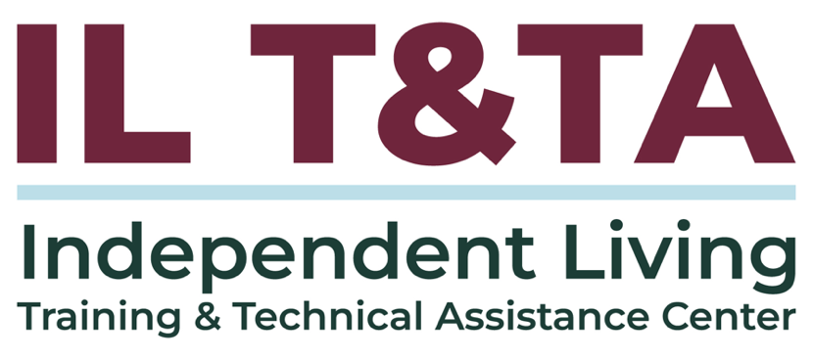
This project is on assignment through contract with the Administration on Disabilities, Administration for Community Living, Health and Human Services.

About the IL T& TA Center
The Independent Living Training and Technical Assistance Center (IL T&TA Center) is available to you through a contract with the US Department of Health and Human Services.
The IL T&TA Center provides expert training and technical assistance to CILs, SILCs, and DSEs.
The Center is operated by the University of Montana's Rural Institute for Inclusive Communities.
