Designated State Entity (DSE) Role in the Independent Living (IL) Network
September 24, 2025
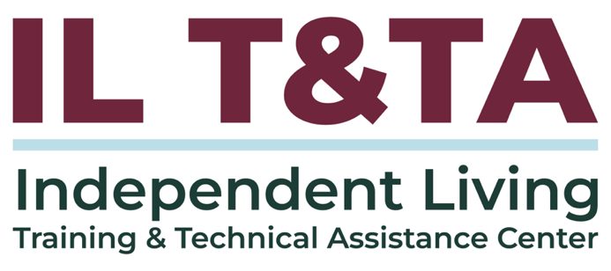

Before We Begin:
- ASL & Spanish Interpreters are available and labeled.
- Access Closed Captioning by clicking the CC button located at the bottom of your Zoom window.
- Use Zoom's Raise Hand or Chat features to ask questions.
- Remember to state your name and organization before speaking.
- Message our IL T&TA team using the Chat feature if you have difficulties with today's call.
- Please complete the survey at the end of today's training.

Today’s Agenda:

Key Takeaways:
- Describe the DSE role related to the network including CILs and the SILC
- Understand how DSEs are selected
- Understand the autonomy of the SILC and how the SILC and the DSE interact

Learn & Share Format:
- Approx. 45-60 minutes of spotlight content
- Goal of at least 30 minutes of peer discussion

Overall Goal:
- Let's learn with and from each other!

Presenters:
Heyab Berhan, CRC
Program Officer
Office of Independent Living Programs Administration on Community Living
Kristen Mackey
Arizona RSA Program Administrator
Division of Employment and Rehabilitation Services
Paula McElwee
Director of Technical Assistance
Independent Living Training and Technical Assistance Center
Maria Seaman
Chief Fiscal Officer
Opportunities for Ohioans with Disabilities

Notice a Few Acronyms?
CIL – Center for Independent Living. Name might reference an Independent Living Center (ILC) or not have these initials in the name at all.
SILC – Statewide Independent Living Council
SPIL – State Plan for Independent Living
DSE – Designated State Entity
These are the partners and processes in your state’s Independent Living Network.

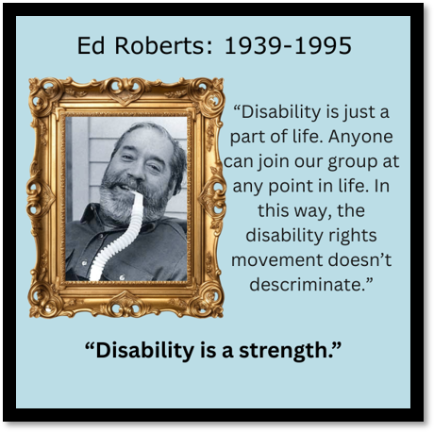
Highlights from the Story of Independent Living (IL)
The IL movement beginnings: late ‘60s, early ’70’s
Conceptualized by Ed Roberts of Berkeley CA as a moral imperative, NOT a social services model.
The concept that the consumer is in control saturates the history, law and regulations.
We believe that people with disabilities need and want to exert control over their own lives and decisions.

Background: Rehabilitation Act of 1973
The Rehabilitation Act of 1973, as amended, originally a separate piece of legislation, is now within the Workforce Innovation and Opportunity Act (WIOA) of 2014.
Title VII (7) of the Act, which pertains to Centers for Independent Living (CILs) and Statewide Independent Living Councils (SILCs) was transferred from the Department of Education (Rehabilitation Services Administration) to the Department of Health and Human Services (HHS) in 2016.

Background: Rehabilitation Act of 1973 (cont.)
HHS is responsible for planning, developing, and implementing the rules, policies, and guidelines for programs within Independent Living.

DSE Duties as Defined in the Rehab Act
(from Rehab Act: 29 U.S.C. § 796c: State Plan (c))
(c) DESIGNATION OF STATE ENTITY.—The plan shall designate a State entity of such State (referred to in this title as the ‘‘designated State entity’’) as the agency that, on behalf of the State, shall—
(1) receive, account for, and disburse funds received by the State under this chapter based on the plan;
(2) provide administrative support services for a program under part B, and a program under part C in a case in which the program is administered by the State under section 723;

DSE Duties as Defined in the Rehab Act (cont.)
(3) keep such records and afford such access to such records as the Administrator finds to be necessary with respect to the programs;
(4) submit such additional information or provide such assurances as the Administrator may require with respect to the programs; and
(5) retain not more than 5 percent of the funds received by the State for any fiscal year under part B, for the performance of the services outlined in paragraphs (1) through (4).

Challenges for the DSE
- Promoting the IL philosophy
- Understanding the autonomy of the CILs and SILC
- Assuring that pass through funds are properly spent and accounted for
- Reviewing fiscal compliance for centers receiving Part B funds
Would you agree?

The IL Philosophy in your State’s Network
CILs must be made up of a majority (51% or more) members who have a significant disability. A majority of SILC members be people with disabilities who are not employed by the state or a CIL.
This assures the organizations are run by consumers who are living day-to-day life as people with disabilities.
The DSE is designated by the CILs and SILC in the SPIL. The DSE is in place to receive and pass along Part B funds according to the State Plan. The DSE may also have a role in administering state funds.

Title VII (7), Part A: Setting the Foundation
Defines the purpose of Independent Living.
Establishes the federal administration and oversight of the program.
Establishes the State Plan for Independent Living and the requirements.
Establishes the State Independent Living Council (SILC), its purpose, requirements, and membership.

Title VII (7) Part B: Independent Living Services
Creates the Independent Living Services or Part B funding.
Sets the allowable use of Part B funds and how they will be divided to states.

Part B Funding
Funds are granted to the Designated State Entity (DSE).
Amount of funds to the state is determined by the population.
  - For every dollar of state funds you get $9 of federal, up to the award amount.
There is a match required by the state of 10% of the total project.
Up to 5% may be retained for DSE administrative costs.
The State Plan for Independent Living (SPIL) controls how the funds are used.

Part B Funding (cont.)
Reporting is on the Independent Living Services (ILS) Program Performance Report (PPR) jointly submitted by the State Independent Living Councils and the Designated State Entity (DSE).
Review of Part B center compliance in fiscal accountability and PPR reporting

Part C – Centers for Independent Living (CILs)
Creates the Centers for Independent Living or Part C funding.
Sets the standards and assurances for CILs.
Sets up how new grants will be awarded and existing grants funded.

More About Part C Funding:
Direct federal grants to CILs.
Total amount of funds to the state is determined by population.
Each CIL then receives the same percentage of funds as they did the year before.
Unless changed, the amount each CIL gets is not based on their service area population.
Funding of CILs takes place in this order:
- Priority #1: They must fund existing awards.
- Priority #2: If more funds are available, provide a cost-of-living adjustmen (COLA).
- Priority #3: Fund new grants to CILs.

Similarities and Differences DSE/DSU
- Prior to the WIOA amendments to the Rehabilitation Act, the state Department of Rehabilitation was designated to oversee the Title VII funds coming into the state as the Designated State Unit.
- With WIOA the entity receiving funds is designated in the State Plan and may be an agency other than the Department of Rehabilitation.
- With WIOA the role of the DSE was specified as a pass-through entity rather than an oversight body.

What are the Centers’ Roles in the Network?
CILs are community-based, consumer-controlled organizations that provide and advocate for a range of services to support people with disabilities in living independently and fully participating in their communities. They:
- Promote the Independent Living Philosophy
- Provide the core IL services
- Contribute to the development and implementation of SPIL goals and objectives
Much of the work of the CILs overlaps or dovetails with that of the VR agencies, which are often the DSE.

Purpose of Title VII (7) of the Act is to:
Promote a philosophy of independent living (IL) –
- Consumer Control
- Self-Help
- Equal Access
- Peer Support
- Self-Determination
- Individual and Systems Advocacy
in order to maximize the:
Leadership, empowerment, independence, and productivity of individuals with
Purpose of Title VII (7) of the Act is to: (cont.)
disabilities, and to promote the integration and full inclusion of individuals with disabilities into the mainstream of American society...
Regulations: 45 CFR 1329.2 quotes the Rehab Act’s Purpose for IL

What are the Core Services?
- Information and Referral (I&R)
- IL skills training
- Peer counseling;
- Individual and systems advocacy
- Services that facilitate transition from nursing homes and other institutions to the community, provide assistance to those at risk of entering institutions, and facilitate transition of postsecondary youth to community life.

Disability is Self-Identified
- When requesting services of a Center, an individual must state they are eligible, that is that they have a significant disability.
- Medical reports are not required for Independent Living services.
- Some centers may receive other funding that can require proof of disability, but that is not typical.
- CIL Board and SILC council members are identified as having a disability when they state that they have a disability.

History of the State Independent Living Council (SILC)
In the 1980s there was an Independent Living Advisory Board, appointed by the state Department of Rehabilitation.
In the 1992 amendments to the Rehabilitation Act this was strengthened to be a council which approved, with the DSU and the CILs, the State Plan for Independent Living.
In the WIOA amendments in 2014 key changes were:
- The SPIL was expanded to include Part C
- The state was no longer in an oversite role, but instead in a role of receiving the federal funds to be spent according to the SPIL.
History of the SILC (cont.)
- The DSE prepares the resource plan in conjunction with the DSE; however the DSE is no longer required to agree to the goals and objectives.
- The DSE develops its own section of the SPIL, Section 4 including agreement to receive and disperse funds.
- A voting representative of the CILs, chosen by and from among the CIL Directors, was added to the council.
- Consumer control was strengthened by establishing that 51% of the membership must be people with disabilities that do not work for either a center or the state.

The Establishment of the SILC
- Regulations are found in 45 CFR 1329.14
- To be eligible to receive assistance under this part, each State shall establish and maintain a SILC that meets the requirements of section 705 of the Rehabilitation Act, including composition and appointment of members.
- The SILC shall not be established as an entity within any state agency, including the DSE.
- The SILC shall be independent of and autonomous from the DSE and all State agencies.

The Establishment of the SILC (cont.)
- The Council members are appointed by the governor unless othervise specified in state law.
- Members may serve up to two consecutive three-year terms (plus fulfill an incomplete term).

Placement and Autonomy of SILC
The Council shall not be established as an entity within a State agency (Rehab Act Sec. 705(a))
- The conflict of interest policy at Sec. 705(e)(3) won’t allow SILC staff to also be assigned duties by the DSE.
- It would be an apparent conflict of interest for the DSE staff who administer and monitor the IL Program to also serve as a SILC staff.
How do we determine if the SILC is autonomous?

SILC Autonomy – DSE Will Not Interfere With Business or Operations of the SILC
(From the DSE Assurances in the State’s contract with ACL)
- The expenditure of federal funds
- Meeting schedules and agendas.

- SILC board business
- Voting actions of the SILC Board
- Personnel actions
- Allowable travel
- Trainings
- And will fully cooperate with the SILC in the nomination and appointment process for the SILC in the State.

The SILC Resource Plan and the DSE Role
SILC:
- Develops Resource Plan as part of the SPIL.
- Can use more than 30% of Part B funds (including state match) if justified and agreed to in the SPIL.
- Works with the DSE to advocate for the needed funds sufficient for its work.
DSE:
- Assures that funds provided to the SILC are sufficient to accomplish its role.
- Helps with securing available resources including Innovation and Expansion funds, State matching funds, State General Revenue and other public funds such as Social Security Reimbursement.

A Word About “Ex Officios”

“Ex officio” means that the person holds the position because of the position they hold in a state agency related to disabilities.
The individual may have helpful information about their agency, or expertise about a funding sources that the Council will find useful.
These are non-voting positions on the SILC, by law.

A Word About “Ex Officios” (cont.)
The SILC may choose in policy or bylaws to limit the contribution of these members to observation or specific items on the agenda. They are not required to include them in open discussions of the Council, although typically they participate.

Role of the DSE
Serves as “grantee” for Part B $.
Accounts to the SILC for the PART B $ and disperses those funds according to the SPIL (usually verified in a financial report to the SILC at each meeting).
Keeps financial records of Part B expenditures and makes them available for SILC and federal review.
Completes the ILS PPR report with the SILC. (Program Performance Report or 704).
The DSE cannot hold funds.
Signs the SPIL agreeing to serve as the DSE.
Has an “ex officio” position on the SILC (appointed by governor) and subject to terms.

Interagency Collaboration with State Vocational Rehabilitation (VR) Agencies
- Memos of Understandings (MOUs) with CILs to provide Pre-Employment Transition Services (Pre-ETS). This can overlap with CIL requirements to provide the core service of transition.
- Fee-For-Service (FFS) agreements with CILs for employment services. This can overlap with CIL requirements to provide the core service of independent living skills training, individual advocacy or other core services.
- There is no conflict in having a person with a disability be both a consumer of
Interagency Collaboration with State VR Agencies (cont.)
a CIL and be a client of a vocational rehabilitation counselor. In fact, it is encouraged so that the client/consumer has a bigger support system and both parties can contribute meaningfully to that potential success story.
Doing all these things contributes to the quality of your state plan and resulting services over time.

Let's Talk to Our Experts from DSEs

- What wisdom can you share with others who are in your position?
- What have been your biggest challenges?
- What is the best thing about the SILC and CIL collaborations?

More Questions for Discussion
- What are you curious about?
- Need clarification or more explanation?

Learn & Share: Your Experience Matters
Recording has stopped – now it’s time to share.

Ways to Engage:
- Raise your hand to be spotlighted to speak
- Turn on your camera if you're comfortable
- Use the chat to share insights, questions, resources, or tools
- React, reflect, or build on what others say
- Share real challenges or successes from your CIL
- Let’s turn ideas into action — your voice is the most valuable part of this session.

Evaluation
Thank you for participating in today's Learn and Share.
Your feedback is important and helps us plan future training.
Please use the link in the chat to share your feedback!
Evaluation Link:


How to Connect with Us!

Website: https://tinyurl.com/ILTTACenter
Request training and / or technical assistance (expert help for your organization): fill out a form on our website to let us know how we can help.
Call: 406-243-5300 and someone will get back to you as soon as we can.
Sign-Up for Events & Announcements:

Visit our website to sign up for updates about live training, group technical assistance, new publications, and other happenings around the Center.

IL T&TA Center Attribution

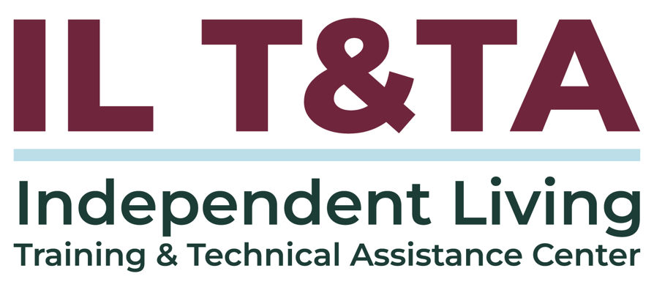
This project is on assignment through contract with the Administration on Disabilities, Administration for Community Living, Health and Human Services.

About the IL T& TA Center
The Independent Living Training and Technical Assistance Center (IL T&TA Center) is available to you through a contract with the US Department of Health and Human Services.
The IL T&TA Center provides expert training and technical assistance to CILs, SILCs, and DSEs.
The Center is operated by the University of Montana's Rural Institute for Inclusive Communities.
