What Worked for Us: Tools from Puerto Rico’s IL Network
Examples from peers in Puerto Rico that you can adapt to fit your own SILC context.
Introduction:
These four tools were highlighted in IL T&TA’s 9-4-2025 webinar: Reaching the Unheard; Identifying Underserved Populations and Strengthening Outreach for State Plans for Independent Living as practical examples of how Puerto Rico’s Independent Living Network strengthens outreach, inclusion, and accountability in the SPIL process. Each tool reflects lived experience and peer innovation — not a one-size-fits-all solution. We encourage you to adapt what fits your context, start small, and scale over time. Think of these resources as starting points: simple, actionable steps you can take to ensure every voice is heard in your state’s IL planning and implementation.
Tool #1 — Bilingual Pocket Glossary of Independent Living Terms
Purpose: This is a quick-reference glossary for SILCs, CILs, and collaborators. It makes it easier to understand acronyms and terms in both English and Spanish, and to ensure everyone shares the same language.
1. Institutions & Structures
• CEVI (SILC) – Puerto Rico’s Independent Living Council / Consejo Estatal
de Vida Independiente
• CVI (CIL) – Centers for Independent Living / Centros de Vida
Independiente. In Puerto Rico: MAVI y CPVI
• ARV (DSE) – Vocational Rehabilitation Administration / Administración
de Rehabilitación Vocacional
• ACL – Administration for Community Living / Administración para la
Vida Comunitaria (EE. UU.)
• OILP – Office of Independent Living Programs / Oficina de Programas
de Vida Independiente (dentro de ACL)

2. Plans & Processes
• PEVI (SPIL) – State Plan for Independent Living / Plan Estatal de Vida
Independiente
Example: three-year plan listing goals, activities, and measurable
indicators.
• Indicators (Indicadores) – Goals you can count to see if the plan is
working / Metas medibles para ver si el plan funciona
• Compliance Instrument (Instrumento de Cumplimiento) – CEVI’s
Excel/Forms tool for simple, accessible, and real-time reporting / Herramienta de Excel/Formularios de CEVI para informes simples, accesibles y en tiempo real
• Cumulative Reporting (Informe Cumulativo) – Data that adds up each
quarter and year / Datos que se acumulan trimestre tras trimestre
3. Core Concepts
• Independent Living (IL / VI) – Philosophy of autonomy, rights, and self-
determination / Filosofía de autonomía, derechos y autodeterminación
• Consumer (Consumidor) – Person with an impedimento who uses IL
services / Persona con impedimento que recibe servicios de Vida Independiente
• Equity (Equidad) – Making sure underserved and rural communities are
counted / Asegurar que las comunidades desatendidas y rurales se incluyan
• Five Core Services (Cinco Servicios Medulares) – Info & Referral, Skills
Training, Peer Support, Advocacy, Transition / Información y referido, destrezas, apoyo entre pares, incidencia, transición
4. Advanced Terms
• SILC Assurances (Aseguramientos del SILC) – Federal rules that
guarantee SILC independence / Requisitos federales que garantizan independencia del SILC
• Funding Streams (Fondos) – Part B, Part C, and I&E under the Rehab
Act / Fondos Parte B, Parte C e I&E de la Ley de Rehabilitación
• TA (Asistencia Técnica) – Training and resources from IL-NET, NCIL, ACL,
and IL TA / Capacitación y recursos de IL-NET, NCIL, ACL y la red de asistencia técnica
Reminder – Shared language = shared power.
This glossary helps SILCs and CILs communicate clearly, reduce confusion, and include all voices in building stronger SPILs/PEVIs.

Tool #2 — Campaign Consent Form
Purpose: CEVI uses a Google Form to collect informed consent for the Aquí se Vive Independiente campaign and other outreach. It ensures participation is voluntary, ethical, and accessible, while feeding into PEVI outreach and engagement indicators.
Link to our CEVI Google Form as an example: https://docs.google.com/forms/d/e/1FAIpQLSfou0kjPl9LX3Tqr_-RqQVIzwSotIlAYFddUI7PTPZP4CVyHw/viewform
When to use
At forums, outreach events, social/PSA campaigns, or whenever gathering testimonies, photos, videos, or quotes.
Core elements
• Consent covers photos, videos, audios, testimonies, and text quotes.
• Duration options: (a) only this campaign, or (b) also future CEVI
educational/institutional use.
• Accessibility: alternate formats available (audio, Braille, large print, sign
language).
• Privacy: option to use a pseudonym.
• Consent can be withdrawn at any time.
• QR code created for easy access: placed on table tops at events
and embedded in slides so participants can scan with smartphones.
Routing (within 48 hours)
1. Responses received via Google Form.
2. CEVI staff forward content to the Communications & Outreach
Committee.
3. Content logged, tagged (campaign/date), and routed to the local CIL if
follow-up is needed.
Equity impact
Ensures stories from rural and underserved municipios are documented with dignity and reflected in PEVI compliance data.
Safeguards
• No sensitive PII collected.
• Consent choices documented and respected.
• Withdrawal honored immediately.
• Form and consent text can be cloned/adapted by other SILCs.
Acknowledgment
Developed by CEVI’s Communications and Outreach Committee: Gabriela Joglar, Adyan Ríos, Natasha Santiago, and Madeleine Schwartz.
Tool #3 — Accessible Social Media Toolkit (Plain Text, EN)
Purpose: Provide a simple template for Independent Living campaigns that are inclusive, accessible, and replicable with free tools (Facebook, Instagram, WhatsApp, community radio).
Core elements
• One clear message: short, plain language statement tied to your SPIL goal.
• Visual accessibility: high contrast, large font, alt text for all images.
• Language access: bilingual versions if your state/territory has
diverse language needs.
• Format diversity: image posts, short videos, audio PSAs, and plain-text
versions.
• Distribution: post on social media, share QR codes at events, send via
WhatsApp/text, adapt for local radio.
Template (fill-in-the-blank)
1. Headline: [Short phrase, ≤6 words]
2. Message: [What people need to know/do, ≤50 words]
3. Hashtag/campaign tag: [e.g., #IndependentLiving]
4. Visual: [Simple photo/graphic with alt text]
5. Call to Action: [Link, phone number, or QR code]
Example
• Headline: “Aquí se Vive INDEPENDIENTE”
• Message: “Every person with an impediment deserves services in
their community. Fill out our PEVI survey to help shape the future.”
• Hashtag: #VidaIndependientePR
• Visual: photo of a ramp + alt text
• CTA: QR code linking to Google Form
Tips
• Test posts with a screen reader.
• Add captions to videos.
• Keep it short, clear, and direct.
Tool #4 - CEVI SPIL Compliance Tool — Quick Guide (Plain Text)
Purpose: A standardized, automated Excel workbook (desktop only) that helps SILCs and CILs: (1) demonstrate SPIL compliance in real time, and (2) see trends early to adjust outreach and services.
What it solves
- Multi-municipality service was invisible in older reports.
- Inconsistent files slowed consolidation and added staff burden.
- Data couldn’t easily inform decisions about underserved areas.
Core features
- Locked structure with dropdowns + short text for consistency.
- Filters by Center / Fiscal Year / Quarter.
- Multi-municipality selection to make rural/smaller areas visible.
- Shared vocabulary of measurable indicators across centers.
- Strict file naming for version control and audit trail.
How to use (quick start)
1. Enter current-quarter data in the “New” fields; SILC maintains cumulative (“Past”).
2. Filter by Center/FY/Quarter to view coverage and gaps.
3. Review monthly trends; identify underserved/unserved areas.
4. Report back every 60 days; adjust outreach and supports.
5. Support available: CEVI provides a WhatsApp digest with updates, email guidance, and short live help windows for coordinators.
Equity & outcomes
• Visibility for rural/smaller municipalities.
• Lower administrative load → more time with consumers.
• Faster pivot to meet real-time needs.
Guardrails
• Desktop Excel required; web/mobile won’t run automation.
• Mock data only in demos; no PII in shared views.
• If blocked by IT, use Trusted Locations or a Word/Google Form fallback; SILC consolidates centrally.
Example Data Entry Screen (Spanish): This example shows Puerto Rico’s SPIL Compliance Tool in Excel. It captures data from consumer forums, including the number of panelists and participants, knowledge gained, methods used, and municipalities served. The tool standardizes reporting across CILs, making rural and smaller communities visible and helping SILCs track outreach in real time.
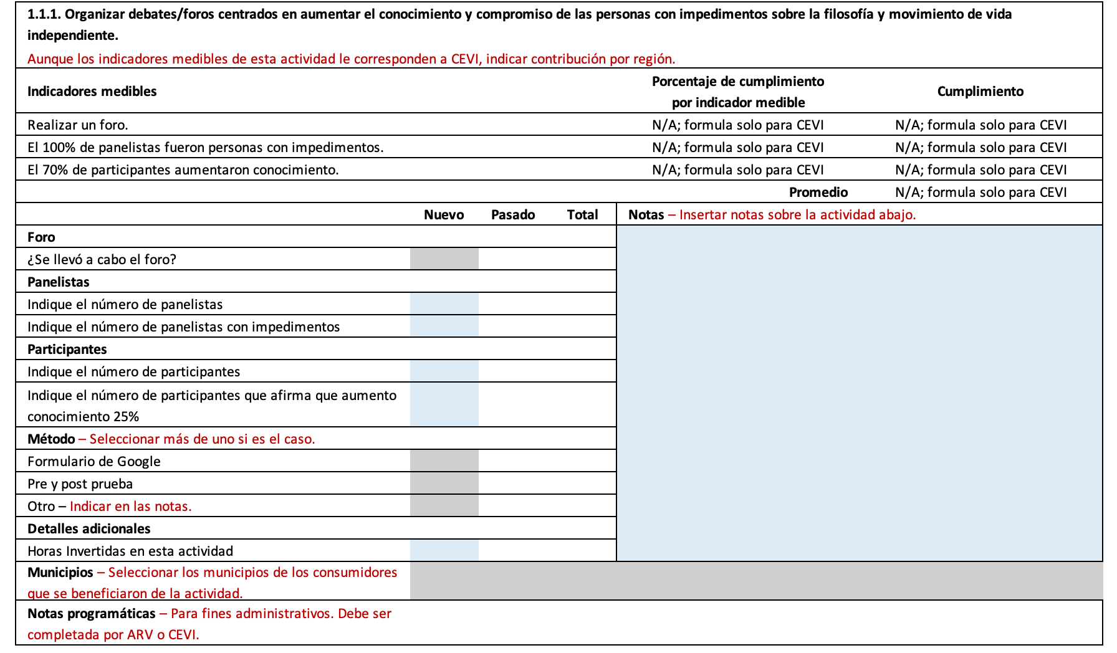
Closing: Data that hears the unheard isn’t an accident—it’s a system. CEVI’s instrument provides that system.

