Reaching the Unheard: Identifying Underserved Populations and Strengthening Outreach for State Plans for Independent Living
September 4, 2025

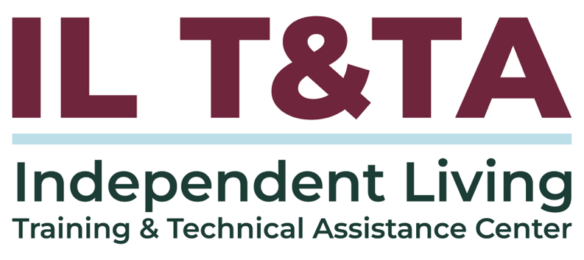

Before We Begin
- ASL & Spanish Interpreters are available and labeled.
- Access Closed Captioning by clicking the CC button located at the bottom of your Zoom window.
- Use Zoom's Raise Hand or Chat features to ask questions.
- Remember to state your name and organization before speaking.
- Message our IL T&TA team using the Chat feature if you have difficulties with today's call.
- Please complete the survey at the end of today's training.

Today’s Agenda –

Key Takeaways:
- Identify effective strategies for (State Plan for Independent Living) SPIL engagement that ensure the representation of underserved and unserved communities
- Apply practical tools and technology to modernize and improve outreach, data collection, community input during the SPIL development and monitoring process.
- Explore real-world examples of community-driven SPIL development, including grassroots engagement tactics, multilingual outreach, and culturally relevant practices such as social media campaigns and public events.

Today’s Agenda (cont.) –

Learn & Share Format:
- Approx. 45-60 minutes of spotlight content
- Goal of at least 30 minutes of peer discussion

Overall Goal:
Let's learn with and from each other!

Facilitators
Mary-Kate Wells
Director of Programs
National Council on Independent Living

Technical Assistance
Tyler Morris
Director of Programs
Independent Living Training & Technical Assistance Center

What is “Section 21”?
Section 21 is not a standalone law — it’s a specific provision within the original Rehabilitation Act of 1973, codified at 29 U.S.C. § 718.
It was added to strengthen outreach efforts to individuals from minority backgrounds, which may include:
- From racial or ethnic minority groups
- From disadvantaged backgrounds
- Limited English Proficiency (LEP) or non-English speakers
- Living in rural or underserved areas

How Section 21 Shows Up in Independent Living (IL)
While Section 21 itself doesn’t prescribe specific regulatory steps, its requirements are embedded in some Independent Living regulations:
- 45 CFR § 1329.4 – Definitions: Defines “unserved and underserved populations” to include linguistic and cultural minorities.
- 45 CFR § 1329.10 – State Plan Requirements (SPIL): Requires IL State Plans to address outreach to LEP and minority groups.
- 29 U.S.C. § 796f-4. Standards and assurances for centers for independent living:
  - Mandates that Centers for Independent Living must “promote equal access” for individuals from minority or disadvantaged backgrounds

How Section 21 Shows Up in IL (cont.)
  - Also requires aggressive outreach to unserved and underserved populations, and ensure staff receive training to better serve minority, rural, and urban communities.
- SILC Indicators & Assurances (ACL, 2018): Requires SILCs to hold accessible, public meetings, consult with unserved and underserved populations, provide materials in plain language or alternate formats, monitor and update the SPIL, and ensure members are trained for effective outreach and engagement.

Why it Matters for SILCs & SPILs?
Section 21 makes clear that outreach, inclusion, and representation are not optional — they are federal priorities tied to SILC responsibilities and SPIL compliance.

Section 21 is the lens for ensuring that all voices — especially “the unheard” — are reflected in SPIL priorities.

Section 21 in Practice (for SILCs & CILs)
When developing or monitoring a SPIL, ask:
- Who is missing from the table?
- Which communities are underserved in our state?
- How are we ensuring language and cultural access?
Outreach strategies should include:
- Multilingual materials and plain language standards
- Community partnerships with trusted leaders and organizations
- Accessible data tools to track who is being reached and who isn’t
- Training staff on cultural and linguistic competence

Presenters

Peer Presenters from CEVI (Puerto Rico SILC):
Gabriela Joglar Burrowes
SILC Communications and Community Outreach Specialist
Info@cevirpr.org

Sofia Pantel del Cueto
SILC President
Sofiapantel@gmail.com

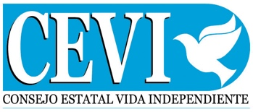

Puerto Rico’s IL Network
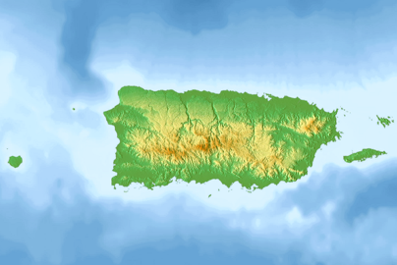
- Where are we? A small island in the Caribbean, directly below Florida and next to the Dominican Republic.
- Who we Serve? Communities across the island in a bilingual environment (Spanish is primary).
- How do we work? Consejo Estatal de Vida Independiente (CEVI) – Puerto Rico’s SILC works together with PR’s CILs Movimiento para el Alcance de Vida Independiente (MAVI) and Centro Ponceno de Vida Independiente (CPVI):
  - To lead the SPIL (PEVI) process, which emphasizes outreach to underserved/unserved groups.

Culture of Disability in PR
- Family First: Strong familial caregiving traditions—families often serve as primary support networks.
- Stigma is real: Cultural stigma can discourage people from identifying as disabled or seeking IL services.
- Trust Matters: Community relationships must come before service engagement.

Who We Reach in PR
- Rural residents with limited transportation options
- People disconnected by stigma or lack of information
- Youth with disabilities transitioning from school to adulthood
- Older adults with disabilities not yet engaged in IL services
- Linguistic minorities across the island
Our goal: reduce barriers, meet communities where they are, and count every municipio (town).

How Did We Identify the Unheard?
- Regional forums in trusted spaces (churches, municipal halls)
- Plain-Spanish surveys & WhatsApp intake
- Direct outreach by CIL staff & community leaders
- Leveraging fairs & community events
- Youth/peer ambassadors on social media
- PR SPIL Compliance Tool to track rural/linguistic gaps
Takeaway: We didn’t guess — we listened where people already were, in their language, and in real time.

PR’s IL Strategies in Action
How We Identified and Reached the Unheard:
Identifying who’s missing
- Through forums, surveys, youth voices, and data tools that show underserved communities.
How do we reach people?
- Through consumer-led outreach — listening first, then acting together.
How do we make participation possible?
- By ensuring bilingual access and plain language so everyone can engage.
How do we share our message?
- With accessible media campaigns that elevate youth voices and community influencers.

PR’s IL Strategies in Action (cont.)
How do we know it’s working?
- A lighter-load SPIL compliance tool shows, in real time, which communities are being reached — and who is still missing.
What’s our approach?
- Honest and systematic: foundations first, then steady improvement.

What Has Worked for Us:

Grassroots SPIL Development for PR (PEVI)
- Public forums across regions
- Plain-Spanish online surveys
- Direct outreach through CIL staff & community leaders
- Leveraged existing community events to explain IL & gather input from Puerto Ricans with disabilities
- Plain language + accessibility practices at every touchpoint

What Has Worked for Us:

Grassroots SPIL Development for PR (PEVI) (cont.)
Results:
- 5 regional hybrid hearings with 114 participants.
- 41 public survey comments incorporated into the SPIL.
- 24 governance meetings (11 SPIL committee + 13 CIL coordination) ensured consumer voices stayed central.
- Transportation, housing access, and youth transition emerged as top consumer-led priorities.

What Has Worked for Us:

Language Access & Plain Language
- Materials produced in plain Spanish and English
- Visual aids + short videos to explain IL & SPIL concepts clearly
- Staff trained in cultural & linguistic competency
- Streamlined translation workflow:
  - Developed a bilingual glossary (Tool #1: Bilingual Pocket Glossary of Independent Living Terms) to ensure consistent terms across documents
  - Used a machine translation tool for speed (e.g., DeepL)
  - Added rapid human review to secure accuracy and cultural relevance

What Has Worked for Us:

Language Access & Plain Language (cont.)
Result:
- Consumers participated more fully when materials were provided in Spanish and plain language.
- Consistent bilingual terms built trust, reducing confusion across agencies and CILs.
- Visual tools lowered barriers, helping people with varied literacy levels understand SPIL concepts.
- On-time delivery of materials meant consumers could actively take part in forums and surveys.

What Has Worked for Us:

Community Spaces & Trust
- Held forums in familiar, accessible spaces — community centers, churches, municipal halls.
- Used local facilitators to build trust, credibility, and encourage open sharing.
- Began each forum with a short IL “101” in plain language to build understanding before collecting input.
- Used QR consent + simple sign-ups so participation was safe, dignified, and easy.

What Has Worked for Us:

Community Spaces & Trust (cont.)
Result:
- Turnout of consumers higher in trusted community spaces than in formal venues.
- Local facilitators built credibility, especially in rural municipios.
- Plain-language IL 101 gave confidence to participate.
- Consent forms ensured ethical use of stories/photos and reduced barriers for people with low literacy or tech access – (Tool #2 :Campaign Consent Form).

What Has Worked for Us:

Community Spaces & Trust (cont.)
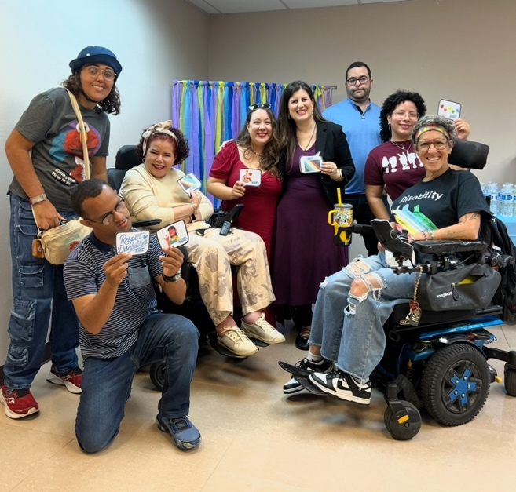
“Building Community Through Disability Pride”

What Has Worked for Us:

Youth, Social Media & Campaigns
- Two main channels: Facebook + Instagram
- Spanish-language content with culturally relevant imagery
- Campaign: Aquí se Vive Independiente
  - Consumer voice front and center
  - Posts always include alt text, captions, clear calls to action to ensure engagement and accessibility (Tool #3: Accessible Social Media Toolkit)
- Youth + peer ambassadors with disabilities co-create posts/videos:
  - Many already had large followings and represented diverse disabilities and perspectives
- Posts link directly to services, events, and feedback forms – closing the loop between outreach and planning.

What Has Worked for Us:

Youth, Social Media & Campaigns (cont.)
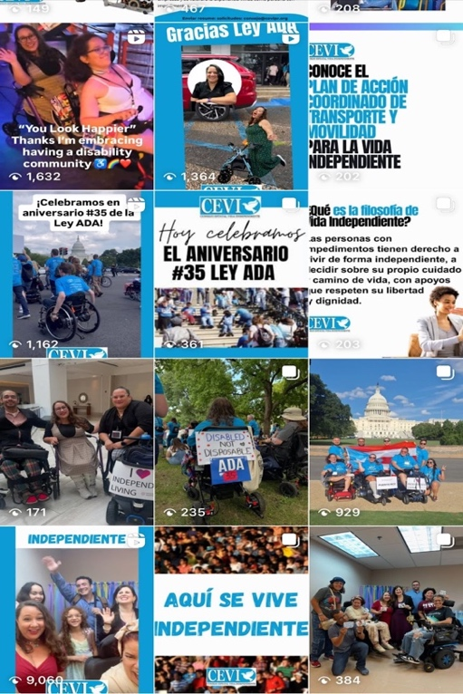

Snapshot of short Video / Reels we have shared on Instagram and Facebook

What Has Worked for Us:

Youth, Social Media & Campaigns (cont.)
Results:
- Campaign posts reached far more consumers compared to CEVI’s official channels alone.
  - Example (without disabled youth ambassadors): 1,746 views – “What is Disability Pride Month?”
  - With disabled youth ambassadors:
18,090 views – “What is Disability Pride Month”
9,060 views – “Aquí se Vive Independiente” launch
- Youth-led content built credibility and resonated with PR’s diverse disability communities.
- Social media became a direct bridge between outreach and SPIL planning.

What Has Worked for Us:

Youth, Social Media & Campaigns (cont.)
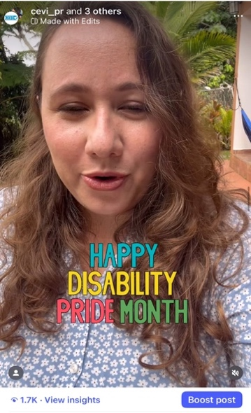
(Left) Snapshot of “Happy Disability Pride Month?” post with 1,746 views (without ambassadors)
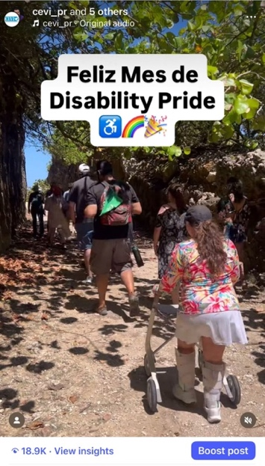

(Right) Snapshot of “Happy Disability Pride Month” post with 18,090 views (with ambassadors)

From Stories to Systems: SPIL Compliance Tool
The Challenge We Faced
- Outreach created a flood of input from forums, surveys, WhatsApp, and social media.
- Without a system, rural and smaller municipios disappeared in reporting.
- Inconsistent files slowed consolidation and made it harder to spot trends.
- Time was critical — SILCs needed to know where to go next before resources were gone.
- Without timely data, planning stayed reactive, and opportunities to reach unserved areas were missed.

From Stories to Systems: SPIL Compliance Tool (cont.)
Our Solution – (Tool #4: SPIL Compliance Tool Quick Guide)
- A shared Excel workbook for all CILs — consistent, standardized, and easy to use.
- Multi-municipio capture makes small and rural towns visible for the first time.
- Cumulates and filters CIL data, in real time, to reflect which communities we are missing input.
- Every 60 days, SILC can review progress, pivot outreach, and redirect resources.
- Backed by CIL collaboration + live staff support (WhatsApp digest, email, quick help).
- Equity impact: turns compliance into action — ensuring every community counts and the SPIL becomes a living, responsive plan.

Extending the Solution:

Tech & Real-Time Response
- Paired the developed SPIL Compliance Tool with simple forms + light automation for easier use.
- Exploring AI-assisted trend checks so gaps are flagged early.
- Cumulative views across quarters reveal:
  - Which communities are unserved & under-served
  - What services consumers request most
  - Which gaps keep repeating
- With this system, SILC can pivot events, transport, or partnerships quickly — before the SPIL year ends.

Extending the Solution:

Tracking Progress & Feedback Loops
- Report back to consumers, participants and partners so people see how their input shaped the SPIL.
- Share short summaries after forums, PSA updates, and “what we heard/what we’ll do” notes.
- Builds trust over time by showing real action on feedback.
- Fosters a culture of shared accountability across SILC, CILs, and consumers.

Extending the Solution:

What Your SILC Can Do
These are the “starter pieces” to create your own loop: outreach → capture → response.
- Create a IL Glossary – ensures language equity from the beginning.
- Communication Platform – simple, real-time CIL and SILC staff communication keeps reporting consistent.
- Your own SPIL Compliance Tool – distribute a dedicated version on either a Locked Excel/Google Form to prevent data loss and build.
- QR Consent Form – builds trust and simplifies participation
- Consumer Forum – your first feedback channel to close the loop
Start small, refine as you go –
each step builds the system stronger.

Extending the Solution:

First 30 Days (Quick Wins)
These are small but powerful actions that mirror CEVI’s cycle:
- Choose one tool to lock down.
- Translate one key document using your IL glossary + quick human review.
- Run a short informal, open and transperant peer-discussion in a trusted space.
- Share a one-page “What We Learned” back with your council, partners, and consumers.

Bringing It All Together: From Outreach to Action
- Outreach → forums, surveys, trusted spaces, disabled youth ambassadors
- Input captured → bilingual materials, SPIL Compliance Tool, social media feedback
- Response → reporting back, feedback loops, adjustments in real time
- Impact → Puerto Rico peers with disabilities from unserved / underserved communities see their voices reflected, “every municipio counts”, and the SPIL becomes a living responsive plan
This is how we move from hearing the unheard — to ensuring they are part of the plan.

Peer Tools You Can Use From PR
Adapt what fits your context; start small, then scale
- Tool #1: Bilingual Pocket Glossary of Independent Living Terms: Quick reference in Spanish and English for commonly used IL terms. Ensures clarity and shared language across CILs, SILCs, and consumers.
- Tool #2: Campaign Consent Form: Bilingual, plain-language form to obtain informed consent for photos, videos, or stories. Designed to be accessible (audio, Braille, QR code) and to document participation ethically and clearly.

Peer Tools You Can Use From PR (cont.)
Adapt what fits your context; start small, then scale
- Tool #3: Accessible Social Media Toolkit:
Tips and templates for inclusive posts: alt text, captions, culturally relevant imagery, and youth/peer-led content. Supports accessible and culturally resonant outreach.
- Tool #4: SPIL Compliance Tool (Quick Guide): A step-by-step guide to how Puerto Rico tracks outreach data in real time. Built in Excel with dropdowns and filters, it reduces errors and makes rural/smaller areas visible and gives SILCs a practical way to see gaps and adjust outreach in real time.

Resources for Additional Guidance
- Administration for Community Living: Section 21 Program
- Section 21 of Rehab Act: 29 USC § 718: Traditionally underserved populations
- Plain Language Resources:
  - Self Advocacy Resource and Technical Assistance Center (SARTAC)
  - Plain Language Action and Information Network (PLAIN)
  - Communication Planning Tips (Administration of Community Living)
- DeepL Translator – AI-powered translation solution

Learn & Share: Your Experience Matters
Recording has stopped – now it’s time to share.

Ways to Engage:
- Raise your hand to be spotlighted to speak
- Turn on your camera if you're comfortable
- Use the chat to share insights, questions, resources, or tools
- React, reflect, or build on what others say
- Share real challenges or successes from your CIL
Let’s turn ideas into action — your voice is the most valuable part of this session.

Evaluation
Thank you for participating in today's Learn and Share.
Your feedback is important and helps us plan future training.
Please use the link in the chat to share your feedback!
Evaluation Link:
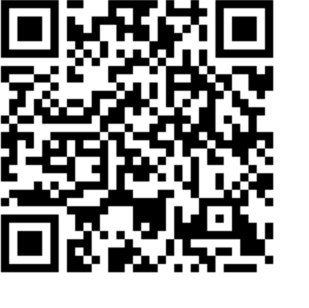

How to Connect with Us!

Website: https://tinyurl.com/ILTTACenter
Request training and / or technical assistance (expert help for your organization): fill out a form on our website to let us know how we can help.
Call: 406-243-5300 and someone will get back to you as soon as we can.
Sign-Up for Events & Announcements:
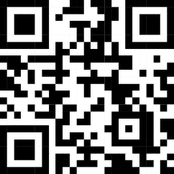
Visit our website to sign up for updates about live training, group technical assistance, new publications, and other happenings around the Center.

IL T&TA Center Attribution

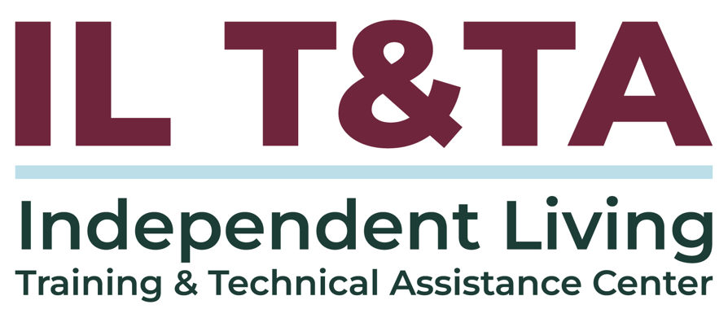
This project is on assignment through contract with the Administration on Disabilities, Administration for Community Living, Health and Human Services.

About the IL T& TA Center
The Independent Living Training and Technical Assistance Center (IL T&TA Center) is available to you through a contract with the US Department of Health and Human Services.
The IL T&TA Center provides expert training and technical assistance to CILs, SILCs, and DSEs.
The Center is operated by the University of Montana's Rural Institute for Inclusive Communities.
