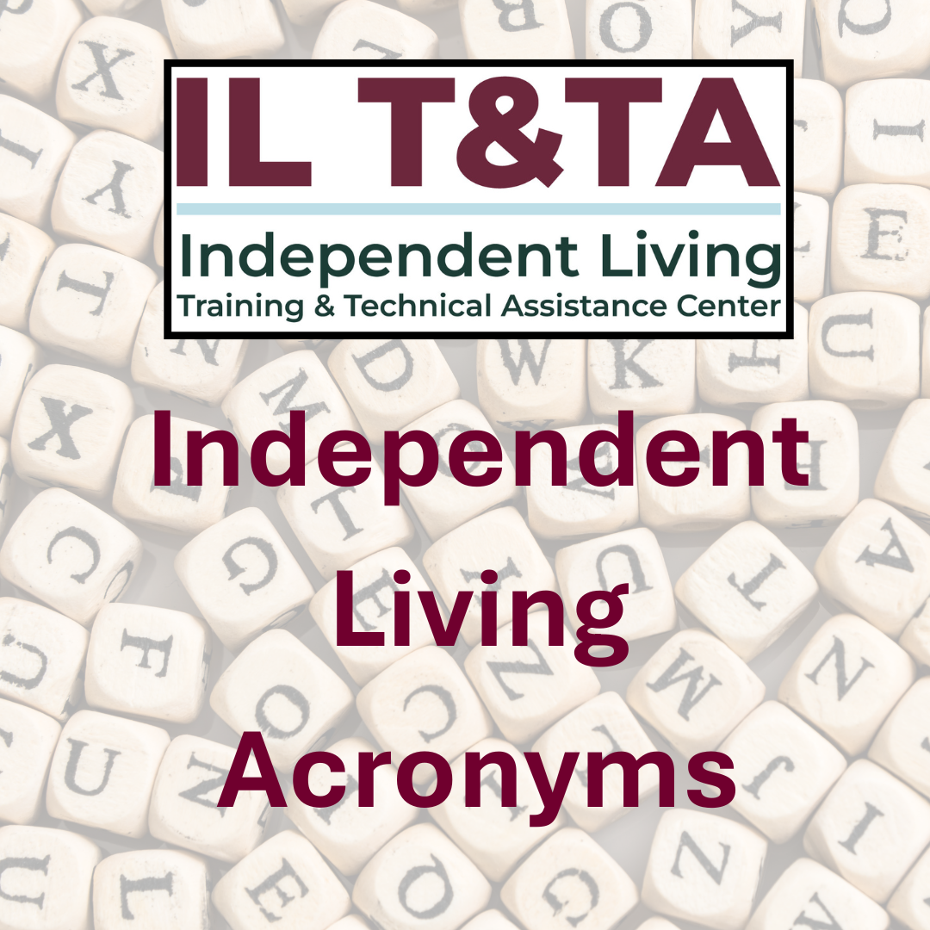

Independent Living Acronyms ©2015 ILRU; updated 2021, 2025

Independent Living Training and Technical Assistance (IL T&TA) Center Rural Institute for Inclusive Communities
University of Montana Room 035 N. Corbin Hall Missoula, MT 59812-7056
406-243-5300 (V)
ILTTACenter@mso.umt.edu www.ilttacenter.org

Project Director: Sandra Breitengross Bitter
Publications Staff: Tyler Morris, Paula McElwee, Joey Vega, Emily Wolinsky, Jeremy Morris

This is a publication of the IL Training & Technical Assistance Center operated at the Rural Institute for Inclusive Communities at the University of Montana. The IL Training & Technical Assistance Center is supported by contract number 75P00125C00005 from the U.S. Administration for Community Living, Department of Health and Human Services, Washington, D.C. 20201.

NOTE: This publication was previously produced by the IL-NET National Training and Technical Assistance Center for Independent Living operated at ILRU (Independent Living Research Utilization) at TIRR Memorial Hermann Research Center, Houston, Texas. The previous publication was supported by grant number 90ILTA0001 from the U.S. Administration for Community Living, Department of Health and Human Services, Washington, D.C. 20201.

Independent Living Acronyms, ©June 2025
If you are new to Independent Living and our acronyms have you dizzy with confusion, this reference is for you. If you are tired of Alphabet Soup, this ready reference will help you unpack the confusion of letters and bring better understanding to your board and staff. If you need to know more than just what the letters stand for, visit our website at ILTTACenter.org for more information about all things Independent Living.

704 Report – An annual program performance report of services provided, prepared by a SILC (Part I) or a center (Part II); obsolete term; replaced with Program Performance Reports (PPR).

723 State – State in which State funding for centers equals or exceeds the amount of Federal funds allotted to the State under Part C, Chapter 1 and in which the Director of the Designated State Entity (DSE) submits an application and is approved by ACL/OILP to administer the CIL program as provided in section 723 of the Act.

A
AAA or Triple A – Area Agency on Aging
AAGAM – Awarding Agency Grant Administration Manual
AAPD – American Association of People with Disabilities
AARP – American Association of Retired Persons
ACA – Affordable Care Act
ACL – Administration for Community Living
ADA – Americans with Disabilities Act
ADA Center – Americans with Disabilities Act Center; (11) centers form the ADA National Network
ADAAA – Americans with Disabilities Amendments Act of 2008
ADAPT – An organization of disability rights activists.
ADLs – Activities of Daily Living
ADRC – Aging and Disability Resource Center AJC – American Job Center
APRIL – Association of Programs for Rural Independent Living

ASAN – Autistic Self Advocacy Network
ASL – American Sign Language AT – Assistive Technology
AT – Assistive Technology
AUCD - Association of University Centers on Disabilities

C
CAP – Client Assistance Program OR Cost Allocation Plan OR Corrective Action Plan
CARES – Coronavirus Aid, Relief, and Economic Security
CART – Communication Access Real- Time Translation
CAS – Cost Accounting Standards
CBO – Community Based Organization CC – Closed Captioning
CDBG – Community Development Block Grant
CFDA – Catalog of Federal Domestic Assistance
CFR – Code of Federal Regulations CIF – Consumer Information Files CIL – Center for Independent Living
CLA – Community Living Administration
CLSP – Community Living Services Program
CMS – Centers for Medicare & Medicaid Services
COMP – Compliance and Outcome Monitoring Protocol
COSO – Committee of Sponsoring Organizations
CRP – Community Rehabilitation Program
CRPD – Convention on the Rights of Persons with Disabilities
CSR – Consumer Service Record (obsolete term; replaced with Consumer Information Files)

D
DBTAC – Disability and Business Technical Assistance Centers (on the ADA) (obsolete term; replaced with Americans with Disabilities Act Centers (ADA Centers))
DD – Developmental Disability DME – Durable Medical Equipment DOE – Department of Education DOL – Department of Labor
DOR – Department of Rehabilitation

DREDF – Disability Rights Education and Defense Fund
DSE – Designated State Entity
DSU – Designated State Unit (vocational rehabilitation term)

E
ELO – Extended Learning Opportunity EN – Employment Network
ES – Electrical Sensitivities or Enviornmental Sensitivities
EVV – Electronic Visit Verification

F
F&A– Facilities and Administrative
FAC – Federal Audit Clearinghouse
FAPE – Free Appropriate Public Education
FAPIIS – Federal Awardee Performance and Integrity Information System
FAR – Federal Acquisition Regulation
FASB – Financial Accounting Standards Board
FERPA – Family Educational Rights and Privacy Act
FFY – Federal Fiscal Year
FHC – Fair Housing Council
FLSA – Fair Labor Standards Act
FMS – Financial Management Services

G
GAAP – Generally Accepted Accounting Principles
GOTV – Get out the Vote
GSA – General Services Administration

H
HAVA – Help Americans Vote Act
HCBS – Home and Community-Based Services
HHS – Department of Health & Human Services
HIPAA – Health Insurance Portability and Accountability Act
HPRP – Homelessness Prevention and Rapid Re-Housing Program
HUD – Housing and Urban Development

I
IDD – Intellectual Developmental Disability

IDEA – Individuals with Disabilities Education Act
I & E – Innovation and Expansion
IEP – Individualized Education Program
IEPIL – IEP for Independent Living
ILA – Independent Living Administration
ILC – Independent Living Center
ILP – Independent Living Plan
ILRU – Independent Living Research Utilization
I & R – Information and Referral

L
LRE – Least Restrictive Environment
LTSS – Long-Term Services & Supports

M
MCO – Managed Care Organization MCS – Multiple Chemical Sensitivity MFP – Money Follows the Person
MOU – Memorandum of Understanding
MTDC – Modified Total Direct Costs

N
NASIL – National Association of Statewide Independent Living Councils
NCIL – National Council on Independent Living
NFE – Non-federal Entity
NIA – Notice of Intent to Award
NIDILRR – National Institute on Disability, Independent Living, and Rehabilitation Research
NPRM – Notice of Proposed Rulemaking

O
OCR – Office for Civil Rights
OIG – Office of Inspector General
OILP – Office of Independent Living Programs
OMB – Office of Management and Budget
OPM – Office of Personnel Management
OSERS – Office of Special Education and Rehabilitative Services

P
PA – Personal Assistant
PAR – Personnel Activity Report

PAS – Personal Assistance (or Attendant) Services
P & A – Protection and Advocacy
Part B – Refers to Title VII Part B of the Rehabilitation Act, which passes money through the SILC to CILs, more accurately Subsection B
Part C – Refers to Title VII Part C of the Rehabilitation Act, which authorizes direct grants to CILs; more accurately Subsection C
PMS – Payment Management System, the system for drawing funds from the Department of Health and Human Services
PO – Project Officer (ACL/ILA state assignments)
PPE – Personal Protection Equipment
Pre-ETS – Pre-Employment Transition Services
PPP – Paycheck Protection Program PPR – Program Performance Report PTI – Parent Training and Information PWD – People with Disabilities

Q
QA – Quality Assurance
R
RFP – Request for Proposal
RSA – Rehabilitation Services Administration
RTC – Research and Training Center

S
SAA – Single Audit Act
SAM – System for Award Management
SCA – System Change Advocate
SCI – Spinal Cord Injury
SEFA – Schedule of Expenditures for Federal Awards
SF 425 – A form for reporting on expenditures of federal funds.
SILC – Statewide Independent Living Council
SPIL – State Plan for Independent Living
SRC – State Rehabilitation Council SSA – Social Security Administration SSD – Social Security Disability
SSDI – Social Security Disability Insurance
SSI – Social Security Income

T
TDD – Telecommunication Device for the Deaf
TA – Technical Assistance
Title VII (7) – Refers to the sections of the Rehabilitation Act relevant to Independent Living programs
TQM – Total Quality Management
TTY – An older designation for a TDD, from teletype

U
UAR – Uniform Administrative Requirements
UG – Uniform Guidance
UCEDD - University Center for Excellence in Developmental Disabilities
USC – United States Code
UEI – Unique Entity Identifier

V
VOA – Volunteers of America
VOAD – Voluntary Organizations Active in Disasters
VR – Vocational Rehabilitation
VRI – Video Remote Interpreting (for Deaf and Hard of Hearing)
VRS – Video Relay Service (for Deaf and Hard of Hearing)
VRS – Vocational Rehabilitation Services

W
WIB – Workforce Investment Board
WID – World Institute on Disability
WIOA – Workforce Innovation and Opportunity Act (July 22, 2014 revision to the Rehabilitation Act)
WIPA – Work Incentive Planning Assistance

Y
YLF – Youth Leadership Forum

USE THIS SPACE TO WRITE YOUR STATE’S UNIQUE ACRONYMS:

