Ask Anything – Digital Accessibility & Assistive Technology
November 13, 2025

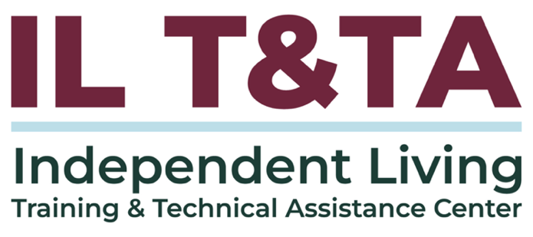

Before We Begin
ASL & Spanish Interpreters are available and labeled.
Access Closed Captioning by clicking the CC button located at the bottom of your Zoom window.
Use Zoom's Raise Hand or Chat features to ask questions.
Remember to state your name and organization before speaking.
Message our IL T&TA team using the Chat feature if you have difficulties with today's call.
Please complete the survey at the end of today's training.

The IL T&TA Center – Who We Are
The IL T&TA Center, operated by the University of Montana’s Rural Institute for Inclusive Communities (RIIC), is funded by the Office of Independent Living Programs, Administration on Disabilities, Administration for Community Living (ACL) to provide expert information, support, and training tailored for Centers for Independent Living (CILs), Statewide Independent Living Councils (SILCs), and Designated State Entities (DSEs) across the country.
- We are Disability-Led
- We have a Peer-Based Partnership Structure
- We Prioritize Community-Based Approaches
- We are Accessible and Inclusive

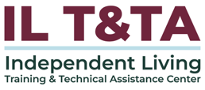

What to Expect from the IL T&TA Center
The IL T&TA Center collaborates with the National Council on Independent Living (NCIL), Association of Programs for Rural Independent Living (APRIL), National Association of Statewide Independent Living Councils (NASILC), and a consultant network of subject-matter experts to provide:
- One-on-One Peer Consulting
- Engaging Virtual Small Group Meetings
- Informative Webinars
- Helpful Videos
- Eye-Catching Infographics
- Interactive Training Modules
- Insightful Fact Sheets
- Comprehensive Toolkits
- Practical Guidebooks

Presenters from Independent Living Training and Technical Center (ILT&TA)
Sandra Breitengross Bitter
Director

Tyler Morris
Director of Training

Paula McElwee
Director of Technical Assistance

Sarah Messengale
Technical Assistance Consultant

Ask Anything
Let's start the discussion!
- Use the Chat and Raise Hand features to ask your questions.
- Remember to state your name and organization before speaking.

Evaluation
Thank you for participating in today's Learn and Share.
Your feedback is important and helps us plan future training.
Please use the link in the chat to share your feedback.
Evaluation Link:
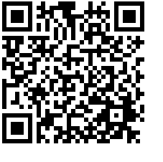

How to Connect with Us!

Website: https://tinyurl.com/ILTTACenter
Request training and / or technical assistance (expert help for your organization): fill out a form on our website to let us know how we can help.
Call: 406-243-5300 and someone will get back to you as soon as we can.
Sign-Up for Events & Announcements:
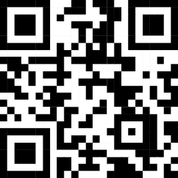
Visit our website to sign up for updates about live training, group technical assistance, new publications, and other happenings around the Center.

IL T&TA Center Attribution

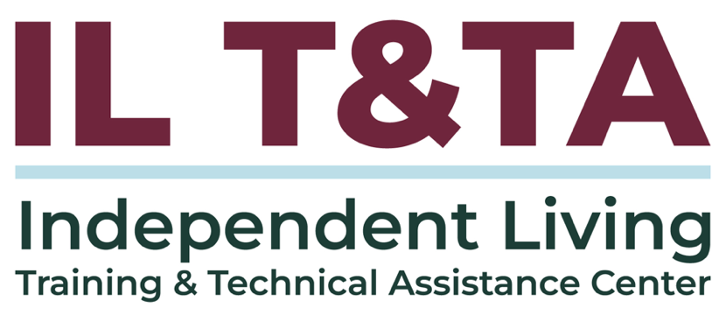
This project is on assignment through contract with the Administration on Disabilities, Administration for Community Living, Health and Human Services.

