SILC Connection – Serving on the Board / Council
November 18, 2025

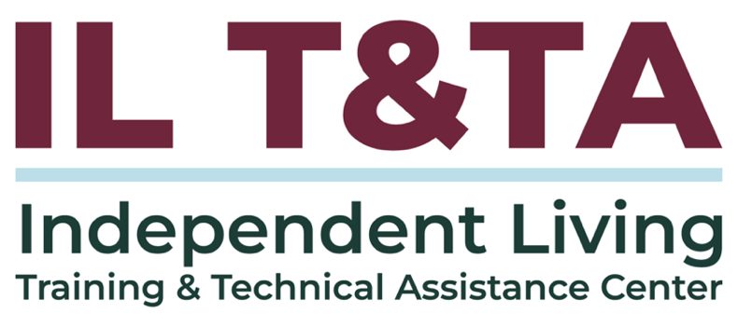

Before We Begin
ASL & Spanish Interpreters are available and labeled.
Access Closed Captioning by clicking the CC button located at the bottom of your Zoom window.
Use Zoom's Raise Hand or Chat features to ask questions.
Remember to state your name and organization before speaking.
Message our IL T&TA team using the Chat feature if you have difficulties with today's call.
Please complete the survey at the end of today's training.

Today’s Agenda –
Key Takeaways:
- Clarify what the executive director does, what the board/council chair does, and the role of the full board/council.
- Apply Independent Living Philosophy in the composition and work of the SILC Board/Council.
- Provide SILC board members with the information they need to meet their responsibilities for overseeing the work of the SILC, but not overstepping.
Overall Goal:
Let's learn with and from each other!

Presenters & Facilitators
Sandra Breitengross Bitter
Director of Independent Living Training and Technical Center (ILT&TA)
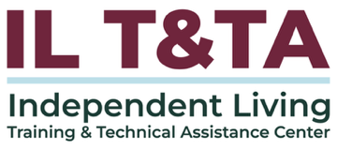

Paula McElwee
Director of Technical Assistance of Independent Living Training and Technical Center (ILT&TA)

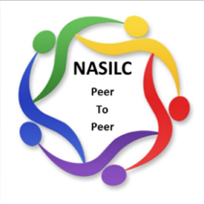
Facilitated by:
Brooke Wilson
Chair- NASILC (National Association of State Independent Living Councils)

Challenges for State Independent Living Council (SILC) Boards
- Understanding and promoting the Independent Living (IL) philosophy
- Hiring and supervising the Executive Director
- Legal responsibilities
- Financial management responsibilities

Would you agree?

The Independent Living (IL) Philosophy: Your Mission & Beyond
- Embody and put into practice consumer control - in your governance, in your day-to-day operations, and in your interactions in the community.
- In the case of the SILC, your council must be made up of a majority (51% or more) of members who have a disability, but do not work for either a CIL or the state.
- This assures that it isn't run by professionals, but by consumers who are living day-to-day life outside a CIL.
- You operate based on your SPIL, which should give evidence of advocacy and system change so that your state is responsive to the IL Philosophy in all its operations.

Highlights from the Story of IL
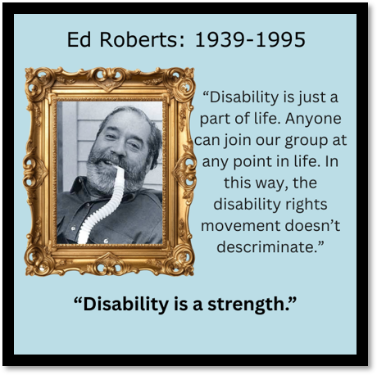
The IL movement beginnings: late ‘60s, early ’70’s
Conceptualized by Ed Roberts of Berkeley CA as a moral imperative, NOT a social services model.
A few centers predated funding through the Rehab Act, like the ones in Berkeley CA or Atlantis in CO.
Do you know of others?
Highlights from the Story of IL (cont.)
- People with disabilities need to be able to exert control over their own lives and decisions affecting their lives.
- Centers were developed in the early 80s and into the 90s as new funds became available through the states and through the Rehabilitation Act. There has been little recent expansion of the number of CILs.

The Rehabilitation Act

Purpose of Title VII (7) of the Act is to:
Promote a philosophy of independent living (IL) –
- Consumer Control
- Self-Help
- Equal Access
- Peer Support
- Self-Determination
- Individual and Systems Advocacy
in order to maximize the:
Leadership, empowerment, independence, and productivity of individuals with disabilities, and to promote the integration and full inclusion of individuals with disabilities into the mainstream of American society...

By funding the SILC and the CILs...
These principles bring us together:
- Consumer control
- Peer support
- Self-help and self-determination
- Equal access Individual and system advocacy
- Maximizing leadership, empowerment, independence, and productivity of individuals with disabilities
- Integration and full inclusion of individuals with disabilities into the mainstream of American society

Promoting and Implementing the IL Philosophy:
Your Mission & Beyond
Ensure mission and the resulting State Plan for Independent Living upholds the rights of individuals with disabilities to be fully and meaningfully engaged members of their communities.
IL is NOT about:
- Charity
- Saviorism
- Serving or helping the “needy,” “vulnerable,” “folks with special needs,” or the “voiceless.”
IL IS about:
- Empowering peers to lead and control their lives.

What are Your Legal Responsibilities?
- Criminal accountability of boards
- Civil accountability of boards
- Individual board member accountability/responsibility
- Risk Management
- Insurance

Legal Responsibilities of the Board & Board Members
- Board / Council Members = Mission Fulfillment & Organizational Integrity
  - Duty of Care
  - Duty of Loyalty
  - Duty of Obedience
- Executive Director / Other Staff = Day to Day Operations

Duty of Obedience
- Board members must be true to the mission of the SILC.
- Board members must not act in a manner that is inconsistent to the mission.
- Board members must act in observance of the local, state and federal laws and regulations that apply.

Duty of Loyalty
- This includes the principle that the board members will make all decisions without personal conflict of interest.
A failure to meet a duty of loyalty may result in payment of restitution.

Duty of Care
- Ensuring no foreseeable physical harm because of its work.
- Make reasonable decisions based on facts that will ensure there is no negligence on the part of the organization.
- Overseeing financial accountability to ensure that the public funds received are treated with care.
In order to perform your “Duty of Care” you need to understand a few things about federal funding...

Federal Regulations Regarding Finances
- Regulations are found in "Uniform Guidance or 2 CFR 200".
- These regulations outline the allowability of federal spending.
- Costs must be necessary and reasonable.
- Some costs are specifically not allowed under any circumstances (such as alcohol, bad debts or fines, most food).
- Costs must be treated consistently – you can’t charge it to one program this month and a different one next month, if you have more than one funding source or program.
- As a board you will want a financial review or audit annually to assure funds are spent as you believe they were. Auditors are secured by and report to the council/board.

Board Oversight & Responsibilities

Because the majority of board members have a significant disability you have disability input into these areas, but you may also want to solicit input from the disability community, especially into planning for the future.

Role of Executive Committee vs. Executive Session
- Any role other than the role of the full council must be described in policy and procedure.
- Because of the open meeting requirements, the executive committee cannot operate independent of the council as a whole.
- An “executive session” is defined in your state’s open meeting law, but typically can allow closed meetings only for the discussion of a personnel or legal item. The decision made there must be carried forward to the open meeting and voted on in open session.
- IT IS NOT THE SAME AS THE EXECUTIVE COMMITTEE! Your state may require that committee meetings are also open, including your officers or executive committee.

The Council May Delegate Specific Duties to the Chair
- Drafting the agenda with the Executive Director or other staff
- Reviewing monthly financial statements in between quarterly SILC meetings.
- Approving certain types or amounts of expenditures.

- Approving the time documents of the ED.
- Evaluating the performance of the ED in a one-to-one meeting.

Hiring / Supervising the Executive Director
Important Reminders for Recruiting and Hiring
- The Independent Living Movement is a disability-led movement created by us (individuals with significant disabilities) for us (individuals with significant disabilities).
- While there are no requirements that you hire a SILC director who has a disability, think about this –
  - Disability representation in SILC executive leadership roles is crucial. You are allowed to require that the SILC hire staff who have a disability.

Hiring / Supervising the Executive Director (cont.)
  - The lived experience of parents, caregivers, guardians, siblings, advocates/allies, service providers, etc. with children, loved ones, and/or clients with disabilities does NOT equate to the lived experience of individuals with disabilities.
  - You are required to evaluate the performance of the Executive Director.
- Hire someone who supports your mission and truly understands/embraces the IL Philosophy.
- Know your challenges and recruit someone with the capacity and expertise to find solutions.

Hiring / Supervising the Executive Director (cont.)
- Review the position description and make sure it reflects what you want at this point in time. (Yes, your challenges may evolve and change.)
- Determine the job duties/responsibilities and equitable pay/ compensation for the ED member.
- Advertise within the IL movement. (Your membership organizations will assist with this, as will the T & TA Center.)
- Review the performance of the ED annually. (Typically, this is done by the chair or a committee of the council, not the full council, just to ensure open dialogue.)

Financial / Fiscal Responsibilities
- Development or resource plan in the SPIL
- Annual budget process
- Accounting and auditing guidelines
- Allowability of costs
- Bank reconciliation
- Cash management
- Code of ethics including conflict of interest

Financial / Fiscal Responsibilities (cont.)
Your policies and procedures should address:
- What financial statements or reporting the council/board wants to see (often this comes from the DSE for the larger Part B grants, from your ED for the direct expenses of the SILC)
- Expenditure limits for staff (when is board prior approval required?)
- Internal controls (separation of duties)
- Inventory controls
- Procurement – processes and approvals
- Payroll and time/effort reporting
- Travel and operational expenses of ED

Conflicts of Interest
Board members and employees should avoid any activity, investment, or association that might interfere with or conflict with their judgment or duties.
- Conflicts of interest must be disclosed as soon as possible.
- Members should immediately disqualify themselves prior to discussion or voting on any matters where there is or even a possibility of a conflict of interest.
- The policies and code of ethics should state that members must reveal the conflict as soon as possible and refrain from voting, discussing, or making decisions related to the conflict.

Nepotism
- The council should not hire a family member of a board member.
- If a family member applies, we suggest the council member should resign before the individual can be considered.

Codes of Ethical Conduct
Your policies should include a code of ethics and standards of professional conduct for both your staff and council members. Standards expected could include:
- Acting professionally, competently and honorably.
- Fulfilling assigned duties.
- Complying with standards established in performance appraisals.
- Maintaining an acceptable level of performance and conduct on all verbal and written job duties.
- Using funds prudently.
- Reporting conditions and circumstances that may prevent the member from performing their duties effectively and safely.

The good, the bad, and the ugly!

When You're on the WRONG Track!
- Tokenism in board recruitment and composition.
- Failure to provide members with meaningful training so they understand and accomplish their role.
- Lack of consumer control (out of disability composition compliance).
- Council failing to receive and/or understand financial statements.
- Financial statements not connected back to the SPIL resource plan and the required spending

When You're on the WRONG Track! (cont.)
- Lack of consumer control (out of disability composition compliance).
- Member taking a public position criticizing the organization.
- Violating policies regarding discrimination and sexual harassment or other forms of harassment.

When You're on the RIGHT Track!
- Diverse, inclusive, and equitable board composition beyond the minimum required standards – reflective of voices and lived experience of most marginalized, representative of diverse experiences in your service area.
- Respects / adheres to the delineation of duties regarding the Executive Director and additional staff conducting day-to-day operations.
- High level of meaningful engagement by individuals with disabilities in SILC efforts, especially in the development of the SPIL.

When You're on the RIGHT Track! (cont.)
- Strong Code of Conduct/Ethics (including sound conflict of interest policy/procedures).
- Robust succession planning for board members as well as the ED.
- The board knows what is happening at the high level of how public meetings occur, what the overall financial status is, and the role of the partners in accomplishing the SPIL.
- Term limits with a required year off periodically to ensure fresh ideas and representation on the board.

Learn & Share: Your Experience Matters
Recording has stopped – now it’s time to share.
Ways to Engage:
- Raise your hand to be spotlighted to speak
- Turn on your camera if you're comfortable
- Use the chat to share insights, questions, resources, or tools
- React, reflect, or build on what others say
- Share real challenges or successes from your CIL
Let’s turn ideas into action — your voice is the most valuable part of this session.

Evaluation
Thank you for participating in today's Learn and Share.
Your feedback is important and helps us plan future training.
Please use the link in the chat to share your feedback.
Evaluation Link:


How to Connect with Us!
Website: https://ilttacenter.org/
Request training and / or technical assistance (expert help for your organization): fill out a form on our website to let us know how we can help.
Call: 406-243-5300 and someone will get back to you as soon as we can.

Sign-Up for Events & Announcements:
Visit our website to sign up for updates about live training, group technical assistance, new publications, and other happenings around the Center.

IL T&TA Center Attribution

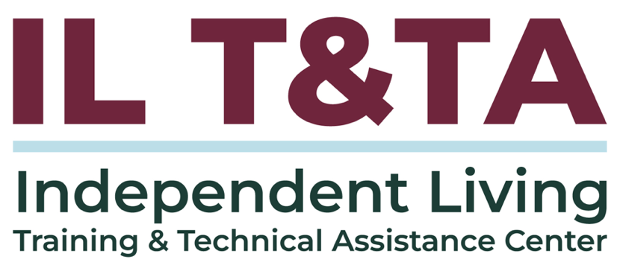
This project is on assignment through contract with the Administration on Disabilities, Administration for Community Living, Health and Human Services.

About the IL T& TA Center
The Independent Living Training and Technical Assistance Center (IL T&TA Center) is available to you through a contract with the US Department of Health and Human Services.
The IL T&TA Center provides expert training and technical assistance to CILs, SILCs, and DSEs.
The Center is operated by the University of Montana's Rural Institute for Inclusive Communities.
