Good Governance – Building Highly Effective Boards
December 10, 2025

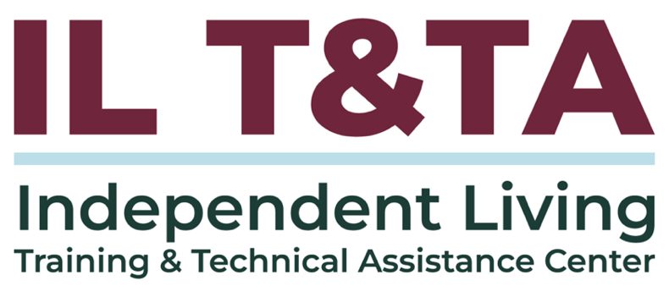

Before We Begin
ASL & Spanish Interpreters are available and labeled.
Access Closed Captioning by clicking the CC button located at the bottom of your Zoom window.
Use Zoom's Raise Hand or Chat features to ask questions.
Remember to state your name and organization before speaking.
Message our IL T&TA team using the Chat feature if you have difficulties with today's call.
Please complete the survey at the end of today's training.

Cohort Learning Objectives –

Week One:
- Define the roles of the Executive Director, Board Chair, and Board of Directors.
- Understand how roles interrelate in practice to foster effective leadership.

Week Two (Today):
- Apply the Independent Living Philosophy in board composition and decision making.
- Understand CIL standards and assurances.

Week Three:
- Understand board responsibilities for strategic planning, financial oversight, and organizational accountability.
- Apply tools and resources to enhance governance and oversight.

Small Cohort Facilitator
Tyler Lasher Morris, MBA, CPTM
Director of Training Independent Living Training & Technical Assistance Center (IL T&TA)
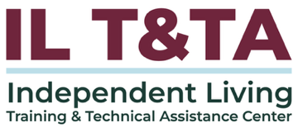

Cohort Overview:
- Dates: December 3, December 10, December 17, 2025
- Format: Weekly 90-minute Zoom sessions (60 minutes instruction + 30 minutes peer learning)
- Audience: Board Chairs, Board Members, Executive Directors, and Leadership
- Style: Interaction, Peer-Driven, Conversation

Overall Norms:
- Participation and Presence
- Learning Together
- Respect and Inclusion
- Confidentiality and Trust
Time and Structure

Learning Objectives – Week Two:

Building Consumer-Driven Boards
- Apply the Independent Living Philosophy in board composition and decision making
- Understand CIL standards and assurances
Leadership is not about making all the decisions. It’s about creating the conditions where the best decisions can be made.
– Unknown

The IL Philosophy in Governance

Centering Decision-Making, Policy and Oversight
Independent Living (IL) Philosophy believes that:
- Individuals with disabilities are the best experts of their own needs
- Individuals should be empowered to make their own decisions
- Individuals deserve the dignity of risk and to learn from their life experiences
- Our communities should be welcoming and accessible of all disabilities

The IL Philosophy in Governance (cont.)

Centering Decision-Making, Policy and Oversight
The Independent Living Movement was founded on the Philosophy and built into the structure of how every single
Center for Independent Living (CIL) is designed, operated, and governed.
The IL Philosophy should be embedded in everything about your CIL, from job descriptions and interview questions, to how daily decisions are made, to the long-term planning decisions, and how you interact and work with consumers and each other.
Advancing the IL Movement
History, Responsibility, and Vision for the Future
CIL boards are different from typical non-profit organizations because they must be consumer-controlled, with the majority of board members who are people with significant disabilities¹.
Overall, the organization is designed and operated within a local community by individuals with disabilities.
Centers must make sure that the philosophy of independent living is carried over into center operations. CILs were established to confront and replace paternalistic or controlling service providers.
Advancing the IL Movement (cont.)
History, Responsibility, and Vision for the Future
The board is responsible for ensuring that the center does not become just another social service agency.
¹Significant Disability: means an individual with a severe physical or mental impairment whose ability to function independently in the family or community or whose ability to obtain, maintain, or advance in employment is substantially limited and for whom the delivery of independent living services will improve the ability to function, continue functioning, or move toward functioning independently in the family or community or to continue in employment, respectively.

The Rehabilitation Act

Why is it important to my role?
The Rehabilitation Act is the legal foundation for everything a CIL does. For board members, the Rehab Act – especially Title VII (7) – isn’t just helpful, it’s essential.
- It defines your legal and ethical responsibilities
The act outlines the standards and assurances your organization must follow to receive federal funding. As a board member, you’re legal responsible for ensure those requirements are met – including oversight of consumer control, service delivery, financial integrity, and staff leadership.

The Rehabilitation Act (cont.)

Why is it important to my role?
- It protects the mission of Independent Living
The act ensures that CILs are run by and for people with disabilities. Knowing it helps you uphold the values of consumer control, peer leadership, and self-determination, and push back if decisions ever drift away from those principles.
- It strengthens your role as a governance leader
Board members are not just advisors – they are accountable stewards of the organization’s compliance, mission, and effectiveness.

The Rehabilitation Act (cont.)

Why is it important to my role?
A working knowledge of the Rehab Act empowers you to ask the right questions, shape the right policies, and partner confidently with the Executive Director.

The Rehabilitation Act

Highlighted Sections to Guide CIL Governance
The Rehabilitation Act of 1973, as Amended
Title VII – Independent Living Services and Centers for Independent Living
- Chapter 1 – Individuals with Significant Disabilities
  - Part A – General Provisions
    - Sections 701 will define IL Philosophy, and
    - Section 702 will define Consumer Control
  - Part B – Independent Living Services
  - Part C – Centers for Independent Living
    - Section 725 will provide definitions of (b) Standards and (c) Assurances

Definition: Independent Living Philosophy
Rehabilitation Act of 1973
Title VII (7). Chapter 1. Part A. Section 701. Purpose.
The purpose of this chapter is to promote philosophy of IL, including a philosophy of consumer control, peer support, self-help, self-determination, equal access, and individual and system advocacy, in order to maximize the leadership, empowerment, independence, and productivity of individuals with disabilities, and the integration and full inclusion of individuals with disabilities into the mainstream of American society, by…

Definition: Consumer Control
Rehabilitation Act of 1973
Title VII (7). Chapter 1. Part A. Section 702. (3) Consumer Control
The term “consumer control” means, with respect to a CIL, that the center vest power and authority in individuals with disabilities, in terms of the management, staffing, decision making, operation, and provision of services.

Standards and Assurances for Independent Living

Section 725 (b) and (c)
In General. - Each center for independent living that receives assistance under this subpart shall comply with the standards set out in subsection (b) and provide and comply with the assurances set out in subsection (c) in order to ensure that all programs and activities under this subpart are planned, conducted, administered, and evaluated in a manner consistent with the purposes of this part and the objective of providing assistance effectively and efficiently.

Overview: CIL Standards
CIL Standards – found in the Rehab Act, Section 725(b):
- Standards are the required core principles and practices that federally funded CIL must meet.
- They define what a CIL is and how it must function to emobody the IL Philosophy.
- In short: Standards are the foundation for how CILs operate – ensure they are consumer -controlled, provide core services, promote self-determination, and reflect the values of the disability rights movement.

Overview: CIL Assurances
CIL Assurances – Found in the Rehab Act, Section 725(c):
- Assurances are the commitments that a CIL makes to the federal government to show it will meet the standards.
- They outline the procedures, safeguards, and planning a CIL agrees to follow to ensure accountability and effectiveness.
- In short: Assurances are the promises a CIL makes about how it will operate – such as involving consumers in decisions, submitting reports, and complying with federal regulations.

7 CIL Standards: An Abbreviated Summary of 725(b)
- Philosophy – The CIL must promote and practice the independent living philosophy.
- Provision of Services – The CIL must help people with all kinds of disabilities.
- IL Goals – The CIL must support people with disabilities in setting and reaching their personal goals.
- Community Options – The CIL must work to create more and better choices for independent living.
- IL Core Services – The must CIL provides core services.

7 CIL Standards: An Abbreviated Summary of 725(b) (cont.)
- Activities to Increase Community Capacity – The CIL must help communities become better at meeting the needs of people with disabilities, making services and opportunities more accessible.
- Resource Development Activities – The CIL must find funding from different sources to support its programs, beyond just government funding

14 CIL Assurances of 725 (c)
- the applicant is an eligible agency;
- the center will be designed and operated within local communities by individuals with disabilities, including an assurance that the center will have a Board that is the principal governing body of the center and a majority of which shall be composed of individuals with significant disabilities;
- the applicant will comply with the standards set forth in subsection (b);
- the applicant will establish clear priorities through annual and 3-year program and financial planning objectives for the center, including overall goals or a mission for the center, a work plan for achieving

14 CIL Assurances of 725 (c)(cont.)
the goals or mission, specific objectives, service priorities, and types of services to be provided, and a description that shall demonstrate how the proposed activities of the applicant are consistent with the most recent 3-year State plan under section 704;
- the applicant will use sound organizational and personnel assignment practices, including taking affirmative action to employ and advance in employment qualified individuals with significant disabilities on the same terms and conditions required with respect to the employment of individuals with disabilities under section 503;

14 CIL Assurances of 725 (c) (cont.)
- the applicant will ensure that the majority of the staff, and individuals in decision making positions, of the applicant are individuals with disabilities;
- the applicant will practice sound fiscal management;
- the applicant will conduct annual self-evaluations, prepare an annual report, and maintain records adequate to measure performance with respect to the standards, containing information regarding, at a minimum—
  - the extent to which the center is in compliance with the standards;

14 CIL Assurances of 725 (c) (cont.)
  - the number and types of individuals with significant disabilities receiving services through the center;
  - the types of services provided through the center and the number of individuals with significant disabilities receiving each type of service;
  - the sources and amounts of funding for the operation of the center;
  - the number of individuals with significant disabilities who are employed by, and the number who are in management and decision-making positions in, the center; and
  - a comparison, when appropriate, of the activities of the center in prior

14 CIL Assurances of 725 (c) (cont.)
years with the activities of the center in the most recent year;
- individuals with significant disabilities who are seeking or receiving services at the center will be notified by the center of the existence of, the availability of, and how to contact, the client assistance program;
- aggressive outreach regarding services provided through the center will be conducted in an effort to reach populations of individuals with significant disabilities that are unserved or underserved by programs under this title, especially minority groups and urban and rural populations;

14 CIL Assurances of 725 (c) (cont.)
- staff at centers for independent living will receive training on how to serve such unserved and underserved populations,
including minority groups and urban and rural populations;
- the center will submit to the Statewide Independent Living Council a copy of its approved grant application and the annual report required under paragraph (8);
- the center will prepare and submit a report to the designated State unit or the Administrator, as the case may be, at the end of each fiscal year that contains the information described in paragraph (8) and information regarding the extent to

14 CIL Assurances of 725 (c) (cont.)
which the center is in compliance with the standards set forth in subsection (b); and
- an independent living plan described in section 704(e) will be developed unless the individual who would receive services under the plan signs a waiver stating that such a plan is unnecessary.

What is Informed Decision Making?
Informed decision making, is a process of making a thoughtful, well-informed choice based on facts and information. It involves analyzing potential outcomes, benefits, and risks before deciding on the best option.
Informed decision making is not just a vote – it’s a collaborative, reflective process that strengthens efficiency and effectiveness.

What informed decision making is NOT:
- Making decisions that are not disability-led
- Rushing votes without discussion
- Acting on assumptions or personal opinion alone

What is Informed Decision Making? (cont.)
- Letting one person (like the ED or Board Chair) make all decisions
- Ignoring the IL philosophy

How IL Philosophy Shapes Informed Decision Making
“Nothing About Us, Without Us”
The Independent Living Philosophy is more than a mission – it’s a mindset that shapes how board members lead and decide. It centers self-determination, consumer control, dignity, and inclusion.
Consumer voice is not symbolic – it’s central to every decision.
The board cannot delegate the responsibility of adhering to the IL Philosophy.
How IL Philosophy Shapes Informed Decision Making (cont.)

Remember, the board ensures:
- People with disabilities are leading the development of services and setting priorities, not just offering feedback.
- Programs are responsive to the needs of people with disabilities
- Staff and leadership reflect the cross-disability community
- Policies preserve independence, dignity, and choice
- Lived experience shapes services and priorities

Key Inputs for Informed Decision Making
- Lived Expertise and Consumer Voice
- Mission and Strategic Alignment
- Program and Service Data
- Staff Recommendations
- Community Needs and Demographics
- Financial Impact
- Legal and Regulatory Considerations
- Board Knowledge and Collective Expertise
- Stakeholder Feedback
Reflection Note
What inputs are critical to your decision making as a board member?

Informed Decision Making: Questions Asked by Highly Effective Boards
Highly effective boards | by asking questions like
Keep the “Why” front and center | Is this decision advancing self-determination and community integration?
Prioritize lived expertise | What do consumers say about this? Have they shaped this plan?
Use the Right Inputs at the Right Moments | What do we need to know to make the best possible decision in this case?
Know the Line Between Oversight  and Operations | Is this a board-level decision? Are we guiding the mission – or managing the staff?
Ask Critical Questions | Who benefits? Who may be left out? Are we unintentionally reinforcing ableism?
Create Space for Deliberation | Are there perspectives we haven’t heard?
Reflect on the Decision | Did it go as planned? Was it the right call? What did we learn?

In Practice Example Steps for Informed Decision Making
Step 1: Program Development Committee Reviews the Proposal
Step 2: Board Chair Prepares for the Full Board Meeting
Step 3: Full Board Reviews & Votes
Step 4: ED Implements & Reports Back
In this example, the committee vets the idea deeply without overstepping its role. The ED informs, not decides. The Board Chair ensures process and structure. The Board of Directors holds the strategic authority, not operational control.

Scenario One
Your CIL is exploring the launch of a fee-for-service program that provides accessibility audits to local businesses. This could generate income and advance the mission – but it involves staff time, budget decisions, and potential mission drift if not handled well.

Scenario Two
Your board has 51% people with disabilities, but one member notes that most board conversations are driven by members without disabilities. Members with lived experience are rarely asked for input or offered leadership roles on committees.

Scenario Three
The ED presents a plan to launch a new housing navigation service. The program looks promising, but there was no consumer input during development, and one staff member privately shared concerns it may “overstep into social work territory.”


Questions for Discussion
- Where do you see the IL philosophy guiding decisions in your board's recent work? Where is it missing?
- How does your board ensure that consumer control is more than just a checkbox?
- In what ways are people with disabilities leading – not just involved – in your organization's direction-setting?
- What types of information do you rely on to make thoughtful board decisions? How do you know it's enough?

Questions for Discussion (cont.)
- Can you recall a time when a board decision was rushed or made without consumer input? What might you do differently now?
- How do you balance the urgency of funding or partnerships with your organization?
- How do you know if a board decision has upheld – or undermined – the IL philosophy? What's your feedback loop?
- In what ways does your board’s decision-making reflect true consumer control and self-direction? Where is there room for deeper alignment?

Resources for Additional Guidance:
Board Governance of Centers for Independent Living. Independent Living Research Utilization (ILRU)

Coming Up Next – Week 3: Strengthening Accountability & Strategic Oversight on December 17, 2025!

Your Experience Matters
Recording has stopped – now it’s time to share.
Ways to Engage:
- Raise your hand to be spotlighted to speak
- Turn on your camera if you're comfortable
- Use the chat to share insights, questions, resources, or tools
- React, reflect, or build on what others say
- Share real challenges or successes from your CIL
Let’s turn ideas into action — your voice is the most valuable part of this session.

Evaluation
Thank you for participating in today's Learn and Share.
Your feedback is important and helps us plan future training.
Please use the link in the chat to share your feedback.
Evaluation Link:


How to Connect with Us!

Website: www.ILTTACenter.org
Request training and / or technical assistance (expert help for your organization): fill out a form on our website to let us know how we can help.
Call: 406-243-5300 and someone will get back to you as soon as we can.
Sign-Up for Events & Announcements:

Visit our website to sign up for updates about live training, group technical assistance, new publications, and other happenings around the Center.

IL T&TA Center Attribution

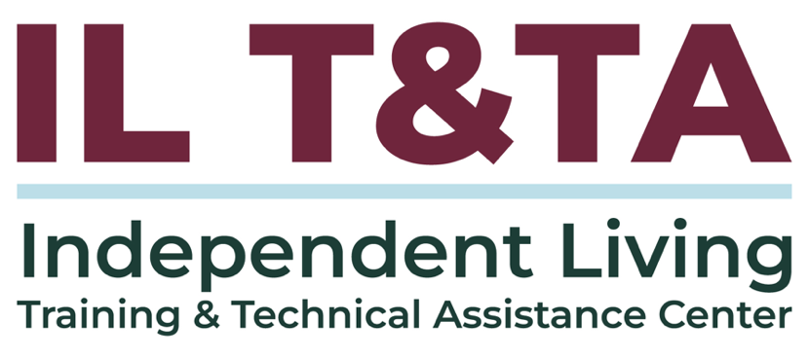
This project is on assignment through contract with the Administration on Disabilities, Administration for Community Living, Health and Human Services.

About the IL T& TA Center
The Independent Living Training and Technical Assistance Center (IL T&TA Center) is available to you through a contract with the US Department of Health and Human Services.
The IL T&TA Center provides expert training and technical assistance to CILs, SILCs, and DSEs.
The Center is operated by the University of Montana's Rural Institute for Inclusive Communities.


