Ask Anything

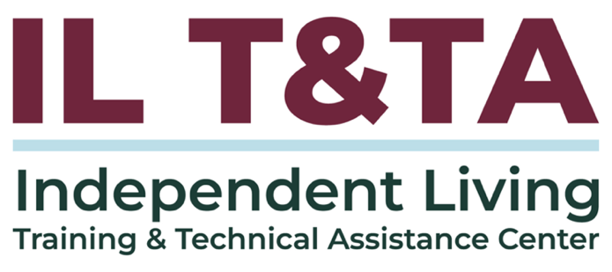

Before We Begin
ASL & Spanish Interpreters are available and labeled.
Access Closed Captioning by clicking the CC button located at the bottom of your Zoom window.
Use Zoom's Raise Hand or Chat features to ask questions.
Use the Q&A box to send us your questions at any time.
Remember to state your name and organization before speaking.
Message our IL T&TA team using the Chat feature if you have difficulties with today's call.
Please complete the survey at the end of today's training.

Your Experience Matters
Recording has stopped – now it’s time to share.
Ways to Engage:
- Raise your hand to be spotlighted to speak
- Turn on your camera if you're comfortable
- Use the chat to share insights, questions, resources, or tools
- React, reflect, or build on what others say
- Share real challenges or successes from your CIL
Let’s turn ideas into action — your voice is the most valuable part of this session.

Evaluation
Thank you for participating in today's Learn and Share.
Your feedback is important and helps us plan future training.
Please use the link in the chat to share your feedback.
Evaluation Link:
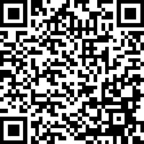

How to Connect with Us!

Website: www.ILTTACenter.org
Request training and / or technical assistance (expert help for your organization): fill out a form on our website to let us know how we can help.
Call: 406-243-5300 and someone will get back to you as soon as we can.
Sign-Up for Events & Announcements:
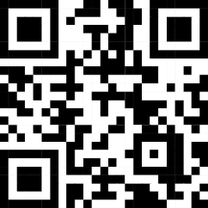
Visit our website to sign up for updates about live training, group technical assistance, new publications, and other happenings around the Center.

IL T&TA Center Attribution

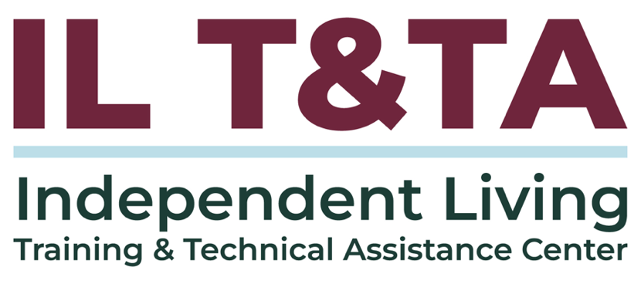
This project is on assignment through contract with the Administration on Disabilities, Administration for Community Living, Health and Human Services.

About the IL T& TA Center
The Independent Living Training and Technical Assistance Center (IL T&TA Center) is available to you through a contract with the US Department of Health and Human Services.
The IL T&TA Center provides expert training and technical assistance to CILs, SILCs, and DSEs.
The Center is operated by the University of Montana's Rural Institute for Inclusive Communities.
