Good Governance – Building Highly Effective Boards
December 17, 2025

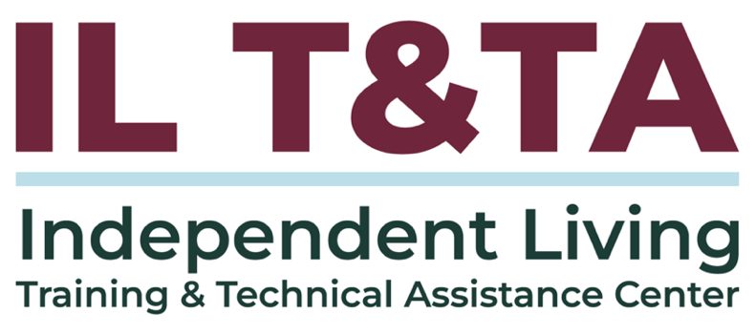

Before We Begin
ASL & Spanish Interpreters are available and labeled.
Access Closed Captioning by clicking the CC button located at the bottom of your Zoom window.
Use Zoom's Raise Hand or Chat features to ask questions.
Remember to state your name and organization before speaking.
Message our IL T&TA team using the Chat feature if you have difficulties with today's call.
Please complete the survey at the end of today's training.

Cohort Learning Objectives –

Week One:
- Define the roles of the Executive Director, Board Chair, and Board of Directors.
- Understand how roles interrelate in practice to foster effective leadership.

Week Two:
- Apply the Independent Living Philosophy in board composition and decision making.
- Understand CIL standards and assurances.

Week Three (Today):
- Understand board responsibilities for strategic planning, financial oversight, and organizational accountability.
- Apply tools and resources to enhance governance and oversight.

Small Cohort Facilitator
Tyler Lasher Morris, MBA
Director of Training Independent Living Training & Technical Assistance Center (IL T&TA)
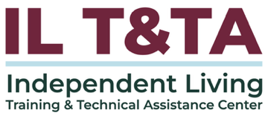

Cohort Overview:
- Dates: December 3, December 10, December 17, 2025
- Format: Weekly 90-minute Zoom sessions (60 minutes instruction + 30 minutes peer learning)
- Audience: Board Chairs, Board Members, Executive Directors, and Leadership
- Style: Interaction, Peer-Driven, Conversation

Overall Norms:
- Participation and Presence
- Learning Together
- Respect and Inclusion
- Confidentiality and Trust
- Time and Structure

Learning Objectives – Week Three:

Strengthening Accountability & Strategic Oversight

- Understand board responsibilities for strategic planning, financial oversight, and organizational accountability
- Apply tools and resources to enhance governance and oversight
Leadership is not about being in charge. it is about taking care of those in your charge.
– Simon Sinek

Board Ethics: The Big 3

Duty of Care, Loyalty, and Obedience
Duty of Care – mandates that board members must act with the level of diligence and sound judgement that a reasonably careful person would exercise under similar circumstances.
- Examples: Attending meetings regularly, Reviewing materials in advance of meetings, Asking thoughtful questions
Duty of Loyalty – requires board members to prioritize the interest of the CIL and its consumers above their own personal interests.
- Examples: Avoiding and disclose conflicts of interest, Maintaining confidentiality, Refraining from self-dealing.

Board Ethics: The Big 3 (cont.)
Duty of Obedience – obligates board members to ensure the organization follows its mission, complies with laws and regulations, and adheres to its governing documents.
- Examples: Upholding the IL Philosophy and federal requirements and Following bylaws, strategic plans, and funding conditions

What is My Role in Strategic Planning ?
- Set direction aligned with the Independent Living philosophy and community priorities
- Participate actively in visioning and planning discussions
- Ensure goals are mission-driven and reflect consumer needs and voices
- Approve the final plan and monitor progress toward outcomes

- Support accountability by asking questions and evaluating implementation over time
- Champion the plan publicly to reinforce purpose and build trust
What is My Role in Fiscal Oversight?
- Review and approve budgets to ensure alignment with mission and goals.
- Monitor financial reports (e.g., income/expense statements, balance sheets) at regular meetings.
- Understand major funding sources (e.g., federal grants, match requirements, program income).
- Ask informed questions about spending, sustainability, and risks.
- Ensure proper controls are in place to prevent fraud, waste, or abuse.

What is My Role in Fiscal Oversight? (cont.)

- Support transparency with staff, funders, and the community.
- Guarantee costs are necessary, reasonable, allowable, and treated with consistency.
Uniform Administrative Requirements, Cost Principles, and Audit Requirements for Federal Awards can be found in 2 CFR 200

What is My Role in
Organizational Accountability?
- Monitor progress toward goals outlined in the work plan, strategic plan and State Plan for Independent Living (SPIL).
- Evaluate the Executive Director’s performance regularly and fairly.
- Review and adopt key policies that ensure ethical operations, accessibility, and equity.
- Oversee compliance with federal and state requirements, including standards and assurances.

What is My Role in
Organizational Accountability? (cont.)
- Uphold transparency and integrity in decision-making and communications.
- Foster a culture of consumer control, responsiveness, and continuous improvement.
The Administration for Community Living’s CIL Evaluation Tool

What’s at Stake?
The Consequences of Neglect
When a board member neglects their responsibilities, the consequences can ripple far beyond just one seat at the table.
Here’s what’s truly at stake:
- Legal & Fiduciary Consequences
- Financial & Operational Risk

- Reputational Damage
- Team Morale & Culture
- Mission Drift
- Failure to meet strategic and SPIL goals

Governance Documents
to Assist Board Members
The following slides provide examples of documents that assist leadership in their governance functions. As we explore the intent and application of these documents, use these questions for reflection:

Purpose & Alignment
- What is the core purpose of this document?
- Is it required by policy or regulation, or simply recommended?
- Does it reflect the principles of Independent Living Philosophy and consumer control?
- How does it support our mission, vision, and values?

Governance Documents
to Assist Board Members (cont.)

Impact & Utility
- Does this document enhance efficiency or effectiveness?
- Is it duplicative or could it be streamlined?
- Is the administrative burden justified and within scope?

Ownership & Engagement
- Are roles and responsibilities clearly understood by all involved?
- What level of engagement or oversight is appropriate for me in my role?
- How can it be used to inform my decisions?


Legal & Compliance Documents
to Assist Board Members
- Most recent programmatic performance report including feedback received
- CIL Standards & Assurances
- Articles of incorporation & bylaws
- IRS determination letter & 990
- State nonprofit registration
- Board approved policies (e.g., board agreement, conflict of interest policy, whistleblower policy, accommodation request policy)
- Insurance policies
- Accreditation or licensure documentation (if applicable)

Personnel Documents
to Assist Board Members
- Personnel Policies/ Employee Handbook

- Employee satisfaction surveys
- Professional Employer Organization (PEO) contact information


Financial Documents to Assist Board Members
- Annual budget
- Fiscal policies and procedures (GAAP, Investments, Procurement)
- Most recent financial audit
- Financial statements (e.g., balance sheet, P&L)
- Banking information

Programmatic Documents
to Assist Board Members
- Service delivery manual
- Schedule of Awards
- Consumer satisfaction survey results
- Disability demographics and needs assessments from CIL catchment area
- Internal forms: (e.g., Intake, Independent Living Plans, eligibility determination, Client Assistance Program (CAP), Grievance procedure)

Operational Documents
to Assist Board Members
- Board agendas & minutes

- Standard Operating Procedures (SOP)
- Awards & contracts with contact information
- Partnership MOUs or collaborative agreements

Strategic and Planning Documents
to Assist Board Members
- Strategic Plan

- Annual work plans
- Disability data of catchment area
- Program goals and objectives
- State Plan for Independent Living (SPIL)
- Community needs assessments
- SWOT analysis
- Succession plan (ED, Leadership, Board)

Resource Development Documents to Assist Board Members
- Development plan
- Case for support
- Board pledge
- Annual report
- Schedule of annual resource development activities

Standards of Excellence for
CIL Board Member Engagement
- Show up and come prepared
- Focus on mission, not management
- Respect time and process
- Practice active listening
- Speak with purpose
- Disclose and manage conflicts of interest
- Maintain confidentiality
- Respect the work being done behind the scenes
- Be a team player
- Stay curious and engaged
- Commit to ongoing learning
- Follow through


Critical Components for Conducting a Highly Effective Meeting
- Meetings start and end on time
- Agendas focus on key topics and use time wisely
- Input on agenda items can be provided by any board member
- Materials are shared early and in accessible formats
- Clear language helps everyone follow, including those new to nonprofit or IL terms
- Meetings follow rules of order to stay fair and organized
- Background info is provided for informed decisions

Critical Components for Conducting a Highly Effective Meeting (cont.)
- Reports are accurate, timely, and easy to understand
- Strong facilitation is used to keep discussions focused and balanced
- Board business centers on oversight, strategy, and governance
- Dashboards give clear snapshots of current status
- Action items include names, deadlines, and follow-up
- Decisions are clearly stated and documented
- Questions are encouraged to support understanding—not control

Example Board Meeting Agenda
- Call to Order
- Roll Call & Establishment of Quorum
- Approval of the Agenda *
- Approval of Minutes *
- Reports *
- Unfinished Business *
- New Business *
- Announcements
- Public Comment
- Adjournment *
* May contain items for board vote

Scenario One

Your CIL adopted a 3-year strategic plan last year. At recent board meetings, updates on the plan haven’t been included. The Executive Director has started launching new initiatives that aren’t reflected in the plan, saying “things are moving quickly” and “we need to be responsive.”

Scenario Two
Six months into the fiscal year, the board learns the organization is significantly over budget in several program areas due to unexpected staffing changes and service demand. The Finance Committee hadn’t flagged this, and some members are surprised by the news.

Scenario Three
An anonymous complaint alleges that staff at your CIL feel uncomfortable raising concerns internally, citing a lack of transparency in how leadership decisions are made. The board receives the complaint but isn’t sure how to respond.


Questions for Discussion
- In what ways do I personally contribute to fostering a culture of accountability and trust within my board?
- What beliefs or assumptions do I hold about board service that may need to evolve to better support the CIL’s future?
- What would it look like for our board to lead with transparency, event when it’s uncomfortable?
- What signals – spoken or unspoken – shape how decisions are made or avoided on our board?
- How does your board currently stay informed about your organization’s strategic priorities?

Questions for Discussion (cont.)
- What barriers prevent boards from engaging fully in long-term planning?
- What financial reports does your board review regularly – and do you feel confident reading them?
- On a scale from 1, extremely inefficient, to 10, extremely efficient, I would rate our board meetings as a ____ .
- What one process or practice, if improved, would have the biggest impact on your board’s efficiency?
- How can you help orient new board members to these roles and tools?

Resources for Additional Guidance:
Board Governance of Centers for Independent Living. Independent Living Research Utilization (ILRU)
Center for Independent Living Evaluation Tool. Administration for Community Living
2 CFR 200. Part 200 – Uniform Administrative Requirements, Cost Principles, and Audit Requirements for Federal Awards

Your Experience Matters
Recording has stopped – now it’s time to share.
Ways to Engage:
- Raise your hand to be spotlighted to speak
- Turn on your camera if you're comfortable
- Use the chat to share insights, questions, resources, or tools
- React, reflect, or build on what others say
- Share real challenges or successes from your CIL
Let’s turn ideas into action — your voice is the most valuable part of this session.

Evaluation
Thank you for participating in today's Learn and Share.
Your feedback is important and helps us plan future training.
Please use the link in the chat to share your feedback.
Evaluation Link:
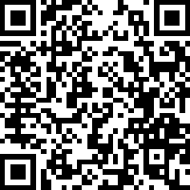

How to Connect with Us!

Website: www.ILTTACenter.org
Request training and / or technical assistance (expert help for your organization): fill out a form on our website to let us know how we can help.
Call: 406-243-5300 and someone will get back to you as soon as we can.
Sign-Up for Events & Announcements:
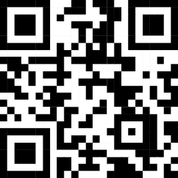
Visit our website to sign up for updates about live training, group technical assistance, new publications, and other happenings around the Center.

IL T&TA Center Attribution

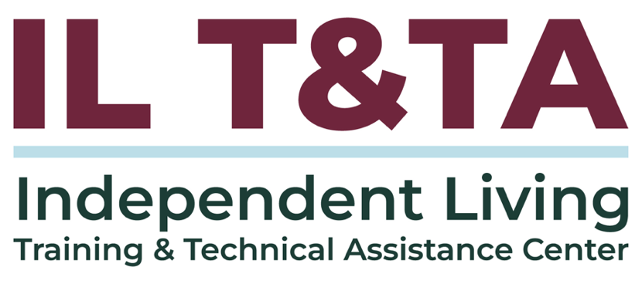
This project is on assignment through contract with the Administration on Disabilities, Administration for Community Living, Health and Human Services.

About the IL T& TA Center
The Independent Living Training and Technical Assistance Center (IL T&TA Center) is available to you through a contract with the US Department of Health and Human Services.
The IL T&TA Center provides expert training and technical assistance to CILs, SILCs, and DSEs.
The Center is operated by the University of Montana's Rural Institute for Inclusive Communities.
