Good Governance – Building Highly Effective Boards
December 3, 2025

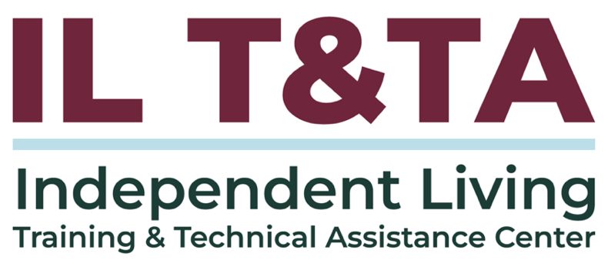

Before We Begin
ASL & Spanish Interpreters are available and labeled.
Access Closed Captioning by clicking the CC button located at the bottom of your Zoom window.
Use Zoom's Raise Hand or Chat features to ask questions.
Use the Q&A box to send us your questions at any time.
Remember to state your name and organization before speaking.
Message our IL T&TA team using the Chat feature if you have difficulties with today's call.
Please complete the survey at the end of today's training.

Cohort Learning Objectives –

Week One (Today):
- Define the roles of the Executive Director, Board Chair, and Board of Directors.
- Understand how roles interrelate in practice to foster effective leadership.

Week Two:
- Apply the Independent Living Philosophy in board composition and decision making.
- Understand CIL standards and assurances.

Week Three:
- Understand board responsibilities for strategic planning, financial oversight, and organizational accountability.
- Apply tools and resources to enhance governance and oversight.

Small Cohort Facilitator
Tyler Lasher Morris, MBA
Director of Training
Independent Living Training & Technical Assistance Center (IL T&TA)

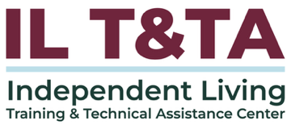

Cohort Overview:
- Dates: December 3, December 10, December 17, 2025
- Format: Weekly 90-minute Zoom sessions (60 minutes instruction + 30 minutes peer learning)
- Audience: Board Chairs, Board Members, Executive Directors, and Leadership
- Style: Interaction, Peer-Driven, Conversation

Cohort Norms:
- Participation and Presence
- Learning Together
- Respect and Inclusion
- Confidentiality and Trust
- Time and Structure
Learning Objectives – Week One:

Defining Leadership: Who Does What
- Define the roles of the Executive Director, Board Chair, and Board of Directors
- Understand how these roles interrelate in practice to foster effective leadership

The function of leadership is to
produce more leaders, not more followers.
– Ralph Nader

Center for Independent Living (CIL)
means a consumer-controlled, community-based, cross-disability, nonresidential, private nonprofit agency for individuals with significant disabilities (regardless of age or income) that –
- designed and operated within a local community by individuals with disabilities;
- provide an array of IL services as defined in Section 7(18) of the Act, including, at minimum, independent living core services as defined in this section; and

Center for Independent Living (CIL) (cont.)
- complies with the standards set out in Section 725(b) and provides and complies with the assurances in Section 725(c) of the Act and the regulations at § 1329.5
- More than 50% of the board of directors (BOD) must be individuals with significant disabilities.
- The board must control decision-making, staffing, operations, and service provision.
Executive Director
Definition and Key Functions
The Executive Director (ED) is the CIL’s chief staff leader, responsible for the day-to-day operations, staff supervision, financial management, and implementing the board’s strategic vision.
The ED acts as a bridge between the board and staff, translating board policy into action and bringing operational insight to board decisions.

Key Functions:
- Leads and manages staff and programs
- Develops and executes the strategic plan
- Oversees budgets and financial reporting

Executive Director (cont.)

Key Functions:
- Serves as spokesperson and liaison to the community
- Partners with the Board Chair to prepare meetings and reports

Board of Directors
Definition and Key Functions
The Board of Directors (BOD) is the governing body ultimately responsible for a nonprofit and has specific legal and ethical responsibilities to the organization. Boards are comprised of different positions: board members, who may be called directors, committee chairs, and officers.¹ In the IL movement, the board must also meet consumer control requirements.

Key Functions:
- Sets mission, vision, and strategic direction
- Approves annual budgets and monitors financial health

Board of Directors (cont.)

Key Functions:
- Hires, evaluates, and supports the Executive Director
- Ensures organizational compliance and public accountability
- Recruits and retains diverse, qualified board members

Board Officers
Definition and Key Functions
Board Chair (or President)
- Responsible for leading the board, serving as the day-to-day supervisor and partner of the Executive Director, and facilitating board meetings
Vice Chair (or Vice President)
- Fills in for the chair when necessary and may also be assigned particular work. This position provides expected succession for the chair.
Board Secretary
- Responsible for keeping or overseeing the keeping of board meeting minutes and the board’s records
Board Officers (cont.)
Definition and Key Functions
Board Treasurer
Oversees all matters related to the organization’s finances and budget, and usually serves as the chair of the finance committee

Board Chair
Definition and Key Functions
The Board Chair is a volunteer leader elected by the Board of Directors to preside over the board meetings and guide the governance process. The Chair works closely with the Executive Director to ensure alignment between governance and operations, while maintaining the board’s independence and accountability.

Key Functions
- Presides over the board and executive committee meetings
- Partners with the ED to set agendas and ensure follow-through

Board Chair (cont.)

Key Functions
- Supports board evaluations and performance oversight
- Serves as a sounding board and advisor to the ED

Board Committees
Definition and Key Functions
Board Committees are small working groups made up of members of the Board of Directors (and occasionally staff or community advisors) that are formed to focus on specific areas of governance, oversight, or strategic need. Committees allow the board to be more efficient, informed, and effective by dividing complex or ongoing tasks into manageable parts.

Key Functions
- Increase focus on key responsibilities like finance, fundraising, or governance

Board Committees (cont.)

Key Functions
- Build expertise by assigning board members to areas where they have skill or interest
- Make recommendations to the full board after deeper exploration
- Strengthen accountability by monitoring progress between full board meetings

Leadership Roles Comparison

Primary Focus
- Executive Director: Day-to-day operations, staff leadership, program implementation.
- Board Chair: Board governance, meeting leadership, partnership with the ED.
- Board of Directors: Mission, strategy, oversight, and accountability.

Leadership Type
- Executive Director: Operational leader (staff role).
- Board Chair: Governance leader (volunteer role).
- Board of Directors: Governing body (volunteer role).

Leadership Roles Comparison (cont.)

Decision-Making Role
- Executive Director: Advises; implements board-approved decisions.
- Board Chair: Facilitates board decision-making; does not act independently.
- Board of Directors: Makes major decisions such as budget approval, strategic plan, and hiring the ED.

Relationship to Staff
- Executive Director: Supervises all staff, including hiring and evaluation.
- Board Chair: No supervisory role over staff (except ED).

Leadership Roles Comparison (cont.)
- Board of Directors: No direct staff supervision (beyond ED evaluation).

Relationship to Board
- Executive Director: Reports to the board; collaborates with the chair.
- Board Chair: Supports and evaluates ED; guides board performance.
- Board of Directors: Hires, supports, and evaluates the ED.

Meeting Responsibilities
- Executive Director: Prepares materials; attends but does not vote.

Leadership Roles Comparison (cont.)
- Board Chair: Presides over board and executive committee meetings.
- Board of Directors: Participates in board and committee meetings.

Strategic Planning
- Executive Director: Executes the strategic plan and reports progress.
- Board Chair: Leads the board in setting strategic direction.
- Board of Directors: Approves and monitors strategic goals.

Leadership Roles Comparison (cont.)

Financial Oversight
- Executive Director: Prepares budget; monitors and reports finances.
- Board Chair: Ensures board reviews budget and financial reports.
- Board of Directors: Develops fiscal policy; ensures internal controls are adequate.

Public Representation
- Executive Director: Often serves as public spokesperson.
- Board Chair: Represents the board as needed in partnership with the ED.

Leadership Roles Comparison (cont.)
- Board of Directors: Champions the mission; some members may speak publicly.

Evaluation Responsibilities
- Executive Director: Evaluated annually by the board.
- Board Chair: Leads evaluation of ED and board effectiveness.
- Board of Directors: Evaluates ED performance, the strategic plan, and conducts board self-assessment.

How Key Leadership Roles Interrelate in Practice
Leadership roles work together – not in isolations – to drive governance, strategic action, and accountability. Effective leadership relies on mutual trust, communication, and clearly defined roles.
- Leadership is shared – no single role governs alone
- Governance leads, operations execute
- The Board Chair and Executive Director are bridges
- Committees strengthen – not replace – the board
- The ED informs decisions, not drives them
- Ongoing communication prevents confusion

Scenario One
The Executive Director has started attending all committee meetings, giving direction to board members, and making final decisions on fundraising plans without board input.
The board meets quarterly with little discussion before decisions.

Scenario Two
The Board Chair has begun meeting directly with staff – without the Executive Director present – to ask about program performance, request reports, and give feedback on operations.
Staff are unsure whether to treat these meetings as directives or informal check-ins. The ED feels bypassed and undermined but is hesitant to address it directly, fearing it will appear defensive or uncooperative.

Example Steps for Correcting Role Confusion

Indicators of a Healthy Board of Directors

Sample Metrics to Evaluate Board Health
Indicator | Sample Metric
Understanding of the Mission and its connection to IL | Can the member share an example of your mission in action and its connection to the Independent Living movement?
Consumer Control | % of members with significant disabilities
Role Understanding | % of members who report confidence in their federal requirements
Attendance | % of members attending meetings
Demographics | Does your board represent your community?
ED performance review | Has the ED been evaluated in the past 12 months?
Buy In | # of members giving at a level meaningful to them
Board Performance | Has the board conducted an annual self-evaluation?
Ongoing Development | # of trainings attended per member per year
Succession | Is there an established pipeline of future board members?

Questions for Discussion
- What’s a strength you bring to your role that you hadn’t named before this session?
- What would you need to feel more confident in your own leadership role?
- Where have you experienced role confusion in your own leadership journey – and how did it feel?
- What would you share with a board member who missed today’s training?
- How do the roles discussed today show up (or blur) in your organization?
- What’s one action you’ll take to strengthen leadership alignment in your CIL?
- What’s one boundary or expectation you could help define or reinforce in your role?

Resources for Additional Guidance:
- Roles and Responsibilities. BoardSource
- Board Governance of Centers for Independent Living. Independent Living Research Utilization (ILRU)

Coming Up Next – Week 2: Building Consumer-Driven Boards on December 10, 2025!

Your Experience Matters
Recording has stopped – now it’s time to share.
Ways to Engage:
- Raise your hand to be spotlighted to speak
- Turn on your camera if you're comfortable
- Use the chat to share insights, questions, resources, or tools
- React, reflect, or build on what others say
- Share real challenges or successes from your CIL
Let’s turn ideas into action — your voice is the most valuable part of this session.

Evaluation
Thank you for participating in today's Learn and Share.
Your feedback is important and helps us plan future training.
Please use the link in the chat to share your feedback.
Evaluation Link:


How to Connect with Us!

Website: www.ILTTACenter.org
Request training and / or technical assistance (expert help for your organization): fill out a form on our website to let us know how we can help.
Call: 406-243-5300 and someone will get back to you as soon as we can.
Sign-Up for Events & Announcements:

Visit our website to sign up for updates about live training, group technical assistance, new publications, and other happenings around the Center.

IL T&TA Center Attribution

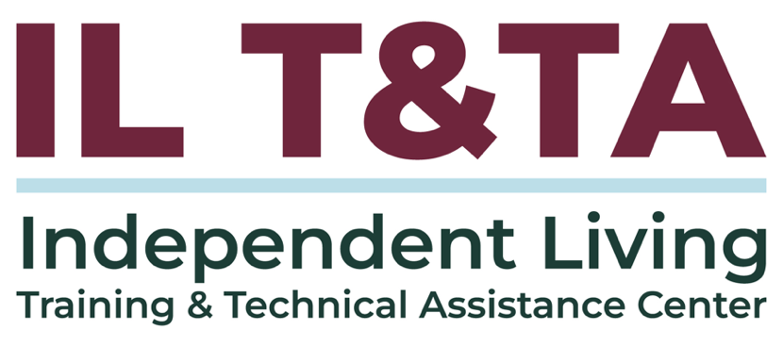
This project is on assignment through contract with the Administration on Disabilities, Administration for Community Living, Health and Human Services.

About the IL T& TA Center
The Independent Living Training and Technical Assistance Center (IL T&TA Center) is available to you through a contract with the US Department of Health and Human Services.
The IL T&TA Center provides expert training and technical assistance to CILs, SILCs, and DSEs.
The Center is operated by the University of Montana's Rural Institute for Inclusive Communities.
