SILC Connection – Council Member Recruitment and Terms
January 20, 2026

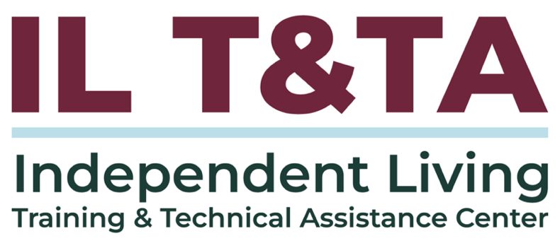

Before We Begin
ASL & Spanish Interpreters are available and labeled.
Access Closed Captioning by clicking the CC button located at the bottom of your Zoom window.
Use Zoom's Raise Hand or Chat features to ask questions.
Use the Q&A box to send us your questions at any time.
Remember to state your name and organization before speaking.
Message our IL T&TA team using the Chat feature if you have difficulties with today's call.
Please complete the survey at the end of today's training.

Today’s Agenda –

Key Takeaways:
- Understand SILC composition and term-limits of SILC members.
- Identify recruitment strategies to strengthen your council.

Overall Goal:
- Let's learn with and from each other!

Presenter

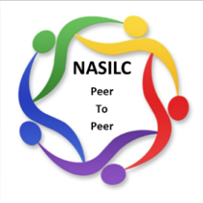
Brooke Wilson
Chair- National Association of State Independent Living Councils (NASILC)


Title VII of the Rehabilitation Act of 1973

Sec. 705 STATEWIDE INDEPENDENT LIVING COUNCIL
- ESTABLISHMENT.—To be eligible to receive financial assistance under this chapter, each State shall establish and maintain a Statewide Independent Living Council (referred to in this section as the ‘Council’).
The Council shall not be established as an entity within a State agency.

Composition and Appointment
(1) APPOINTMENT.—Members of the Council shall be appointed by the Governor or, in the case of a State that, under State law, vests authority for the administration of the activities carried out under this Act in an entity other than the Governor (such as one or more houses of the State legislature or an independent board), the chief officer of that entity. The appointing authority shall select members after soliciting recommendations from representatives of organizations representing a broad range of individuals with disabilities and organizations interested in individuals with disabilities.

COMPOSITION
(2) COMPOSITION.—The Council shall include—
(A) among its voting members, at least 1 director of a center for independent living chosen by the directors of centers for independent living within the State;
(B) among its voting members, for a State in which 1 or more centers for independent living are run by, or in conjunction with, the governing bodies of American Indian tribes located on Federal or State reservations, at least 1 representative of the directors of such centers; and
(C) as ex officio, nonvoting members, a representative of the designated State entity, and representatives from
State agencies that provide services for individuals with disabilities.

ADDITIONAL MEMBERS
(3) ADDITIONAL MEMBERS.—The Council may include—
(A) other representatives from centers for independent living;
(B) individuals with disabilities;
(C) parents and guardians of individuals with disabilities;
(D) advocates of and for individuals with disabilities;
(E) representatives from private businesses;
(F) representatives from organizations that provide services for individuals with disabilities; and
(G) other appropriate individuals.

QUALIFICATIONS
(A) IN GENERAL.—The Council shall be composed of members—
(i) who provide statewide representation;
(ii) who represent a broad range of individuals with disabilities from diverse backgrounds;
(iii) who are knowledgeable about centers for independent living and independent living services; and
(iv) a majority of whom are persons who are—
(I) individuals with disabilities described in
section 7(20)(B); and
(II) not employed by any State agency or center for independent living.

VOTING MEMBERS
(B) VOTING MEMBERS.—A majority of the voting members of the Council shall be—
(i) individuals with disabilities described in section 7(20)(B); and
(ii) not employed by any State agency or center for independent living.

LENGTH OF TERM
(A) LENGTH OF TERM.—Each member of the Council shall serve for a term of 3 years, except that—
(i) a member appointed to fill a vacancy occurring prior to the expiration of the term for which a predecessor was appointed, shall be appointed for the remainder of such term; and
(ii) the terms of service of the members initially appointed shall be (as specified by the appointing authority described in paragraph (3)) for such fewer number of years as will provide for the expiration of terms on a staggered basis.

NUMBER OF TERMS
(B) NUMBER OF TERMS.— No member of the Council, other than a representative described in paragraph (2)(A) if there is only one center for independent living within the State, may serve more than two consecutive full terms.

REAPPOINTMENT
The Act does not specify how long a SILC member must remain off the council after their term expires before they may be reappointed. Often, however, the SILC may be bound by state rules or by their own bylaws that specify such a time period.

Other Considerations

- Number of Council Members
- Term limits apply to ALL members*
- Recruitment and Engagement Strategies

Resources for Additional Guidance
- SILC Indicators and Assurances for the Designated State Entities (ILT&TA)
- Guidebook for SILC Chairpersons, Members, and Administrators (ILRU)
- Publications and Resources for State Independent Living Councils (ILT&TA)

- SILC Operations Videos (IL-NET Archive)

Your Experience Matters
Recording has stopped – now it’s time to share.
Ways to Engage:
- Raise your hand to be spotlighted to speak
- Turn on your camera if you're comfortable
- Use chat for comments and resources; use the Q&A box for your questions.
- React, reflect, or build on what others say
- Share real challenges or successes from your CIL
Let’s turn ideas into action — your voice is the most valuable part of this session.

Evaluation
Thank you for participating in today's SILC Connect.
Your feedback is important and helps us plan future training.
Please use the link in the chat to share your feedback.
Evaluation Link:


Upcoming Events to Join Us On!
- Learn & Share – Fresh Focus: Fiscal Policies and Procedures Manual – January 28, 2026, 3 PM ET
- Ask Anything – February 12, 2026, 3 PM ET
- SILC Connection: Effective Strategies for Gathering Public Input – February 17, 2026, 3 PM ET

How to Connect with Us!

Website: www.ILTTACenter.org
Request training and / or technical assistance (expert help for your organization): fill out a form on our website to let us know how we can help.
Call: 406-243-5300 and someone will get back to you as soon as we can.
Sign-Up for Events & Announcements:

Visit our website to sign up for updates about live training, group technical assistance, new publications, and other happenings around the Center.

IL T&TA Center Attribution

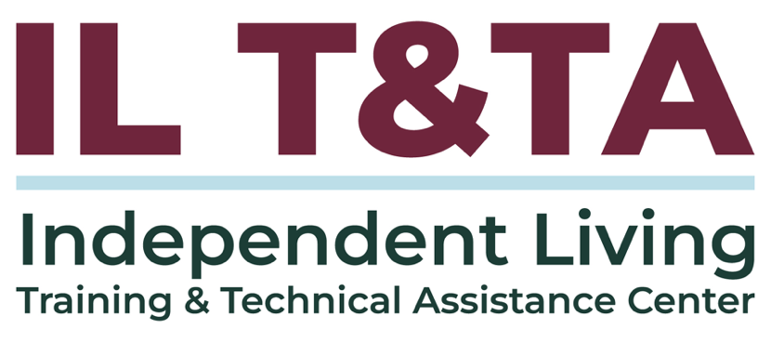
This project is on assignment through contract with the Administration on Disabilities, Administration for Community Living, Health and Human Services.

About the IL T& TA Center
The Independent Living Training and Technical Assistance Center (IL T&TA Center) is available to you through a contract with the US Department of Health and Human Services.
The IL T&TA Center provides expert training and technical assistance to CILs, SILCs, and DSEs.
The Center is operated by the University of Montana's Rural Institute for Inclusive Communities.
