Fresh Focus: Fiscal Policies and Procedures
January 28, 2026

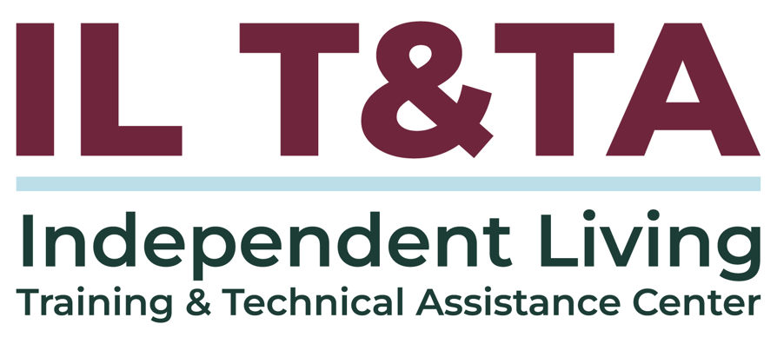

Before We Begin
ASL & Spanish Interpreters are available and labeled.
Access Closed Captioning by clicking the CC button located at the bottom of your Zoom window.
Use Zoom's Raise Hand or Chat features to ask questions.
Use the Q&A box to send us your questions at any time.
Remember to state your name and organization before speaking.
Message our IL T&TA team using the Chat feature if you have difficulties with today's call.
Please complete the survey at the end of today's training.

Today’s Agenda –

Key Takeaways:
- Identify the essential components of a compliant Fiscal Policies and Procedures Manual aligned with ACL requirements.
- Evaluate and update existing financial procedures to strengthen your organization’s fiscal foundation at the start of the year

Learn & Share Format:
- Technical Foundation
- Peer Content
- Peer Discussion

Overall Goal:
- Let's learn with and from each other!

The Federal Framework Behind Your Fiscal Policies

Peer Presenter

Jeremy Caffee M.S. CFRE
Executive Director
Access Center for Independent Living (ACIL)
jeremy.caffee@acils.com



In Practice: The Access Center for Independent Living (ACIL)

About ACIL
- Center for Independent Living (CIL) founded in 1984 with vision of affecting change that would make the community to any person with a disability who wished to pursue a more independent, self-directed lifestyle.
- Long-standing commitment to accountability and ethical stewardship.
- Fiscal systems strengthened over time as the organization grew in size and complexity.
  - Earned Candid Platinum Seal of Transparency.

ACIL’s Fiscal Policies & Procedures in Practice
- Fiscal Policies & Procedures (FPP) were reviewed and updated to better align with:
  - Federal requirements
  - Organizational capacity
  - Day-to-day operations
- The current FPP is a living document that reflects learning, adaptation, and continuous improvement:
  - Emphasis on trust, transparency, and responsible use of funds
  - Ethical stewardship that supports public and funder confidence


The Purpose of FPP in Independent Living
Establishes how funds are managed responsibly and transparently.
Supports compliance with federal requirements and ACL expectations.
Aligns fiscal practices with the Independent Living philosophy and mission.
Funds are used to advance IL core services and consumer-directed outcomes.
Creates consistency across staff, leadership, and board oversight.
Financial controls align spending with approved scopes, budgets, and objectives.


Board & Staff Responsibilities

Why This Matters:
- Defines who is responsible for fiscal decisions.
- Connects Board oversight with staff execution.
- Prevents gaps, duplication, or confusion in financial roles.
- Ensures financial actions align with:
  - Independent Living mission and philosophy.
  - Federal requirements and ACL expectations.
- Makes fiscal expectations clear across leadership and staff.

Internal Controls & Oversight

Includes:
- Information Technology Controls
- Whistle-Blower Policy
- Facilities & Operational Procedures

Why This Matters:
- Protects financial, operational, and data integrity with separation of responsibilities.
- Reduces risk and supports accountability.
- Promotes transparency and audit readiness.

Financial Procedures & Controls
Includes:
- Security of financial information and records
- Separation of responsibilities

Why This Matters:
- Establishes the foundation for all other fiscal activities.
- Written procedures guide and protect financial records and sensitive information.
- Reduces risk of error, misuse, or fraud.
- Oversight supports internal accountability and accuracy.
Strong financial procedures create the structure that makes compliance possible.

Cash Management & Federal Funds
Includes:
- Cash Management
- Cash receipts
- Federal drawdowns

Why This Matters:
- Covers some of the highest-risk fiscal activities for CILs.
- Ensures federal funds are drawn, received, and recorded accurately.
- Supports compliance with grant terms and federal requirements.
- Reduces risk related to timing, documentation, and misuse of funds.

Cash Management & Federal Funds (cont.)

In Practice at ACIL:
- Federal drawdowns are tied to actual, allowable expenditures — not anticipated costs.
- Timing of drawdowns reflects real program activity.
- Cash receipts are documented and tracked consistently to support reconciliation.
- Procedures evolved over time as organizational capacity and funding complexity increased.
- Documentation supports and protects fiscal decisions.

Cost Allocation & Grant Administration
Includes:
- Expense allocation Methods
- Grant Administration and Payment Systems

Why This Matters:
- Defines how costs are allowable and reasonable
- Demonstrates how shared expenses are allocated across programs
- Ensures allocations reflect actual operations
- Aligns spending with approved budgets and scopes
- Reduces audit risk by clearly documenting funding decisions


Disbursements & Banking
Includes:
- Check preparation and signatures
- Bank reconciliations

Why This Matters:
- Controls how and when money leaves the organization.
- Establishes checks and balances around financial transactions.
- Requires separation of key financial roles on deposits, approvals, and reconciliation.
- Helps detect and correct errors through reconciliation to verify activity.


Payroll, Cards & Travel
Includes:
- Payroll procedures
- Personnel Activity Reports (PARs)/ Time and Effort Reporting
- Debit and Credit Card Use
- Travel and Expense Reimbursement

Why This Matters:
- These are high-frequency, high-risk activities where staff interact directly with funds.
- Largest and most scrutinized expense area documentation is critical for compliance and audit readiness.
- Clear rules protect staff, funds, and the organization.

ACIL’s Personnel Activity Report (PAR)
- Time and effort reporting reflects actual work performed, not estimates.
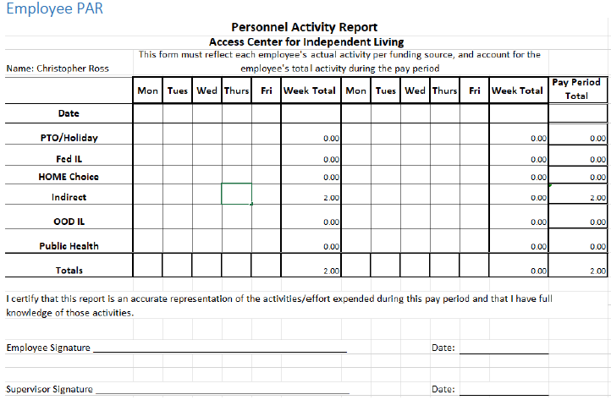
- PARs support accurate charging of payroll across funding sources.


Accounting, Procurement & Assets
Includes:
- Accounting Policies and Financial Reports
- Purchasing and Procurement Standards (with supporting appendices, where applicable)
- Ethical Conduct and Conflicts of Interest
- Property and Equipment Management
- Capitalization, Depreciation, and Inventory Control

Why This Section Matters:
- Determines how financial decisions are reflected in reports reviewed by the Board and funders.
- Sets guardrails for how purchases are made and justified, especially with federal funds.

Accounting, Procurement & Assets (cont.)
- Prevents conflicts of interest from undermining credibility or compliance.
- Ensures assets can be tracked, explained, and accounted for over time.
- Protects the organization when decisions are questioned months or years later.


Program Income & Reporting
Includes:
- Program Income
- Reports to Funding Agencies and Organizations

Why This Section Matters:
- Defines how program-generated funds are handled.
- Ensures reporting reflects actual use of funds and outcomes.
- Serves as the primary way funders assess compliance and performance.
- Requires reporting to follow documented procedures, not ad hoc (one-off) processes.
- Connects fiscal activity to external accountability.

Audit Readiness & Continuous Compliance
- Audits assess how well all fiscal systems work together, not individual policies in isolation
- Demonstrates organizational fiscal capacity and oversight, not just technical compliance
- Confirms alignment with:
  - Single Audit requirements (for organizations with annual expenditures of $1 million or more in federal funds annually)
  - Uniform Guidance
  - Generally Accepted Accounting Principles (GAAP) and ACL expectations.
- Shifts compliance from a one-time event to an ongoing practice

From Policy to Practice

Your Fiscal Policies & Procedures is the Tool that:
- Connects federal requirements to daily fiscal practice
- Anchors fiscal decision-making across the organization
- Supports reporting, accountability, and audit readiness
- Signals when updates are needed
Strong fiscal policies give CILs the stability to respond to community needs and advance Independent Living.

Resources for Additional Guidance
- Uniform Administrative Requirements, Cost Principles, and Audit Requirements for Federal Awards - 2 CFR 200
- Financial Management for CILs – ILT&TA
- Financial Management: Workshop for CILs – IL-NET Archive
- Cohort: Good Governance: Fiscal Oversight for IL Leaders –ILT&TA
Supplemental Material:
ACIL’s Fiscal Policy and Procedures: 2024
ACIL’s FPP Compliance Review

Your Experience Matters
Recording has stopped – now it’s time to share.

Ways to Engage:
- Raise your hand to be spotlighted to speak
- Turn on your camera if you're comfortable
- Use the chat to share insights, questions, resources, or tools
- React, reflect, or build on what others say
- Share real challenges or successes from your CIL
Let’s turn ideas into action — your voice is the most valuable part of this session.

Evaluation
Thank you for participating in today's Learn and Share.
Your feedback is important and helps us plan future training.
Please use the link in the chat to share your feedback.
Evaluation Link:


Upcoming Events to Join Us On!
- Ask Anything – February 12, 2025, 3 PM ET
- SILC Connection: Effective Strategies for Gathering Public Input – February 17, 2026, 3 PM ET
- Learn & Share: Consumer Rights and Responsibilities – February 25, 2026, 3 PM ET

How to Connect with Us!

Website: https://tinyurl.com/ILTTACenter
Request training and / or technical assistance (expert help for your organization): fill out a form on our website to let us know how we can help.
Call: 406-243-5300 and someone will get back to you as soon as we can.
Sign-Up for Events & Announcements:

Visit our website to sign up for updates about live training, group technical assistance, new publications, and other happenings around the Center.

IL T&TA Center Attribution

This project is on assignment through contract with the Administration on Disabilities, Administration for Community Living, Health and Human Services.

About the IL T& TA Cent
The Independent Living Training and Technical Assistance Center (IL T&TA Center) is available to you through a contract with the US Department of Health and Human Services.
The IL T&TA Center provides expert training and technical assistance to CILs, SILCs, and DSEs.
The Center is operated by the University of Montana's Rural Institute for Inclusive Communities.


