SILC Connection – Effective Strategies for Gathering Public Input
February 17, 2026

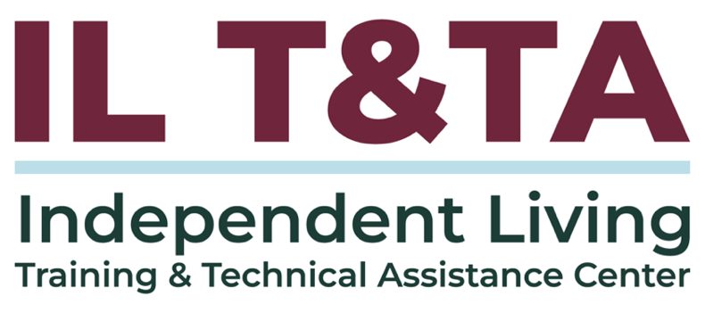

Before We Begin
ASL & Spanish Interpreters are available and labeled.
Access Closed Captioning by clicking the CC button located at the bottom of your Zoom window.
Use Zoom's Raise Hand or Chat features to ask questions.
Use the Q&A box to send us your questions at any time.
Remember to state your name and organization before speaking.
Message our IL T&TA team using the Chat feature if you have difficulties with today's call.
Please complete the survey at the end of today's training.

Today’s Agenda –

Key Takeaways:
- Learn how to use tools like surveys, listening sessions, and meetings to engage consumers and community partners.
- Learn how to turn public input into real next steps for council activities, including SPIL development and evaluation.

Overall Goal:
- Let's learn with and from each other!

Presenter:
Mel Leviton
Executive Director
Idaho State Independent Living Council
Mel.Leviton@silc.idaho.gov

Facilitator:
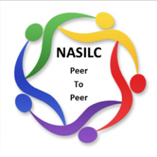
Brooke Wilson
Chair- NASILC (National Association of State Independent Living Councils)

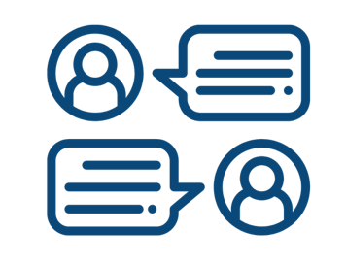
What is Public Input?
Feedback we invite, receive, and meaningfully consider from people with disabilities and other community stakeholders across the state.

The Purpose of Public Input:
- Public Input drives SPIL Priorities and aligns the SPIL with community needs.
- Public Input directly connects to CIL Services.
- Focused Public Input is easier to summarize, review and use.
- Public Input is meaningful when it informs decisions and evaluates efforts.

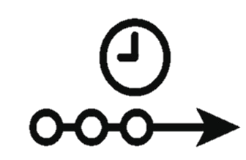
What is a SPIL Timeline?
- A set of key milestones:
  - Needs assessment
  - Draft development
  - Public Input windows
  - Revisions, approvals, and submission
- A set of Decision Points: what will be decided at each stage.
- A planning tool that keeps engagement realistic and accessible.
- Note: Every SILC must have an implemented method for developing, seeking, and incorporating public input into the SPIL in their policies.

The Purpose of Your SPIL Timeline
- Turns a schedule into strategy
- Guides engagement methods, collaboration, and decision making
- Prioritizes what matters right now

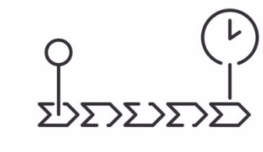
Use your SPIL Timeline as a tool to plan:
- When Public Input is needed and reviewed
- What level/type of Public Input is realistic
- How Public Input will be used to make decisions
Your SPIL Timeline helps you focus on what matters now vs. what comes next - not everything has to happen at once.

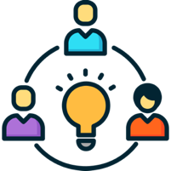
Collaboration with CILs
- Collaborate intentionally - based on your SPIL Timeline, not assumptions.
- Identify when CIL support is most useful along your SPIL Timeline.
- Decide where engagement should happen based on geography, access, and capacity.
- Clarify roles early to prevent confusion or overreach.
- Collaboration works best when tied to a specific Decision Point on your SPIL Timeline.
- Note: Have a written process on how input from CILs and people with disabilities will be collected and considered.

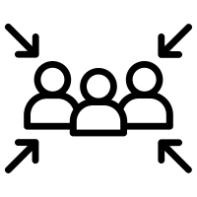
Ways to Gather Public Input

Chosen methods that fit the decision you’re making on your SPIL Timeline:
- Surveys (online, paper, phone)
- SPIL quarterly reports with a feedback option
- Listening sessions and town halls
- Public meetings and partner meetings
- Relevant data from other agencies or plans
An effective strategy doesn’t require using every method to gather Public Input.
It requires choosing methods that fit where you are on your SPIL Timeline.
Public Input can be gathered more than once.

Compiling Public Input
- Gather Public Input in one place (notes, surveys, emails, comments)
- Summarize key themes (what you heard most often)
- Review Public Input at planned points in your SPIL Timeline.
- Sort feedback into:
  - Action now (fits current Decision Point)
  - Action later (track for future planning)

Using Input to Make Decisions
- Share Public Input with SILC and SPIL committees
- Review SPIL progress on goals and objectives
- Compare Public Input to SPIL progress: what's working, what's missing, what's changed.

- Make decisions and document next steps:
  - Update goals/ strategies/ timelines as needed
  - Assign owners and due dates
- Report back on what you heard and how it will be used (or why not yet).
Public Input is meaningful when it informs decisions, not just documentation.

Your Experience Matters
Recording has stopped – now it’s time to share.
Ways to Engage:
- Raise your hand to be spotlighted to speak
- Turn on your camera if you're comfortable
- Use chat for comments and resources; use the Q&A box for your questions.
- React, reflect, or build on what others say
- Share real challenges or successes from your CIL
Let’s turn ideas into action — your voice is the most valuable part of this session.

Evaluation
Thank you for participating in today's SILC Connect.
Your feedback is important and helps us plan future training.
Please use the link in the chat to share your feedback.
Evaluation Link:
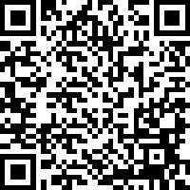

Upcoming Events to Join Us On!
- Learn & Share – Fresh Focus: Consumer Rights & Responsibilities – February 25, 2026, 3 PM ET
- Ask Anything – March 12, 2026, 3 PM ET
- Learn & Share – Fresh Focus: Performance Evaluations– March 25, 2026, 3 PM ET

How to Connect with Us!

Website: www.ILTTACenter.org
Request training and / or technical assistance (expert help for your organization): fill out a form on our website to let us know how we can help.
Call: 406-243-5300 and someone will get back to you as soon as we can.
Sign-Up for Events & Announcements:
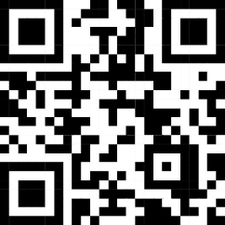
Visit our website to sign up for updates about live training, group technical assistance, new publications, and other happenings around the Center.

IL T&TA Center Attribution

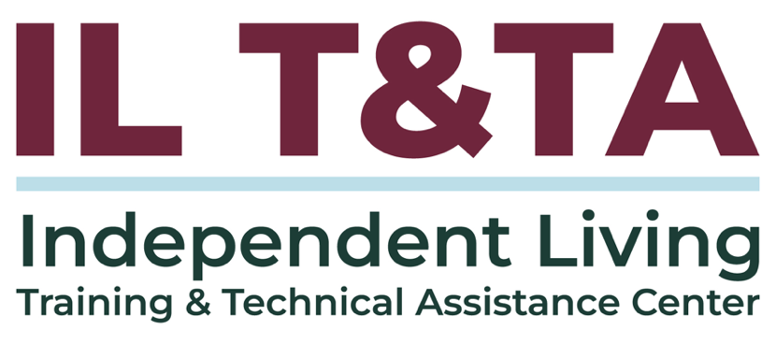
This project is on assignment through contract with the Administration on Disabilities, Administration for Community Living, Health and Human Services.

About the IL T& TA Center
The Independent Living Training and Technical Assistance Center (IL T&TA Center) is available to you through a contract with the US Department of Health and Human Services.
The IL T&TA Center provides expert training and technical assistance to CILs, SILCs, and DSEs.
The Center is operated by the University of Montana's Rural Institute for Inclusive Communities.
