Fresh Focus: Consumer Rights and Responsibilities
February 25, 2026

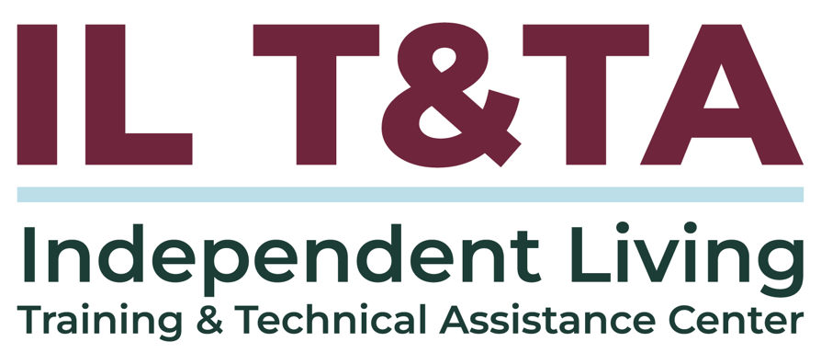

Before We Begin
ASL & Spanish Interpreters are available and labeled.
Access Closed Captioning by clicking the CC button located at the bottom of your Zoom window.
Use Zoom's Raise Hand or Chat features to ask questions.
Use the Q&A box to send us your questions at any time.
Remember to state your name and organization before speaking.
Message our IL T&TA team using the Chat feature if you have difficulties with today's call.
Please complete the survey at the end of today's training.

Today’s Agenda –

Key Takeaways:
- Understand the purpose and key components of a Consumer Rights and Responsibilities document.
- Recognize the roles and responsibilities of both staff and consumers in maintaining respectful and accountable relationships.
- Demonstrate how staff and consumers can use the document to clarify expectations and uphold shared standards of conduct.

Learn & Share Format:
- Technical Foundation
- Peer Content
- Peer Discussion

Peer Presenter
Kelsey Bell
Executive Director
Southwest Center for Independence
Kelsey@swilc.org

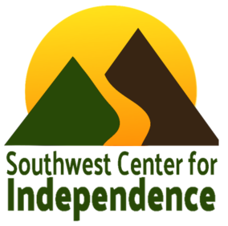

About Southwest Center for Independence (SWCI)
- Located in Southwest Colorado (Four Corners region)
- Serve five counties
- Approximately 15 employees
- Core services, housing vouchers, accessible transportation, and Veteran-Directed Care
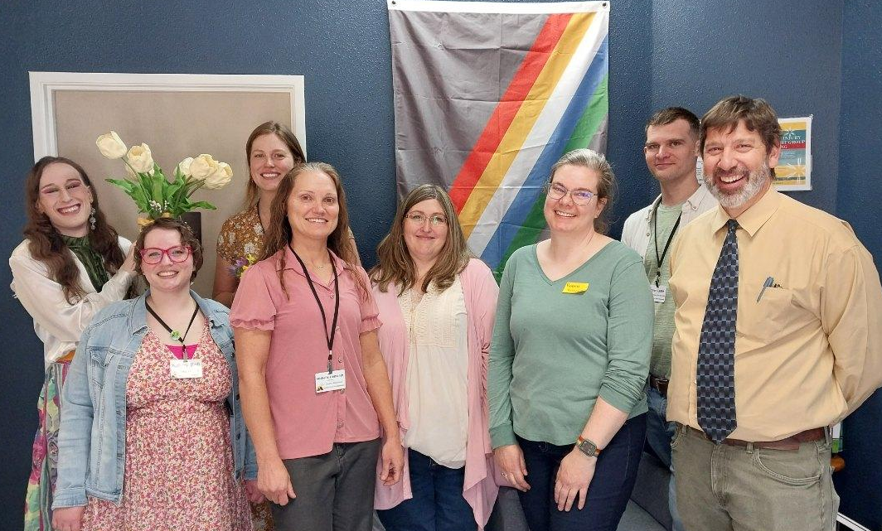

Framework Behind Consumer Rights and Responsibilities
Purpose of Title VII Independent Living Philosophy 45 CFR § 1329.2
- Consumer Rights and Responsibilities establishes the framework for respectful engagement and expectations consistent with Independent Living principles.
Consumer Rights and Responsibilities help guide:
- Intake and early conversations
- How behavior and conduct are addressed
- Consumer and staff expectations

CR&R Structure and Purpose

Sections of CR&R:
- Consumer Rights – Protects access, confidentiality, non-discrimination, and accommodations.
- Consumer Responsibilities – Defines expectations for participation, respectful conduct, and collaboration in services.
- Program-Specific Expectations – Establishes operational and safety standards for services such as transportation.
- Organizational Authority – Clarifies the Center’s responsibility to maintain safety and set boundaries when necessary.
- Grievance Procedures – Provides clear pathways for resolving concerns and filing complaints, both internally and externally through the state Client Assistance Program (CAP).

CR&R Structure and Purpose (cont.)
- Formal Complaint Protections (Title VI) – Outlines processes for addressing discrimination and civil rights violations.
- Acknowledgment of Understanding – Documents that Rights & Responsibilities have been reviewed and agreed upon.

CR&R is more than a document –
- Creates buy-in for both staff and consumers.
- Supports overall work culture and working relationships with consumers.
- Tool to support consumers and staff address conflict and other difficult situations.

Shared Roles & Responsibilities
CR&R strengthens consumer control by clearly defining expectations for consumers and staff, promoting respectful and accountable interactions.
Consumers
Engage respectfully, participate in goal-setting, and follow agreed-upon expectations.
Staff
Apply CR&R consistently, maintain safety, communicate expectations clearly and follow agreed-upon expectations.
Leadership
Support staff, provide escalation pathways, and ensure fairness in decision-making.
Shared Accountability
Respectful engagement requires clarity, consistency, and mutual responsibility.

How CR&R is Applied

Intake & Early Conversations
Reviewing Consumer Rights and Responsibilities during intake or initial conversations

Leadership and Team Consultation
Consulting supervisors or leadership when escalation or safety concerns arise.

Maintains Organizational Trust
Using CR&R consistently so staff feel supported and consumers understand expectations.

Responding to Challenging Situations
Using CR&R as a reference point when behavior or participation becomes disruptive or unclear.


How CR&R Clarifies Expectations in Difficult Situations

Expectations and uphold shared standards of conduct:
- Navigating sticky or subjective situations
- Determining severity and identifying appropriate options
- Understanding non-negotiables (e.g., zero tolerance for harassment)
- Knowing when to engage leadership
- Using a collaborative team process to determine responses
- Supporting and managing how consumers respond

Re-Engagement After Difficult Situations
When participation has been disrupted, CR&R provides a structured way to reset expectations and determine whether services can resume safely.
- Reviewing what occurred and how it impacted the environment
- Re-visiting Consumer Rights & Responsibilities together
- Clarifying what will be different moving forward
- Identifying supports or accommodations, when appropriate
- Re-establishing boundaries and shared responsibilities
Re-engagement is not automatic — it is intentional and grounded in safety, clarity, and Independent Living principles.


Reflecting on Your CR&R
- Where does your CR&R provide clear guidance in difficult situations?
- Are expectations and non-negotiables clearly defined?
- Do staff know when and how to escalate concerns?
- Is there a consistent process for pause and re-engagement?
- Does your CR&R balance safety and Independent Living principles?

Your Experience Matters
Recording has stopped – now it’s time to share.

Ways to Engage:
- Raise your hand to be spotlighted to speak
- Turn on your camera if you're comfortable
- Use the chat to share insights, questions, resources, or tools
- React, reflect, or build on what others say
- Share real challenges or successes from your CIL
Let’s turn ideas into action — your voice is the most valuable part of this session.

Evaluation
Thank you for participating in today's Learn and Share.
Your feedback is important and helps us plan future training.
Please use the link in the chat to share your feedback.
Evaluation Link:


Upcoming Events to Join Us On!
- Ask Anything – March 12, 2026, 3 PM ET
- Learn & Share – Fresh Focus: Performance Evaluations– March 25, 2026, 3 PM ET

How to Connect with Us!

Website: https://tinyurl.com/ILTTACenter
Request training and / or technical assistance (expert help for your organization): fill out a form on our website to let us know how we can help.

Call: 406-243-5300 and someone will get back to you as soon as we can.

Sign-Up for Events & Announcements:

Visit our website to sign up for updates about live training, group technical assistance, new publications, and other happenings around the Center.

IL T&TA Center Attribution

This project is on assignment through contract with the Administration on Disabilities, Administration for Community Living, Health and Human Services.

About the IL T& TA Cent
The Independent Living Training and Technical Assistance Center (IL T&TA Center) is available to you through a contract with the US Department of Health and Human Services.
The IL T&TA Center provides expert training and technical assistance to CILs, SILCs, and DSEs.
The Center is operated by the University of Montana's Rural Institute for Inclusive Communities.
