SILC 101 –Roles, Responsibilities, and Foundations of Effective Councils
March 31, 2026

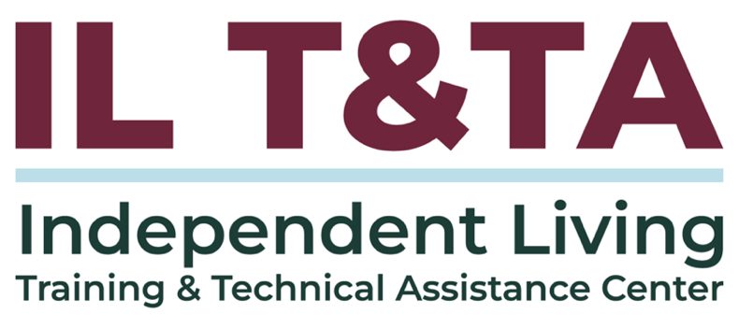

Before We Begin
ASL & Spanish Interpreters are available and labeled.
Access Closed Captioning by clicking the CC button located at the bottom of your Zoom window.
Use Zoom's Raise Hand or Chat features to ask questions.
Use the Q&A box to send us your questions at any time.
Remember to state your name and organization before speaking.
Message our IL T&TA team using the Chat feature if you have difficulties with today's call.
Please complete the survey at the end of today's training.

Cohort Learning Objectives –
- Understand the regulations and indicators regarding the duties, standards, and authorities of all the IL Network partners (CILs, SILC, and DSE).
- Clarify the differences between the roles of CILs, SILCs, and DSEs.
- Know the basics of what the SILC is, what it does, and how it interacts with the other partners.
Abbreviations to Know:
CIL = Center for Independent Living
SILC = Statewide Independent Living Council
DSE = Designated State Entity

Cohort Overview:
- Dates: March 31, April 7, April 14, 2026
- Format: Weekly 90-minute Zoom sessions (60 minutes instruction + 30 minutes peer learning)
- Audience: Board Chairs, Board Members, Executive Directors, and Leadership
- Style: Interaction, Peer-Driven, Conversation

Cohort Norms:
- Participation and Presence
- Learning Together
- Respect and Inclusion
- Confidentiality and Trust
Time and Structure

Your Presenters:
Carrie England, Executive Director at California State Independent Living Council (CA SILC) & Peer Consultant with the IL T&TA Center
Tyler Wilcox, Executive Director of the Independent Living Council of Wisconsin & Peer Consultant with the IL T&TA Center
Jeremy Morris, Executive Director at Ohio Statewide Independent Living Council & Peer Consultant with the IL T&TA Center

Purpose of Title VII (7) of the Act is to:
Promote a philosophy of independent living (IL) –
- Consumer Control
- Self-Help
- Equal Access
- Peer Support
- Self-Determination
- Individual and Systems Advocacy
in order to maximize the:
Leadership, empowerment, independence, and productivity of individuals with

Purpose of Title VII (7) of the Act is to: (cont.)
disabilities, and to promote the integration and full inclusion of individuals with disabilities into the mainstream of American society...
Regulations: 45 CFR 1329.2 quotes the Rehab Act’s Purpose for IL

What is the SILC?
- Federal law established that each state would have a Statewide Independent Living Council.
- While not all have done this, most SILCs choose to organize as 501(c)(3) non-profits (an IRS designation).
- Even though you are independent by law, the governor appoints the members of the SILC.
- Even though the Council is appointed by the governor, it cannot be established as an entity within a State agency. It must be independent of and autonomous from the DSE and all other State agencies. (Assuring this is one of the main reasons for becoming a 501(c)(3).

What is the Makeup of the SILC?
Section 705 (b) of the Act states that the membership of the council must include:
- among its voting members, at least 1 director of a center for independent living chosen by the directors of centers for independent living within the State;
- among its voting members, for a State in which 1 or more centers for independent living are run by, or in conjunction with, the governing bodies of American Indian tribes located on Federal or State reservations, at least 1 representative of the directors of such centers; and
- as ex officio, nonvoting members, a representative of the designated

Makeup of the SILC? (cont.)
- State entity, and representatives from State agencies (at least one other agency) that provide services for individuals with disabilities. (You decide which agency or agencies are included in this.)

Additional members may include:
- other representatives from centers for independent living;
- individuals with disabilities;
- parents and guardians of individuals with disabilities;
- advocates of and for individuals with disabilities;
- representatives from private businesses;
- other appropriate individuals.

Makeup of the SILC? (cont.)
A majority (51% or more) of the SILC membership must be individuals with significant disabilities that:
- Do not work for a Center for Independent Living
- Do not work for your State AND
- Individuals that provide statewide representation
- Individuals that represent a broad range of individuals with disabilities from diverse backgrounds (both ethnicity and type of disability)
- Individuals who are knowledgeable about centers for independent living and independent living services

All SILC Members Must be Appointed by the Governor
- Appointments include ex-officio, non-voting members and the CIL rep chosen by the centers.
- A term is three years unless the person is filling an incomplete term. Then it may be one or two years.
- A member cannot serve more than two three-year terms unless they are filling an incomplete term; then they may fill two full terms after that.
- The SILC should solicit applications for membership and after staff, chair and/or committee review, provide those applicants to the governor for consideration.

All SILC Members Must be Appointed by the Governor (cont.)
- As a member you can provide applications to others you know or suggest they apply to serve on the council. As you complete your service this would be extremely helpful.

What Kind of Board is the Council?
- If you are a non-profit, it is a non-profit board, bound by its bylaws and IRS requirements. Of course, you can change your bylaws if you wish, following the requirements of the bylaws for that process.
- It is also a governmental entity, established in law and not only in your by-laws. The council cannot change those laws. That is why you are subject to open meeting requirements, for example.
- It is a governing board, that typically hires and oversees staff to accomplish the day-to-day work of the council.
- The responsibility of the council is to approve the SPIL (with the CILs) and then monitor and evaluate the implementation of the SPIL.

Role of the DSE
- Serve as the “grantee” for Part B $.
- Account to SILC for the Part B $ and disperse those funds according to the SPIL (usually verified in a report at every meeting).
- Keep records. Complete the PPR report with the SILC.
- Complete any other reports required.
- Retain not more than 5% of Part B for DSE administrative costs. It is not required to take 5%.
- The DSE cannot hold funds.
- Sign the SPIL agreeing to serve as the DSE.
- Have an “ex officio” position on the SILC (appointed by governor).

A Word About “Ex-Officios”
- “Ex officio” means that the person holds the position on your SILC because of the position they hold in a state agency related to disabilities.
- The individual may have helpful information about their agency, or expertise about a funding source that the Council will find useful.
- In the case of the SILC, these are non-voting positions. Some SILCs also define the position further in either their policies or their bylaws.
- It is not unusual to limit the contribution of ex officio members to observation or specific items on the agenda, and not always have them involved in the open discussions of the Council.

Role of CILs
- Provide the Core Services.
- Provide other Independent Living Services.
- Develop SPIL with SILC.
- Help to implement SPIL.
- Comply with CIL Standards & Assurances and Indicators.
- Conduct Resource Development Activities.
- Select a CIL ED to serve on the SILC, subject to appointment by the Governor.
- More than 50% of the CIL Directors must sign the SPIL to approve its content.

45 CFR (Code of Federal Regulations) § 1329.15 – Duties of the SILC.
- The duties of the SILC are those set forth in section 705(c), (d), and (e) of the Act.
- The SILC shall develop the SPIL (State Plan for Independent Living) in accordance with guidelines developed by the Administrator;

What This Means:
- This section of the law sets the standards of a State Independent Living Council (SILC).
- The SILC must follow the federal process for developing the SPIL, typically every three years.

§ 1329.15 Duties of the SILC. (cont.)
- The SILC shall monitor, review and evaluate the implementation of the SPIL on a regular basis as determined by the SILC and set forth in the SPIL;

What This Means:
- The SILC must review how the SPIL is working and if the plan is being followed.
- The SILC must follow the review process set in the SPIL.
- This is the main job of the SILC when it isn’t developing the SPIL.

§ 1329.15 Duties of the SILC. (cont.)
- The SILC shall meet regularly, and ensure that such meetings are open to the public and sufficient advance notice of such meetings is provided;

What This Means:
- The SILC must meet regularly.
- The SILC must make sure anyone can attend their meetings.
- The SILC must announce the meeting ahead of time.
**More info on meetings in SILC Assurances

§ 1329.15 Duties of the SILC. (cont.)
- The SILC shall submit to the Administrator such periodic reports as the Administrator may reasonably request, and keep such records, and afford such access to such records, as the Administrator finds necessary to verify the information in such reports; and

What This Means:
- The SILC submits a report each year to ACL, called the Program Progress Report (PPR, formerly 704).
- The SILC completes this report with the DSE.
- The last year’s report is due the end of this month.

§ 1329.15 Duties of the SILC. (cont.)
- The SILC shall, as appropriate, coordinate activities with other entities in the State that provide services similar to or complementary to independent living services, such as entities that facilitate the provision of or provide long-term community-based services and supports.

What This Means:
- There are entities in your state that offer services similar to or that can be paired with independent living services.
- The SILC must coordinate activities with these types of entities.
- This work is often accomplished by SILC staff.

§ 1329.15 Duties of the SILC. (cont.)
In carrying out the duties under this section, the SILC may provide contact information for the nearest appropriate CIL. Sharing of such information shall not constitute the direct provision of independent living services as defined in section 705(c)(3) of the Act.

What This Means:
- The SILC is allowed to provide information to the public about the CILs.
- This is allowed and not considered directly providing independent living services.
- The SILC cannot directly provide independent living services.
§ 1329.15 Duties of the SILC. (cont.)
- The SILC, in conjunction with the DSE, shall prepare a plan for the provision of resources, including staff and personnel that are necessary and sufficient to carry out the functions of the SILC.

What This Means:
- The SILC and the DSE will work together to come up with a resource plan (budget). The resource plan will show what types of funding will be used and how much will be used to support the SILC’s responsibilities.
- This plan must be enough to operate the SILC.

§ 1329.15 Duties of the SILC. (cont.)
(6) A description of the SILC's resource plan must be included in the State plan. The plan should include:
- Staff/personnel;
- Operating expenses;
- Council compensation and expenses;
- Meeting expenses, including public hearing expenses, such as meeting space, alternate formats, interpreters, and other accommodations;
- Resources to attend training and/or secure training for staff and Council members; and
- Other costs as appropriate.

§ 1329.15 Duties of the SILC. (cont.)
- The resource plan amount shall be commensurate, to the extent possible, with the estimated costs related to SILC fulfilment of its duties and authorities consistent with the approved State Plan.

What This Means:
- The plan’s funding should cover the costs of the SILC’s required activities.
- The plan must have enough funding for the SILC to follow federal rules and the State Plan.

§ 1329.15 Duties of the SILC. (cont.)
- Available resources include: Innovation and Expansion (I&E) funds authorized by 29 U.S.C. 721(a)(18); Independent Living Part B funds; State matching funds; other public funds (such as Social Security reimbursement funds); and private sources.

What This Means:
- Your resource plan can be made up of different federal, state, and private sources.
- Some of these sources include VR Innovation and Expansion Funds, federal Part B Funds, Social Security reimbursement funds, etc.

§ 1329.15 Duties of the SILC. (cont.)
- In accordance with § 1329.10(a)(1), no more than 30 percent of the State's allocation of Subchapter B and Subchapter B State matching funds may be used to fund the resource plan, unless the approved SPIL provides that more than 30 percent is needed and justifies the greater percentage.

What This Means:
- Your resource plan cannot include more than 30% of the state’s Subchapter B funds.
- An exception to this rule is when your state plan provides an explanation as to why more than 30% is needed by the SILC.
- Not all SILCs receive Part B funds.

§ 1329.15 Duties of the SILC. (cont.)
- No conditions or requirements may be included in the SILC's resource plan that may compromise the independence of the SILC.

What This Means:
- Your resource plan cannot require you to agree to something that will risk the SILC’s independence.

§ 1329.15 Duties of the SILC. (cont.)
- The SILC is responsible for the proper expenditure of funds and use of resources that it receives under the resource plan.

What This Means:
- The SILC is responsible for ensuring it follows the rules when spending money from its Resource Plan.
- Often this means the council has someone perform an independent audit of the use of Part B and other SILC funds.

§ 1329.15 Duties of the SILC. (cont.)
- The SILC shall carry out the activities in paragraph (a), to better serve individuals with significant disabilities and help achieve the purpose of section 701 of the Act.

What This Means:
- The SILC is required to follow the federal rules to better serve people with significant disabilities.
- The SILC is also required to help achieve the purpose of this part of the Rehab Act.

Resources for Additional Guidance:
- The Rehabilitation Act
- SILC Indicators and SILC and DSE Assurances
- Independent Living Regulations

Coming Up Next – Week 2: SILC 101 - Clarify the differences between the roles of CILs, SILCs, and DSEs. on April 7, 2026!

Your Experience Matters
Recording has stopped – now it’s time to share.
Ways to Engage:
- Raise your hand to be spotlighted to speak
- Turn on your camera if you're comfortable
- Use the chat to share insights, questions, resources, or tools
- React, reflect, or build on what others say
- Share real challenges or successes from your CIL
Let’s turn ideas into action — your voice is the most valuable part of this session.

Evaluation
Thank you for participating in today's Learn and Share.
Your feedback is important and helps us plan future training.
Please use the link in the chat to share your feedback.
Evaluation Link:


How to Connect with Us!

Website: https://ilttacenter.org/

Request training and / or technical assistance (expert help for your organization): fill out a form on our website to let us know how we can help.
Call: 406-243-5300 and someone will get back to you as soon as we can.
Sign-Up for Events & Announcements:

Visit our website to sign up for updates about live training, group technical assistance, new publications, and other happenings around the Center.

IL T&TA Center Attribution

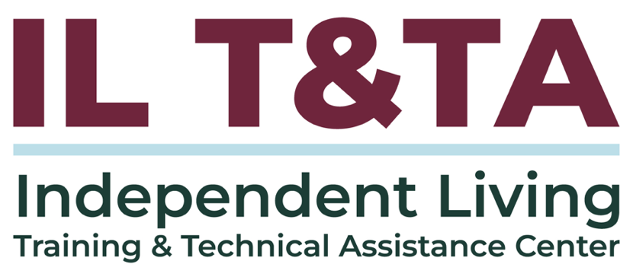
This project is on assignment through contract with the Administration on Disabilities, Administration for Community Living, Health and Human Services.

About the IL T& TA Center
The Independent Living Training and Technical Assistance Center (IL T&TA Center) is available to you through a contract with the US Department of Health and Human Services.
The IL T&TA Center provides expert training and technical assistance to CILs, SILCs, and DSEs.
The Center is operated by the University of Montana's Rural Institute for Inclusive Communities.
