Fresh Focus: Performance Evaluations
March 25, 2026

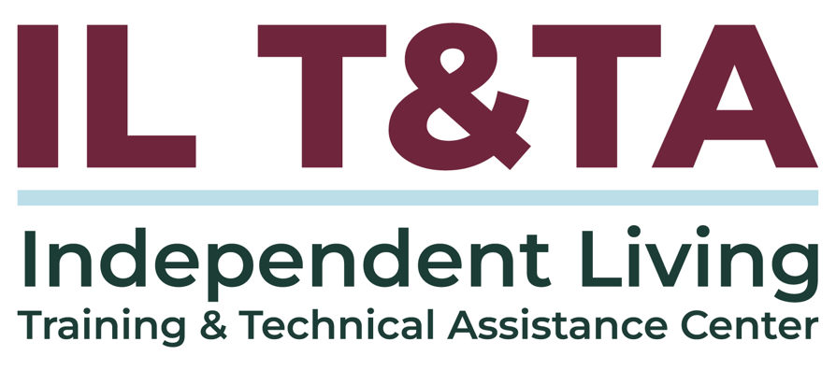
Before We Begin
ASL & Spanish Interpreters are available and labeled.
Access Closed Captioning by clicking the CC button located at the bottom of your Zoom window.
Use Zoom's Raise Hand or Chat features to ask questions.
Use the Q&A box to send us your questions at any time.
Remember to state your name and organization before speaking.
Message our IL T&TA team using the Chat feature if you have difficulties with today's call.
Please complete the survey at the end of today's training.

Today’s Agenda –

Key Takeaways:
- Apply principles of the IL philosophy to guide meaningful performance feedback.
- Recognize performance evaluations as opportunities for growth, reflection, and collaborative dialogue between staff and supervisors.

Learn & Share Format:
- Peer Content
- Peer Discussion

Overall Goal:
- Let's learn with and from each other!

Presenters
Autumn Kubatzke
Human Resources Director
RAMP Disability Resources & Services
akubatzke@rampcil.org

Jackie Sundquist
Chief Executive Officer
RAMP Disability Resources & Services
jsundquist@rampcil.org

In Practice: RAMP Disability Resources & Services
RAMP’s mission is to build an inclusive community that encourages individuals with disabilities to reach their full potential.
- Serve 1,000+ individuals annually across four counties
- Team of 45 employees
- Provide 25,000+ hours of community action & advocacy each year
- Deliver the five core IL services
- Expanded programming in youth transition, employment services, and community-based education & training

Introduction to Performance Evaluations
- Performance evaluations are a structured opportunity for reflection and growth
- Grounded in the IL Philosophy
- Promote consistency, accountability, and transparency
- Focus on outcomes, expectations, and professional development
- Serve as the capstone of ongoing supervision and coaching


Why Evaluations Fail
- Expectations are unclear or inconsistent across supervisors
- Feedback is delayed, avoided, or softened
- Evaluations are treated as a one-time event
- Compensation overshadows development
- Accountability is uneven or absent

IL Philosophy & Leadership
The Independent Living Philosophy should shape how we lead – not just what we do.
Performance feedback should reflect dignity, clarity, and share expectations
Consistent accountability supports autonomy, equity, and trust.

Introducing the Year-in-Review + Individual Development Plan (IDP)

The Year-in-Review is a structured tool for consistent performance conversations.
- Aligns evaluations with role expectations and outcomes
- Balances results, behaviors, and professional growth
- Creates a shared framework for reflection and accountability
- Supports two-way feedback between staff and supervisors


Structure of the Year-in-Review & IDP Tool
Goal of the Process
- Reflect on the past year
- Plan intentionally for the year ahead
- Support career growth at RAMP — and beyond
How It Works
- Employee and supervisor complete separate sections
- Exchange forms in advance
- Engage in a structured, in-person conversation

Structure of the Year-in-Review & IDP Tool (cont.)
Employee First
- Career Interests Worksheet
- Short-term (1–2 year) & long-term (3–5 year) interests
- Reflection (enjoyed / frustrated)
- Draft IDP commitments
Individual Development Plan (IDP)
- 2–5 SMARTER professional development goals
- Behavioral and outcome-based priorities
Supervisor Feedback
- Strengths & accomplishments
- Growth areas
- Expectations for the upcoming year

Structure of the Year-in-Review & IDP Tool (cont.)
Shared Accountability
- Joint review & signatures
- Submitted to HR
- IDP tracked throughout the year (ROWE Results)


Implementation & Timing
Clear communication and training is essential.
- Training begins with leadership, followed by supervisors, then staff
- Establish shared language and expectations before rollout
- Performance conversations occur year-round during coaching
- The Year-in-Review tool serves as the framework for annual evaluation reviews

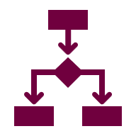
Results Only Work Environment (ROWE) as the Foundation
- Performance is measured by outcomes, not activity
- Expectations are clear and visible
- Ownership of results exists at every level
- when accountability is consistent

What Makes This Work
Radical Candor
- Care personally. Challenge directly.
- Clear, specific, respectful feedback — practiced year-round.
Coaching
- Protected 1-on-1 conversations.
- Address barriers, name strengths, clarify expectations.
- Evaluations should never feel like a surprise.
Accountability & ROWE
- Shared standards and consistent follow-through.
- Focus on outcomes, ownership, and transparency.

Culture & Buy-in
Culture determines whether tools succeed or fail.
- Each organization has a unique culture and level of readiness
- Buy-in is required at all levels, starting with leadership
- This approach is not plug-and-play; progress happens in stages

Resources for Additional Guidance
- https://www.radicalcandor.com/
- https://www.gorowe.com/services/go-rowe
- https://hr.mit.edu/learning-topics/leading/articles/what-is-coaching

Learn & Share: Your Experience Matters
Recording has stopped – now it’s time to share.

Ways to Engage:
- Raise your hand to be spotlighted to speak
- Turn on your camera if you're comfortable
- Use the chat to share insights, questions, resources, or tools
- React, reflect, or build on what others say
- Share real challenges or successes from your CIL
Let’s turn ideas into action — your voice is the most valuable part of this session.

Evaluation
Thank you for participating in today's Learn and Share.

Your feedback is important and helps us plan future training.
Please use the link in the chat to share your feedback.
Evaluation Link:
QR Code

Upcoming Events to Join Us On!

How to Connect with Us!

Website: https://tinyurl.com/ILTTACenter
Request training and / or technical assistance (expert help for your organization): fill out a form on our website to let us know how we can help.
Call: 406-243-5300 and someone will get back to you as soon as we can.
Sign-Up for Events & Announcements:

Visit our website to sign up for updates about live training, group technical assistance, new publications, and other happenings around the Center.

IL T&TA Center Attribution

This project is on assignment through contract with the Administration on Disabilities, Administration for Community Living, Health and Human Services.

About the IL T& TA Cent
The Independent Living Training and Technical Assistance Center (IL T&TA Center) is available to you through a contract with the US Department of Health and Human Services.
The IL T&TA Center provides expert training and technical assistance to CILs, SILCs, and DSEs.
The Center is operated by the University of Montana's Rural Institute for Inclusive Communities.


