SILC 101 –Roles, Responsibilities, and Foundations of Effective Councils
April 16, 2026

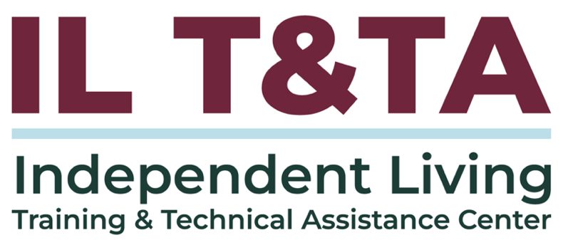

Before We Begin
ASL & Spanish Interpreters are available and labeled.
Access Closed Captioning by clicking the CC button located at the bottom of your Zoom window.
Use Zoom's Raise Hand or Chat features to ask questions.
Use the Q&A box to send us your questions at any time.
Remember to state your name and organization before speaking.
Message our IL T&TA team using the Chat feature if you have difficulties with today's call.
Please complete the survey at the end of today's training.

Cohort Learning Objectives –
- Understand the regulations and indicators regarding the duties, standards, and authorities of all the IL Network partners (CILs, SILC, and DSE).
- Clarify the differences between the roles of CILs, SILCs, and DSEs.
- Know the basics of what the SILC is, what it does, and how it interacts with the other partners.

Abbreviations to Know:
CIL = Center for Independent Living
SILC = Statewide Independent Living Council
DSE = Designated State Entity

Your Presenters:
Carrie England, Executive Director at California State Independent Living Council (CA SILC) & Peer Consultant with the IL T&TA Center
Tyler Wilcox, Executive Director of the Independent Living Council of Wisconsin & Peer Consultant with the IL T&TA Center
Jeremy Morris, Executive Director at Ohio Statewide Independent Living Council & Peer Consultant with the IL T&TA Center

Cohort Overview:
- Dates: April 7, April 14, April 16 2026
- Format: Weekly 90-minute Zoom sessions (60 minutes instruction + 30 minutes peer learning)
- Audience: Board Chairs, Board Members, Executive Directors, and Leadership
- Style: Interaction, Peer-Driven, Conversation

Cohort Norms:
- Participation and Presence
- Learning Together
- Respect and Inclusion
- Confidentiality and Trust
- Time and Structure

Week 1 & 2 Recap: SILC Foundations and Roles
- We grounded our work in the Independent Living philosophy
Centered on consumer control, self-determination, peer support, and systems advocacy as the foundation of the IL network
- We defined the SILC as an independent, federally established council
Responsible for planning, coordination, and oversight—not direct service delivery
- We reviewed how the SILC is structured and operates
Including membership requirements, public meetings, reporting, and overall accountability

Week 1 & 2 Recap: SILC Foundations and Roles (cont.)
- We clarified the distinct roles across the IL network
  - SILC: Planning, oversight, and SPIL accountability
  - CILs: Direct services and SPIL implementation
  - DSE: Fiscal and administrative responsibilities tied to funding
- We introduced how these partners work together through the SPIL
A shared, statewide plan that guides priorities, funding, and coordinated action across the network

SPIL Basics

What is a SPIL?
To be eligible to receive Part B and Part C funding, a state needs to submit an approvable three-year State Plan for Independent Living (SPIL) to the Administration for Community Living / Office of Independent Living Administration (ACL/OILP).
The SPIL should serve as a blueprint for the independent living network in the state.

SPIL Basics (cont.)

Who Develops the SPIL?
Developed by the chairperson of the SILC, and the directors of the CILs, after receiving public input from individuals with disabilities and other stakeholders throughout the State. Signed by the chair with authorization of the council, and at least 51% of the CILs.

SILC Process for the SPIL
The regulations lay out the requirements the SILC must follow to get public input on the development of the SPIL. **Indicators provide greater detail.
At a minimum, the SILC must have document that you’ve followed your written process for:
- The SPIL development process
- How information is collected and used in SPIL development
- How input is gathered from the CILs
- How input is gathered from people with disabilities
You should have a current approved SPIL. If you feel your process needs to be improved, decide on that now! The next one is only two years away!

Keep a list now of things you want to change in your SPIL…
- You may want to add the authority of resource development for your SILC or another “missing” authority. (The CILs are already required to conduct resource development.)
- You may not want to revise your SPIL before next is developed in 2+ years, but you don’t want to forget the things that come up. The chair, the secretary or a committee chair may take on the role of keeping that list.
- As you monitor and evaluate progress you will want to keep track of the new indicators you want to add.

So, Let’s Talk About Your SPIL
- You recently developed and submitted a three-year State Plan for Independent Living (SPIL).
- That plan went into effect October 1, 2024.
- What is the SILC role in monitoring the effectiveness of that plan?
- This is the primary purpose of your meetings now that you are monitoring the implementation of your SPIL.
- This includes assuring Part B funds are spent according to the SPIL.

An Interesting Fact...
The SILC cannot provide any direct services except referring someone to their local CIL.
- So if your SPIL addresses service needs for your state, the CILs provide those services.
- Are your CILs reporting on their progress related to SPIL goals? You don’t need full reports of everything they’ve done, but you must be reviewing and evaluating the implementation of the SPIL.

So, If the CILs are Doing a Lot of the Work...
- How can the SILC monitor the implementation of the SPIL?
- What measures are in your plan and how are the CILs reporting on them?
- The SILC doesn’t monitor the effectiveness of the CILs, but there has to be a relationship here in order to monitor if the agreed-to plan is being worked on.
- Because this is the SILC’s primary role – to monitor and evaluate the progress on the SPIL – the reports from the CILs are a (the?) primary agenda item for the Council’s meetings.

Reminder: A SILC is fully operational if —
- There is a current, complete and approved SPIL
- The Council is properly constituted (meeting the membership requirements).
BUT the SILC can continue to do business as it works with the appointing authority to fill all the SILC positions. The Rehabilitation Act states in Section705.b.7: (B) any vacancy occurring in the membership of the Council shall be filled in the same manner as the original appointment.
The vacancy shall not affect the power of the remaining members to execute the duties of the Council.

DSE Roles and Responsibilities—The Highlights
- Because of the autonomy of the SILC, the SILC takes much more of a role than in the past.
- While most SILCs stayed with the Department of Rehabilitation as their DSE, there have been successful transitions to others – ask if you want to consider another arrangement.
- The DSE is specified in the SPIL and a change can only be made with a new or amended SPIL.
- The DSE agrees to assume these duties by signing the SPIL that designates them.

DSE Roles and Responsibilities—The Highlights (cont.)
- The DSE can only retain 5% for the administrative operations (but doesn’t need to keep that).
- The DSE receives, accounts for, and disburses funds received by the State under Subchapter (Part) B and Subchapter C in a State under section 723 of the Act based on the State plan (Minnesota and Massachusetts).

Roles – DSE:
- Serve as the “grantee” for Part B dollars.
- Account to SILC for funds and disbursement funds per SPIL.
- Provide administrative support for IL Program.
- Keep records. Complete PPR report with the SILC.
- Submit required reports/information.
- Retain not more than 5% of Part B for DSE administrative costs.
  - The DSE cannot hold funds.
- Sign the SPIL agreeing to serve as the DSE.

Roles – SILC
- Develop the SPIL.
- Monitor, review, and evaluate the implementation of the SPIL.
- Meet regularly – open meetings.
- Submit reports including SPIL fulfillment portion of PPR report Part 1.
- Coordinate activities with other entities.
- Conduct Authorities as described in the law and outlined in the SPIL, including advocacy and resource development.
- Shall NOT provide or manage IL services.
- Sign the SPIL to approve content.

Roles – CILs
- Provide the Core IL Services.
- Provide other IL services consistent with Federal and State Law.
- Comply with CIL Standards, Assurances and Indicators
- Develop SPIL with SILC.
- Implement SPIL.
- Conduct Resource Development activities.
- More than 50% of CIL Directors must sign the SPIL to approve content.

Resources for Additional Guidance:
- The Rehabilitation Act
- SILC Indicators and SILC and DSE Assurances
- Independent Living Regulations

Your Experience Matters
Recording has stopped – now it’s time to share.
Ways to Engage:
- Raise your hand to be spotlighted to speak
- Turn on your camera if you're comfortable
- Use the chat to share insights, questions, resources, or tools
- React, reflect, or build on what others say
- Share real challenges or successes from your CIL
Let’s turn ideas into action — your voice is the most valuable part of this session.

Evaluation
Thank you for participating in today's Learn and Share.
Your feedback is important and helps us plan future training.
Please use the link in the chat to share your feedback.
Evaluation Link:


How to Connect with Us!
Website: www.ILTTACenter.org
Request training and / or technical assistance (expert help for your organization): fill out a form on our website to let us know how we can help.
Call: 406-243-5300 and someone will get back to you as soon as we can.
Sign-Up for Events & Announcements:

Visit our website to sign up for updates about live training, group technical assistance, new publications, and other happenings around the Center.

IL T&TA Center Attribution

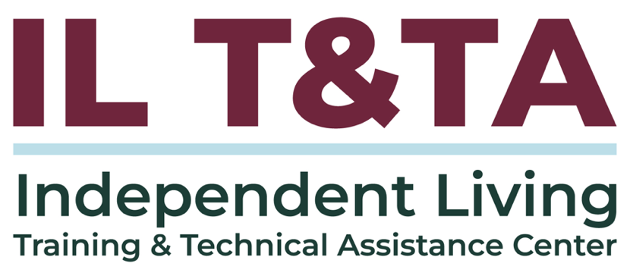
This project is on assignment through contract with the Administration on Disabilities, Administration for Community Living, Health and Human Services.

About the IL T& TA Center
The Independent Living Training and Technical Assistance Center (IL T&TA Center) is available to you through a contract with the US Department of Health and Human Services.
The IL T&TA Center provides expert training and technical assistance to CILs, SILCs, and DSEs.
The Center is operated by the University of Montana's Rural Institute for Inclusive Communities.
