SILC Connection – Resource Development: Strategies that Strengthen Your SPIL & Statewide Network
April 21, 2026

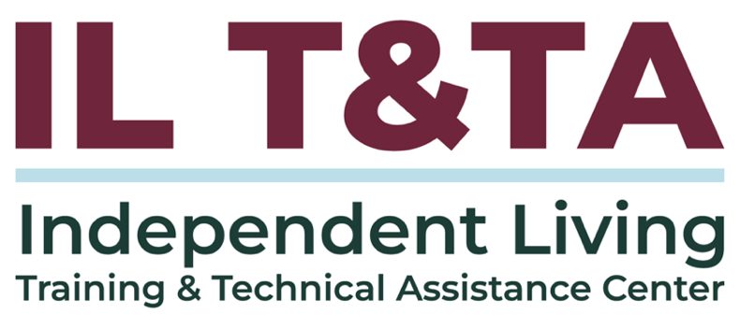

Before We Begin
ASL & Spanish Interpreters are available and labeled.
Access Closed Captioning by clicking the CC button located at the bottom of your Zoom window.
Use Zoom's Raise Hand or Chat features to ask questions.
Use the Q&A box to send us your questions at any time.
Remember to state your name and organization before speaking.
Message our IL T&TA team using the Chat feature if you have difficulties with today's call.
Please complete the survey at the end of today's training.

Today’s Agenda –

Key Takeaways:
- Identify resource development strategies to support activities that align with SPIL goals and statewide priorities.

Overall Goal:
- Let's learn with and from each other!

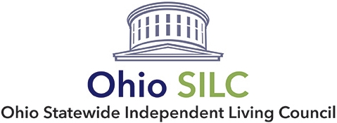
Presenter:
Peer Presenter:
Jeremy Morris
Executive Director
Ohio State Intendent Living Council
Jmorris@ohiosilc.org

Facilitator:
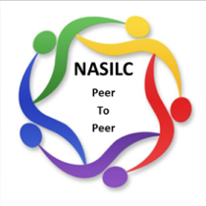
Brooke Wilson
Chair- NASILC (National Association of State Independent Living Councils)

Background

Section 705, SILC, (c) Functions:
(2) Authorities. The council may, consistent with the State plan described in section 704, unless prohibited by state law
- in order to improve services provided to individuals with disabilities, work with centers for independent living to coordinate services with public and private entities;
- conduct resource development activities to support the activities described in this subsection or to support the provision of independent living services by centers for independent living; and

Background (cont.)
perform such other functions, consistent with the purpose of this chapter and comparable to other functions described in this subsection, as the Council determines to be appropriate.
(3) Limitation. –The Council shall not provide independent living services directly to individuals with significant disabilities or manage such services. Process:
- If a SILC is going to engage in an authority, it must be addressed in an approved SPIL. Typically this is covered in Section 5 related to SILCs.

Resource Development Supports Other Duties and Authorities

Sec. 705 (c)(1) Duties
- (E) As appropriate, coordinate activities with other entities in the State that provide services similar to or complementary to independent living services, such as entities that facilitate the provision of or provide long-term community-based services and supports.

Sec. 705 (c)(2) Authorities
- (A) In order to improve services provided to individuals with disabilities, work with centers for independent living to coordinate services with public and private entities;

Examples
- SILCs can help identify statewide opportunities for CILs to become engaged in
- Working with other entities and building partnerships is a great place to start resource development approaches.
- Having strong partnerships and relationships allows others to see the connections of their program to Independent Living and the work of the CILs
- SILC can inform partners on how CILs can potentially engage in their work, and connect them to the CILs

Acquiring resources for SILC
- Funding can be brought in for the SILC to engage in activities that further the work of the SPIL.
- Examples: SPIL Goal around systemic advocacy on housing barriers. The SILC applies for a DD Council grant that is to conduct surveys and listening sessions in rural communities about access to housing and home modification resources. The SILC getting this grant can help achieve the work of the SPIL goal and collaborate with the CILs in the workplans.

Identify resources that can benefit the IL Network
- The SILC can research and identify resources in the state that align with the SPIL and IL.
- Examples: The SILC is in a statewide coalition that has discussed the state’s plans for funding for rural health transformation. The SILC can share the information and projects that the CILs may be able to apply for or partner with in the planning.

Acquire funding that can benefit the IL Network
- The SILC can conduct resource development in the state that aligns with the SPIL and benefits the CILs
- Examples: The SILC finds information about funding that can be used to hire consultants to do a series of trainings that improve the network’s ability to engage with unserved and underserved populations. The SILC applies for the funds and is able to schedule a series of trainings for all CILs to participate assisting the CILs in their outreach and aligning with the outreach plans of the SPIL.

Safeguards

Sec. 705 (c)(2) Authorities - The council shall not provide independent living services directly to individuals with significant disabilities or manage such services.
- Any Resource Development done must be conducted in a manner to not violate this limitation
- Building consumer-control and cross-disability into projects
- As much as possible, have CIL involvement in the process
- Always keep SILC Members informed, potentially voting on approving direction
- Have records and policies to show the work that has been done.

Your Experience Matters
Recording has stopped – now it’s time to share.
Ways to Engage:
- Raise your hand to be spotlighted to speak
- Turn on your camera if you're comfortable
- Use chat for comments and resources; use the Q&A box for your questions.
- React, reflect, or build on what others say
- Share real challenges or successes from your CIL
Let’s turn ideas into action — your voice is the most valuable part of this session.

Evaluation
Thank you for participating in today's SILC Connect.
Your feedback is important and helps us plan future training.
Please use the link in the chat to share your feedback.
Evaluation Link:


Upcoming Events to Join Us On!
- Learn & Share – Sustaining Community Partnerships Skills & Strategies– April 22, 2026, 3 PM ET
- Cohort: Leveraging Resources During Times of Scarcity – April 28, May 5 & 12, 3 PM ET
- Ask Anything – May 14, 2026, 3 PM ET
- SILC Connection – Building Strategic Alliances – Collaborations that Advance SPIL Goals – May 19, 2026, 3 PM ET

How to Connect with Us!

Website: www.ILTTACenter.org
Request training and / or technical assistance (expert help for your organization): fill out a form on our website to let us know how we can help.
Call: 406-243-5300 and someone will get back to you as soon as we can.
Sign-Up for Events & Announcements:

Visit our website to sign up for updates about live training, group technical assistance, new publications, and other happenings around the Center.

IL T&TA Center Attribution

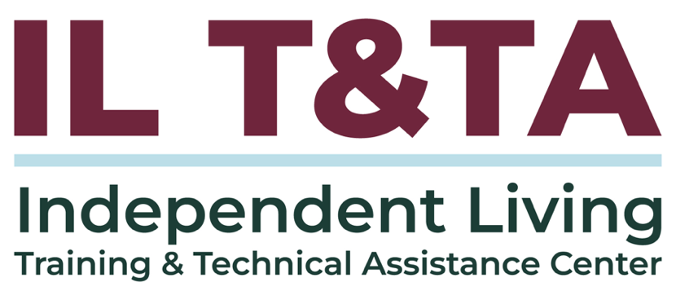
This project is on assignment through contract with the Administration on Disabilities, Administration for Community Living, Health and Human Services.

About the IL T& TA Center
The Independent Living Training and Technical Assistance Center (IL T&TA Center) is available to you through a contract with the US Department of Health and Human Services.
The IL T&TA Center provides expert training and technical assistance to CILs, SILCs, and DSEs.
The Center is operated by the University of Montana's Rural Institute for Inclusive Communities.
