Resource Development Cohort –Creating a Culture of Resource Finding – A Financial Sustainability Framework
April 28, 2026

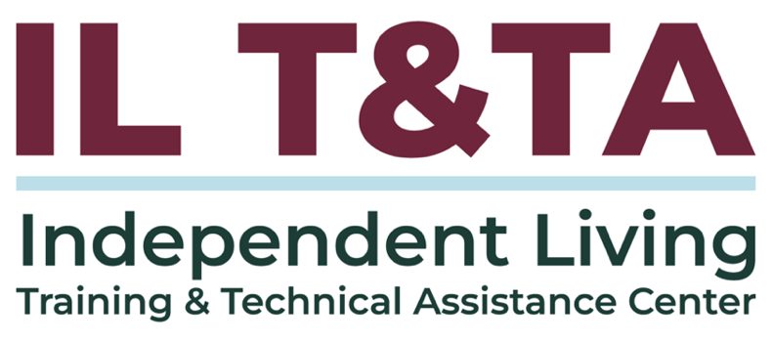

Before We Begin
ASL & Spanish Interpreters are available and labeled.
Access Closed Captioning by clicking the CC button located at the bottom of your Zoom window.
Use Zoom's Raise Hand or Chat features to ask questions.
Use the Q&A box to send us your questions at any time.
Remember to state your name and organization before speaking.
Message our IL T&TA team using the Chat feature if you have difficulties with today's call.
Please complete the survey at the end of today's training.

Cohort Learning Objectives –

Week One:
- Identify gaps, uncover underutilized resources, and explore strategies for diversifying and managing funding to strengthen organizational sustainability.

Week Two:
- Learn how to develop a comprehensive Resource Development Plan that supports both short‑term and long‑term organizational and community goals.

Week Three:
- Learn how to implement a Resource Development Plan across short‑ and long‑term timelines by applying strategies to real‑world scenarios and leveraging their existing organizational expertise.

Cohort Overview:
- Dates: April 28, May 5, May 12 2026
- Format: Weekly 90-minute Zoom sessions (60 minutes instruction + 30 minutes peer learning)
- Audience: Board Chairs, Board Members, Executive Directors, and Leadership
- Style: Interaction, Peer-Driven, Conversation

Cohort Norms:
- Participation and Presence
- Learning Together
- Respect and Inclusion
- Confidentiality and Trust
- Time and Structure

Why This Matters: Resource Development in the IL Network
- Independent Living services are funded and guided through Title VII of the Rehabilitation Act
- Centers for Independent Living (CILs) are required to maintain the capacity to provide and expand services
- CILs are expected to actively engage in resource development to support service delivery and community impact
- Resource development supports the ability to:
  - Reach unserved and underserved populations
  - Sustain core services
  - Build community-based solutions that align with the Independent Living philosophy
  - Achieve goals in your strategic plan and work plan

Why This Matters: Resource Development in the IL Network
Resource development activities are embedded in:
- 45 CFR § 1329.2 – Purpose of the Independent Living Program
- 29 U.S.C. § 796f-4 – CIL Standards and Assurances (capacity, community engagement, service delivery)
Resource development is how we ensure our services reflect real community needs—and it is part of our responsibility to uphold the Independent Living philosophy in practice.

Your Presenter:
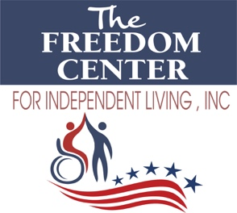
Jody Hougentogler, Executive Director at The Freedom Center for Independent Living, director@fcilde.org
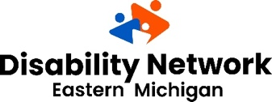
Kelly Winn, Chief Executive Officer at Disability Network Eastern Michigan
Kwinn@dnemichigan.org

Starting Point: Where Freedom Center for Independent Living (FCIL) Began

Leadership Background
- Transitioned from computer engineering to disability advocacy and leadership
- Became Executive Director in 2021 during the COVID-19 pandemic

Organizational Reality
- ~$246,000 in annual funding
- 3-4 staff serving a large geographic area
- Catchment area of ~350,000 people
We had a mission—but not the systems, staff capacity, or reach to fully carry it out.

Before FCIL Begin – A Few Realities
- People with disabilities are not one group—we serve across the lifespan and across all disabilities.
- There is never “enough” funding—but funding is only one part of the resources available to you.
- Resource development is not a straight line—it often looks more like trial, adjustment, and learning over time.
Resource development starts with mindset—not funding.

What is a Resource? (Beyond Funding)
When we talk about resources, we’re not just talking about money.
Resources can include:
- Physical items you have within your Center
- Relationships with organizations and partners
- Knowledge, training, and vetted information
- Staff skills, lived experience, and personal connections
- Funding is only one part of the resources available to you
- Many of these resources already exist within your organization or community

Why Build Resources?

Resources are knowledge and personal connections that help you support and complete consumer goals.
- Resources help you better understand and respond to gaps
- They create a stronger foundation for how your CIL operates
- They position your organization to pursue and use funding more effectively

Questions that often come up:
- Why does another CIL have something we don’t?
- How did they build that process or program?
- Where did their funding come from?

What are Gaps?
A gap is something that is missing, insufficient, or not meeting expectations or requirements.

Common Types of Gaps:
- Funding Gap: The difference between available funding and what is needed to fully support a program.
- Service Gap: When community needs exceed the services provided.
- Compliance Gap: When current practices do not meet regulatory or grant requirements.
- Capacity Gap: A lack of staff, systems, or resources needed to effectively operate.
- Performance Gap: When actual results fall short of goals or targets.

How to Identify Gaps?
- Start by looking at who you are not reaching—and why
- Identify what is getting in the way (not just what is missing)
- Conduct resource mapping exercises
- Engage stakeholders & community members
- Review past programs and outcomes
- Maintain and update a resource database

What Did FCIL Do About Its Gaps?
- Staff took on new roles and built new skills
- We used free training and technical assistance (ILNet, ACL)
- Board members and networks helped open doors to new opportunities
- We strengthened relationships already in place
- We used core services (like I&R) as a foundation for outreach and engagement
- We recognized how services are connected (I&R → outreach → new consumers → new opportunities)
Many of the resources we needed were already there—we just weren’t using them fully to grow.

Shifting How FCIL Think About Resources
- Move beyond “we need funding” to looking at people, skills, and relationships
- Understand that opportunities (funding or connections) are stepping stones
- Be creative and learn how to “sell your work and mission”
- Take time to understand funding before applying
- Focus on opportunities that align with:
  - Independent Living philosophy
  - Staff capacity
  - Long-term sustainability

Building Capacity Within Our Team

We focused internally before expanding outward.

Using staff as a key resource:
- Invested in cross-training staff to “wear multiple hats”
- Made resource development a shared responsibility

Making intentional decisions about growth:
- Built capacity instead of hiring too quickly
- Focused on what the team could realistically sustain

What this made possible:
- Strengthened networks—not just funding opportunities
- Built a culture around the question: “How many can we help?”

How to Find New Resources – Beyond the Basics
Be intentional about where you look
- Map your network
Identify connections across staff, board, and partners—start with who you already know
- Follow the work and the data
Look at demand, outcomes, and gaps to identify who is already funding similar efforts
- Focus your funding strategy
Build around 1–2 funding types that best fit your work—not every opportunity
Understand your funding model
- Different work is supported by different funding sources
- The strongest organizations align funding with their services

How to Find New Resources – Beyond the Basics (cont.)

Examples:
- Government funding (VR, Medicaid, contracts) → ongoing services
- Foundations & grants → innovation and pilot programs
- Community-based support → local needs and outreach
Look in the right places
- National platforms
  - Grants.gov
  - Candid
- Local & community-based opportunities
  - Walmart Spark Good
  - Community foundations
  - State and local agencies

How to Find New Resources – Beyond the Basics (cont.)
- Partnership-driven resources
  - Chamber of Commerce
  - Local businesses and civic groups
  - State programs (VR, AT, Medicaid)

Build relationships—not just proposals
- Connect before you apply
- Pay attention to funder priorities—not just open opportunities
- Stay engaged beyond one request

How FCIL Found New Resources

Once we strengthened our internal capacity, we were able to expand outward.

Reaching the community differently:
- Built a digital presence to increase visibility and access
- Expanded outreach beyond traditional methods
- Showed up more consistently in the community

Building and leveraging partnerships:
- Partnered with Vocational Rehabilitation (Part B connections)
- Connected with MCOs to support HCBS access
- Worked with Assistive Technology and home modification programs

How FCIL Found New Resources (cont.)
- Leveraged board members and networks to identify opportunities

Strengthening our role in the community:
- Positioned ourselves as a resource within I&R and community systems
- Improved how we communicate and present our work

What We Learned Along the Way
- Growth has to match capacity
- Not all funding is sustainable—or the right fit
- You have to work through the tension between growth and sustainability
- It takes time to build programs the right way
- Partnerships strengthen programs and opportunities
- Resource development is ongoing—not one-time

Before You Say Yes to Funding
One of the biggest lessons we learned:
it’s not just about finding funding—it’s about being ready for it

Before moving forward, ask:
- Do we have a clear need we can explain?
- Do we have a plan for how we’ll respond?
- Do we have the capacity to carry it out?

Then decide:
- Move forward
- Adjust
- Or say no
Funding follows clarity—not the other way around

Final Takeaways
- Start with the need
- Use what you have
- Build what you can sustain
Resource development isn’t about finding funding—it’s about building something that lasts, using each opportunity as a stepping stone.
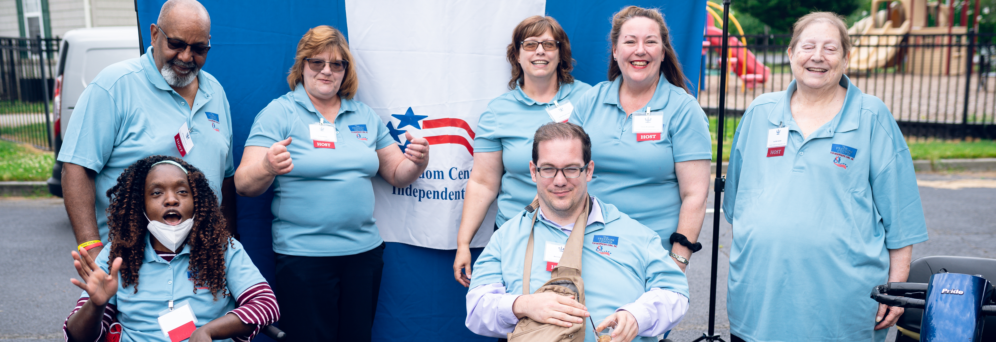

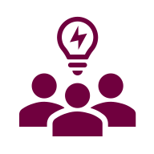
Let’s Pause & Reflect:
Recording has stopped.
- Who is responsible for resource development in your organization?
- Where are you currently feeling the most pressure—capacity or growth?
- Have you ever said yes to something that didn’t fully align?

Ways to Engage:
- Raise your hand to be spotlighted to speak
- Turn on your camera if you're comfortable
- Use the chat to share insights, questions, resources, or tools
- React, reflect, or build on what others say

Disability Network Eastern Michigan (DNEM)

Background
- With DNEM for 20 years
- CEO for 13 years
- Grew from ~$635,000 to over $5 million
- Experienced significant organizational growth

Approach to Growth
- Growth was not just about bringing in funding
- Focused on building something sustainable
- Aligned decisions with:
  - Mission
  - Organizational capacity
  - The needs of the people we serve

Start with Philosophy, Not Funding
IL Philosophy should guide what we pursue – not just what is available
IL Philosophy isn’t just what we believe – it’s how we decide

Use it as a decision filter:
- Does this align with IL’s mission?
- Does this support consumer choice and control?
- Does this move us toward independence and community-based living?
- Does this reflect what our consumer actually need?
Not all opportunities are the right fit—IL Philosophy helps us decide

Building a Culture of Resource Finding
- Understanding where opportunities exist both internally and externally
- Recognizing the role each staff member plays in the process
- Making sure everything we pursue aligns with IL philosophy

Not All Money is Good Money: A DNEM Story
- We saw an increase in referrals-people navigating benefits, housing, and staying independent
- On paper, we were strong: programs, staff, and funding opportunities
- We were presented with a funding opportunity
- It would have required us to shift how we delivered services
- But what consumers needed was the opposite
- We had to make a decision that aligned with our mission and the Independent Living philosophy

Resource Finding & Resource Matching
- Resource finding is identifying opportunities
- Resource matching is making sure those opportunities align with your mission and needs
- You can find resources all day—but if they don’t match your mission, they can pull you off course

Culture
- Culture is what your staff believe—and what they do consistently
- It’s about building an organization that identifies opportunities, not just reacts to them
A question to think about:
- Who in your organization is responsible for resource development?
- If the answer is one person—that may be your first gap
- At DNEM, we shifted from:
  - Resource development as leadership’s responsibility
  - To everyone having a role in sustaining the mission
- If your staff don’t see themselves in resource development, you’re missing your strongest asset

The Need & Gaps

Start by asking:
- Where are we stretched thin?
- Where is demand growing?
- Where are we turning people away?
Look at what you already have:
- Internal Resources
  - Staff Skills
  - Data
  - Programs
- External Resources
  - Community Connections
  - Sponsors and Events
Most organizations don't lack resources-they lack visibility into what they already have

A Quick Process to Identify and Act on Gaps
Who should be involved:
- Leadership
- Frontline staff
- Board, as appropriate
- Consumer input
Use this process to guide decisions:
- Identify 2–3 gap points
(Where demand, access, or outcomes aren’t being met)
- Define one clear gap
(What is the specific need?)
- Identify one available resource
(Internal or external)

A Quick Process to Identify and Act on Gaps (cont.)
- Make the match
(Does this resource actually address the gap?)

Then decide:
- Move forward
- Adjust
- Or say no
- Use DNEM’s Strategic Thinking Guide to support the decision
Not every opportunity should move forward—only the ones that match

Strategic Thinking Guide
A guide we use at DNEM to work through decisions as a team
Helps us slow down, stay aligned with our mission and IL philosophy, and avoid reacting to every opportunity
When we use it:
- New funding opportunities
- New program ideas
- New partnerships
How it works:
- Check alignment (mission + IL philosophy)
- Identify the gap it addresses
- Check capacity (staff, systems, sustainability)
- Decide: move forward—or not

Resource: DNEM Strategic Thinking Guide

Using the Guide: Recreation Program Decision

From Idea to Action
- We knew there was a gap in our community around recreation, especially accessible, inclusive opportunities
- It was one of our strategic priorities-we believed in it and knew it mattered
- The reality was, we didn't have outside funding or a full team in place
- Using the guide, we asked:
  - Does this align with our mission and IL philosophy?
  - Do we have the capacity to start?
- Instead of waiting, we started small
  - An adaptive cooking class

Using the Guide: What Happened Next

From Action to Growth
Once we started:
- People showed up
- Stories started to emerge
- Community interest grew
- Opportunities began to follow
Today, DNEM proudly has:
- 2 Recreation Therapists, 2 Recreation Coordinators, and 2 assistants
- Adaptive kayaking, golf, bowling, pickleball, biking, art, cooking, and wellness classes
- 70 programs delivered to consumers last fiscal year
We started with alignment—the resources came later.

Where to Start
Once you understand your resources, you can start building sustainability
A mix of funding matters – relying on one source puts your stability at risk
Start Here:
- Identify one gap
- Identify one underutilized resource
- Make one intentional match

Keep it Simple:
- Start with your mission
- Use what you already have
- Stay grounded in your gaps
- Match resources intentionally

What Matters Most
- Resource development isn’t
about chasing dollars—it’s about being intentional
- It’s about having the clarity to say yes when something aligns—and the confidence to say no when it doesn’t
When we get that right, we are not just funding programs, we are creating opportunities for people to live independently and fully in their communities.

Resources for Additional Guidance:
- The Rehabilitation Act
- Resource: DNEM Strategic Thinking Guide
- Bridgespan Group
- Grants.gov – Grants Learning Center
- Nonprofit Ready – Cornerstone OnDemand Foundation
- IL T&TA E-Course: Title VII (7) of the Rehabilitation Act and Funding Explained

Coming Up Next – Week 2: Resource Development Cohort: Creating a Culture of Resource Finding – A Financial Sustainability Framework on May 5, 2026!

Your Experience Matters
Recording has stopped – now it’s time to share.
Ways to Engage:
- Raise your hand to be spotlighted to speak
- Turn on your camera if you're comfortable
- Use the chat to share insights, questions, resources, or tools
- React, reflect, or build on what others say
- Share real challenges or successes from your CIL
Let’s turn ideas into action — your voice is the most valuable part of this session.

Evaluation
Thank you for participating in today's Learn and Share.
Your feedback is important and helps us plan future training.
Please use the link in the chat to share your feedback.
Evaluation Link:
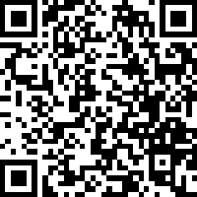

How to Connect with Us!
Website: www.ILTTACenter.org
Request training and / or technical assistance (expert help for your organization): fill out a form on our website to let us know how we can help.
Call: 406-243-5300 and someone will get back to you as soon as we can.
Sign-Up for Events & Announcements:
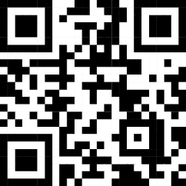
Visit our website to sign up for updates about live training, group technical assistance, new publications, and other happenings around the Center.

IL T&TA Center Attribution

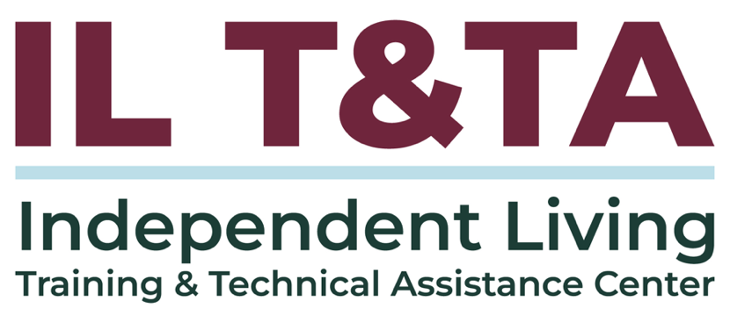
This project is on assignment through contract with the Administration on Disabilities, Administration for Community Living, Health and Human Services.

About the IL T& TA Center
The Independent Living Training and Technical Assistance Center (IL T&TA Center) is available to you through a contract with the US Department of Health and Human Services.
The IL T&TA Center provides expert training and technical assistance to CILs, SILCs, and DSEs.
The Center is operated by the University of Montana's Rural Institute for Inclusive Communities.
