Sustaining Community Partnerships: Skills and Strategies
April 22, 2026
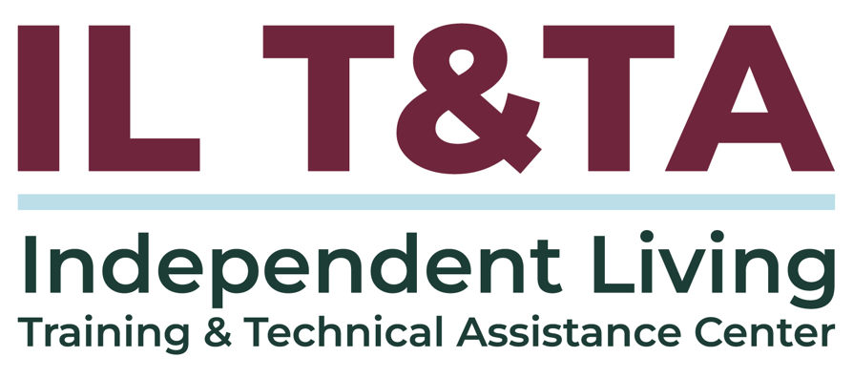

Before We Begin
ASL & Spanish Interpreters are available and labeled.
Access Closed Captioning by clicking the CC button located at the bottom of your Zoom window.
Use Zoom's Raise Hand or Chat features to ask questions.
Use the Q&A box to send us your questions at any time.
Remember to state your name and organization before speaking.
Message our IL T&TA team using the Chat feature if you have difficulties with today's call.
Please complete the survey at the end of today's training.

Today’s Agenda –

Key Takeaways:
- Identify essential skills for building and maintaining strong community partnerships.,
- Discuss strategies for navigating challenges and changes.

Learn & Share Format:
- Technical Foundation
- Peer Content
- Peer Discussion

Overall Goal:
- Let's learn with and from each other!

Presenter
Lidia Fonseca, Ph.d.
Executive Director
VAIL (Valley Association for Independent Living)
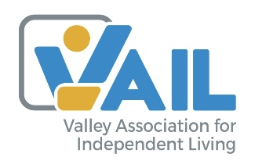
Lfonseca@vailrgv.org

VAIL’s Mission & Community Partnerships
Valley Association for Independent Living empowers individuals with disabilities through advocacy, independence, community inclusion, and services across the South Texas region.
VAIL has strengthened its legacy as a trusted hub for independent living by delivering person‑centered services while advancing systems change through decades‑rooted advocacy in the Rio Grande Valley. Today, VAIL partners closely with local chambers of commerce, city and county public health departments, and regional transportation agencies to build accessible communities, expand Healthcare access, and ensure individuals with disabilities are fully integrated into civic and economic life.
What is Expected of the IL Network?

Rehab Act: 29 U.S.C. § 796 f-4: Standards and assurances for centers for independent living (4-6)
CILs must demonstrate efforts to:
- “Increase the availability of quality community options for independent living.”
- Improve the quality of those options
- Build community capacity to meet the needs of individuals with significant disabilities

45 CFR 1329.2 – Rehab Act’s Purpose for IL
The IL program exists to:
- Promote consumer control, peer support, self-determination, and equal access.

What is Expected of the IL Network? (cont.)
- Advance individual and systems advocacy
- Support integration and full inclusion in society
- Includes improving working relationships among CILs, SILCs, VR, and other public and private programs

Why This Matters
- No single CIL can meet all community needs alone
- Partnerships allow CILs to fill gaps, extend reach, and influence systems
- Strong partnerships help ensure individuals have real choices and access in their communities
This is how the IL network moves from services → systems impact

Session Purpose and Focus
Community partnerships require intention, adaptability, and trust.

This session focuses on:
- Essential skills for building partnerships
- Maintaining partnerships over time
- Navigating challenges and change
- Learning from peer experiences

Why Partnerships Matter for CILs
Community partnerships are critical to advancing independent living and disability rights.
Partnerships help CILs expand access:
- Housing
- Transportation
- Health Care
- Employment
- Community Participation
Strong partnerships increase impact, strengthen advocacy, and support systems change.

What Strong Partnerships Require

Strong partnerships are built on:
- Intention and shared purpose
- Trust and transparency
- Adaptability over time
- Mutual benefit
- Clear roles and expectations

Essential Skill: Communication
- Clear, timely communication reduces confusion.
- Active listening ensures partners feel heard.
- Accessible, plain‑language communication supports disability inclusion.
- Set expectations early: frequency, methods, and points of contact.

Essential Skill: Relationship Building
- Trust grows through consistency and transparency.
- Understanding partner motivations strengthens alignment.
- Shared expectations prevent misunderstandings.
- Relationships deepen through empathy and cultural humility.

Essential Skill: Collaboration & Inclusion
- Identify each partner’s strengths and roles early
- Co‑design solutions for joint ownership
- Embed disability inclusion as essential
- Ensure meetings, documents, and events are accessible

Common Challenges in Community Partnerships
- Leadership turnover
- Changing priorities
- Resource limitations
- Power imbalances
- Communication breakdowns

Strategies for Navigating Challenges
- Revisit goals and expectations when things change
- Regular check‑ins keep communication flowing
- Use conflict resolution tools
  - Example: VAIL Conflict Resolution Toolkit
- Stay flexible and adjust timelines
- Document agreements (MOU, communication plan)

Action Steps & Closing
- Identify one partnership you would like to strengthen
- Name one action you can take in the next 30 days
- Strong partnerships require intention, trust, and adaptability

Peer learning and collaboration strengthen our collective work.

Resources for Additional Guidance
- Sustaining community partnerships: Partnership scenario reflection worksheet [Worksheet]. Valley Association for Independent Living, Inc. Fonseca, L. (2026).
- Empowerment through partnership: Enhancing employment programs for people with disabilities: A toolkit for Centers for Independent Living (CILs). Disability Employment TA Center. Fonseca, L. (2025) – Disability Employment TA Center (DETAC)
- VAIL Conflict Resolution Toolkit.

Your Experience Matters
Recording has stopped – now it’s time to share.

Ways to Engage:
- Raise your hand to be spotlighted to speak
- Turn on your camera if you're comfortable
- Use the chat to share insights, questions, resources, or tools
- React, reflect, or build on what others say
- Share real challenges or successes from your CIL
Let’s turn ideas into action — your voice is the most valuable part of this session.

Evaluation
Thank you for participating in today's Learn and Share.

Your feedback is important and helps us plan future training.
Please use the link in the chat to share your feedback.

Evaluation Link:


Upcoming Events to Join Us On!
- Cohort: Leveraging Resources During Times of Scarcity – April 28, May 5 & 12, 3 PM ET
- Ask Anything – May 14, 2026, 3 PM ET
- SILC Connecrion: Building Strategic Alliances - Collaborations that Advance SPIL Goals – May 19, 2026, 3 PM ET
- Learn & Share: Preparing your Continuity of Operations Plan (COOP) – May 27, 2026, 3 PM ET

How to Connect with Us!

Website: https://ilttacenter.org/

Request training and / or technical assistance (expert help for your organization): fill out a form on our website to let us know how we can help.
Call: 406-243-5300 and someone will get back to you as soon as we can.
Sign-Up for Events & Announcements:

Visit our website to sign up for updates about live training, group technical assistance, new publications, and other happenings around the Center.

IL T&TA Center Attribution

This project is on assignment through contract with the Administration on Disabilities, Administration for Community Living, Health and Human Services.

About the IL T& TA Cent
The Independent Living Training and Technical Assistance Center (IL T&TA Center) is available to you through a contract with the US Department of Health and Human Services.
The IL T&TA Center provides expert training and technical assistance to CILs, SILCs, and DSEs.
The Center is operated by the University of Montana's Rural Institute for Inclusive Communities.
