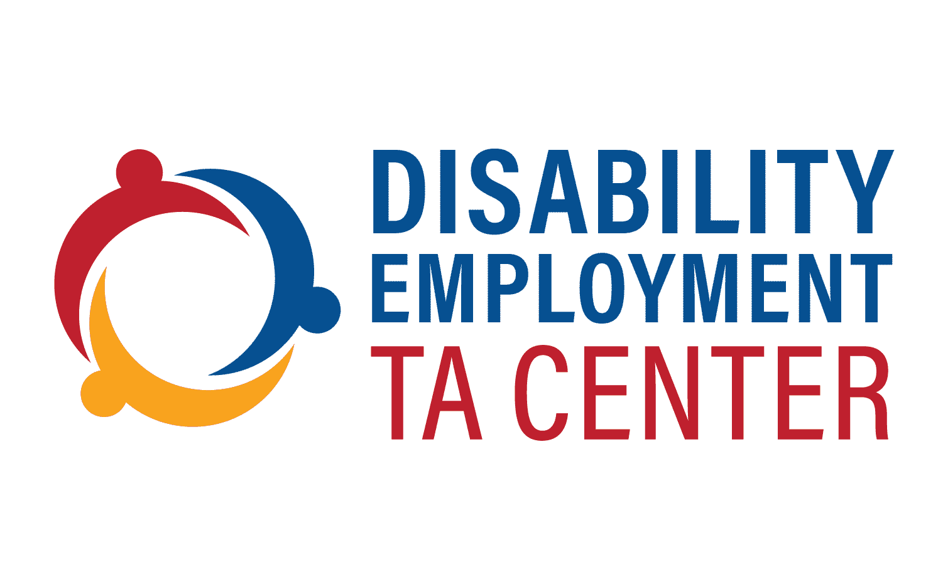
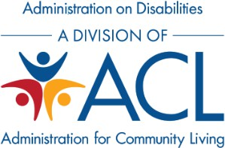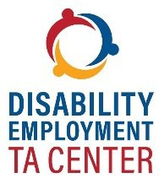

Disability Employment Technical Assistance Center (DETAC)

IL T&TA
Ask Anything Event

April 9, 2026

Disclaimer: This presentation was created by The Lewin Group/TASH under the Administration for Community Living (ACL), Administration on

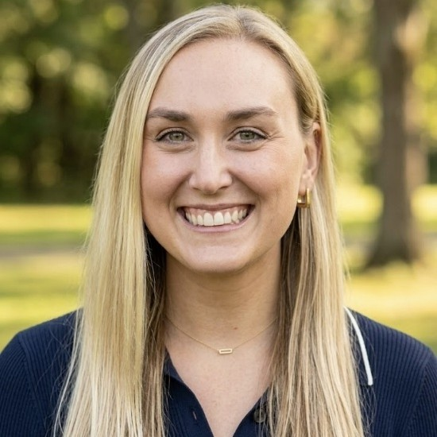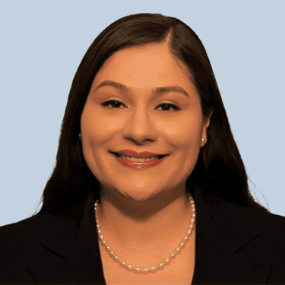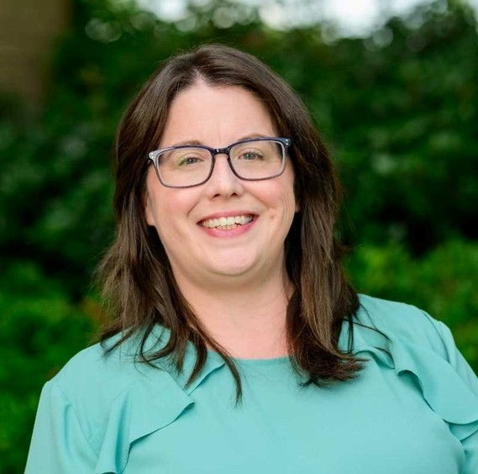

Megan Ryan
Speakers
Project Manager

DETAC

Amy Gonzalez
Senior Advisor

DETAC

Sandy Jordan
Vice President and Chief Community Integration Officer
Able South Carolina

Joe Michener
Assistant Executive Director

Lehigh Valley Center for Independent Living

What is DETAC?
- DETAC provides training and technical assistance (TA) to the Administration on Disabilities (AoD) grantees aimed at improving competitive, integrated employment (CIE) and economic outcomes for individuals with disabilities across the nation. AoD grantees include:
  - Centers for Independent Living (CILs)
  - State Councils on Developmental Disabilities (Councils)
  - University Centers for Excellence in Developmental Disabilities (UCEDDs)
  - State Protection and Advocacy Systems (P&As)
  - Traumatic Brain Injury State Partnership Programs (TBI grantees)
  - Projects of National Significance, Community Collaborations for Employment (PNS-CCE)

DETAC’s TA Offerings

Webinars, Office Hours, Conferences, and Convenings
Results and Innovation in Systems Excellence (RISE) e-
Learning Communities
Resources, Podcasts, Blogs, and Newsletter
On-Demand, Individual TA to AoD Grantees
Website







DETAC provides TA to AoD grantees through the channels listed above.

Upcoming RISE Community for CILs

Scaling Independent Living Employment Programs Through Funding Diversification and Partnership Development

Apply by 5:00PM Eastern Time (ET) Friday, April 24 at this link.
Who Should Apply?
CIL staff with authority to make decisions about scaling new partnerships or pursuing new funding streams, including, but not limited to, program managers, administrators, or senior leaders.
Facilitators & Guest Speakers:
This community will be facilitated by DETAC Senior Advisor Amy Gonzalez, with support from co-facilitator, Mary-Kate Wells, from the National Council on Independent Living (NCIL) and featuring peer guest speakers from the following CILs:
- Session 1: ABLE South Carolina (South Carolina)
- Session 2: Direct Advocacy and Resource Center (Arizona)
- Session 3: Lehigh Valley Center for Independent Living (Pennsylvania)
- Session 4: Independence Inc. (Kansas)

Schedule: 5 sessions on Wednesdays from 1:00-2:15PM ET on 4/29, 5/6, 5/13, 5/20, and 6/3

DETAC Resources & Event Recordings for CILs
Employment and Empowerment Through Sustainable Partnerships Webinar (December 2025)
Empowerment Through Partnership: Enhancing Employment Programs for People with Disabilities Toolkit (with MOU templates!) (August 2025)
The Past, Present and Future of CILs Facilitating Pre-Employment Transition Services (Pre-ETS) RISE e-Learning Community One-Page Summary (May – August 2024)
CILs Connecting People with Disabilities to CIE Webinar (September 2024)
Peer Support for CILs Building Employment Services RISE e-Learning Community One-Page Summary (February – August 2024)
Engaging Youth with Disabilities in the Delivery of Pre-ETS Resource (September 2023)
How CILs Can Promote CIE: Developing Successful Strategic Partnerships Resource (September 2021)

Upcoming Webinar

Building Financial Independence: The ABLE Age Adjustment Act and Tools to Support Financial Empowerment
Tuesday, April 14, 2026
3:00 - 4:30 PM Eastern Time (ET) Register Here

Stay Connected!
- Visit our website: https://aoddisabilityemploymenttacenter.com
- Subscribe to the DETAC listserv
- Contact us via email with questions or to request TA: AoDEmploymentTA@gmail.com
- We look forward to engaging with you on the RISE, and at the NCIL conference in July.

