SILC 101 –Roles, Responsibilities, and Foundations of Effective Councils
April 14, 2026

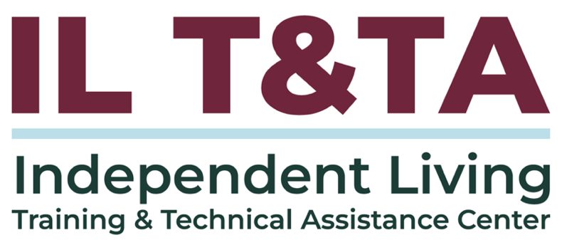

Before We Begin
ASL & Spanish Interpreters are available and labeled.
Access Closed Captioning by clicking the CC button located at the bottom of your Zoom window.
Use Zoom's Raise Hand or Chat features to ask questions.
Use the Q&A box to send us your questions at any time.
Remember to state your name and organization before speaking.
Message our IL T&TA team using the Chat feature if you have difficulties with today's call.
Please complete the survey at the end of today's training.

Cohort Learning Objectives –
- Understand the regulations and indicators regarding the duties, standards, and authorities of all the IL Network partners (CILs, SILC, and DSE).
- Clarify the differences between the roles of CILs, SILCs, and DSEs.
- Know the basics of what the SILC is, what it does, and how it interacts with the other partners.
Abbreviations to Know:
CIL = Center for Independent Living
SILC = Statewide Independent Living Council
DSE = Designated State Entity

Cohort Overview:
- Dates: April 7, April 14, April 16 2026
- Format: Weekly 90-minute Zoom sessions (60 minutes instruction + 30 minutes peer learning)
- Audience: Board Chairs, Board Members, Executive Directors, and Leadership
- Style: Interaction, Peer-Driven, Conversation

Cohort Norms:
- Participation and Presence
- Learning Together
- Respect and Inclusion
- Confidentiality and Trust
- Time and Structure

Your Presenters:
Carrie England, Executive Director at California State Independent Living Council (CA SILC) & Peer Consultant with the IL T&TA Center
Tyler Wilcox, Executive Director of the Independent Living Council of Wisconsin & Peer Consultant with the IL T&TA Center
Jeremy Morris, Executive Director at Ohio Statewide Independent Living Council & Peer Consultant with the IL T&TA Center

Week 1 Recap: SILC Foundations –
- We grounded our work in the Independent Living philosophy
Emphasizing consumer control, self-determination, peer support, and systems advocacy as the foundation of the IL network
- We defined what the SILC is and how it is established
A federally mandated, independent council—separate from state agencies—appointed by the governor and structured to ensure autonomy
- We reviewed how the SILC is structured and who is represented
A majority of members must be individuals with disabilities, alongside representation

Week 1 Recap: SILC Foundations – (cont.)
from CILs, state partners, and the broader community
- We clarified the primary role of the SILC as a governing and planning body
Responsible for developing, monitoring, and evaluating the SPIL—not providing direct services
- We walked through key responsibilities and requirements
Including public meetings, reporting (PPR/704), coordination across the IL network, and maintaining a resource plan to support the work

Other Duties/Requirements for the SILC
- The plan also guides how the Part C centers, who receive direct grants, are to work within the state network, whether or not they receive Part B funds.
- The SILC members are appointed by the governor. The SILC is a public entity, and meets regularly with open or public meetings. These may or may not include public comments. Your plan describes this and must also comply with state open meeting requirements.
- Your SILC is independent and cannot agree to conditions or requirements in your SPIL or Resource Plan that risk that independence.

Some Notes About Public Meetings
- You are required to publish the date and location of the meeting prior to the meeting. How much prior is based on your state’s open meetings act.
- You are required to publish the agenda prior to the meeting based on the open meetings act in your state.
- Typically, you are not required to take public comments.
- You can choose if you take comments and when the public comments take place in your agenda.
- You can limit the length of comments provided by the public.

Some Notes About Public Meetings

(cont.)
- You CANNOT respond to public comments during the meeting if those items are not on the published agenda. Because you are a public entity you CANNOT deviate from the agenda to address comments.
- You can add the questions raised to a future agenda or offer to meet with the individual to answer their questions off the record.

Other duties/requirements (cont.)
- You are also required to coordinate activities with other entities in your state that relate to your SPIL or people with disabilities. Often this coordination is a staff role. Often these entities can provide funding for their specialty services (grants or fees for service) to either the SILC or the CILs.
  - Developmental Disabilities Council
  - Commission on Deaf/HH
  - Older Individuals who are Blind
  - Department of Education Special Education Department
  - Division of Vocational Rehabilitation
  - Are there other state entities that you include in your Council or your SPIL?

Other duties/requirements (cont.)
- You may hire or contract with an Executive Director or other staff to manage the day-to-day operations of the SILC. You should have a Scope of Work or job description for that role.
- The SILC should have a policy for how the performance of the staff is evaluated. This is at least annually, and typically is conducted by either the chair or a committee of the SILC.
- The staff role is to manage the day-to-day communication and operation of the SILC.
- Usually staff is the contact for other organizations and the routine contact for the DSE.

§ 1329.15 Duties of the SILC. (cont.)
e) The SILC shall, consistent with State law, supervise and evaluate its staff and other personnel as may be necessary to carry out its functions under this sections.

What This Means:
- The SILC must supervise and evaluate its staff.
- This also means that if the SILC is assigned one or more State employees, they shall supervise and evaluate that personnel. The State must accept this feedback.

§ 1329.16 Authorities of the SILC
    - The SILC The SILC may conduct the following discretionary activities, as authorized & described in approved State Plan:

What This Means:
- The SILC is allowed to do the following optional activities if they are included in the State Plan:

§ 1329.16 Authorities of the SILC (cont.)
- The SILC The SILC may conduct the following discretionary activities, as authorized & described in approved State Plan:
  - Work with Centers for Independent Living to coordinate services with public and private entities to improve services provided to individuals with disabilities;
  - Conduct resource development activities to support the activities described in the approved SPIL and/or to support the provision of independent living services by Centers for Independent Living; and

§ 1329.16 Authorities of the SILC (cont.)
  - Perform such other functions, consistent with the purpose of this part and comparable to other functions described in section 705(c) of the Act, as the Council determines to be appropriate and authorized in the approved SPIL (including advocacy and disaster planning).

§ 1329.16 Authorities of the SILC (cont.)
- Work with Centers for Independent Living to coordinate services with public and private entities to improve services provided to individuals with disabilities;

What This Means:
- Work with CILs to come together with other entities to improve services for people with disabilities.

§ 1329.16 Authorities of the SILC (cont.)
- Conduct resource development activities to support the activities described in the approved SPIL and/or to support the provision of independent living services by Centers for Independent Living; and

What This Means:
- The SILC is allowed to find new funding sources to support the CILs or SPIL activities.
- You cannot spend federal funds on “fund raising” but other resource development is allowed if you include it in your SPIL

§ 1329.16 Authorities of the SILC (cont.)
- Perform such other functions, consistent with the purpose of this part and comparable to other functions described in section 705(c) of the Act, as the Council determines to be appropriate and authorized in the approved SPIL (including advocacy).

What This Means:
- The SILC is allowed to do other activities as long as:
  - The activity lines up with the Rehab Act,
  - The Council approves it, and,
  - The State Plan allows it.

Emergency Response Coordination as an authority in your SPIL
Many SPILs include this, typically that the CILs will work with the SILC to establish state-wide emergency response coordination to better reach and support individuals with disabilities residing in identified unserved counties.
- How many of you do this?
- Take a minute to tell your peers how this is coordinated.

Advocacy as an Authority in Your SPIL
This is the most common authority, as advocacy is such an important part of Independent Living.
- How many of you do this?
- Take a minute to tell your peers how this is coordinated.
- Is this a staff function or do council members participate?
Do you know how advocacy is different from lobbying, which is not allowed with federal funds or by you in your official council member role?

§ 1329.16 Authorities of the SILC (cont.)
In undertaking the foregoing duties and authorities, the SILC shall:
- Coordinate with the CILs in order to avoid conflicting or overlapping activities within the CILs' established service areas;
- Not engage in activities that constitute the direct provision of IL services to individuals, including the IL core services; and
- Comply with Federal prohibitions against lobbying.

What This Means:
When a SILC is doing activities allowed under federal law, it must:

§ 1329.16 Authorities of the SILC (cont.)
- Work with CILs to prevent duplicate or conflicting activities in a service area.
- Not directly provide IL services.
- Follow federal lobbying rules.

Many of the Things we are Discussing Require Policies and Procedures for the SILC
- Whether or not your SILC is a 501(c)(3) you need written and Council approved policies and procedures.
- The SILC Indicators and Assurances (effective January 31, 2018) include some areas for policies.
- If you don’t have a copy of the SILC Indicators and the SILC and DSE Assurances you can find them here.
- Your SILC should have these policies approved by the full Council.

Highlights of SILC Policies Needed
- Conflict of Interest and Disputes: A method for identifying and resolving actual or potential disputes and conflicts of interest that are in compliance with State and federal law.
- Appointment Process: The SILC must “maintain regular communication with the appointing authority to ensure efficiency and timeliness of the appointment process.”
**Notice that it is the SILC – either the chair or the staff, typically – that should have contact with the governor’s office regarding appointments to the SILC.

Highlights of SILC Policies Needed (cont.)
- Training Plans: The SILC must maintain individual training plans for each member.
**NOTE: Your training plan can include handouts and/or short training videos for a 20-minute segment of each meeting.
Resources for Additional Guidance:
- The Rehabilitation Act
- SILC Indicators and SILC and DSE Assurances
- Independent Living Regulations

Coming Up Next – Week 3: SILC 101 - Know the basics of what the SILC is, what it does, and how it interacts with the other partners on April 16, 2026!

Your Experience Matters
Recording has stopped – now it’s time to share.
Ways to Engage:
- Raise your hand to be spotlighted to speak
- Turn on your camera if you're comfortable
- Use the chat to share insights, questions, resources, or tools
- React, reflect, or build on what others say
- Share real challenges or successes from your CIL
Let’s turn ideas into action — your voice is the most valuable part of this session.

Evaluation
Thank you for participating in today's Learn and Share.
Your feedback is important and helps us plan future training.
Please use the link in the chat to share your feedback.
Evaluation Link:


How to Connect with Us!

Website: www.ILTTACenter.org
Request training and / or technical assistance (expert help for your organization): fill out a form on our website to let us know how we can help.
Call: 406-243-5300 and someone will get back to you as soon as we can.
Sign-Up for Events & Announcements:

Visit our website to sign up for updates about live training, group technical assistance, new publications, and other happenings around the Center.

IL T&TA Center Attribution

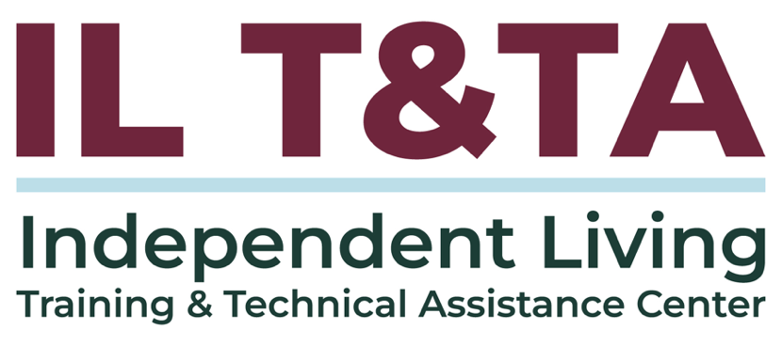
This project is on assignment through contract with the Administration on Disabilities, Administration for Community Living, Health and Human Services.

About the IL T& TA Center
The Independent Living Training and Technical Assistance Center (IL T&TA Center) is available to you through a contract with the US Department of Health and Human Services.
The IL T&TA Center provides expert training and technical assistance to CILs, SILCs, and DSEs.
The Center is operated by the University of Montana's Rural Institute for Inclusive Communities.
