Resource Development Cohort: Activating your Resource Development Plan
May 12, 2026

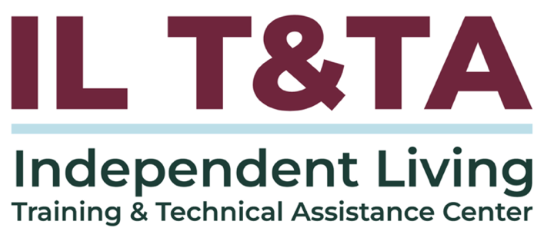

Before We Begin
ASL & Spanish Interpreters are available and labeled.
Access Closed Captioning by clicking the CC button located at the bottom of your Zoom window.
Use Zoom's Raise Hand or Chat features to ask questions.
Use the Q&A box to send us your questions at any time.
Remember to state your name and organization before speaking.
Message our IL T&TA team using the Chat feature if you have difficulties with today's call.
Please complete the survey at the end of today's training.

Cohort Learning Objectives –

Week One:
- Identify gaps, uncover underutilized resources, and explore strategies for diversifying and managing funding to strengthen organizational sustainability.

Week Two:
- Learn how to develop a comprehensive Resource Development Plan that supports both short‑term and long‑term organizational and community goals.

Week Three:
- Learn how to implement a Resource Development Plan across short‑ and long‑term timelines by applying strategies to real‑world scenarios and leveraging their existing organizational expertise.

Cohort Overview:
- Dates: April 28, May 5, May 12, 2026
- Format: Weekly 90-minute Zoom sessions (60 minutes instruction + 30 minutes peer learning)
- Audience: Board Chairs, Board Members, Executive Directors, and Leadership
- Style: Interaction, Peer-Driven, Conversation

Cohort Norms:
- Participation and Presence
- Learning Together
- Respect and Inclusion
- Confidentiality and Trust
- Time and Structure

From Gaps to Plan
In Week 1, you identified:
- Gaps in services, capacity, funding, and reach
- Underutilized resources already within your organization
- Opportunities that align with your mission and IL philosophy
In Week 2, you built:
- Priority programs or services
- Funding gaps and aligned strategies
- Roles, timelines, and ways to track progress

From Planning to Action

This week, we answer:
- How do we move the plan into action?
- How do we apply strategies in real-world situations?
- How do we adjust when opportunities, risks, or funding realities change?
Next Step: Activating the Plan
Connection to Resource Development Sessions 1 & 2:
Small markers in the Week 3 slide deck show how this session connects back to earlier cohort content:
¹ Week 1: gaps, underutilized resources, IL alignment
² Week 2: plan, roles, timelines, risk, evaluation
¹, ² Both: examples that connect to both identifying resources/gaps and organizing those ideas into a Resource Development Plan

Presenters
Kimberly Tissot
President & CEO
Able SC
ktissot@able-sc.org
David Laird
Vice President & Chief Advancement Officer
Able SC
dlaird@able-sc.org

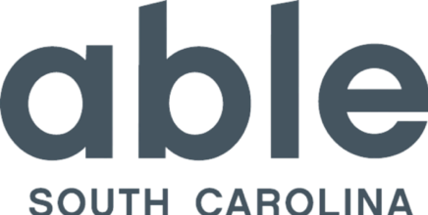

What Implementation Looks Like
As you hear Able SC’s examples, listen for how we:
- Identified needs, gaps, and opportunities
- Used disability-led expertise and relationships
- Built infrastructure before expanding
- Managed risk, timing, and capacity
- Adjusted strategies as funding realities changed

Able SC’s Mission & Vision
Mission
We are an organization of people with disabilities leading the charge to:
- Equip people with disabilities with tools to foster pride and to direct their own lives;
- Educate the community to challenge stereotypes and eliminate barriers; and
- Advocate for access, equity, and inclusion at the individual, local, state, and national level.
Vision
A South Carolina that is a national model of equity and inclusion for all people with disabilities.

Able SC In Action

Disability-Led Visibility Builds Value¹
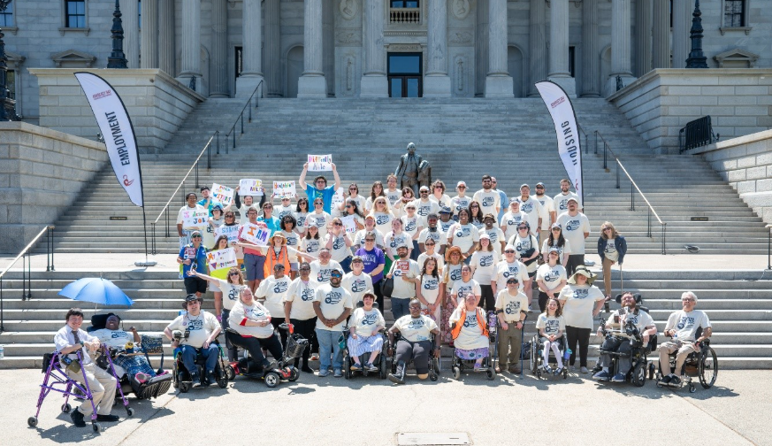
- Showing up publicly builds trust and name recognition
- Community visibility helps partners and donors understand your impact
- Resource development is also movement-building — not just funding

Able SC Today: What Long-Term Activation Can Build
- Annual operating budget of $5.5 million
- ~65 Full Time Staff
- Core services in 23 of 46 counties
- Statewide outreach in other programs
- Nearly 7,000 individuals served annually
- Reach +1.2 million annually through education, outreach, and advocacy
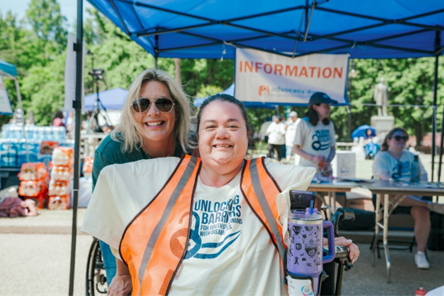

Able SC Today: Infrastructure Behind the Growth
- Manages ~35 grants at any time
- Program and coalition builders
- Systems advocacy and disability-led policy leadership
- FY25: $2.17M awarded from 26 grants
- 40%+ grant success rate
The growth reflects intentional decisions over time — aligning mission, infrastructure, partnerships, and revenue strategies.

Resource Development Is a Mix of Strategies ^{1, 2}
- Funding and contracts:
  - Grants: federal, state, and private foundations
  - Contracts: government and partner agency agreements
  - Medicaid funding: IL skills under HCBS waivers
- Earned and flexible revenue:
  - Fee-for-service: training, accessibility audits, technical assistance
  - Fundraising: individual donors, corporate giving, events
  - Endowment development: long-term sustainability
Refer to the ILT&TA Center’s Key Guidance on Program Income

Resource Development Is a Mix of Strategies ^{1, 2}
- Capacity and relationships:
  - In-kind donations
  - Interns and supervised placements
  - Partnerships and collaborations

Steady Growth through Strategic Action²

Able SC Funding Growth:
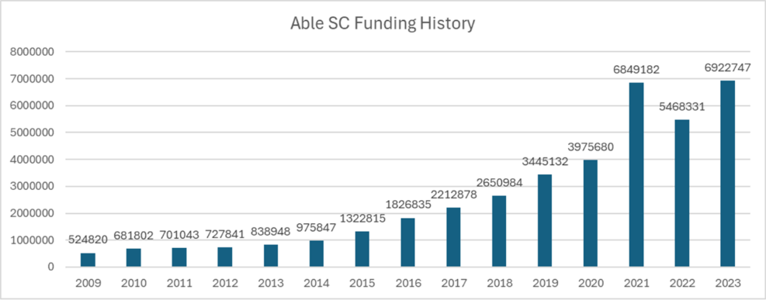
2009: $524k | 2023: $6.9M
- Growth did not happen from one funding source or one strategy
- Each stage required infrastructure, relationships, and follow-through
- Long-term growth comes from activating the plan consistently over time

Visibility Creates Opportunity^{1, 2}
- People may be watching before they ever become donors or partners
- Consistent work builds visibility and trust
- Strong visibility can lead to unexpected opportunities
  - Our work inspired our largest single donation of $2 million
  - This year, the largest has been $50,000
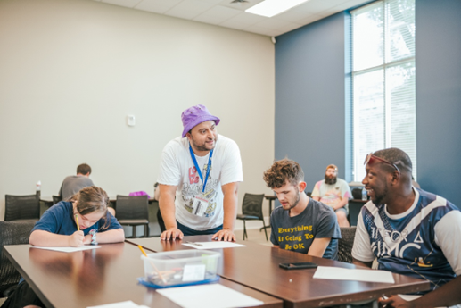

Implementation Reality:

Barriers, Bias, and System Challenges²

Ableism in funding decisions:
- Disability-led organizations are often underestimated, with assumptions about capacity, professionalism, or expertise impacting funding opportunities and partnerships.

Bias toward traditional leadership models:
- Funders may prioritize non-disabled-led organizations, overlooking the lived expertise and innovation that disability-led organizations bring.

Implementation Reality:

Funding and Partnership Delays²

State agency partnership challenges:
- Government partners don’t always operate on nonprofit timelines or realities, leading to delays in contracts, reimbursements, and program implementation.
Cash flow strain from delayed funding:
- Late payments and slow contract execution create financial instability, especially for organizations heavily reliant on state or federal funds.

Implementation Reality:

Funding and Partnership Delays²(cont.)

Misalignment in partnership expectations:
- Some agencies view partnerships as transactional (referrals), rather than collaborative systems-change efforts.

Implementation Reality:

Advocacy, Bureaucracy, and Sustainability

Navigating government bureaucracy:
- Working within systems like SC government can require significant time, compliance, and relationship management, slowing innovation.

Risk in addressing ableism directly:
- Naming ableism can create discomfort or defensiveness among funders and partners, potentially impacting relationships or funding opportunities.

Balancing advocacy with sustainability:
- Pushing for systems change while maintaining funding relationships requires careful strategy and strong communication.

Implementation Reality:

Disability-Led Power is Often Underestimated

Limited understanding of disability-led power:
- Many partners underestimate the policy, programmatic, and community expertise within disability-led organizations, limiting deeper investment and trust.
Reflection Point: Keeping the Plan Moving
- What can still move forward now?
- What needs more clarity before moving ahead?
- What part of the plan needs to be adjusted — not abandoned?

Starting Point: Stabilizing Before Expanding
Established in 1994:
- Minimal reach – six staff for half the state
- Poor financial stability
- Only received Part C funding
- Low Impact
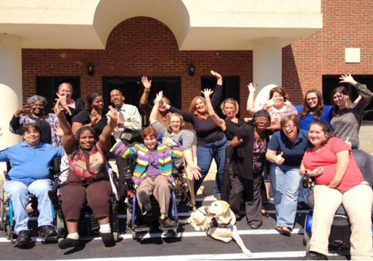
- Compliance issues
2010 Leadership Change to:
- Amplify impact
- Enhance fiscal solvency
- Expand mission
- Stabilize operations and governance
- Re-center the Independent Living philosophy in all that we do as an organization

Change Can Happen Quickly: Building Trust, Value, and Visibility ¹
Early actions:
- Started from scratch
- Built initial state contract with the DD Council for youth programming
- Strengthened partnerships
- Developed a trusted brand
- Focused on consistency in operations and services
How Able SC demonstrated value:
- Under-promised and over-delivered
- Addressed funders’ “pain points”
- Showed what disability-led expertise could offer
- Created organizational advocates who could speak to Able SC’s impact
- Partnered with universities and state leaders

Leveraging Expertise to Create New Resources¹
Built from strong IL service delivery:
- Strong core services
- Solid infrastructure for growth
- Community-driven programming
Expanded fee-for-service opportunities:
- Architectural assessments
- Digital accessibility testing and training
- Policy and procedure review
- Job-site assessments and recommendations
- Professional trainings, presentations, and keynotes

Leveraging Expertise to Create New Resources¹ (cont.)
Created disability-led programming:
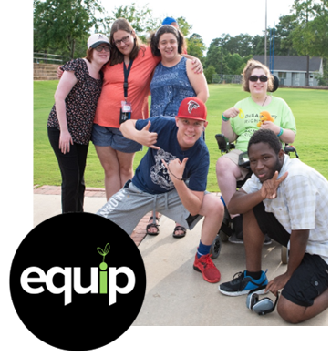
- Disability culture and understanding disability
- ADA architectural standards and barrier removal
- Creating accessible digital resources
- Youth mentoring and peer leadership
- Bull Street Project and other unique programming
Resource development grows when CILs use what they already know and turn that expertise into strategy.

Partnerships That Move the Plan Forward²
SC Developmental Disabilities Council
- Longstanding collaboration
- Youth Leadership Forum
- Multi-day college campus experience for youth with disabilities ages 14–25
- Leadership, self-advocacy, peer connection, and role models with disabilities
Area Mobility Program
- Coordination with area transit system
- Supports mobility and access for people with disabilities

Partnerships That Move the Plan Forward² (cont.)
SC Arts Commission
- Accessibility alignment across state arts association members
- 60+ arts-based organizations reached
- Webinar series reached 40+ states

Good Stewards of Public Funds Start with Strong Infrastructure²
Strong infrastructure includes:
- Disability-led structure and decision-making
- Building your brand
- Expert staff leadership and organizational depth
- Paying your staff, supported by regular comparisons to state and national averages
- Community-driven program development within core CIL services
- Strong service delivery model with integrated continuous quality improvement
- Financial systems and grant management infrastructure

Infrastructure That Supports Growth²
Growth is sustained through:
- Revenue diversification through fee-for-service
- Reserve funding and financial stability
- Data tracking, reporting, and outcomes measurement
- Strategic partnerships beyond referrals
- Internal culture, accountability, and mission alignment
- Strong board members with relationships, professions, and lived experience
Sustainability depends on the people, systems, and relationships behind the funding.

Reducing Risk Through Financial Strategy²
Reduce Reliance on Grants
- Grants are often time-limited, restrictive, and externally driven
- Reducing reliance helps protect mission-driven decision-making
- Less dependency creates more flexibility when funding shifts
Generate Independent Revenue
- Grow earned income streams through fee-for-service, contracts, partnerships, and business models
- Reinforce Able SC’s expertise as a disability-led organization

Reducing Risk Through Financial Strategy (cont.)
- Expand impact beyond traditional funding limitations
- Create flexible, unrestricted funding that supports innovation and systems change
Build a Self-Sustaining Organization
- Building and maintaining financial reserves
- Diversifying revenue streams
- Investing in infrastructure that supports long-term growth
- A self-sustaining model allows us to lead boldly, advocate effectively, and remain accountable to the disability community—not funding trends.

Big Goals: Long-Term Vision
Building What Comes Next

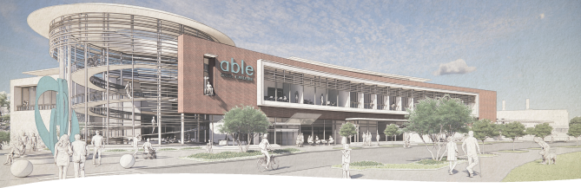
Rendering of Able SC’s future headquarters, representing a long-term vision for accessibility, community engagement, and disability-led sustainability.

Capital Campaign: Long-Term Resource Development Strategy
Long-term resource development happens when a plan moves beyond immediate needs and begins building future capacity.
Bull Street vision:
Transform a site of historic segregation into a hub of disability inclusion and a multi-use campus with diverse revenue streams.
Potential revenue streams:
- Disability Rights & History Museum — admissions, memberships, sponsorships, educational programming
- All-inclusive fitness center — memberships, classes, training, and wellness partnerships

Capital Campaign: Long-Term Resource Development Strategy (cont.)
- Accessible office space — long-term leases with mission-aligned tenants
- Conference and event rentals — facility rentals and hosted events
- National disability-led training center — training contracts, certification programs, consulting, and strategic partnerships
Long-term resource development can turn mission, expertise, and community need into sustainable revenue strategies


Let’s Pause & Reflect:
Recording has stopped.
- What is something your CIL does really well?
- What relationship or partnership are you proud of?
- What is one recent win we can celebrate with you?
Ways to Engage:
- Raise your hand to be spotlighted to speak
- Turn on your camera if you're comfortable
- Use the chat to share insights, questions, resources, or tools
React, reflect, or build on what others say

Donor Engagement as a Resource Development Strategy²

What Wasn’t Working:
- Recognized the need for more diverse funding streams
- Relied on traditional approaches: galas, year-end appeals, giving days
- Saw limited results from those efforts
- Donor conversations were often event-heavy
- Donor data and profiles were inconsistent
- Hesitated to make a bolder, more direct ask
Activating a plan starts with naming what is not working — and being willing to shift the strategy.

Turning a Funding Gap Into a Clear Call to Action
The challenge:
- $750,000 budget shortfall
- Threats to federal grants, agencies, disability protections, and essential work
- Needed a new approach that was clear, unified, and community-facing
The strategy needed to:
- Center the disability voice
- Recognize Able SC’s impact
- Create a unified agency message
- Elevate the reality that 1 in 3 South Carolinians has a disability
- Be honest and real with the community

Strengthening the Message Before the Ask
- Engaged an external communications firm with nonprofit fundraising expertise
- Recognized the need for an outsider perspective
- Shifted away from language that only made sense internally
- Asked: Do people know what a CIL is? Do they understand disability-led value?
- Led with vulnerable strength: strong, still here, but impacted by cuts
- Acknowledged that Able SC could not stop every cut — but together we can fill the gap
A strong donor strategy requires clear language, audience awareness, and a direct connection to impact.

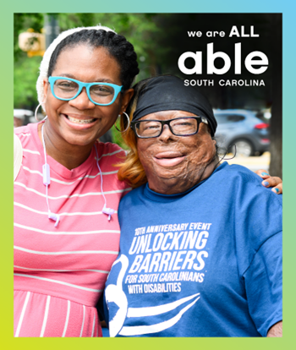
Campaign in Action: We Are All Able
- Launched as a crisis campaign to create urgency
- Acknowledged the budget shortfall directly
- Shared that Able SC began the year with a budget deficit
- Named the remaining gap: narrowed to $350,000
- Made a clear and direct ask for support
- Became Able SC’s first direct public ask in 32+ years to help meet a goal
Did not mask the ask —connected the need, the progress, and the role supporters could play.

Campaign Implementation: Focused Outreach
- Concentrated communications presence
- Paused most messages not directly related to the campaign
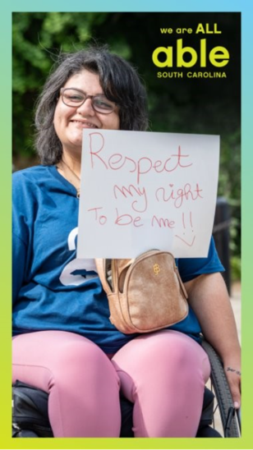
- Used a heavy communication blitz across social channels, email signatures, and business cards
- Created printed campaign pamphlets for higher-level donors
- Sent direct mail three times
- Focused on reengaging lapsed donors
- Used direct, personal touches

Campaign Results: Tracking Progress²
- $183,332 raised from individual philanthropic support since October 2025
- Additional $10,000 received from transferred stock
- 52.3% of campaign goal reached
- 86% increase in total charitable donations received in FY24–25
Tracking results helps show progress, adjust strategy, and maintain momentum.
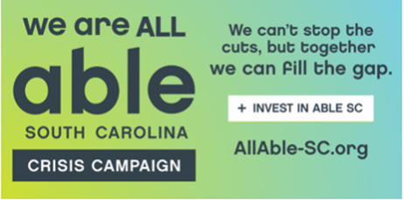

Campaign Results: Donor Engagement Measures
 | Number / % | Change from FY24-25 to date
Total Donations | 245 | +31.2%
Total Donors | 199 | +43.5%
Donor Retention | 20.5% | +17.9%
1st Year Retention | 12% | +4%
Multi-Year Retention | 35.7% | +3%
Reactivation Rate | 5.2% | +3.6%
Resource development is not just dollars raised — it is also donor growth, retention, and reactivation.

What We Learned: Clarity Matters
- Most people will not know the nuances of your programs, funding sources, or regulations
- Most people will not understand how your funding streams work or what funds can and cannot support
- People are often most interested in what you provide, who you serve, and why it matters
- A clear message helps people understand the need
- A direct opportunity to help gives people a way to respond

What We Learned: Cultivation Takes Time
- Make friends first, then cultivate ways for them to become supporters
- Keeping supporters engaged can be even harder than securing the first gift
- Know your audience and speak to what they value
- Donors love a big vision — what are you driving toward?
- Big gifts typically do not happen overnight
- Cultivation is ongoing, not a one-time ask

What’s Next: Building Donors Into the Bigger Vision
Able SC is working to:
- Strengthen donor retention strategies
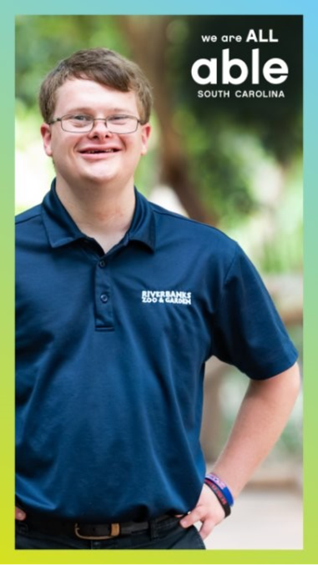
- Use non-standard events to bring donors together to learn why they support Able SC
- Convert donors into ambassadors
- Re-envision how Able SC can become more integrated into the community
- Show that Able SC is beyond services — it represents 1 in 3 people in the state

What’s Next: Building Donors Into the Bigger Vision (cont.)
- Be unique — not just seen as a service provider
- Embed Able SC in new places outside of the traditional service sphere
- Create fresh approaches for everyday givers to advance the mission and programs
- Begin introducing bigger, bolder dreams

Applying This to Your Plan
Able SC’s scale may look different from your CIL, but the process can apply anywhere:
- Start with one strategy that is ready to move forward
- Build from existing expertise, relationships, or programs
- Identify one risk, barrier, or timing issue to manage
- Adjust the plan where needed — don’t abandon it
- Define progress at 30, 90, or 180 days
Activation can start small and build over time.

Resources for Additional Guidance
- The Rehabilitation Act
- ILT&TA Key Guidance on Program Income
- Resource Development Planning Worksheet – Fillable Template²
- Resource: DNEM Strategic Thinking Guide

Connection to Resource Development Sessions 1 & 2
The Week 3 slide deck includes small markers to show where today’s content connects back to earlier cohort themes.
¹ Week 1: Week 1: Creating a Culture of Resource Finding
Identifying gaps, underutilized resources, existing strengths, and alignment with the Independent Living philosophy.
² Week 2: Designing a Resource Development Plan for Sustainability
Organizing those ideas into a Resource Development Plan through goals, strategies, roles, timelines, risk, evaluation, and sustainability.
¹, ² Both: Content that connects to both identifying resources/gaps and organizing those ideas into a Resource Development Plan.

Your Experience Matters
Recording has stopped – now it’s time to share.
Ways to Engage:
- Raise your hand to be spotlighted to speak
- Turn on your camera if you're comfortable
- Use the chat to share insights, questions, resources, or tools
- React, reflect, or build on what others say
- Share real challenges or successes from your CIL
Let’s turn ideas into action — your voice is the most valuable part of this session.

Evaluation
Thank you for participating in today's Learn and Share.
Your feedback is important and helps us plan future training.
Please use the link in the chat to share your feedback.
Evaluation Link:
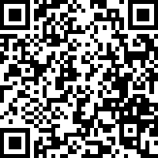

How to Connect with Us!

Website: www.ILTTACenter.org
Request training and / or technical assistance (expert help for your organization): fill out a form on our website to let us know how we can help.
Call: 406-243-5300 and someone will get back to you as soon as we can.
Sign-Up for Events & Announcements:
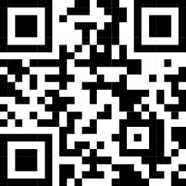
Visit our website to sign up for updates about live training, group technical assistance, new publications, and other happenings around the Center.

IL T&TA Center Attribution

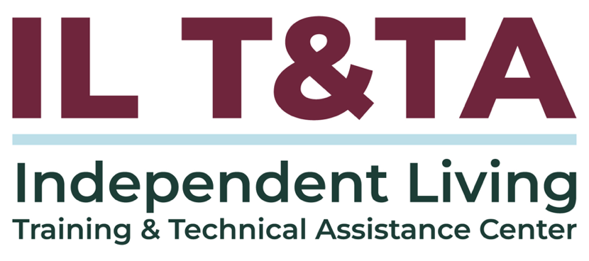
This project is on assignment through contract with the Administration on Disabilities, Administration for Community Living, Health and Human Services.

About the IL T& TA Center
The Independent Living Training and Technical Assistance Center (IL T&TA Center) is available to you through a contract with the US Department of Health and Human Services.
The IL T&TA Center provides expert training and technical assistance to CILs, SILCs, and DSEs.
The Center is operated by the University of Montana's Rural Institute for Inclusive Communities.
