iLab Communications Create Connection: Authentic Storytelling
May 27, 2026
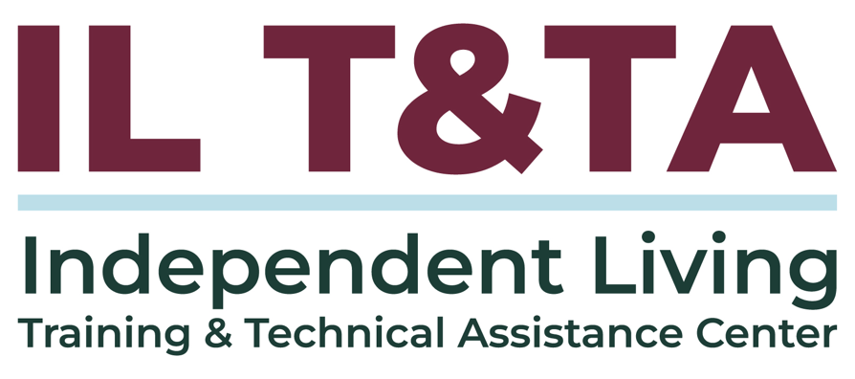

Before We Begin
ASL & Spanish Interpreters are available and labeled.
Access Closed Captioning by clicking the CC button located at the bottom of your Zoom window.
Use Zoom's Raise Hand or Chat features to ask questions.
Use the Q&A box to send us your questions at any time.
Remember to state your name and organization before speaking.
Message our IL T&TA team using the Chat feature if you have difficulties with today's call.
Please complete the survey at the end of today's training.

Today’s Agenda –

Key Takeaways:
- Practice sharing stories in a supportive peer setting and incorporate feedback to strengthen everyday communications
- Identify key elements of authentic, impactful storytelling that reflect Independent Living values and lived experience.

Overall Goal:
- Let's learn with and from each other!

Why do stories matter?
- Stories centered in lived experience reinforce Independent Living values
- Stories help people connect
- Stories create understanding beyond facts, statistics, or program descriptions
- Stories support advocacy, outreach, and relationship-building

What makes a story effective?
- Authentic and grounded in real experience
- Clear and easy to follow
- Focused on impact rather than excessive detail
- Relevant to the audience
- Centered on dignity, choice, and consumer control

Storytelling is not a performance
- The goal is connection – not perfection
- Avoid sounding scripted or overly polished
- Focus on clarity and relevance
- Use plain language and real examples
- Invite conversation instead of delivering a presentation

Know your audience
- Consumers may want connection and practical relevance
- Community partners may want collaboration opportunities
- Legislators or funders often look for impact and outcomes
- Adjust the story without changing its authenticity

Anchors for storytelling
- Keep one short story ready for everyday conversations
- Use one clear takeaway or impact point
- Prepare one question that keeps the conversation going
- Avoid jargon and acronyms whenever possible
- Identify what matters most to the listener

A simple story structure
- Situation – What was happening?
- Barrier or challenge – What needed to change?
- Action – What support, advocacy, or resource helped?
- Impact – What difference did it make?
- Connection – Why does this matter to others?

Peer-learning activity
- Share a story connected to your work or lived experience
- Limit stories to approximately 2-3 minutes
- Peers will identify strengths and areas that felt most impactful, offering supportive, constructive feedback

Guidance for peer feedback
As you are listening, consider:
- What part of the story felt most meaningful or memorable?
- Which Independent Living values came through clearly?
- What details strengthened the message?
- What could be simplified or clarified?

Evaluation
Thank you for participating in today's Learn and Share.
Your feedback is important and helps us plan future training.
Please use the link in the chat to share your feedback.
Evaluation Link


Upcoming Events to Join Us On!
- Webinar: Collaboration with State Assistive Technology Programs – June 9, 2026, 3 PM ET
- Ask Anything – June 11, 2026, 3 PM ET
- SILC Connection: The SILC's Role in Advocacy – June 16, 2026, 3 PM ET
- Learn and Share: Supporting Consumers Through a Service Disruption – June 24, 2026, 3 PM ET

How to Connect with Us!

Website: https://tinyurl.com/ILTTACenter
Request training and / or technical assistance (expert help for your organization): fill out a form on our website to let us know how we can help.
Call: 406-243-5300 and someone will get back to you as soon as we can.
Sign-Up for Events & Announcements:

Visit our website to sign up for updates about live training, group technical assistance, new publications, and other happenings around the Center.

IL T&TA Center Attribution

This project is on assignment through contract with the Administration on Disabilities, Administration for Community Living, Health and Human Services.

About the IL T& TA Center
The Independent Living Training and Technical Assistance Center (IL T&TA Center) is available to you through a contract with the US Department of Health and Human Services.
The IL T&TA Center provides expert training and technical assistance to CILs, SILCs, and DSEs.
The Center is operated by the University of Montana's Rural Institute for Inclusive Communities.


