Resource Development Cohort: Designing a Resource Development Plan for Sustainability
May 5, 2026

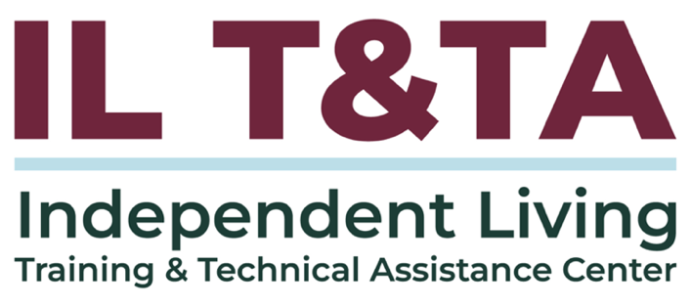

Before We Begin
ASL & Spanish Interpreters are available and labeled.
Access Closed Captioning by clicking the CC button located at the bottom of your Zoom window.
Use Zoom's Raise Hand or Chat features to ask questions.
Use the Q&A box to send us your questions at any time.
Remember to state your name and organization before speaking.
Message our IL T&TA team using the Chat feature if you have difficulties with today's call.
Please complete the survey at the end of today's training.

Cohort Learning Objectives –

Week One:
- Identify gaps, uncover underutilized resources, and explore strategies for diversifying and managing funding to strengthen organizational sustainability.

Week Two:
- Learn how to develop a comprehensive Resource Development Plan that supports both short‑term and long‑term organizational and community goals.

Week Three:
- Learn how to implement a Resource Development Plan across short‑ and long‑term timelines by applying strategies to real‑world scenarios and leveraging their existing organizational expertise.

Cohort Overview:
- Dates: April 28, May 5, May 12, 2026
- Format: Weekly 90-minute Zoom sessions (60 minutes instruction + 30 minutes peer learning)
- Audience: Board Chairs, Board Members, Executive Directors, and Leadership
- Style: Interaction, Peer-Driven, Conversation

Cohort Norms:
- Participation and Presence
- Learning Together
- Respect and Inclusion
- Confidentiality and Trust
- Time and Structure

Key Guidance from the Rehab Act on Resource Development for CILs
- [the CIL] will conduct resource development activities to obtain funding from sources other than this chapter. Section 725 (b) Standards (7)
- [the CIL] will establish clear priorities through annual and 3-year program and financial planning objectives for the center, including overall goals or a mission for the center, a work plan for achieving the goals or mission, specific objectives, service priorities, and types of services to be provided, and a description that shall demonstrate how the proposed activities of the applicant are consistent with the most recent 3-year State plan under section 704; Section 725 (c) Assurances (4)

From Foundation to Action

Last week, you identified:
- Gaps in your services
- Underutilized resources
- What aligns with your mission

This week, we answer:
- How do we turn that into a plan?
- How do we organize it into action?
- How do we sustain it long-term?
Next Step: Building the Plan

Presenters
Amy Morris
Chief Operating Officer & Development Director
RAMP Disability Resources & Services
Amorris@rampcil.org
Amanda Fair
Development Associate
RAMP Disability Resources & Services
Afair@rampcil.org

About RAMP Disability Resources & Services
- RAMP is a Center for Independent Living in Northern Illinois, established in 1980
- Serve 1,000+ across four counties
- Team of 45 total employees
- Began fundraising on a small scale in 90’s with a Wheel-A-Thon
- An endowment was established in 1992
- Today, we utilize a mix of grants, contracts, donations, special events, and earned revenue to support our programs and mission.

What We’ll Cover Today
- What resource development means (beyond fundraising)
- How to design a simple, actionable Resource Development Plan
- How to align funding with your mission and budget
- How to build sustainable, diversified funding

Types of Funding (Quick Overview)
Grants
- Funding from government (State, Federal, Institutional)
- Usually tied to specific programs
Contracts
- Payment for delivering services
- Often ongoing and structured
Foundation Gifts/Grant
- Funding from private or family foundations
- Often aligned to mission and may offer more flexibility (some unrestricted)
Donations
- Individuals or businesses
- Flexible but relationship-based

Types of Funding (Quick Overview) (cont.)
Special Events
- Fundraising events (runs, dinners, etc.)
- Also build awareness
Earned Revenue
- Fees for services (training, consulting)
- Growing opportunity for CILs for more partnerships
- Provides flexibility to respond to needs that traditional funding may not cover
Refer to the ILT&TA Center’s Key Guidance on Program Income
Which sources do you rely on most today?
Which are you not currently using?

Resource Development = More Than Fundraising
Resource development is how we sustain and grow our mission.
It includes:
- Funding
- Partnerships
- Organizational expertise
- Community relationships

Using What You Already Have
Start with what already exists within your organization.
- Alignment to IL Philosophy
- What skills does your team have?
- What programs or services are you already strong in?
- What assets or resources are available to you?
Examples:
- Existing programs expand or adapt to reach new audiences
- Training programs fee-for-services
- Partnerships expanded reach
- Staff Expertise consulting or partnerships
- Space or assets generating small revenue streams

Resource Development Plan
What Makes a Strong Plan?

A Resource Development Plan includes:
- Alignment to the IL Philosophy
- Clear goals and priorities
- Revenue strategy
- Budget alignment
- Roles and timeline
- Relationship building
- Evaluation and monitoring

Determining Which Resources to Pursue

Build with your existing programs and services – don’t chase money
Focus on clear understanding of these:
- What you already do well
- What your community needs
- What you want to sustain
Build your plan around your work and mission —
not funding opportunities.

Budget Alignment: Budget Drives the Plan

Your budget helps identify:
- Fully funded programs
- Partially funded programs
- Unfunded needs
Use funding gaps to guide your resource development efforts.
Reflection: Take a minute and think about your organization – what is one program that is not fully funded?

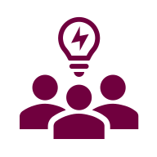
Let’s Pause & Reflect:
Recording has stopped.
- What is one program or service that stands out as a priority?
- Where are you currently not fully funded or at risk?
- What feels most urgent to address?

Ways to Engage:
- Raise your hand to be spotlighted to speak
- Turn on your camera if you're comfortable
- Use the chat to share insights, questions, resources, or tools
- React, reflect, or build on what others say

Revenue Strategy
- Identify funding sources that align with your needs.
- Use a mix of funding to support programs.
- Avoid relying on a single funding source.
- Avoid duplication of funding
  - Charging the same cost to multiple sources beyond actual need
- Set internal targets for diversification (e.g., a portion of revenue from fundraising or earned income)

Diversification Reduces Risk
Diversified funding means using multiple funding sources.
This helps:
- Reduce financial risk
- Increase stability
- Support long-term sustainability and continuity of services
What happens if one funding source ends?

Understanding Financial Risk
Risk increases when you rely on limited funding sources.

Consider:
- What would happen if funding changes or ends?
- How would it impact your programs?

Planning for Sustainability
Focus on long-term stability, not short-term fixes.

Sustainability comes from:
- Diversified funding
- Strong relationships
- Alignment with your mission
- Prioritization vs. expansion

Reworking Budgets
Budgets may need to change as funding changes.
You may need to:
- Adjust programs
- Reallocate resources
- Shift priorities

Keep decisions aligned with your mission.

Roles & Responsibilities
You do not need a large team to do resource development.
Start small – build capacity over time.
Assign simple roles:
- Grant writing
- Relationship building
- Tracking deadlines
Small, consistent efforts make a big impact.

Relationship Building: Development is About Relationships
Strong relationships lead to sustainable support.
Focus on:
- Building awareness
- Creating connections
- Maintaining communication
- Demonstrating impact

Funding often follows relationships – not the other way around.

Where to Begin: Your Plan
Your Plan Should Answer
- What programs need funding?
- Where will funding come from?
- Who is responsible?
- What is the timeline?

Keep your plan simple and actionable.

How to Build Your Resource Development Plan
Start with this simple framework—this is not a 50-page document.
- Identify priority programs or services
  - What needs to be sustained or expanded?
- Determine funding status
  - Fully funded, partially funded, or unfunded?
- Define the gap
  - What is missing or at risk?
- Identify aligned funding strategies.
  - Grants, contracts, donations, earned revenue

How to Build Your Resource Development Plan (cont.)
- Assign roles and responsibilities.
  - Who owns each part?
- Set a realistic timeline.
  - What happens in the next 30, 60, 90 days?
- Define how you will track progress.
  - What does success look like?

What This Looks Like in Practice
Program: Transportation Support Services
Funding Status: Partially Funded
Gap: Limited funding to meet growing demand for accessible transportation
Strategy:
- Apply for local foundation grant
- Explore contract with regional transit partner
Roles:
- Executive Director → partnerships
- Program Manager → implementation
Timeline:
- Identify funders (30 days)
- Submit application (60–90 days)

What This Looks Like in Practice (cont.)
Evaluation:
- Increase number of consumers served
- Track unmet transportation requests

Evaluation & Monitoring
Track your efforts over time.
Plans should be reviewed and adjusted regularly as needs and funding change.
Ask:
- What is working?
- What is not working?
- What should we adjust?
Use this information to improve your strategy.

Key Takeaways
- Resource development is more than fundraising
- Start with your programs and budget
- Funding should support your work – not define it (avoid chasing funding)
- Diversify to reduce risk and increase flexibility
- Keep your approach simple and consistent – it will build over time
- Resource development is ongoing – it should evolve as your needs change

Resources for Additional Guidance:
- The Rehabilitation Act
- IL T&TA E-Course: Title VII (7) of the Rehabilitation Act and Funding Explained
- IL T&TA Guide: Resource Development Planning Guide & Sample Plan

Coming Up Next – Week 3: Resource Development Cohort: Activating your Resource Development Plan on May 12, 2026!

Your Experience Matters
Recording has stopped – now it’s time to share.
Ways to Engage:
- Raise your hand to be spotlighted to speak
- Turn on your camera if you're comfortable
- Use the chat to share insights, questions, resources, or tools
- React, reflect, or build on what others say
- Share real challenges or successes from your CIL
Let’s turn ideas into action — your voice is the most valuable part of this session.

Evaluation
Thank you for participating in today's Learn and Share.
Your feedback is important and helps us plan future training.
Please use the link in the chat to share your feedback.
Evaluation Link:


How to Connect with Us!

Website: www.ILTTACenter.org
Request training and / or technical assistance (expert help for your organization): fill out a form on our website to let us know how we can help.
Call: 406-243-5300 and someone will get back to you as soon as we can.
Sign-Up for Events & Announcements:

Visit our website to sign up for updates about live training, group technical assistance, new publications, and other happenings around the Center.

IL T&TA Center Attribution

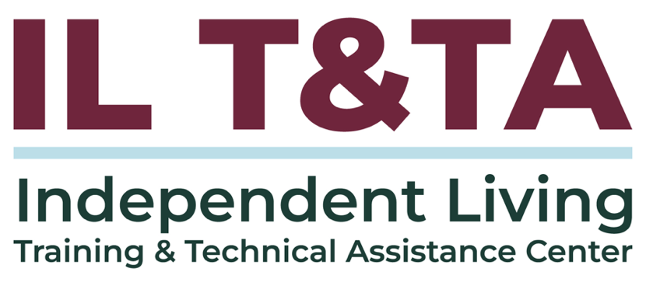
This project is on assignment through contract with the Administration on Disabilities, Administration for Community Living, Health and Human Services.

About the IL T& TA Center
The Independent Living Training and Technical Assistance Center (IL T&TA Center) is available to you through a contract with the US Department of Health and Human Services.
The IL T&TA Center provides expert training and technical assistance to CILs, SILCs, and DSEs.
The Center is operated by the University of Montana's Rural Institute for Inclusive Communities.
