SILC Connect: Building Strategic Alliances: Collaborations that Advance SPIL Goals
May 19, 2026

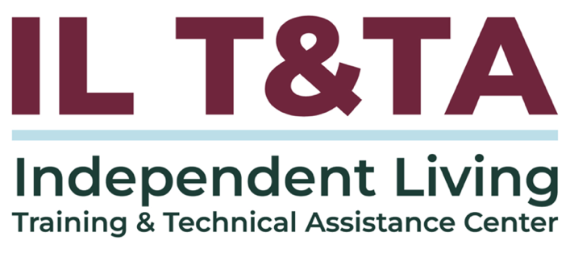

Before We Begin
ASL & Spanish Interpreters are available and labeled.
Access Closed Captioning by clicking the CC button located at the bottom of your Zoom window.
Use Zoom's Raise Hand or Chat features to ask questions.
Use the Q&A box to send us your questions at any time.
Remember to state your name and organization before speaking.
Message our IL T&TA team using the Chat feature if you have difficulties with today's call.
Please complete the survey at the end of today's training.

Today’s Agenda –
Key Takeaways:
- Identify critical collaborators that support SPIL goals and statewide Independent Living activities.
- Assess how collaboration can increase statewide impact and system-level change

Overall Goal:
- Let's learn with and from each other!

Presenter:
Shelly Richardson, Executive Director
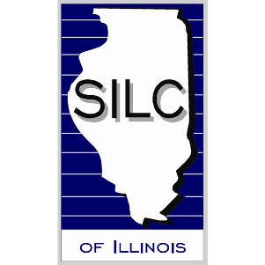
Statewide Independent Living Council of Illinois (SILC)
shelly@silcofillinois.org
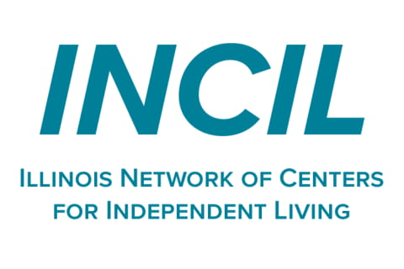
John S. Herring, Sr., Executive Director
Illinois Network of Centers for Independent Living (INCIL)
john.herring@illinoiscils.org

Facilitator:
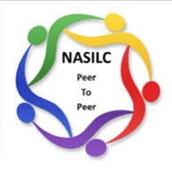
Brooke Wilson , Chair- NASILC (National Association of State Independent Living Councils)

Who and What is INCIL
- INCIL is the statewide network for the 22 Centers for Independent Living in Illinois.
- INCIL contracts with the Department of Human Services and subcontracts with CILs to provide support for consumer services throughout Illinois.
- INCIL also serves as a statewide connection point between CILs, advocacy, consumer services, and Independent Living (IL) priorities.
Mission:
A united network serving as the leading resource for Illinois CILs, ensuring Centers have the resources needed to advocate for the rights of people with disabilities.
Vision:
People with disabilities living barrier-free lives in Illinois.

Embedding Collaboration into Structure
Illinois has an intentional CIL-to-SILC collaboration structure that creates regular connection points between INCIL, CIL leaders, the SILC, and SPIL development.
This includes:
- A CIL Executive Director serving on the SILC Board
- INCIL's Executive Director being invited to each SILC Board meeting
- Several CIL Executive Directors serving on the SPIL writing committee
- The SILC Executive Director being included on the INCIL Board meeting agenda

Why the INCIL/SILC Structure Matters

This structure helps move collaboration beyond informal communication and into regular planning spaces.

It helps ensure:
- CIL experience informs statewide planning
- Consumer needs stay connected to SPIL priorities
- SILC and INCIL maintain ongoing communication
- Collaboration is built into meetings, committees, and leadership spaces

Connection to the SPIL: Consistent communication helps ensure statewide priorities reflect what consumers and CILs are seeing across Illinois.

How SILC Decides Who to Partner With
Start with consumer input before writing SPIL goals and objectives.
Look at what consumers are saying they are having the most trouble with, then identify partners who can help carry out those priorities, such as:
- CILs and IL network partners
- State and federal agencies
- Local governments
- Nonprofits and community organizations
Use SILC board member expertise and relationships to help identify strong collaboration opportunities.

Building a Good Rapport with Your Partners
Strong partnerships begin before SPIL goals and objectives are finalized.

Take time to:
- Reach out early to potential partners
- Get to know their key people and contacts
- Ask about their contract deliverables
- Ask how SILC could help them with their goals
- Look for mutual benefits, such as shared webinars and trainings
- Attend local festivals, resource fairs, and community events to connect with potential partners

Maintaining Strong Partner Relationships
Partnerships need continued communication after the first activity or project.
Ways to maintain the relationship:
- Keep in contact with partners
- Use online meetings to brainstorm ideas
- Meet timeline goals and keep each other updated on progress
- Stay connected after the collaboration or activity is completed
- Share partners’ newsletters, webinars, and resources with your CIL network
Over time, strong relationships can reduce cold outreach and create more natural collaboration opportunities.

Resources for Additional Guidance
How to Develop Nonprofit Relationships to Expand & Scale Programs & Generate Revenue: Exploration of Cooperation, Partnership, and Collaborations
18 Strategies Nonprofits Can Leverage To Build Solid Relationships -

Your Experience Matters
Recording has stopped – now it’s time to share.
Ways to Engage:
- Raise your hand to be spotlighted to speak
- Turn on your camera if you're comfortable
- Use the chat to share insights, questions, resources, or tools
- React, reflect, or build on what others say
- Share real challenges or successes from your CIL
Let’s turn ideas into action — your voice is the most valuable part of this session.

Evaluation
Thank you for participating in today's SILC Connection.
Your feedback is important and helps us plan future training.
Please use the link in the chat to share your feedback.
Evaluation Link:


Upcoming Events to Join Us On!
- Webinar – Engaging the Deaf and Hard of Hearing Community – May 21, 2026, 3 PM ET
- Learn & Share – Preparing your Continuity of Operations Plan (COOP)– May 27, 2026, 3 PM ET
- ILab: Practice Storytelling with Your Peers – May 29, 2026, 3 PM ET
- Ask Anything – June 11, 2026, 3 PM ET
- SILC Connection – The SILC's Role in Advocacy – June 16, 2026, 3 PM ET

How to Connect with Us!

Website: www.ILTTACenter.org
Request training and / or technical assistance (expert help for your organization): fill out a form on our website to let us know how we can help.
Call: 406-243-5300 and someone will get back to you as soon as we can.
Sign-Up for Events & Announcements:

Visit our website to sign up for updates about live training, group technical assistance, new publications, and other happenings around the Center.

IL T&TA Center Attribution

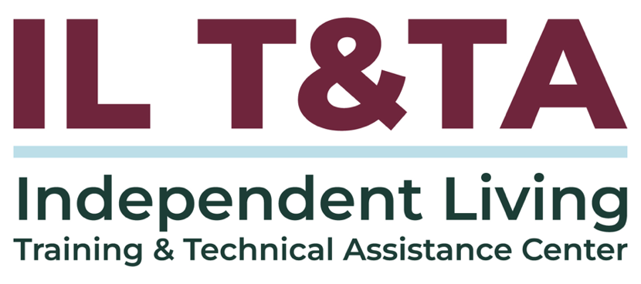
This project is on assignment through contract with the Administration on Disabilities, Administration for Community Living, Health and Human Services.

About the IL T& TA Center
The Independent Living Training and Technical Assistance Center (IL T&TA Center) is available to you through a contract with the US Department of Health and Human Services.
The IL T&TA Center provides expert training and technical assistance to CILs, SILCs, and DSEs.
The Center is operated by the University of Montana's Rural Institute for Inclusive Communities.
