Building Foundations for Access: Exploring Deaf Experiences and Communication Strategies in IL Services
May 21, 2026

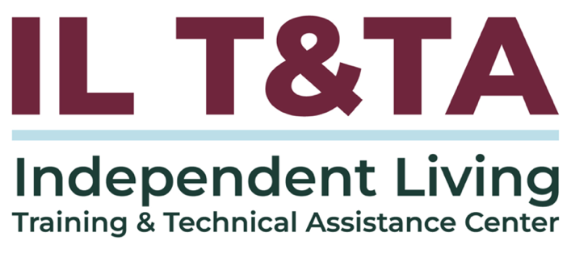

Before We Begin
ASL & Spanish Interpreters are available and labeled.
Access Closed Captioning by clicking the CC button located at the bottom of your Zoom window.
Use Zoom's Raise Hand or Chat features to ask questions.
Use the Q&A box to send us your questions at any time.
Remember to state your name and organization before speaking.
Message our IL T&TA team using the Chat feature if you have difficulties with today's call.
Please complete the survey at the end of today's training.

Today’s Agenda

Learning Objectives:
- Describe core elements of Deaf culture and communication access that influence engagement, trust, and outcomes in IL services.
- Distinguish appropriate uses of interpreters, captioning/CART, relay/VRS, and direct communication strategies while avoiding common ethical pitfalls.

Format:
- Approx 45 minutes of content
- 30 minutes of peer discussion

Goal:
Let’s learn with and from each other!

Building Foundations for Deaf Access:
In Practice, This Means:
- Expanding access to Independent Living services
- Addressing barriers related to language, communication, and culture
- Strengthening communication access and inclusion
- Building capacity within CILs and SILCs to better support Deaf consumers
- Promoting practical strategies, partnerships, and tools that improve access
Bottom Line
- Access is not just about availability — it is about meaningful participation, engagement, and inclusion.

Equal Access & Effective Communication Requirements
Section 504 and 45 CFR § 84.77 require recipients of HHS funding — including CILs and SILCs — to ensure communication with individuals with disabilities is as effective as communication with others.
This includes:
- Providing appropriate auxiliary aids and services when needed
- Giving primary consideration to the individual’s communication request
- Providing access in a timely manner
- Supporting privacy, independence, and equal participation
- Ensuring communication access across services, programs, activities, and public engagement

Equal Access & Effective Communication Requirements (cont.)
Recipients generally may not:
- Require a Deaf individual to bring their own interpreter
- Rely on accompanying adults or children to interpret except in limited emergency situations
Equal access includes meaningful communication access and participation.


Presenters

Malibu Barron
Strategic Support Coordinator
National Deaf Center for Postsecondary Outcomes

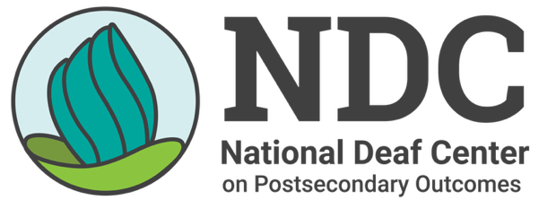

Who We Are
National Deaf Center for Postsecondary Outcomes (NDC)
- Federally funded technical assistance and dissemination center
- Provides research, resources, training, and technical assistance
- Focused on improving education, training, and employment outcomes for Deaf people
- Shares information, networks, and strategies that strengthen access and reduce barriers
- Supports systems, professionals, families, and organizations working alongside Deaf individuals

Building Foundations for Access
- Communication access impacts trust, engagement, autonomy, and participation
- Delays, assumptions, and inconsistent access can shape how Deaf consumers experience services and systems
- Building effective services starts with reducing assumptions and listening directly to Deaf consumers
- Access is strongest when it is built into services from the beginning
Creating meaningful access begins with listening, flexibility, and reducing assumptions about communication and participation.

Core Elements When Working with Deaf Communities
- There is no single Deaf experience
- Deaf people have different identities, language use, communication preferences, and lived experiences
- Assumptions are often incomplete without Deaf voices included
- Deaf individuals are experts in their own lived experiences
- Meaningful access is strengthened when Deaf people help shape systems and practices

“What Deaf Means?” Video

Deaf Culture: Shifting the View
- Many systems still use a medical view to understand Deaf people
- A medical view can frame Deaf people as something to be fixed or accommodated
- A cultural and social view recognizes Deaf culture as a rich community with its own languages, shared values, ways of communicating, and traditions
- Deaf experiences, identities, and communication preferences are not one-size-fits-all
- Communication access impacts trust, autonomy, participation, and belonging
Both views shape how systems respond to Deaf people, but only the cultural/social view fully reflects Deaf people as whole, diverse individuals and communities.

Rethinking Barriers

The problem is not Deaf people.
It’s the system.
- Barriers often appear when systems are not designed with Deaf people in mind
- Communication access impacts participation, trust, engagement, and decision-making
- Delays, assumptions, and inconsistent access can create cumulative barriers over time
- System-level gaps can limit choice, access, independence, and full participation in everyday life


Common Barriers
- Assumptions about communication preferences and language comprehension
- Delays in arranging access
- Over-reliance on one method
- Limited awareness of communication options
- Access fatigue impacting follow-through or engagement

Rethinking Access & Inclusion
- Barriers often appear when systems are not designed with Deaf people in mind from the start
- Access should be built in from the start — not added only after barriers appear
- Effective services are strengthened when Deaf consumers help shape systems, practices, and communication approaches
- Access is not only about compliance or accommodation — it impacts participation, connection, and belonging
Shift From |  | Shift Toward
System-Directed |  | Self-Directed
Accommodations |  | Access
Reactive |  | Proactive
Compliance |  | Belonging

Why Access Matters
Access has a direct impact on how Deaf consumers experience services, systems, and relationships.
- Trust: Consistent communication and responsiveness shape whether Deaf consumers feel valued
- Engagement: Access supports full participation, follow-through, and connection
- Sense of autonomy: Direct access to information supports choice, self-advocacy, and decision-making
- Outcomes / Quality of life: Reduced barriers can strengthen relationships, confidence, and long-term opportunities

Communication Access Tools & Strategies
Access tools work best as part of a broader communication ecosystem — not as a one-size-fits-all solution
Communication access may include:
- ASL interpreters
- Hearing and Deaf interpreters
- CART / live captioning
- Captions / closed captions
- Relay, VRS, and VRI
- Plain language and visual supports
- Visual alert systems
- Layered communication approaches using multiple tools together

Matching the Strategy to the Situation
Communication Strategy | May Be Helpful When… | Considerations
ASL Interpreter | Real-time conversations, meetings, services | Requires visual access, preparation, and qualified interpreters
Deaf Interpreter | Complex communication needs or additional linguistic bridging | May improve understanding in some situations
CART / Live Captioning | Group settings, trainings, meetings | Works best when strong audio is available
Captions | Recorded/live video content | Quality and accuracy matter
VRS / VRI | Remote or quick communication access | Technology, visibility, and pacing can impact effectiveness
Plain Language / Visual Supports | Forms, instructions, high-stress or complex situations | Helps reduce communication complexity

Layered Access Approaches
- Communication tools are not interchangeable
- Some Deaf consumers may prefer multiple tools used together
- Access needs may shift depending on the setting or situation
- Planning ahead can help reduce delays, misunderstanding, and frustration
Effective access often comes from flexibility, planning, and direct communication with the Deaf consumer.

Everyday Access Practices
Access also shows up in how information is designed, shared, and checked for understanding.
- Ask about communication access needs early
- Confirm access before meetings or events
- Share agendas, forms, and materials in advance
- Use plain language and visual supports
- Allow flexibility in communication approaches
- Caption videos and virtual content
- Build relationships with local interpreters and Deaf community resources
- Check for understanding instead of assuming understanding

Common Pitfalls
- Assuming one approach works for every Deaf consumer
- Waiting until barriers appear before planning communication access
- Assuming understanding based only on limited written communication
- Misreading delayed follow-through or missed appointments as disinterest rather than possible access fatigue or communication barriers
- Relying too heavily on technology or remote interpreting without considering visual access or communication flow
These tools are not interchangeable and may not work the same across every setting or situation.

Communication Access in Real-World Practice
- Effective communication access starts with the Deaf consumer’s preferences, goals, and lived experiences
- Access needs may shift depending on the setting, environment, complexity of information, or relationship
- Real-world situations may require flexibility, layered approaches, planning, and ongoing problem-solving
- Communication access is an ongoing process — not a one-time accommodation decision
One of the simplest but most important practices is checking for understanding — making space to confirm information was received and understood, not just delivered.


Reflecting on Communication Access in Real-World Situations
The following scenarios are intended to support reflection, discussion, and practical application within IL settings.
As you move through the following scenarios, consider:
- What are the communication barriers?
- How do the barriers impact engagement, trust, and participation?
- How can the barriers be corrected (e.g., policy, training, or process changes)?
- How do you plan to prevent or correct similar barriers in your own organization?
There may not be one perfect solution — effective access often comes from flexibility, responsiveness, and ongoing communication.

Intake Access vs. Sustained Engagement
A Deaf individual contacts a Center for Independent Living (CIL) and successfully completes the initial intake process.
However, follow-up communication access becomes inconsistent, relying on written English, delayed interpreter scheduling, and unclear next steps – leading the consumer to disengage from services.

Family Member as Interpreter

Deaf consumer arrives with a family member who begins to interpret. Staff proceed in using that family member for communication, including sensitive service-related discussion.
Communication Access & Technology
A CIL staff member plans an event and provides one type of communication access based on what they believe participants need. However, Deaf participants have different communication preferences, and some are unable to fully engage. Over time, participation decreases and opportunities for connection are missed.

Cumulative Barriers, Missed Appointments & Staff Perception

A Deaf consumer navigating multiple systems repeatedly faces barriers to communication access, including unavailable interpreters, delays, and rescheduled appointments. Over time, the consumer becomes overwhelmed and disengaged, while CIL staff may interpret missed appointments or inconsistent follow-through as a lack of motivation, leading to decreased outreach and a weakened relationship.
Skill-Building, Boundaries & Over-Reliance in Accessible Spaces
A Deaf consumer relies heavily on a CIL because it is one of the few spaces with consistent communication access and responsive support. Over time, staff begin taking on more responsibility for navigating systems and decision-making, which can limit opportunities for the consumer to build self-advocacy, independence, and connections with Deaf community resources.


Bottom Line
Communication access is most effective when planned from the beginning, not added after barriers arise
- Deaf consumers often face barriers when systems, services, and supports are not designed with their communication needs in mind
- Strong access requires flexible, layered strategies tailored to real-life situations, goals, and communication preferences
- Collaboration among Deaf consumers, families, providers, and community partners strengthens participation, choice, connection, and independent living
- Everyday practice can improve by building communication access into interactions, planning, and follow-through from the start

Resources for Additional Guidance
- National Deaf Center
- HHS OCR Section 504
- 45 CFR 84.77 for effective communication
- Supplemental Resource: Building Deaf Communication Access into IL Operations

Your Experience Matters
Recording has stopped – now it’s time to share.
Ways to Engage:
- Raise your hand to be spotlighted to speak
- Turn on your camera if you're comfortable
- Use the chat to share insights, questions, resources, or tools
- React, reflect, or build on what others say
- Share real challenges or successes from your CIL
Let’s turn ideas into action — your voice is the most valuable part of this session.

Evaluation
Thank you for participating in today's Learn and Share.
Your feedback is important and helps us plan future training.
Please use the link in the chat to share your feedback.
Evaluation Link:


How to Connect with Us!

Website: www.ILTTACenter.org
Request training and / or technical assistance (expert help for your organization): fill out a form on our website to let us know how we can help.
Call: 406-243-5300 and someone will get back to you as soon as we can.
Sign-Up for Events & Announcements:

Visit our website to sign up for updates about live training, group technical assistance, new publications, and other happenings around the Center.

IL T&TA Center Attribution

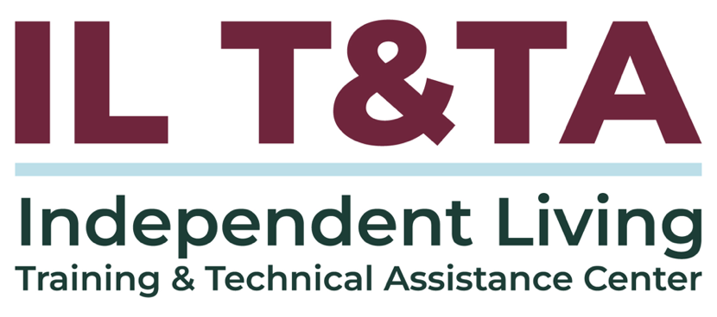
This project is on assignment through contract with the Administration on Disabilities, Administration for Community Living, Health and Human Services.

About the IL T& TA Center
The Independent Living Training and Technical Assistance Center (IL T&TA Center) is available to you through a contract with the US Department of Health and Human Services.
The IL T&TA Center provides expert training and technical assistance to CILs, SILCs, and DSEs.
The Center is operated by the University of Montana's Rural Institute for Inclusive Communities.
