Preparing Your Continuity of Operations Plan (COOP)
May 27, 2026
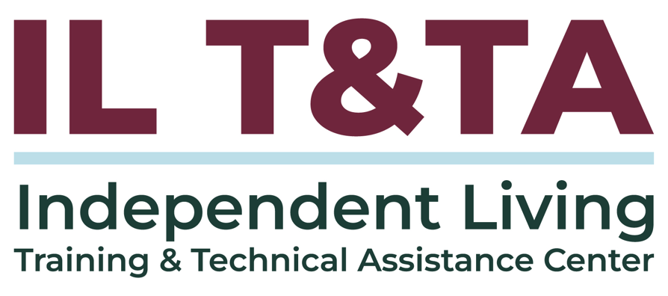

Before We Begin
ASL & Spanish Interpreters are available and labeled.
Access Closed Captioning by clicking the CC button located at the bottom of your Zoom window.
Use Zoom's Raise Hand or Chat features to ask questions.
Use the Q&A box to send us your questions at any time.
Remember to state your name and organization before speaking.
Message our IL T&TA team using the Chat feature if you have difficulties with today's call.
Please complete the survey at the end of today's training.

Today’s Agenda –

Key Takeaways:
- Identify the core components of a Continuity of Operations Plan (COOP),
- Examine common risks and disruptions that impact operations.

Overall Goal:
- Let's learn with and from each other!

What is a Continuity of Operations Plan (COOP)?
A COOP is the plan an organization uses to ensure it can continue its essential functions during any disruption.

Why COOP Matters for IL Programs
- Disruptions do not remove the need to maintain essential IL functions.
- Continuity planning helps organizations prepare for impacts to services, staff roles, communication, records, technology, and fiscal systems.

Why COOP Matters for IL Programs (cont’d.)
- Federal rules may not require a document specifically called a COOP, but recipients still have expectations around internal controls, records, financial systems, and documented procedures.

References:
- 29 U.S.C. § 796f-4 — CIL standards, assurances, and core service expectations
- 45 CFR § 1329.5 — Minimum compliance and grant terms
- 29 U.S.C. § 796c — SPIL/statewide IL service delivery expectations
- 2 CFR § 200.303 — Federal award internal controls


Presenters
Germán Parodi
Co-Executive Director
The Partnership for Inclusive Disaster Strategies
directors@disasterstrategies.org

Ciawanda McDonald

Chief Executive Officer
Disability Solutions for Independent Living, Inc.
ciawanda@dsil.org

From Disruption to Decision-Making
When operations are disrupted, organizations need a plan for:
- What continues, pauses, or changes
- Who has authority to make decisions
- How staff, consumers, and partners receive updates
- Where work happens if the usual location is unavailable
- What systems, records, and supports are needed to keep services moving
Key point: Continuity planning helps move decisions out of one person's head and into a shared process.

Core COOP Components

A COOP should help answer:
- What essential functions must continue?
- Who has authority to make decisions?
- Who are the backups if key staff are unavailable?
- How will staff, consumers, board/council members, and partners be contacted?
- What records, systems, supplies, and access are needed?
- Where and how will work continue if the usual location or systems are unavailable?
- How will the organization return to normal or revised operations?

What Can Disrupt Operations?
- Disasters, emergencies, and public health emergencies
- Unexpected absence or unavailability of key staff
- Power outages, internet outages, or phone failures
- Damage to, closure of, or loss of access to the office
- Transportation barriers or unsafe travel conditions
- Increased consumer need when community systems are overwhelmed can all disrupt CIL and SILC operations.

Succession and Decision-Making
- Name who assumes key responsibilities if a staff member is unavailable for a significant period.
- Make sure successors know their role before a disruption happens.
- Confirm they have access to needed systems, passwords, contacts, and training.
- Clarify when supervisors may assume or delegate responsibilities.
- Distinguish temporary delegation from formal succession.

Crisis Communication When Systems Fail
- Collect more than one contact method for consumers, board members, staff, volunteers, funders, contractors, and partners.
- Decide how staff will check in if internet or phones are down.
- Use the website as a public information point when direct communication is not possible.
- Prepare message templates before disruptions such as disasters and public health emergencies.
- Set expectations for staff when personal internet, power, or equipment fails.

Consumer Preparedness Within the COOP
A COOP clarifies how the organization will:
- Build preparedness into existing IL services, peer support, and skills training
- Let consumers know where to find updates and what the CIL may be able to provide
- Plan around common access needs, such as power, healthcare/HCBS, transportation, and communication
- Review crisis communication during regular consumer contact points
- Track needs that may increase risk if services, systems, or travel are interrupted
Key point: Consumer preparedness should be part of continuity planning, so staff know how to maintain communication, services, and access when normal operations change.

Maintaining Essential Functions During Disruption
- Identify which services must continue, pause, or shift during disruption.
- Clarify temporary changes to hours, locations, supervision, and staff duties.
- Determine whether services shift to remote work, alternate sites, partner locations, or other approved service points.
- Keep core IL services, transition, diversion, and rights advocacy central.
- Document temporary service changes and communication expectations.

Pre-Planned Public Messages and Rights Reminders

A COOP should include ready-to-use language for:
- Office closures, service changes, alternate contacts, and location updates
- Trusted resource links, such as shelters, FEMA, American Red Cross, legal services, P&As, Disability & Disaster Hotline, and local emergency management
- Accessible formats, plain language, and multiple communication methods
- Who approves and posts public updates
- Rights reminders about physical access, effective communication, and reasonable modifications.
Civil rights are never waived in disasters!

Readiness Operations
- Decide when staff work remotely, when an alternate site is used, and who makes return-to-office decisions.
- Prepare shelter-in-place supplies for staff and visitors, with attention to individualized access and health needs.
- Exercise evacuation procedures and describe them at meetings that include non-staff participants.
- Reduce dependence on paper by digitizing essential records and setting a shredding schedule.
- Document policies for emergency staff time and consultant support before disruptions happen.

Sustaining Readiness Over Time
Readiness does not have to start with a large budget. Organizations can:
- Start with low-cost steps: update contacts, identify backups, and prepare message templates.
- Build COOP review into existing IL services and regular staff/board routines.
- Use partnerships, MOUs, and local planning spaces to strengthen readiness.
- Track gaps, outcomes, and lessons learned to support future funding, TA, or planning updates.
- Consider how continuity priorities connect to the SPIL, Part B activities, or statewide planning goals.
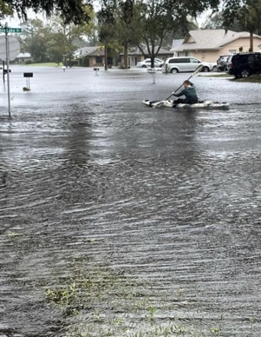
Key point: Continuity planning is not a one-time document. It grows through practice, partnerships, and small steps over time.
From Plan to Practice: A CIL Experience with COOP
Disability Solutions’ experience:
- Hurricane Ian flooded their office building in 2022
- The building was closed for construction for over a year
- Consumers with disabilities were displaced and relocated to disaster shelters
- Disability Solutions later used the COOP again after flooding from Hurricane Milton
The experience showed why continuity planning must be ready before operations are compromised.

What Changed Once It Was Written Down
Everything changed.
- Staff were able to buy in and help implement the COOP
- The Board approved the plan and adopted it into policy
- Leadership could delegate and assign staff responsibilities
- Existing plans were brought into one document:
  - CEO succession plan
  - Telework plan
  - COVID implementation plan

What the COOP Revealed
A COOP helped Disability Solutions move from informal knowledge to a shared plan by clarifying:
- Where gaps may exist in the plan
- How staff succession helps prevent interruptions in service delivery
- How finance/CFO duties continue if key staff are unavailable
- How services continue when the building is closed or inaccessible
- What happens when staff are personally impacted by the same event
- Who performs specific tasks and when
The COOP became a blueprint for recovery and continuity.

Why Not Wait?
- There are too many moving pieces when operations are disrupted to create the plan as you go.
- The COOP gives the organization a blueprint for recovery
- It supports resiliency
- It helps the Board continue operations if the CEO or another key leader is affected
- It answers many of the questions a someone may have when stepping in to continue operations
The COOP is a blueprint unique to your operations.

Quick COOP Self-Check
- Do you have a staff succession plan, and do backups have access and training?
- What is your communication plan if internet, phones, or power are down?
- What expectations are documented for staff during disruptions, equipment/system failures, or emergencies?
- What messages are already prepared for consumers, partners, and the public?
- What is written down — and what is still living in one person’s head?
- What is one COOP action your CIL or SILC can take in the next 30 days?

Key Takeaways
- Effective COOPs clarify essential functions, staff succession, decision-making, communication, and alternate service delivery methods.
- Continuity planning supports consumer access, civil rights, and ongoing IL services when normal operations change.
- Disruptions may include disasters, staffing shortages, outages, inaccessible facilities, and public health emergencies.
- Preparedness does not require a large budget — small, consistent steps build resilience over time.
- A COOP is a living document that should be practiced, updated, and shared across the organization.
- The best time to prepare a COOP is before operations are disrupted.

Resources for Additional Guidance
- The Partnerships for Inclusive Disaster Strategies Hub
- FEMA: Continuity Resources
  - Continuity Plan Template for Non-Federal Entities and Community-Based Organizations
- Supplemental: Disability Solutions for Independent Living COOP

Your Experience Matters
Recording has stopped – now it’s time to share.

Ways to Engage:
- Raise your hand to be spotlighted to speak
- Turn on your camera if you're comfortable
- Use the chat to share insights, questions, resources, or tools
- React, reflect, or build on what others say
- Share real challenges or successes from your CIL
Let’s turn ideas into action — your voice is the most valuable part of this session.

Evaluation
Thank you for participating in today's Learn and Share.
Your feedback is important and helps us plan future training.
Please use the link in the chat to share your feedback.
Evaluation Link:


Upcoming Events to Join Us On!
- ILab: Practice Storytelling with Your Peers – May 29, 2026, 3 PM ET
- Webinar: Collaboration with State Assistive Technology Programs – June 9, 2026, 3 PM ET
- Ask Anything – June 11, 2026, 3 PM ET
- SILC Connection: The SILC's Role in Advocacy – June 16, 2026, 3 PM ET
- Learn and Share: Supporting Consumers Through a Service Disruption – June 24, 2026, 3 PM ET

How to Connect with Us!

Website: https://tinyurl.com/ILTTACenter
Request training and / or technical assistance (expert help for your organization): fill out a form on our website to let us know how we can help.
Call: 406-243-5300 and someone will get back to you as soon as we can.
Sign-Up for Events & Announcements:

Visit our website to sign up for updates about live training, group technical assistance, new publications, and other happenings around the Center.

IL T&TA Center Attribution

This project is on assignment through contract with the Administration on Disabilities, Administration for Community Living, Health and Human Services.

About the IL T& TA Center
The Independent Living Training and Technical Assistance Center (IL T&TA Center) is available to you through a contract with the US Department of Health and Human Services.
The IL T&TA Center provides expert training and technical assistance to CILs, SILCs, and DSEs.
The Center is operated by the University of Montana's Rural Institute for Inclusive Communities.
