April 2026
Independent Living Training & Technical Assistance Center
Abstract
This guidance provides practical direction for identifying, managing, and reporting program income in compliance with federal requirements. It is intended for grantees administering Independent Living programs and related federally funded activities.
KEY GUIDANCE:
Program Income
Independent Living Training & Technical Assistance Center Publication

Table of Contents
Table of Contents 1
Executive Summary 3
What is Program Income 4
Program Income Test 4
Why Proper Management Matters 4
Core Compliance Requirements 5
Common Sources of Program Income 5
Real-World Applications 6
How Program Income Can Be Used 7
▪ Addition Method 7
▪ Deduction Method 7
▪ Cost Sharing or Match 7
Allowable, Reasonable, and Allocable Costs 7
Financial Management Expectations 8
Tracking and Reporting 8
Common Compliance Risks 9
Final Guidance 9
Additional Resources 9
IL T&TA Center Contact Information 9

Executive Summary
Program income is revenue generated as a direct result of federally funded activities or the use of grant-funded resources (2 CFR §200.1). While program income can strengthen and expand services, it must be managed in accordance with federal requirements and the terms of each award.
Grantees are responsible for identifying when income qualifies as program income, ensuring that it is used for allowable purposes, and maintaining accurate records of its receipt and use. In many cases, program income must be used before additional federal funds are drawn.
Failure to properly manage program income can result in audit findings, repayment of funds, and increased monitoring. However, when handled appropriately, program income can enhance service delivery and support long-term program sustainability.
Grantees should review their Notice of Award (NOA) for specific requirements and consult their Program Officer (PO) when clarification is needed.

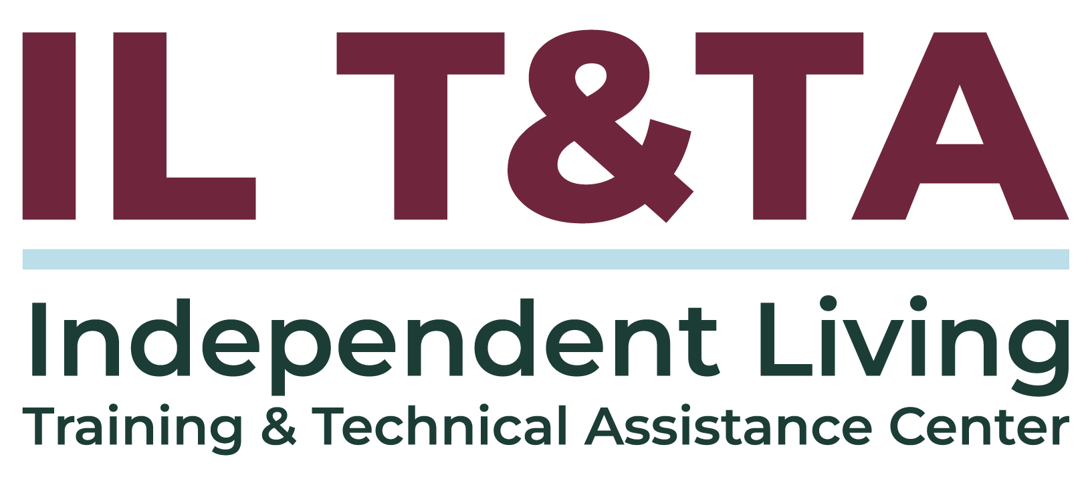

What is Program Income
Program income is gross income earned as a direct result of a federally funded activity or from the use of grant-funded resources (2 CFR §200.1).
In practice, determining whether income is “program income” is not always straightforward. Many activities are supported by a mix of funding sources, and even partial federal support can trigger program income requirements.

Program Income Test
A useful test for program income is:
If the income is generated directly by a federally supported activity or earned as a result of the federal award during the period of performance, it is likely program income.
This includes situations where federal funding supports any part of the activity, such as:
- Staff time
- Facilities or office space
- Equipment
- Administrative or indirect costs
Even indirect support can make the resulting income subject to federal requirements.

Why Proper Management Matters
Program income is not simply “extra” or unrestricted revenue. Although it is not itself a federal drawdown, it is subject to federal award requirements and must be managed accordingly.
Failure to properly identify and manage program income can result in:
- Audit findings
- Repayment of funds
- Increased monitoring
- Restrictions on current or future funding
At the same time, when handled correctly, program income can:
- Expand services and supports
- Increase program reach
- Strengthen long-term sustainability

Core Compliance Requirements
Program income must be managed in accordance with federal regulations and the specific terms of your award.
Grantees are generally required to:
- Use program income for the same purposes as the federal award (2 CFR §200.307)
- Track, document, and report all program income activity
- Follow federal cost principles related to allowability, reasonableness, and allocability (2 CFR §§200.403 – 405)
- Use program income before drawing additional federal funds
- Use the funds in the year in which they were generated. Program income earned during the period of performance may only be used for costs incurred during the period of performance or allowable closeout costs.
Because requirements can vary, grantees should always review their Notice of Award (NOA) for agency-specific direction.

Common Sources of Program Income
Program income can be generated in a variety of ways, particularly when services or products are supported by federal funding.
Common examples include:
- Fees for services such as training, workshops, or employment-related services
- Activities that are partially funded by non-federal sources but supplemented with federal funds
- Sale of materials developed under a federal award (e.g., curriculum, manuals)
- Rental or use of property and equipment purchased with grant funds
The key consideration is whether federal resources contributed - directly or indirectly - to generating that income.

Real-World Applications
Understanding program income is often easiest when applied to real situations.
Example | Description | Determination
Training Fees | Federally funded staff deliver paid training | Program Income
Mixed Funding Event | Federal funds support part of an event or activity | Program Income
Self-Sustaining Program | Activity operates without federal funding | Not Program Income
Curriculum Sales | Materials developed using grant funds are sold | Program Income
Post-Grant Activity | Income earned after the period of performance | Typically not program income (unless specified in NOA)
A key transition point occurs when an activity becomes fully self-sustaining. If an activity later operates without federal support, income may no longer be program income. However, grantees should confirm that the activity is not using award-funded staff time, equipment, property, materials, or other resources and should review any applicable NOA or closeout requirements. If no federal support is verified, the income is no longer considered program income and is not subject to federal requirements.

How Program Income Can Be Used
Federal regulations allow several methods for applying program income. The applicable method is determined by the terms of the award.
These include:
- Addition Method
Program income is added to the federal award and used to expand or enhance program activities. The addition method may be used only if authorized in the Notice of Award, applicable ACL/HHS terms, the NOFO, or through written prior approval. Because CILs are required to conduct resource development, it is expected that prior written approval could be obtained from the Program Officer for the project.
- Deduction Method
Program income reduces the total project cost, thereby decreasing the amount of federal funding needed. If no method is specified in the NOFA, which is the case with the Title VII grants, the deduction method applies by default under 2 CFR 200.307.
- Cost Sharing or Match
Program income may be used to meet required matching or cost-sharing obligations, if permitted.
Grantees should confirm the required method in their Notice of Award (NOA).

Allowable, Reasonable, and Allocable Costs
Program income must be used:
- for the original purpose of the Federal award, and
- in accordance with federal cost principles.
In practical terms:
- A cost is allowable if it is necessary, compliant with regulations, and properly documented (2 CFR §200.403)
- A cost is reasonable if it reflects sound business practices and fair market value (2 CFR §200.404)
- A cost is allocable if it benefits the federal award and can be appropriately assigned or allocated to it (2 CFR §200.405)
These standards apply equally to the original federal funds and any program income.

Financial Management Expectations
Effective management of program income depends on strong financial systems and consistent practices.
Grantees are expected to:
- Maintain separate accounting or cost centers for each funding source
- Track staff time by project or funding source (2 CFR §200.430)
- Apply consistent treatment of direct and indirect costs (2 CFR §§200.413 – 414)
- Maintain complete and audit-ready documentation
Accurate tracking is especially important when activities are supported by multiple funding sources.

Tracking and Reporting
Program income must be tracked and reported as part of standard grant management.
Grantees should:
- Record the source and amount of income
- Document how the income is used
- Track the financial performance of activities generating income
Program income must be reported in:
- Federal Financial Reports (SF-425)
- Any additional reports required by the awarding agency
Maintaining a clear audit trail - including invoices, receipts, and time records - is essential.

Common Compliance Risks
Several common issues can lead to noncompliance if not addressed:
- Treating program income as unrestricted or discretionary funds
- Failing to track staff time associated with revenue-generating activities
- Using program income outside the scope of the award for activities not allowed in the original award
- Delaying or inaccurately reporting program income
Regular internal review of revenue-generating activities can help prevent these issues.

Final Guidance
Program income requirements are governed by federal regulations and the specific terms of each award.
Grantees should:
- Carefully review their Notice of Award (NOA)
- Consult the HHS Grants Policy Statement, as applicable
- Seek clarification from their Program Officer when needed
Proper management of program income ensures both compliance and effective use of resources to support Independent Living services.

Additional Resources
Additional training and technical assistance on this topic and others can be found by visiting www.ILTTACenter.org.

IL T&TA Center Contact Information
Independent Living Training & Technical Assistance Center
Rural Institute for Inclusive Communities at the University of Montana
📞 (406) 243-5300
✉️ ilttacenter@mso.umt.edu
🌐 www.ILTTACenter.org
👉 Stay Connected Email Sign Up | Facebook | LinkedIn | Instagram
The Independent Living Training & Technical Assistance Center is on assignment with the U.S. Department of Health and Human Services, Administration for Community Living.

