Collaboration with Assistive Technology (AT) Act Programs
June 9, 2026

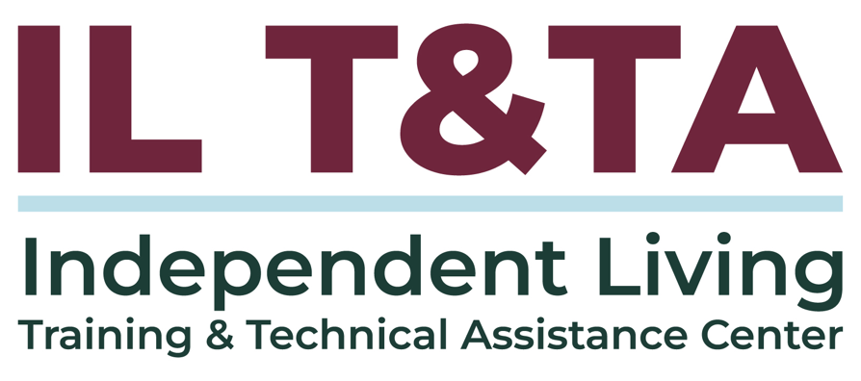

Before We Begin
ASL & Spanish Interpreters are available and labeled.
Access Closed Captioning by clicking the CC button located at the bottom of your Zoom window.
Use Zoom's Raise Hand or Chat features to ask questions.
Use the Q&A box to send us your questions at any time.
Remember to state your name and organization before speaking.
Message our IL T&TA team using the Chat feature if you have difficulties with today's call.
Please complete the survey at the end of today's training.

Today’s Agenda –

Key Takeaways:
- Identify key services offered by Assistive Technology (AT) Act programs and how they can strengthen IL service delivery.
- Describe opportunities for collaboration with AT Act programs to enhance access to assistive technology and communication supports.

Expanding Access to Independent Living (IL) Services

AT as a Tool for Reaching More People
A key responsibility of the IL Network is ensuring people know services exist, can access them, and can benefit from them — particularly individuals and communities who may be underserved, unserved, or face barriers to participation.
- Assistive technology addresses barriers related to communication, mobility, vision, hearing, cognition, and daily living.
- AT Act Programs often serve populations that overlap with IL outreach and access priorities.
- Partnerships create additional pathways to connect consumers with tools, services, and supports.

Listening Through an IL Lens

As you listen today, consider:
- Who may be unaware of these resources ?
- Do we have active consumers or staff who could benefit from AT?
- How can AT improve our operations and service delivery?
- What can a CIL and AT Act Programs partnership achieve?

Today’s Presenters

From National Framework to Local Impact:

Insights from national, state, and local levels on how AT partnerships can enhance access and bolster Independent Living services.
Assistive Technology Act Technical Assistance and Training Center (AT3) and Association of Assistive Technology Act Programs (ATAP)
Marty Exline, MPH
AT3 Center Team Lead
marty.exline@ataporg.org
Ryan Rausch, MOTL/R
AT3 Center Team Lead
ryan.rausch@ataporg.org
Jeannie Krull, MS/CCC-SLP, ATP, CAPS
Executive Director
Jeannie.krull@ataporg.org

The Opportunity for the IL Network
Assistive technology is key to the Independent Living network because it fosters independence, enhances quality of life, and promotes community integration for people with disabilities.
AT Act Programs and CILs share similar missions and priorities: reducing barriers to Independent Living.
Together, these partnerships help:
- Expand access to AT and communication supports
- Support underserved populations
- Strengthen IL service delivery
- Increase reach through partnership

AT Partnerships in Practice: Expanding Access Across IL Services
With 56 State and Territory AT Act Programs and 500+ CILs, there is a significant opportunity to create more access points for consumers and expand the reach of both networks.
Examples of where AT and IL Partnerships can create opportunities for engagement:
- Hospital discharge and transition planning
- Youth transition and education
- Outreach and Information & Referral
- Community living and diversion efforts
- Family members and caregivers

How AT Has Evolved
- AT has evolved over nearly 40 years.
- AT is now an ecosystem that supports functional capability across the lifespan.
- Misunderstandings still persist about what AT is and who it is for.
- AT serves anyone with vision, hearing, memory, mobility, fatigue, speech, behavioral health, and other access needs.
- AT is not limited to people who identify as disabled.
- The 21st Century AT Act (2022) anchors AT in lifespan access and cross-disability reach, defining both the technology and its beneficiary population in functional terms.

What is Assistive Technology?

Assistive Technology (AT)
Assistive technology includes devices and services that help increase, maintain, or improve a person's functional capabilities and independence.
AT Devices
- Any item, equipment, or product system used to improve functional capabilities
- May be commercially available, modified, or customized
AT Services
- Help individuals select, acquire, and use AT
- May include evaluation, training, customization, coordination, and ongoing support
- Expand access to technology, including electronic and information technology

Functions of AT
It's not the device – it's the functional capabilities of the person that are improved, maintained, or increased that make something assistive technology
A simple tablet transforms into assistive technology when it helps a person communicate, remember tasks, or control their environment.
AT Device | Functional Outcome
Tablet or communication app | Express needs, choices, and preferences
Screen reader | Access information
Smart speaker | Control parts of the home environment
Wheelchair or mobility device | Navigate home and community settings
Captioning or speech-to-text | Improve communication access


The AT Umbrella
AT is often illustrated as an umbrella because it encompasses a broad range of technologies and supports. The legal definition is broad enough to include all of these technologies—and those yet to be developed!
- Speech communication: Speech-generating devices, communication apps
- Vision: Magnifiers, screen readers
- Hearing: Amplified phones, captioning tools
- Home Modifications: Ramps, grab bars, walk-in shower
- Environmental Controls: Smart home devices (i.e. sensors, cameras, smartlocks)
- Communications Technology: Telehealth, remote monitoring

The AT Umbrella (cont.)
- Learning, Cognitive, Developmental, Behavior Health Technology: medication management systems, wearables, mobile devices
- Daily Living Technology: Fall detection, smartdevices for living, tech for eating, robotics
- Vehicle Modifications & Transportation Tech: driving controls, ramps, handybar
- Recreation, Sports and Leisure Tech: adapted gaming, gardening tools, adaptive sports
- Mobility, Seating, and Positioning: wheelchairs, walkers, exoskeletons
- Computers and Related: Mainstream technology, eye-gaze, on-screen keyboard

Who Can Benefit from AT?
- People with disabilities across the lifespan
- Older adults and individuals aging into disability
- People who do not yet identify as disabled
- People with temporary, intermittent, or progressive needs
- Support networks
Populations AT Programs Frequently Engage:
- Youth transitioning into adulthood
- Individuals living in rural communities
- Low-income individuals
- Individuals transitioning from institutions to community settings
- Older adults and caregivers through Aging Network partnerships

AT Act Programs: What CILs Need to Know
What: The Assistive Technology (AT) Act is a federal law that helped establish State AT Programs to increase the availability of, access to, and acquisition of AT devices and services.
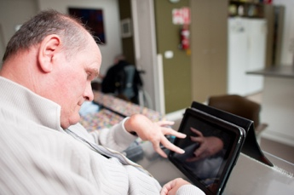
Why: To help people with disabilities of all ages, and those aging into disability, participate more fully in education, employment, and community life — and live more independently in the community of their choice.
Where: AT Act Programs operate in all 50 states, the District of Columbia, Puerto Rico, and four territories.

AT Act Programs: What CILs Need to Know
How: AT Act Programs help individuals:
- More fully participate in education, employment, and community life

- Live more independently and age in place in the community of their choice
- Increase awareness of available AT
- Access, explore, and acquire AT
- Receive training, technical assistance, and support

Changes in the AT Act of 2022

Federal Partner Collaboration
- Collaboration across state agencies:
  - State Educational Agency receiving funds through the Individuals with Disabilities Education Act;
  - Vocational Rehabilitation Agency;
  - State Medicaid Agencies;
  - Aging Entities
This creates additional opportunities for AT Act Programs and CILs to work together to reach consumers.

What AT Act Programs Offer
AT Act Programs provide services that help individuals access, explore, try, acquire, and use assistive technology.
Core State-Level Activities:
AT Device Demonstration
See, touch, and try AT devices to support decision-making.
Short-Term Device Loans
Borrow AT to determine if a device meets your needs before making a purchase.
Device Reutilization
Receive gently used AT devices and durable medical equipment for use as long as needed.
Alternative Financing
Explore financing options to acquire AT devices or equipment.

Additional AT Act Program Supports
State AT Programs also provide activities that increase awareness, connection, and successful use of AT.
State-Leadership Activities:
- Information & Assistance
- Training
- Public Awareness
- Technical Assistance
Resource Note:
The AT Services Flow handout shows how individuals can move from information and assistance to demonstrations, loans, reutilization, acquisition, and financing.

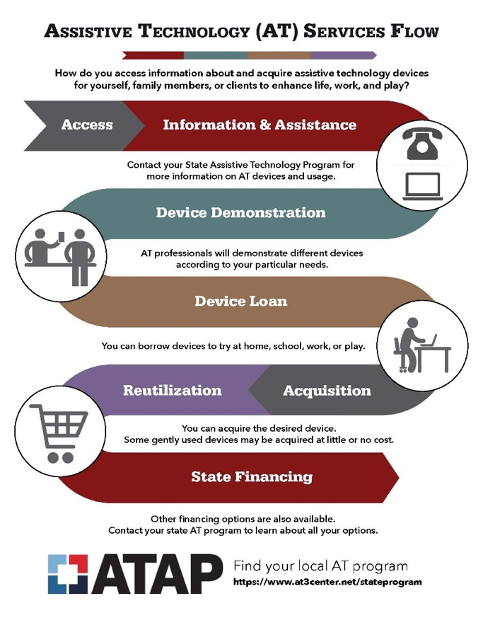

AT Device Demonstrations in Practice

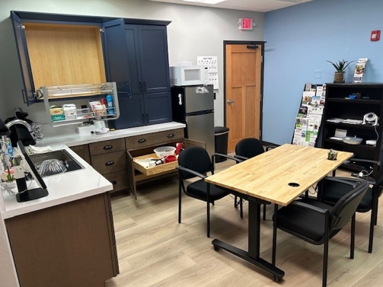
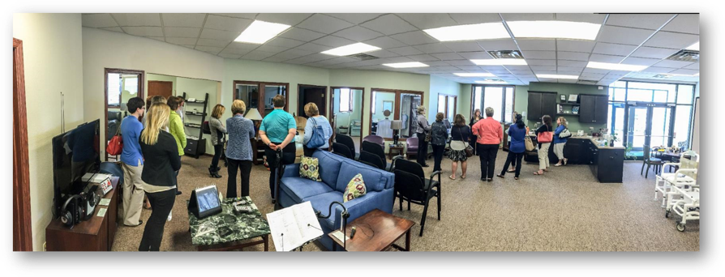
North Dakota AT Act Program Centers

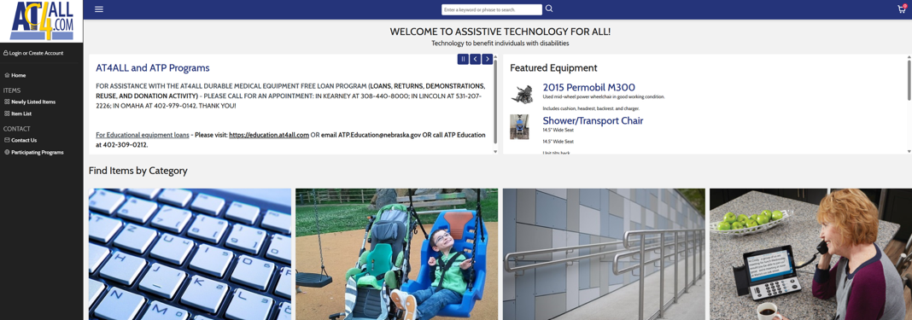
AT Device Loans and Device Reuse

Nebraska’s online Device Library – AT4ALL
- Searchable databases of AT products and solutions
- Explore options before a demonstration, loan, or purchase

Mapping AT Act Services to IL Core Services

A visual crosswalk:
- IL Skills Training AT demonstrations, device loans, training
- Peer Support AT user mentors, ambassador programs
- Advocacy AT funding, accessibility advocacy
- Information & Referral AT program directories, device libraries, AT resources
- Transition Institutional-to-community and school-to-work transition supports

Five Ways to Leverage Your State AT Act Program — Starting Tomorrow
- Refer consumers for free device demos and short-term loans before they buy
- Borrow devices for your own CIL staff to use in IL skills training
- Borrow devices to use with your own consumers
- Take advantage of reutilization for low/no-cost DME for transition and diversion consumers
- Connect consumers to alternative financing resources
- Partner to train your staff - most AT Act Programs offer free training for partner organizations

Transition & Diversion: A Natural Partnership for AT & IL
Transition is a required activity for both AT Act Programs and Centers for Independent Living
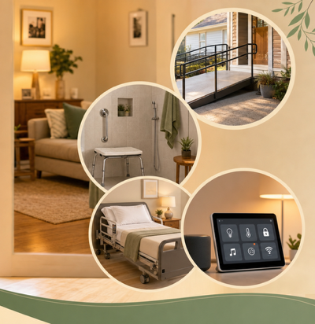
- Reutilized equipment can provide equipment in shorter timeframes
- Smart home technology and environmental controls can support community living
- AT can help individuals remain in or return to their communities
Examples: ramps, shower benches, hospital beds, communication devices, environmental controls

AT & IL Partnerships In Practice
Collaboration may include:
- CILs serving as local extensions of the AT Act Program by providing access to device demonstrations and loans
- Cross-referrals connecting consumers between CILs and AT Act Programs
- Establishing Alternative Finance Program relationship partnerships
- Trainings
- Joint conferences and outreach events
- Collaboration on consumer home assessments
- CIL participating on AT Act program advisory councils
- State AT program staff serving on SILCs and CIL boards

What Can We Achieve Together?
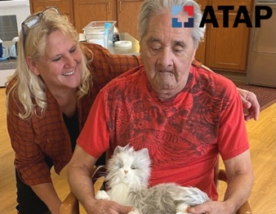
Every person on the planet will either need assistive technology for themselves or they will walk alongside someone in need. The trick is to build AT awareness, so everyone knows about it before they need it, and NO ONE goes without!
This requires a collective effort from all of us who are already familiar with these life-changing solutions! – North Dakota Assistive
56 AT Act Programs + 500+ Centers for Independent Living
= greater reach and impact together

Every State. Every Territory. Every Person.
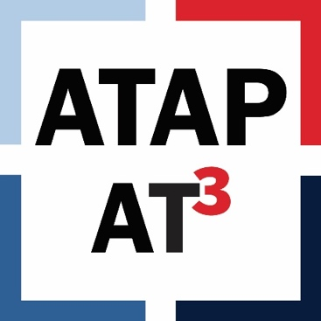
Discover your local AT Act Program

Together, the AT and IL networks create pathways to technology, services, and supports that help people live where and how they choose.

Today’s Presenters

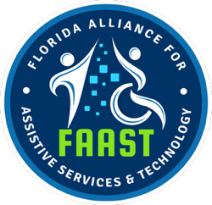
From National Framework to Local Impact
Eric Reed
Executive Director
Florida Alliance for Assistive Services & Technology (FAAST)
Ereed@faast.org

Kelli Fontaine
Assistive Technology Director
Center for Independent Living of Broward and Gulf Coast
Kfontaine@cilbroward.org

Quick Reflection
- In one word or phrase, what is one opportunity you see for AT and IL to work together?

Florida’s Alliance for Assistive Services & Technology (FAAST)

How the AT Program Operates in Florida
- Provides AT Act services across Florida
- Funded through Vocational Rehabilitation
- Services are delivered through a network of Regional Demonstration Centers (RDCs) and community partners.
- RDCs provide local access to Information & Assistance, Training, Device Demonstrations, and Device Loans.
- These partnerships help expand access to AT across Florida.

How FAAST Expands Access
FAAST expands access across Florida through partnerships with community organizations, including Centers for Independent Living.
Regional Demonstration Centers
- Local access points for Information & Assistance, Training, Device Demonstrations, and Device Loans
- Partners include universities, hospitals, workforce programs, and CILs
- 5 of 12 RDCs are Centers for Independent Living
ReUse Grant Partners
- MOUs with CILs around the state
- Help donated equipment return to the community and AT to stay in use
- Cover the cost of repair and reuse of assistive technology and durable medical equipment

How the Partnership with CIL Gulf Coast Functions
CILs are part of our team.
CIL Gulf Coast is both a Regional Demonstration Center and a ReUse Grant Partner, serving as the local access point to FAAST services in Southwest Florida.
Regional Demonstration Center
- FAAST provides a library of AT devices
- FAAST provides monthly funding to support services
- CIL Gulf Coast reports services provided back to FAAST

How the Partnership with CIL Gulf Coast Functions (cont.)
ReUse Grant Partner
- FAAST reimburses quarterly for devices in need of repair
- Repairs help equipment return to use or stay in use
Referrals
- FAAST’s statewide help desk provides Information & Assistance
- Clients are triaged to their local RDC for services
- Calls related to Independent Living services are referred to the local CIL

From Partnership to Practice: The CIL Perspective
CIL Gulf Coast (CILGC) is a consumer-driven organization that strives to enhance the lives of people with disabilities of all ages in Lee, Collier, Charlotte, Glades, and Hendry counties to achieve their goals.
Through its partnership with FAAST, CILGC serves as the Southwest Regional Demonstration Center, bringing AT services into community-based Independent Living work.
AT services include:
- Information and assistance
- Device demonstrations
- Device loans
- Training

AT in Practice at CIL Gulf Coast
Assistive technology is incorporated across all program services rather than operating as a standalone service.
- Designated AT Specialist to manage contract deliverables
- CIL staff are trained on FAAST procedures and relevant devices
- AT is incorporated across programs, including:
  - Employment Services
  - Career Camps
  - Project SEARCH
  - Workshops

AT in Practice at CIL Gulf Coast: Outreach & Access
Through targeted outreach, CIL Gulf Coast increases access, opportunity, and independence by connecting AT resources to community partners, including:
- Disability sensitivity trainings
- Vocational Rehabilitation Counselors and Rehabilitation Engineers
- Division of Blind Services
- Area Agency on Aging
- Colleges and universities
- OT, speech, and education programs

Expanding Access through AT: CIL Gulf Coast Examples
- Reaches individuals who may not otherwise connect with traditional CIL services
- Builds partnerships with community agencies, healthcare providers, schools, and service organizations
- Connects individuals, families, caregivers, and professionals to assistive technology resources
- Provides access to device demonstrations and short-term loans at no cost
- Helps people explore technology solutions before purchasing equipment

Practical Applications of AT in IL
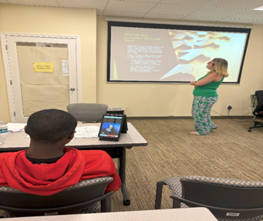
Instant Language Assistant (ILA) at the front desk to support people who are Deaf, hard of hearing, nonverbal, or speak another language

Screen reader software installed on devices for consumers to independently write emails, job search, or stay connected.
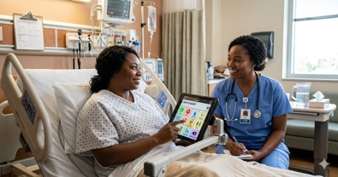
Tablets with communication apps for consumers in the hospital to express needs, receive appropriate care, and transition home safely.
Device loans allow consumers to try technology before making purchases.

CIL and State AT Partnership: Impact on Access
- Expands access to AT for underserved populations
- Reduces barriers related to cost, communication, and access
- Reaches individuals not otherwise connected to IL
- Connects through referrals, outreach, and community partners.

What We Want You to Remember

Resources for Additional Guidance
AT3 Center
Find Your State AT Program
ATAP AT Services Flow Handout
Assistive Technology Industry Association: ATIA Learning Center
Question to Explore with your State AT Program:
- What AT services are available in our area?
- Do you have Regional Demonstration Centers or similar access points?
- How do you currently partner with CILs?
- Are there opportunities for referrals, outreach, or training?
- How can we increase awareness of AT resources among consumers?

Your Experience Matters
Recording has stopped – now it’s time to share.

Ways to Engage:
- Raise your hand to be spotlighted to speak
- Turn on your camera if you're comfortable
- Use the chat to share insights, questions, resources, or tools
- React, reflect, or build on what others say
- Share real challenges or successes from your CIL
Let’s turn ideas into action — your voice is the most valuable part of this session.

Evaluation
Thank you for participating in today's .
Your feedback is important and helps us plan future training.
Please use the link in the chat to share your feedback.
Evaluation Link:
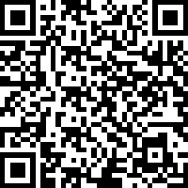

How to Connect with Us!

Website: www.ILTTACenter.org
Request training and / or technical assistance (expert help for your organization): fill out a form on our website to let us know how we can help.
Call: 406-243-5300 and someone will get back to you as soon as we can.
Sign-Up for Events & Announcements:

Visit our website to sign up for updates about live training, group technical assistance, new publications, and other happenings around the Center.

IL T&TA Center Attribution

This project is on assignment through contract with the Administration on Disabilities, Administration for Community Living, Health and Human Services.

About the IL T& TA Center
The Independent Living Training and Technical Assistance Center (IL T&TA Center) is available to you through a contract with the US Department of Health and Human Services.
The IL T&TA Center provides expert training and technical assistance to CILs, SILCs, and DSEs.
The Center is operated by the University of Montana's Rural Institute for Inclusive Communities.
