SILC Connection: The SILC’s Role in Advocacy
June 16, 2026

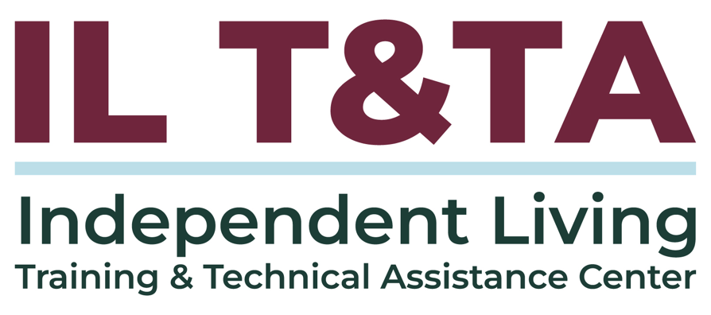

Before We Begin
ASL & Spanish Interpreters are available and labeled.
Access Closed Captioning by clicking the CC button located at the bottom of your Zoom window.
Use Zoom's Raise Hand or Chat features to ask questions.
Use the Q&A box to send us your questions at any time.
Remember to state your name and organization before speaking.
Message our IL T&TA team using the Chat feature if you have difficulties with today's call.
Please complete the survey at the end of today's training.

Today’s Agenda –
Key Takeaways:
- Understand SILC authority and appropriate engagement in advocacy work.
- Distinguish between systems advocacy, policy advocacy, and grassroots advocacy.
- Identify how coalition-building can strengthen cross-disability advocacy.
Overall Goal:
- Let's learn with and from each other!

Presenter
Molly Cole, Executive Director
Connecticut State Independent Living Council (CTSILC)
Molly@ctsilc.org

Facilitator
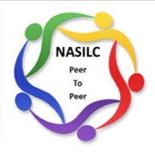
Brooke Wilson, Chair- NASILC (National Association of State Independent Living Councils)

Advocacy in the SILC Role
SILCs can play an important role in identifying systems-level issues, elevating the experiences of people with disabilities, and supporting cross-disability collaboration.
Through education, collaboration, and public input, SILCs can help connect community concerns to broader advocacy efforts.
SILCs play an important role in educating others about policy impact while remaining clear about the SILC’s authority and what it can support, educate on, and elevate.

Advocacy Approaches
SILCs may engage with advocacy work through different approaches:
- Systems advocacy: changing policies, rules, or laws within a system
- Policy advocacy: informing decision-makers about the impact of public policies
- Grassroots advocacy: mobilizing people directly affected by issues, policies, or causes
Coalition building can support each approach by bringing partners together around shared goals and action.

Systems Advocacy: Changing Systems
Systems advocacy is the effort to change policies, rules, or laws within a system to improve outcomes for a group of people, rather than addressing individual cases.
This can include meetings with agency leaders, legislators, and other community leaders.
It often requires consistent work over a period of time.

Systems Advocacy: Mobilizing Around Impact
Systems advocacy should include mobilization of individuals affected by those policies, rules, or laws who can speak to the impact.
It may require public action at events that highlight the particular policy.
In practice: Community First Choice in Connecticut, lack of accessibility in the state capitol, or eligibility criteria that exclude individuals from supports that promote independent living.

Policy Advocacy: Educating on Policy Impact
Policy advocacy is the strategic process of informing decision-makers about the impact of public policies through organized, persuasive, and sustained efforts.
Policy advocacy may include educating people about a particular legislative effort — not lobbying for a bill.
It can include educational hearings, webinars, trainings, materials, rallies, press conferences, and op-eds.

Grassroots Advocacy: Community-Led Action
Grassroots advocacy involves mobilizing ordinary people to collectively advocate for specific issues, policies, or causes.
It emphasizes a bottom-up approach, where change comes directly from individuals within a community rather than professional lobbyists or centralized organizations.
SILCs often use grassroots mobilization with CILs in combination with systems and policy advocacy.

How Does the SILC Identify Advocacy Initiatives?
- SILC Board members
- CILs
- Public input and community concerns
- Other community partners, groups or individuals
- Cross-disability coalitions and partnerships
  - In Connecticut, through the Connecticut Cross Disability Lifespan Alliance

Systems Advocacy in Practice: Wheelchair Repair
- Concerns about wheelchair repair were first raised by members of the SILC Board at a monthly meeting.
- A working committee was formed to explore the issue and potential solutions.
- Protection and advocacy partners also identified wheelchair repair as an issue.
- The issue was discussed through Connecticut’s cross-disability alliance, and the Wheelchair Repair Coalition was formed.
- The coalition held a Capitol rally with press coverage and personal stories.
- The work is now connected to a standing body at the Office of Healthcare Advocate.

Coalition Building for Advocacy
Basic elements of collaboration:
- Shared goals
- Mutual trust
- Clearly defined roles and leadership
- Shared resources

Supporting Other Advocacy Organizations
It is critical that we collaborate with other advocacy efforts.
Sometimes this means supporting emerging groups as they build structure, capacity, and visibility.
CTSILC is currently supporting the development of a CT ADAPT chapter by:
- Assisting with fiscal management while they await nonprofit status
- Coaching them on budget management
- Co-sponsoring events to increase visibility and support successful outreach and events

Building Coalitions Around Action
CTSILC uses coalition-building as an advocacy strategy around specific actions.
Examples include:
- Supported decision-making coalition
- Coalition to close an institution
- Community First Choice Coalition
Every coalition takes time, designated leadership, and a clear focus.
Coalitions can indicate broad support for a specific change and mobilize the public to testify or share stories.

The CT Cross Disability Lifespan Alliance (CCDLA)
- Started in 2013 and is still active
- Current participants: 714
- 20-member core planning group
- Includes CILs, aging partners, CT ADAPT, DD Council, UCEDD, Disability Rights CT, legal partners, family networks, brain injury partners, and independent advocates
- Focused on systems, policy, and grassroots issues
Types of CCDLA Events:
- Press conferences on specific policy and legislative issues
- Rallies on disability rights
- Candidate forums on disability issues

How CCDLA Works and Responds to Issues
- During legislative session, CCDLA meets weekly to monitor legislation affecting people with disabilities and independent living.
- Off session, CCDLA meets monthly or bi-weekly to identify issues for the next legislative session.
- CCDLA shares information on policies, potential impact, and events of interest.
As issues arise, responses may include:
- Sign-on letters
- Press conferences or rallies
- Testimony from people with stories to share

What SILC Advocacy Can Look Like
- Identifying issues raised by the disability community
- Building coalitions around shared concerns
- Elevating lived experience and public input
- Educating decision-makers about policy impact
- Supporting advocacy efforts while remaining clear about what the SILC can support, educate on, and elevate — including talking about the impact of proposed legislation without advocating for or against a bill

Resources for Additional Guidance
ACL FAQs: Permitted Advocacy Activities

Your Experience Matters
Recording has stopped – now it’s time to share.
Ways to Engage:
- Raise your hand to be spotlighted to speak
- Turn on your camera if you're comfortable
- Use the chat to share insights, questions, resources, or tools
- React, reflect, or build on what others say
- Share real challenges or successes from your organization
Let’s turn ideas into action — your voice is the most valuable part of this session.

Evaluation
Thank you for participating in today's SILC Connection.
Your feedback is important and helps us plan future training.
Please use the link in the chat to share your feedback.
Evaluation Link:


Upcoming Events to Join Us On!
- Learn & Share: Supporting Consumers through Service Disruptions– June 24, 2026, 3 PM ET
- Ask Anything – July 9, 2026, 3 PM ET
- Ask Anything – August 13, 2026, 3 PM ET
- SILC Connect: Ask Your SPIL Questions – August 18, 2026, 3 PM ET

How to Connect with Us!
Website: www.ILTTACenter.org
Request training and / or technical assistance (expert help for your organization): fill out a form on our website to let us know how we can help.
Call: 406-243-5300 and someone will get back to you as soon as we can.
Sign-Up for Events & Announcements:

Visit our website to sign up for updates about live training, group technical assistance, new publications, and other happenings around the Center.

IL T&TA Center Attribution

This project is on assignment through contract with the Administration on Disabilities, Administration for Community Living, Health and Human Services.

About the IL T& TA Cent
The Independent Living Training and Technical Assistance Center (IL T&TA Center) is available to you through a contract with the US Department of Health and Human Services.
The IL T&TA Center provides expert training and technical assistance to CILs, SILCs, and DSEs.
The Center is operated by the University of Montana's Rural Institute for Inclusive Communities.
