Supporting Consumers through a Service Disruption
June 24, 2026
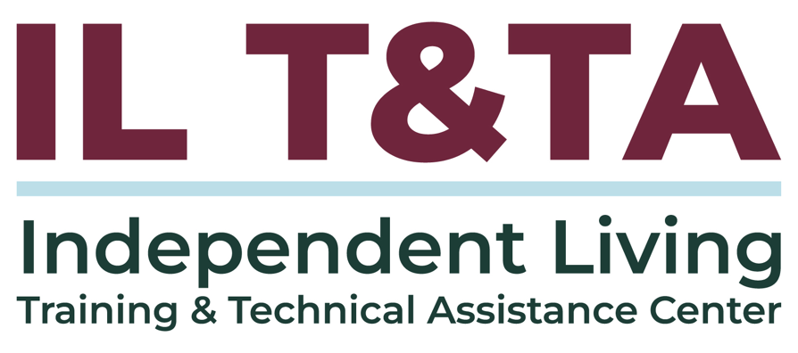

Before We Begin
ASL & Spanish Interpreters are available and labeled.
Access Closed Captioning by clicking the CC button located at the bottom of your Zoom window.
Use Zoom's Raise Hand or Chat features to ask questions.
Use the Q&A box to send us your questions at any time.
Remember to state your name and organization before speaking.
Message our IL T&TA team using the Chat feature if you have difficulties with today's call.
Please complete the survey at the end of today's training.

Today’s Agenda –
Key Takeaways:
- Identify consumer-focused strategies to maintain essential services during operational, staffing, or funding disruptions.
- Describe effective communication practices to keep consumers informed and supported during service disruptions.
- Discuss ways to adapt service delivery models to meet consumer needs during emergencies or transitions.
Overall Goal:
- Let's learn with and from each other!

Presenter
Brittny Zenere
Director of Operations
Alliance of Disability Advocates (ADA)
brittny@adanc.org

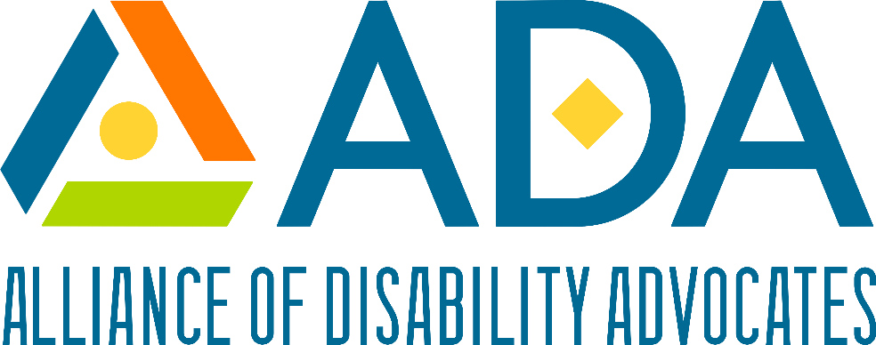

What is a Disruption?
An alteration, interruption, or breakdown of an ongoing system or process.
Example: Severe weather was a major disruption to the bus schedule.
From an IL perspective, the key issue is not only whether the organization or service is disrupted, but also how the disruption affects consumer choice, control, access, safety, and participation.

Types of Service Disruptions
Service disruptions may be temporary or ongoing, and can occur for many reasons. Common types of service disruptions may include, but are not limited to:
- Operational disruptions
- Staffing disruptions
- Funding disruptions

Many other disruptions exist, like weather, policy, or consumer circumstances.

For today's training, we will focus on operational, staffing, and funding disruptions.

What is a Disruptor?
A disruptor is the event, condition, barrier, or change that causes or contributes to a disruption. A disruptor may come from inside the organization, outside the organization, or from the consumer's environment.
Disruptors are not always emergencies. Some are predictable, gradual, or administrative.

Examples of Disruptors
- A key staff member resigns
- A funder delays payment
- The office loses power
- A community partner closes
- A consumer has unstable housing
- A natural disaster
- A policy change to benefits
- A late sign language interpreter

IL Share Point: What other disruptors cause consumer service disruptions?

How Disruptions Impact Consumers
Service disruptions can affect consumers in significant ways, especially when they undermine consumer control and independence.

Potential impacts include:
- Delays in achieving goals
- Increased risk of institutionalization
- Loss of access to benefits, housing, transportation, or personal care attendants
- Confusion about the next steps
- Increased stress or uncertainty
- Loss of trust
- Reduced access

Maintaining Support During Operational Disruptions
Operational disruptions should be managed in ways that preserve consumer access to services and progress towards goals:
- Identify which services are affected and which remain available
- Prioritize time-sensitive needs
- Maintain access to information
- Establish alternative contact methods
- Engage the board or council to initiate a temporary policy
- Document the disruption, response actions, and the impact on the consumer
The goal is not to eliminate every disruption, but to reduce harm, preserve access, and protect consumer-directed decision making.

Maintaining Support During Staff Disruptions
Staffing disruptions can directly affect continuity, responsiveness, and consumer relationships.
Support Strategies Include:
- Cross-training staff on essential service functions
- Identifying backup staff for urgent consumer needs and sharing relevant information to avoid unnecessary repetition by the consumer.
- Communicating staff changes to affected consumers
- Reviewing time-sensitive goals and pending actions
- Monitoring for delays in required follow-up
- Providing supervision and support to staff covering unfamiliar job duties

Staffing disruptions should not be a barrier to a consumer’s right to self-determination.

Maintaining Support during Funding Disruptions
Funding disruptions require careful planning, documentation, and communication:
- Avoid using funding limitations as a reason to steer consumers toward more restrictive settings
- Identify which services, activities, or purchases are affected
- Distinguish between required services, discretionary activities, and temporarily limited resources
- Avoid making assumptions that services must stop before confirming all allowable options
- Review grant requirements, budget flexibility, and prior approvals as needed
- Provide referrals or alternative resources when direct support is temporarily unavailable
- Ensure any changes are applied consistently and without discrimination
- CILs should maintain documentation of how decisions were made, who was affected, what alternatives were offered, and how consumers were informed.

Communication Strategies for Disruptions
Communications during disruptions should be timely, accessible, accurate, and consumer-focused:
- Using plain language
- Explaining what has changed
- Explaining what has not changed
- Identifying who consumers should contact
- Providing realistic steps and timelines
- Offering multiple communication methods
- Using accessible formats
Remember, inaccurate information can worsen or prolong disruptions. Use care in developing and implementing your communication plan.

Communication Best Practices
During disruptions, consumers should not have to search for basic information or guess whether services are available.
Staff should avoid saying:
- “There is nothing we can do.”
- “You will just have to wait.”
- “That service is not available anymore,” without explaining alternatives
- “We decided what is best.”
- “You need to accept this option.”
Instead, staff can say
- “This is what I know is currently available.”
- “Here are options we can explore.”
- “What is most important to you right now?”
- “How would you like us to follow up
- “What communication method works best for you?”
- “Let’s identify the next step you want to take.”
The goal is to remain responsive while sustaining services over time.

Communication Strategies for Disruptions: Staff Changes
When a consumer’s primary contact at the organization changes, communication should explain:
- Who is the new contact
- How to reach that new contact
- Whether scheduled appointments will change
- What the consumer can expect next
- How the consumer can raise concerns
- That the consumer remains in control of their goals and decisions.

Adapting without Compromise
Disruptions can create pressure to make quick decisions. The Independent Living Philosophy should remain central.
This means:
- Consumers remain the decision-makers about their own goals
- Staff provide information, options, support, and advocacy
- Services are consumer-controlled
- Consumers are not steered toward institutional or segregated settings
- Disability-related access needs are anticipated and addressed
- Cross-disability access is maintained
- Peer support remains available when possible
- Communication respects consumer autonomy
- Service adaptations support community living and participation

Key Takeaways
Service disruptions are consumer access issues, not just organizational issues.
- Identify what changed and who is affected
- Prioritize time-sensitive consumer needs
- Communicate early, accurately, and accessibly
- Offer options that preserve consumer choice and control
- Adapt service delivery when needed
- Document decisions, impacts, and follow-up

Resources for Additional Guidance
Partnership for Inclusive Disaster Strategies – consumer-facing preparedness resources.
Internal Practice Guide (Working Draft)- Alliance of Disability Advocates
Example internal tool for I&R intake, triage, waitlist communication, gap response, resource sharing, and follow-up during increased demand.
Contingency of Operations Plan (COOP) IL T&TA Learn & Share

Your Experience Matters
Recording has stopped – now it’s time to share.

Ways to Engage:
- Raise your hand to be spotlighted to speak
- Turn on your camera if you're comfortable
- Use the chat to share insights, questions, resources, or tools
- React, reflect, or build on what others say
- Share real challenges or successes from your organization
Let’s turn ideas into action — your voice is the most valuable part of this session.

Evaluation
Thank you for participating in today's Learn and Share.

Your feedback is important and helps us plan future training.
Please use the link in the chat to share your feedback.
Evaluation Link:
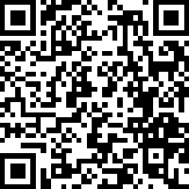

Upcoming Events to Join Us On!
- Ask Anything – July 9, 2026, 3 PM ET
- Ask Anything – August 13, 2026, 3 PM ET
- SILC Connection: Ask Your SPIL Questions – August 18, 2026, 3 PM ET
- Webinar: Board, Council, and Staff Recruitment Pipelines Across Multiple Geographies – August 20, 2026, 3 PM ET
- Learn & Share: Outreach strategies for the Deaf and Hard of Hearing Community– August 26, 2026, 3 PM ET

How to Connect with Us!

Website: https://tinyurl.com/ILTTACenter
Request training and / or technical assistance (expert help for your organization): fill out a form on our website to let us know how we can help.
Call: 406-243-5300 and someone will get back to you as soon as we can.
Sign-Up for Events & Announcements:
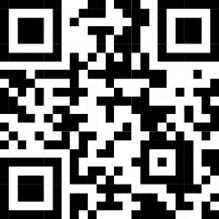
Visit our website to sign up for updates about live training, group technical assistance, new publications, and other happenings around the Center.

IL T&TA Center Attribution

This project is on assignment through contract with the Administration on Disabilities, Administration for Community Living, Health and Human Services.

About the IL T& TA Cent
The Independent Living Training and Technical Assistance Center (IL T&TA Center) is available to you through a contract with the US Department of Health and Human Services.
The IL T&TA Center provides expert training and technical assistance to CILs, SILCs, and DSEs.
The Center is operated by the University of Montana's Rural Institute for Inclusive Communities.
