Outreach Strategies for the Deaf and Hard of Hearing Community
August 26, 2026

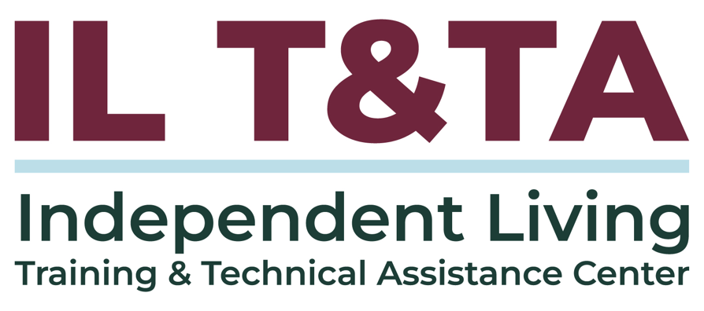
Before We Begin
ASL & Spanish Interpreters are available and labeled.
Access Closed Captioning by clicking the CC button located at the bottom of your Zoom window.
Use Zoom's Raise Hand or Chat features to ask questions.
Use the Q&A box to send us your questions at any time.
Remember to state your name and organization before speaking.
Message our IL T&TA team using the Chat feature if you have difficulties with today's call.
Please complete the survey at the end of today's training.

Today’s Agenda –
Key Takeaways:
- Understands how Deaf culture shapes effective outreach and relationship-building.
- Shapes practical, low-cost strategies for connecting with Deaf and Hard of Hearing (D/HH) communities.
- Identify one concrete step you can take to strengthen D/HH engagement in your Independent Living (IL) program.
Overall Goal:
- Let's learn with and from each other!

Presenters

Malibu Barron
Strategic Support Coordinator
National Deaf Center for Postsecondary Outcomes
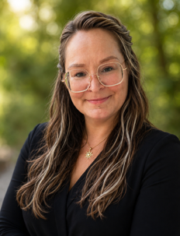
Heather Niedbala
Consultant
Expert in Deaf-Centered Services

How Deaf Culture Influences Engagement
- Deaf culture is a shared language and identity, not just a disability category.
- Even within the broader disability community, Deaf culture may shape communication, identity, and trust in ways that are unfamiliar to CIL staff.
- Trust comes from meaningful relationships.
  - Trust isn't automatic — it's earned, not assumed, because a CIL exists or offers accommodations and services.

Deaf Consumers are Strong Advocates
- In Deaf culture, direct communication can reflect clarity and respect, not confrontation.
- What may seem blunt to non-signing CIL staff may reflect a different communication style.
- Persistence can be shaped by repeated experiences advocating for access.
- Skepticism or detailed questions may reflect earned caution and a need for complete information to make an informed decision.
Give people the benefit of the doubt — read persistence as advocacy, not attitude.
Access Is Not the Same as Trust
- Providing interpreters, captions, or ASL materials creates access — but access alone does not create connection.
- Trust is built through consistency, follow-through, meaningful Deaf involvement, and showing up in community spaces.

Access opens the door. Relationships and deaf leadership help build the connection.
From Awareness to Action
- We've covered the "why" — how Deaf culture and trust can shape engagement opportunities.
- Now the "how" — where do you find connections and begin building your outreach?
Effective outreach means reaching into the Deaf community — not waiting for the community to find IL.

Find Existing Connections: Key Places to Look
The Deaf community already has existing connections; the IL network does not always need to build outreach from the bottom up.
Think in pathways, not just contacts — connect with the systems, organizations, and people Deaf consumers already know and trust.
Start with who is already connected:
- Deaf-led organizations and Deaf clubs
- Schools for the Deaf and their outreach/alumni programs
- State Deaf and Hard of Hearing offices or commissions
- Vocational Rehabilitation contacts who work with Deaf consumers
- Local Deaf community leaders and elders
Show Up Where the Community Already Is
- Attend Deaf community events, meetings, conferences, and gatherings.
- Introduce the CIL/SILC and listen before asking people to participate.
- Invite Deaf community members to co-lead, review materials, or help shape outreach.
- Compensate people when you are asking for their expertise.

Relationship-building is
part of outreach.

Where to Look: National & State

National examples
- National Deaf Center (NDC)
- National Association for the Deaf (NAD)
- American Deafness and Rehabilitation Association (ADARA)
- Communication Services for the Deaf (CSD)

State
- Governor's Commission/Office for DHH
- State Association of the Deaf (NAD-affiliated chapter)
- Vocational Rehabilitation — Deaf/Hard of Hearing unit
- State School (or Program) for the Deaf

Look beyond the usual referral partners — identify organizations and people already connected to and trusted by the Deaf community.
Where to Look: Local

Local Deaf community examples
- San Francisco Deaf Club – California
- Salt Lake Deaf Community Activities –Utah
- Gateway St. Louis Association of the Deaf — Missouri
- Tri-flying Hands Club — Maine
What to look for in your community:
- Deaf clubs and social groups
- Deaf senior groups
- Deaf-led community organizations
- Local Deaf events, conferences, and gatherings
- Opportunities to share resources, exhibit, or network at community events
Use these examples as a model for what may exist in your own service area.
Let Existing Trust Hold the Door
- A warm introduction from a known community connection can carry more weight than an email or a flyer.
- Ask: Who is already trusted here, and who can help make that introduction?
- Deaf community members are more likely to engage when someone they already trust vouches for your CIL.
- Once connected, don’t assume what outreach should look like for Deaf consumers — design it with them.
- Bring Deaf people in early to help shape outreach, messaging, and activities.

Make Independent Living Visible
- Don’t assume Deaf consumers know IL: they may not have been exposed to CIL/SILC services or understand how IL can support their goals.
- Show, don't just tell: use tours, open houses, ASL videos, demonstrations, photos, and real-life examples.
- Create meaningful exposure: Deaf-led panels and peer connections help people see different IL experiences and possibilities.
- Build the bridge early: connect with schools, VR, Deaf organizations, families, and community partners before services are urgently needed.

Make It Deaf-Led – and Be Ready
- Deaf-led from the beginning: Deaf people help identify needs, shape outreach, and serve as experts.
- Expect the layers: One request may involve housing, employment, healthcare, benefits, transportation, and communication access.
- Prepare for the work: Plan for follow-up, interpreting/access needs, cross-system coordination, and advocacy.
- Think beyond the first contact: Successful outreach may increase engagement; make sure staffing, access, and follow-up can support it.

Access ≠ Deaf-led: Access makes participation possible.
Deaf leadership helps shape the work.

Start Relationships Before the Need
- Start before the need: Build relationships with Deaf professionals, schools, VR, state agencies, families, and community organizations now.
- Create a network, not a referral list: Know who can help when needs cross multiple systems.
- Build the bridge: Strengthen connections between IL and the systems Deaf people may already know and use.
- Infuse IL philosophy into partnerships: Promote full access to communication, informed choice, and self-direction so Deaf consumers can understand their options and pursue their own goals.

Your 30-Day Action
Choose one:
- Connect with one Deaf-led organization or community leader.
- Attend one Deaf community event or meeting.
- Contact your state Deaf/HH office or specialized VR staff.
- Invite a Deaf community member to review an outreach effort.
- Arrange an introduction or tour with a school or community program.
- Identify one barrier in how Deaf consumers currently connect with your CIL/SILC

Write down who you will contact first to reach the Deaf community.

Resources for Additional Guidance
- National Deaf Center’s Deaf Awareness Micro Certification: Register Here!
- National Deaf Center’s page: Deaf with Disabilities: Transition & Postsecondary Education

Your Experience Matters
Recording has stopped – now it’s time to share.

Ways to Engage:
- Raise your hand to be spotlighted to share
- Turn on your camera if you're comfortable
- Use the chat to share insights, questions, resources, or tools
- React, reflect, or build on what others say
- Share real challenges or successes from your organization

Let’s turn ideas into action — your input is the most valuable part of this session.

Evaluation
Thank you for participating in today's Learn and Share.

Your feedback is important and helps us plan future training.
Please use the link in the chat to share your feedback.
Evaluation Link:
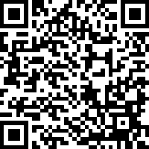

NDC Evaluation:
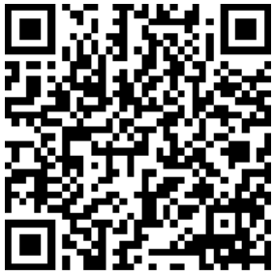

Upcoming Events to Join Us On!
- Cohort: Emotional Wellness & Elevated Engagement – September 2, 9, 16, 3 PM ET
- Ask Anything – September 13, 2026, 3 PM ET
- Webinar: Board, Council, and Staff Recruitment Pipelines Across Multiple Geographies – September 11, 2026, 3 PM ET
- Webinar: Insights from the Tribal Expert Peer Cohort (TEPC) – Advancing Indigenous Independent Living Services – September 23, 2026, 3 PM ET

How to Connect with Us!

Website: https://tinyurl.com/ILTTACenter
Request training and / or technical assistance (expert help for your organization): fill out a form on our website to let us know how we can help.
Call: 406-243-5300 and someone will get back to you as soon as we can.
Sign-Up for Events & Announcements:
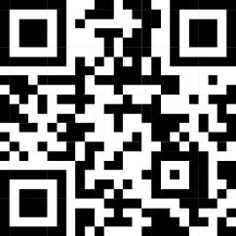
Visit our website to sign up for updates about live training, group technical assistance, new publications, and other happenings around the Center.

IL T&TA Center Attribution

This project is on assignment through contract with the Administration on Disabilities, Administration for Community Living, Health and Human Services.

About the IL T& TA Cent
The Independent Living Training and Technical Assistance Center (IL T&TA Center) is available to you through a contract with the US Department of Health and Human Services.
The IL T&TA Center provides expert training and technical assistance to CILs, SILCs, and DSEs.
The Center is operated by the University of Montana's Rural Institute for Inclusive Communities.
