Board, Council, and Staff Recruitment Pipelines Across Multiple Geographies
September 11, 2026

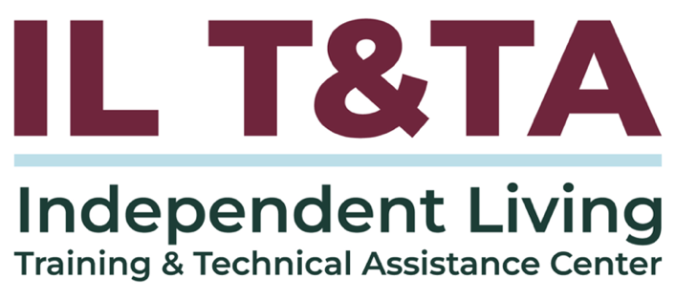

Before We Begin
ASL & Spanish Interpreters are available and labeled.
Access Closed Captioning by clicking the CC button located at the bottom of your Zoom window.
Use Zoom's Raise Hand or Chat features to ask questions.
Use the Q&A box to send us your questions at any time.
Remember to state your name and organization before speaking.
Message our IL T&TA team using the Chat feature if you have difficulties with today's call.
Please complete the survey at the end of today's training.

Learning Objectives –
- Identify at least three rural-specific barriers to workforce and board diversity and match each with a feasible mitigation strategy (e.g., partnerships, remote participation supports, targeted outreach).
- Develop a simple, measurable recruitment plan that includes key actions, responsible parties, and data points, with at least two indicators of success.

Presenters

Rayna Sage: RTC Rural Co-Director and RIIC Director of Training & Connection; Rayna.Sage@umontana.edu
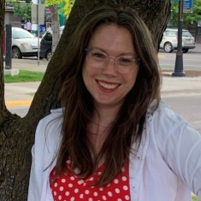
Lillie Greiman: Project Director, Lillie.Greiman@umontana.edu

The Research and Training Center on Disability in Rural Communities (RTC: Rural)

Content Overview and Activities
- Background information about the intersections of rurality and disability to support a deeper understanding of:
  - The rural communities you serve
  - Rural experiences across the United States
  - Shared experiences between rural communities and people with disabilities
- Introduction to the Rural Outreach Training: an online resource to support organizations of different sizes and capacities to build their presence in their rural communities

Understanding Rural Communities
Why It Matters
- Significant overlap exists between rural and disability experiences
- Understanding these connections creates opportunities for:
  - Collaboration
  - Community building
  - Shared advocacy
  - Mutual support

Where is Rural America?
Depends on who you ask!
- More than a dozen different definitions
- County, zip, census tracts, urban areas, Population, housing, commuting patterns, economic activity
- 72% - 97% of total landmass
- 15-20% of total U.S. population
Rural is a broad term – anything not “urban”
- Urban-centric, deficit-based concept

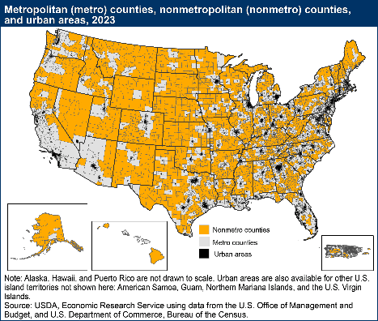
2023 Map of United States Metro Counties, Non-Metropolitan Counties and Urban Areas

Understanding Rural
Modern US history and policy has systematically devalued rural communities and the people who live in them.
Historically, rural places have often been viewed as sources of:
- Natural resources to fund urban development
- Human labor to support extraction
- Economic opportunity for outside investment

Understanding Rural (cont.)
Common Patterns involved
- Outside investment arrives
- Resources are extracted
- Economic boom occurs
- Federal/state priorities shift or resources deplete
- Communities experience disinvestment and loss of resources (people, money, services)

Results of De-valuing Rural Communities
- Economic instability
- Reduced infrastructure investment
- Long-term community challenges
- Health disparities
- Distrust
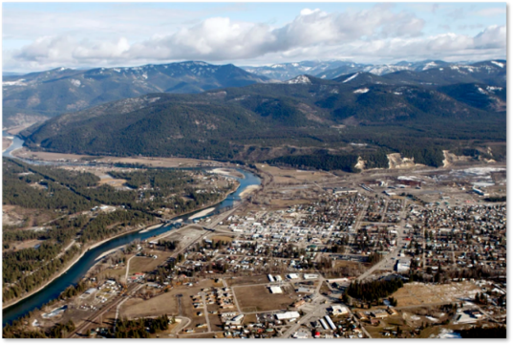
- Erasure
- Example of Libby, MT

Let’s Pause & Reflect: Discussion
Recording has stopped.

- Does this resonate with your experience and with the rural communities you serve?

- What’s similar or different?

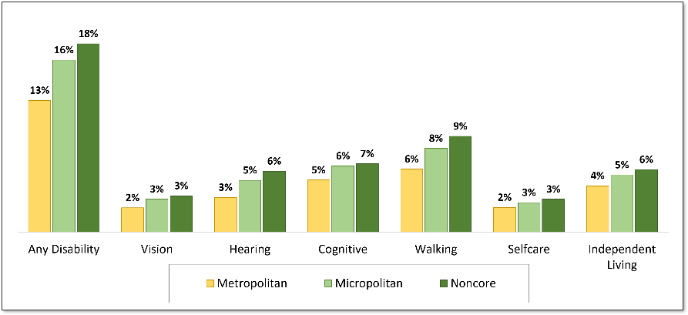
Disability and Rurality

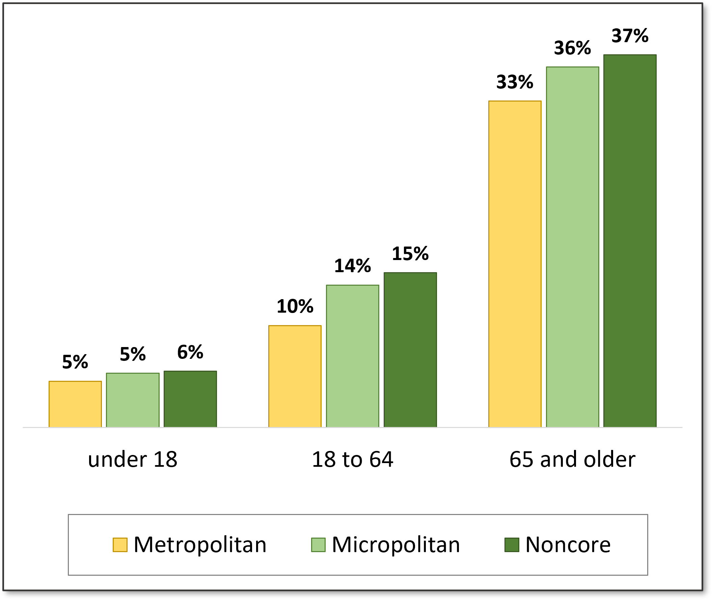
Disability and Age

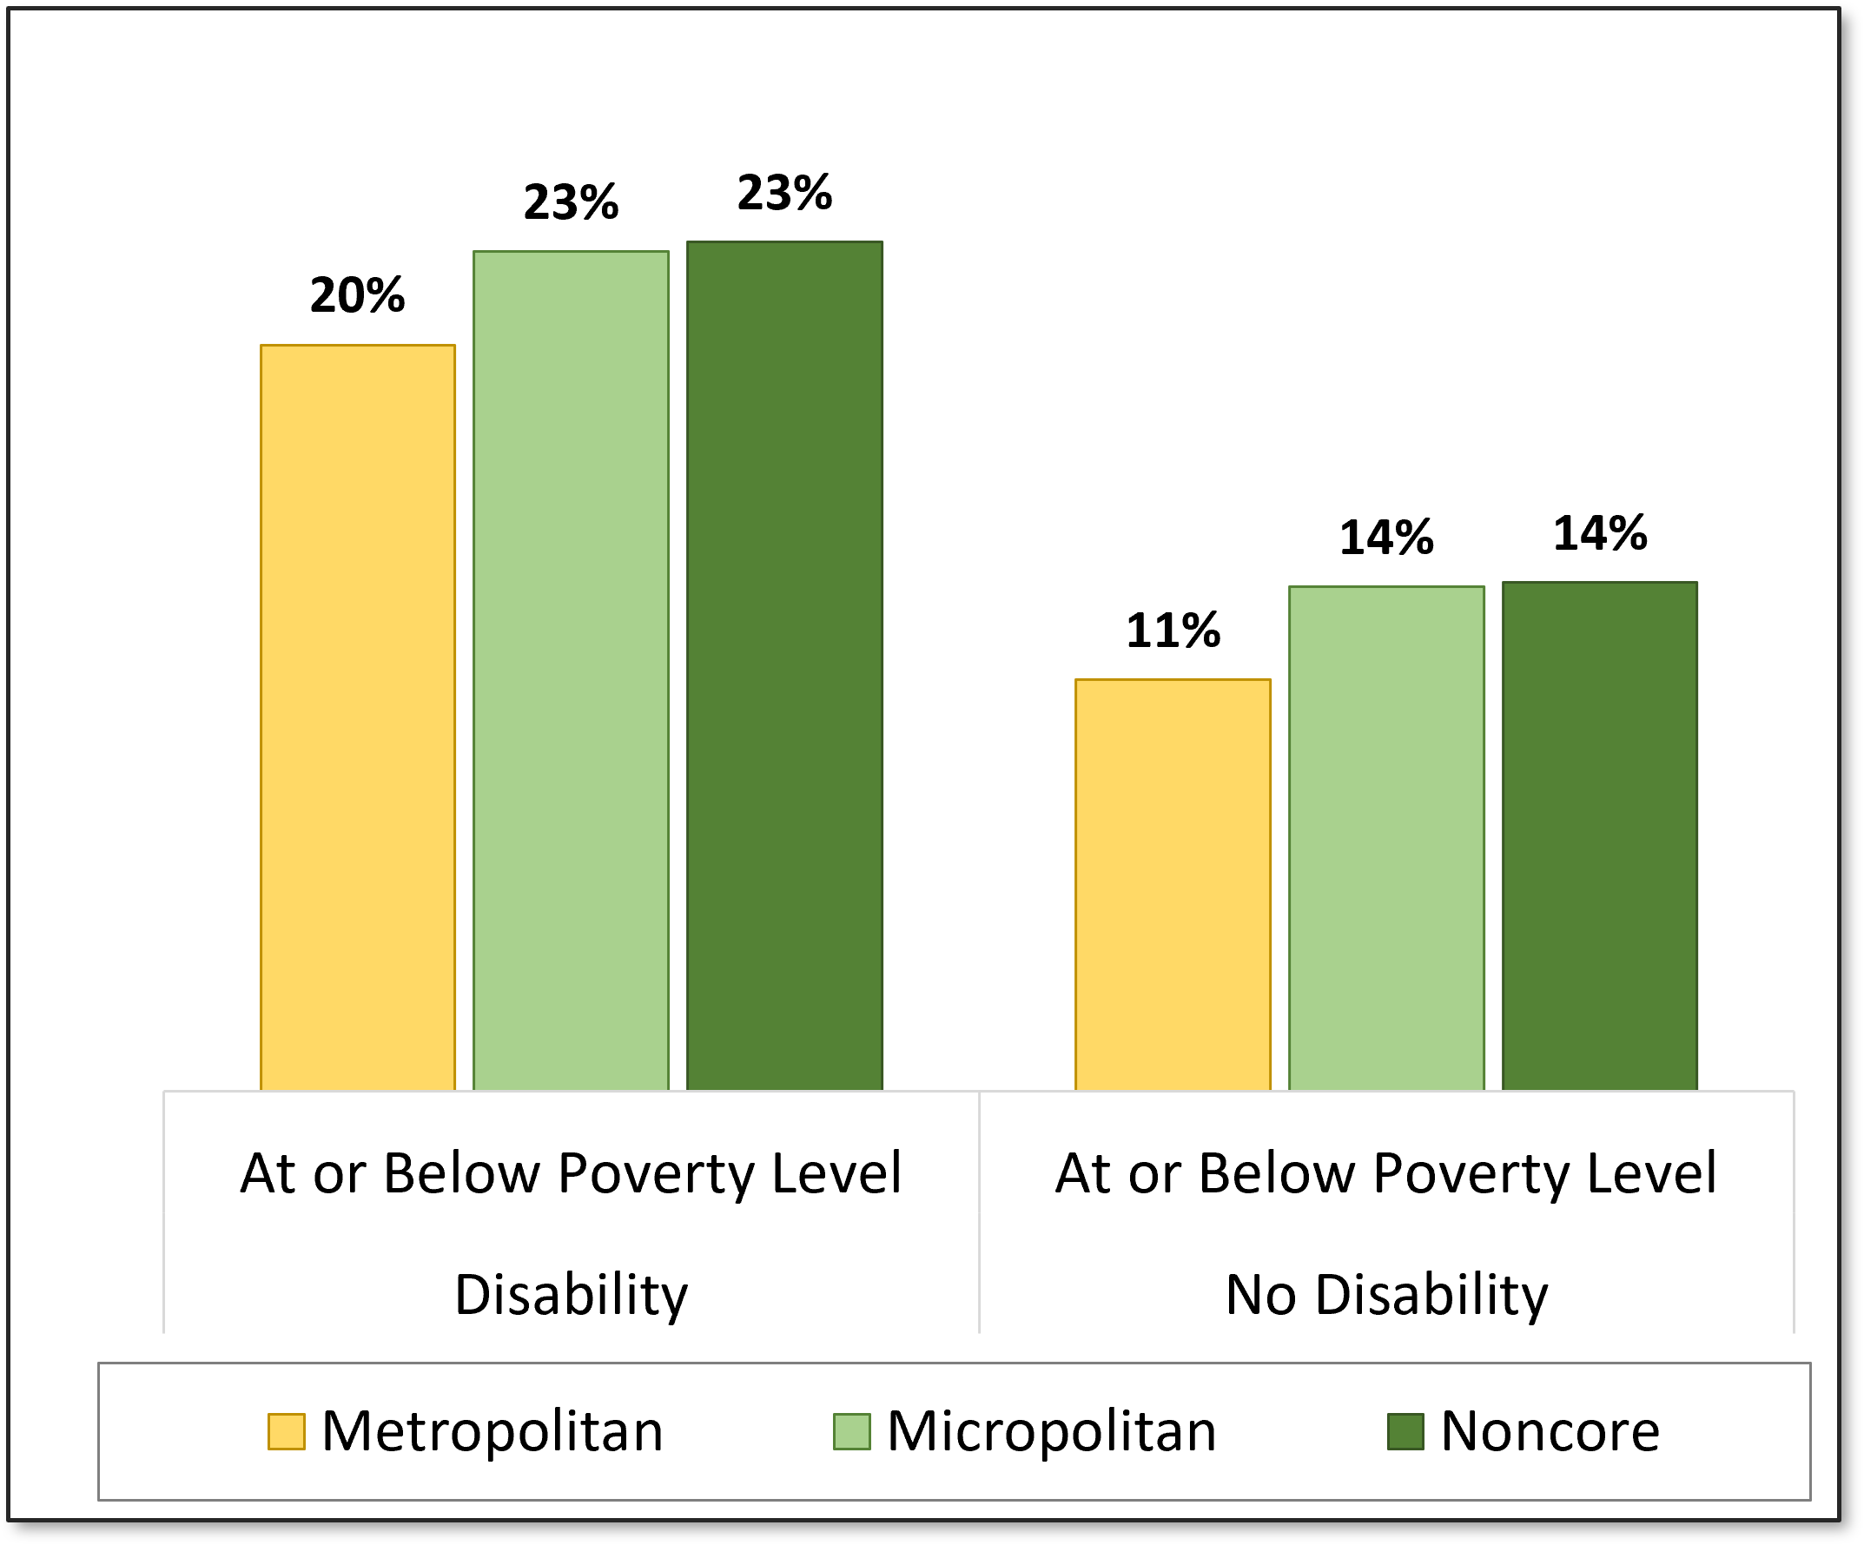
Disability and Poverty

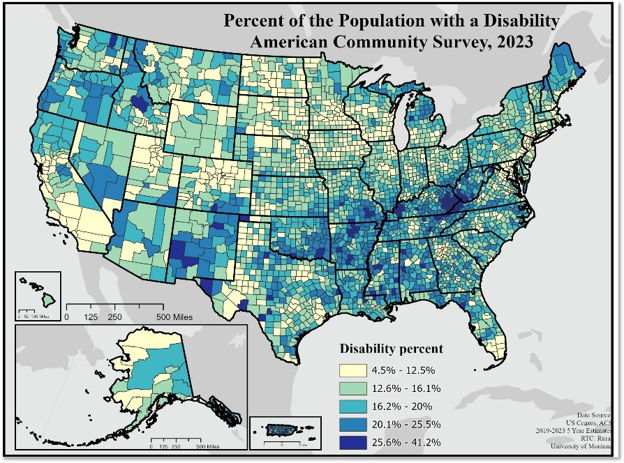
Percent of Population with a Disability

Disability and Rurality
- Complex interactions at the intersections of place, disability, race, culture
- Experience of multiple marginalization
- Diversity within both rural places and the disability community
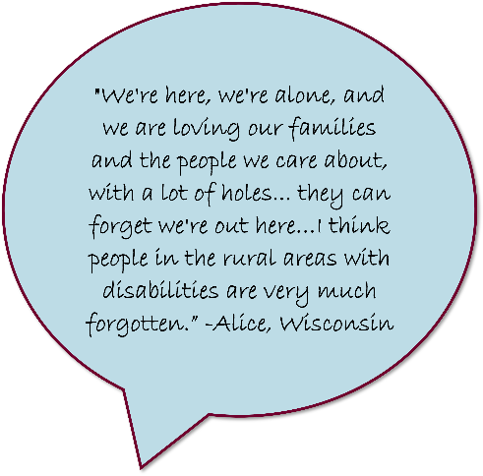

Rurality and Disability: Understanding Shared Values and Experiences
Both rural communities and disability communities have experienced:
- Periods of investment followed by abandonment
- Decision-making imposed by outside entities

- Distrust/wariness of government and external organizations
- Efforts to maintain autonomy and self-determination

What the Research and Data Say
- Some barriers to connecting with rural folks are systemic and structural, tied to everything we discussed previously
- Building trust with rural communities requires sustained engagement and commitment
- Recruiting from rural places takes time to build trust and identify key community leaders and gatekeepers

Rural Outreach Toolkit
- Rural Community Living Development (RCLD) and the Rural Outreach Peer Network
  - Worked collaboratively with 30+ CIL participants over 5 years who were involved in creation, utilization, and evaluation of an online resource to support rural outreach
  - Funded through ACL-NIDILRR
- Rural Outreach Toolkit - Strategies for organizations of different sizes and capacities to build their presence in their rural communities

Get Learning: Rural Cultural Humility
- Norms and culture and how these things are impacted by history
- What do you know about the communities you are working with?
- How can you find out more?
  - Local radio, publications, festivals and parades
  - To know, you gotta go!
Get Learning Rural Cultural Humility Training

Get Learning: Tools to Improve Your Understanding of Your Organization
- Getting to know yourself and your organization
  - “You serve who you are”
  - Who else is in the community?
  - Disability Counts
- CIL readiness questions/discussion
  - What is your commitment to rural outreach?
  - What time and effort can you and your organization commit to building connections?
  - How is this reflected in your strategic planning and policies?

Get Started
- Strategies to get going
  - Being present and spending time without an agenda
  - Listen and learn
- Start with who you know
  - Developing an elevator pitch and outreach materials
- Finding your fit
  - Voice for access
  - Emergency planning
Get Started Training Section

Developing Your Outreach and Recruitment Goals
- What are your rural outreach and recruitment goals?
- What are two actions you can take this month?
- Who needs to be involved?
- Will you need data or information to share?
- How will you know you have succeeded?

Resources for Additional Guidance
Rural Community Living Development
- Outreach Training
- CIL readiness questions/discussion
- Disability Counts
- Rural Cultural Humility Training

This research was developed with funding from the National Institute on Disability, Independent Living, and Rehabilitation Research (NIDILRR grant numbers 90RTCP0007 and 90DPKT0005). NIDILRR is a Center within the Administration for Community Living (ACL), Department of Health and Human Services (HHS). The contents do not necessarily represent the policy of NIDILRR, ACL, or HHS, and you should not assume endorsement by the Federal Government.

Your Experience Matters
Recording has stopped – now it’s time to share.
Ways to Engage:
- Raise your hand to be spotlighted to speak
- Turn on your camera if you're comfortable
- Use the chat to share insights, questions, resources, or tools
- React, reflect, or build on what others say
- Share real challenges or successes from your CIL

Let’s turn ideas into action — your voice is the most valuable part of this session.

Evaluation
Thank you for participating in today's Learn and Share.
Your feedback is important and helps us plan future training.
Please use the link in the chat to share your feedback.
Evaluation Link:
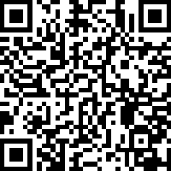

How to Connect with Us!
Website: www.ILTTACenter.org
Request training and / or technical assistance (expert help for your organization): fill out a form on our website to let us know how we can help.
Call: 406-243-5300 and we will get back to you as soon as we can.
Sign Up for Events & Announcements:
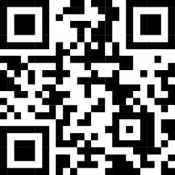
Visit our website to sign up for updates about live training, group technical assistance, new publications, and other happenings around the Center.

IL T&TA Center Attribution

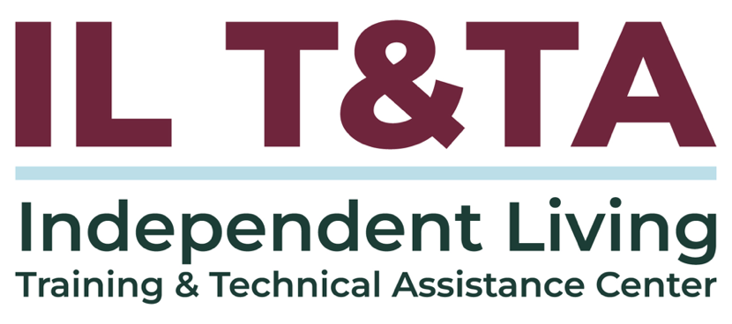
This project is provided under contract with the Administration on Disabilities, Administration for Community Living, U.S. Department of Health and Human Services.

About the IL T& TA Center
The Independent Living Training and Technical Assistance Center (IL T&TA Center) is available to you through a contract with the US Department of Health and Human Services.
The IL T&TA Center provides expert training and technical assistance to CILs, SILCs, and DSEs.
The Center is operated by the University of Montana's Rural Institute for Inclusive Communities.
