Emotional Wellness & Elevated Engagement Cohort: Week 3
September 16, 2026

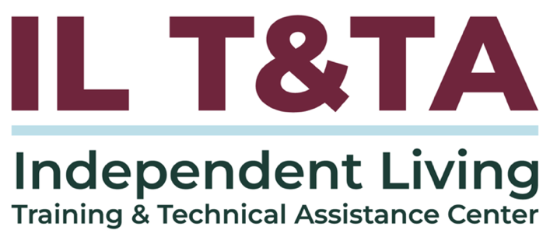

Before We Begin
ASL & Spanish Interpreters are available and labeled.
Access Closed Captioning by clicking the CC button located at the bottom of your Zoom window.
Use Zoom's Raise Hand or Chat features to ask questions.
Use the Q&A box to send us your questions at any time.
Remember to state your name and organization before speaking.
Message our IL T&TA team using the Chat feature if you have difficulties with today's call.
Please complete the survey at the end of today's training.

Cohort Learning Objectives –
Week One: Staying Grounded – Practical Safety Strategies for IL Team/Staff
Week Two: Turning Down the Heat – De-escalation Skills for Challenging Situations
Week Three: Sustaining the Work – Taking Care of Yourself in Our Movement
- Recognize burnout, compassion fatigue, and secondary trauma — in yourself and others.
- Apply whole-health self-care, set boundaries, and build peer support.
- Know when and how to seek support — inside and outside the workplace.

Cohort Overview:
- Dates: September 2, 9, 16, 2026
- Flow: 60 minutes of learning + 30 minutes of peer discussion and application
- Approach: Interactive • Peer-driven • Conversational

How We’ll Learn Together:
- Be Present — Participate in the way that works for you.
- Share the Space — Make room for different voices and experiences.
- Stay Curious — We’re here to learn with and from one another.
- Honor Trust — Take the learning with you; leave personal stories in the room.
- Respect the Time — Help us keep the conversation moving
Presenters

Lead Presenter: Kristina “KK” Kapp
Executive Director
(Liberators 4 Justice)
Tony Brooks
IL Core Specialist (IL Hype Man)
The Center for disABILITY Empowerment (CIL)


Misty Dion
Chief Executive Officer
(Liberators 4 Justice)

Jodie Ricketts
Road to Freedom Director
(IL Values Ambassador)
Roads to Freedom CIL

About Your Presenter
Kristina “KK” Kapp has transformed a life marked by adversity into a masterpiece of possibility. A first-generation American with a rich, global upbringing, she reframes disability and trauma as catalysts for growth. For 24 years she has been a dedicated disability rights and justice advocate. A survivor of ECT, she founded Beliefactory in 2020 to empower others. She is President & CEO of MindFreedom International, Vice President of NARPA, co-founder of SAFE 4 Recovery, an ADA Watch National Advisory Board member, and Executive Director of The Center for disABILITY Empowerment (CIL) in Columbus, Ohio.
BELIEVE IT… BECOME IT… BE IT…

Carrying GRACE Forward: Sustaining the Work
- Week 1 we focused on what happens before we respond.
- Week 2, we focused on how to bring down the heat through genuinely connecting to build trust.
- Week 3 – we’ll focus on Emerge: moving toward wellness, purpose, and each other.

IL work is meaningful and emotionally heavy — sustaining ourselves is part of the work.

We move toward the lives and communities we want, together – grounded in GRACE. The Compassionate Presence Model — created for our community — comes full circle.

Carrying GRACE Forward: Compassionate Consciousness

GROUND
Steady yourself and come into the moment.
REGARD
See the whole person with curiosity and positive regard.
AUTONOMY
Honor agency, choice, and self-direction.
CONNECT
Lead with compassion and presence rather than control.
EMERGE
Move toward what the person wants, together.

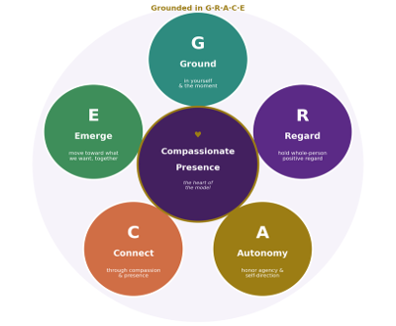
Compassionate Presence · this week: Emerge

What Does Connection & Compassion (the Work) Cost?

- Burnout: the slow erosion from chronic overload.
- Compassion fatigue: empathy worn down by constant exposure to suffering.
- Secondary trauma: absorbing others trauma as our own. Naming what you feel is the first act of care.
- Disregard of Community Care: we need more than self-care; we also need to recognize and understand we are accountable to each other and our community.

When the Work is Wearing on Us
Stress and emotional impact can show up differently for each person.
Some things we might notice:
- Feeling emotionally or physically depleted
- Irritability, frustration, or shorter patience
- Difficulty disconnecting from work
- Changes in sleep, focus, motivation, or energy
- Feeling numb, detached, overwhelmed, or unusually affected by consumer / peer experiences
- Dreading work that previously felt meaningful
- Carrying situations home or replaying them afterward

Grief, Loss, & Moral Distress
Moral distress — knowing what the right thing is and being gatekept (overtly or covertly) from doing it — is a heavy load.
This can contribute to movement / mission drift.
Our movement holds real loss and decay of compassion — people we couldn’t reach, systems that fail.
Grief is often experienced in our work – individually and collectively; we need to honor this and engage in interdependent communication that fosters community for compassionate understanding.

Making Room for Grief & Strong Emotions
Processing doesn't mean leaving emotion at the door — or carrying it alone.
Healthy ways of making room for grief and strong emotions:
- Name what you're feeling rather than discounting this and pushing through automatically.
- Debrief with a trusted peer or supervisor.
- Take time and space after a difficult interaction or conversation.
- Use grounding or whole-health practices.
- Honor a loss individually or collectively
- Recognize when something needs more support than a workplace conversation can provide.

The Heart of IL: Human Connection & Interdependence
- Reclaiming ourselves and reclaiming our movement by reclaiming our narrative – Peer 2 Peer / Human 2 Human: relational connection of shared understanding.
- We tend to carry the full weight of advocacy injustices and ableism alone. This often contributes to advocacy fatigue, which can be traumatizing.
- We must collectively shoulder the weight of our work together by supporting each other — through peer support and community.
Interdependence is not weakness; it reflects the strength of our community and is the spirit of Independent Living.

Wellness Isn't Only an Individual Responsibility
Sometimes the source of stress isn't personal — it's structural.
- Heavy workloads and limited resources
- Inaccessible or unresponsive systems
- Ableism and other systemic barriers
- Repeated advocacy without meaningful change
- Policies that conflict with what consumers need
- Lack of organizational support or capacity
Self-care can help us sustain ourselves — but it doesn't make systemic barriers an individual responsibility.


Let’s Pause & Reflect:
How do you recognize if you (or your organization) is pouring from an empty cup?

Ways to Engage:
- Use the chat to share insights, questions, resources, or tools
- React, reflect, or build on what others say in the chat

Self-Care & Personal Well Being

- Self-care is not a luxury — it is fundamental to sustaining our individual whole health and whole personhood, which ensures our community keeps showing up loud, proud, and meaningfully engaged.
- You Can’t Pour From An Empty Cup – Caring for yourself is caring for the peers you support / empower and our greater cross-disability community

WHAM: Whole-Health Resiliency

- Whole health means tending to body, mind, connection, meaning, and joy (WHAM).
- WHAM builds resilience across whole-health factors: stress management, activity, restful sleep, and more.
- Try implementing one wellness initiative (from WHAM) this week.
  - Starting Point: Engage in small, consistent practices instead of big ones.

Grounding & Self-Care Practices

- Be Relaxed: The Relaxation Response (WHAM): slow breath, longer exhale, rest on one word.
- Be Mindful: A 60-second reset: feet on the floor or ground (or whatever is accessible for you); name what you see, hear, and feel.
- Be Self Aware: Do a body self-scan. Notice early signs of physical tension (in your body) and any mental, emotionally, etc. depletion.

Grounding & Self-Care Practices

- Be Open: Asking for support is a skill, not a weakness or failure. This is an opportunity to learn and grow and embrace interdependence!

- Be Emotional: Emotional needs or expressions does not equate to a mental health diagnosis, distress, or “crisis.”

Start with yourself

Set Boundaries – Embrace & Exercise Personal Governance

- Boundaries protect your time and energy so you can sustain the work.
- Practice saying “no,” or “not like this,” warmly and clearly. No means no.
- Honor personal agency and autonomy.
- No justification, explanation, or apologies are necessary.
- You are the driver of your life and the best expert on what you need — you get to define / set your limits.

Peer Support & Community Wisdom

- Peer support is for staff, too — mutual, non-hierarchical, lived-experience-based.
- Community wisdom reminds us we are held by more than ourselves.
- Community Life Learning Challenge: Come together with peers, check in, share one challenge, reflect together, close. Repeat often.

When Do We Reach for Support?
Consider reaching beyond your usual self-care when:
- Stress isn't easing between difficult situations
- Work is consistently affecting sleep, relationships, concentration, or daily life
- You're feeling increasingly detached, overwhelmed, angry, or depleted
- Boundaries are becoming harder to maintain
- You're carrying something that feels bigger than what peer support or a workplace debrief can hold
- You simply recognize that you need more support
We don't have to wait to seek support until our cup is empty.

Support Looks Different for Each of Us – And Comes in Many Forms
Inside the workplace:
Supervisor • trusted coworker • peer support • team debrief • accommodations/access supports • workload/workflow changes • EAP or organizational resources - Support opportunities for creativity and innovation.
Outside the workplace:
Personal peer/community network • disability community • professional support • community resources • cultural/spiritual supports • crisis or immediate support when needed
Ask yourself: What do I need? → Who can provide that? → What am I comfortable sharing?

Advocating for Your Own Needs

- Advocate for yourself the way you advocate for consumers.
- Nothing About Us, Without Us — includes you.
- Model for your peers asking for what you need --- Name what you need from your team, your leaders, and your community.
- Provide yourself with the same GRACE and space you would your fellow peers.

Advocating for Your Own Needs

What do I actually need to keep doing this work sustainably?

This might mean asking for:
- A debrief after a difficult situation.
- Backup or shared responsibility.
- Time to reset before the next interaction.
- Clearer expectations or priorities.
- An accommodation or access support.
- Training, supervision, or guidance.
- A change in workload, workflow, or reinforcing concrete boundaries.

Advocating for yourself is self-care.

Emerge in Motion: Shifting Toward Want We Want

- Reconnect with meaning and purpose — remember why you came into this work.
- Embrace discomfort and lean into the hard stuff (Emerge) – this is when change and growth happens.
- Dream big. Move toward your hopes embracing detours as part of your life learning experience.
- Honor the ancestors of our movement; leverage their trailblazer wisdom to spark momentum to ignite us forward.

Key Takeaways & Carrying GRACE Forward – Let’s Pause & Reflect
Sustaining yourself is imperative to sustaining our IL movement and the cross-disability community — you can’t pour from an empty cup.
- Leave the performative behind – Don’t just say it, display it.
  - Own and honor our and others authenticity and humanhood.
  - Set boundaries.
  - Engage in meaningful peer support.
  - Commit / Recommit to interdependence.

Key Takeaways & Carrying GRACE Forward – Let’s Pause & Reflect

- Ground: What steadies me?

- Regard: How do I treat myself with compassion?

- Autonomy: What boundary will I honor?

- Connect: Who is my support?

- Emerge: What is one small step toward my own wellness this week?

The Compassionate Presence Model (GRACE) is ours — created for our community, by our community.

Resources for Additional Guidance
- Emotional CPR (eCPR)
- The Compassionate Presence Model (Grounded in GRACE) – Kristina Kapp
  - Sustainability Toolkit (Week 3)
- Whole Health Action Management (WHAM)

That’s a wrap on our cohort — carry the Compassionate Presence Model forward. Nothing About Us, Without Us.

Your Experience Matters
Recording has stopped – now it’s time to share.
Ways to Engage:
- Raise your hand to be spotlighted to speak
- Turn on your camera if you're comfortable
- Use the chat to share insights, questions, resources, or tools
- React, reflect, or build on what others say
- Share real challenges or successes from your CIL
Let’s turn ideas into action — your voice is the most valuable part of this session.

Evaluation
Thank you for participating in today's Learn and Share.
Your feedback is important and helps us plan future training.
Please use the link in the chat to share your feedback.
Evaluation Link:
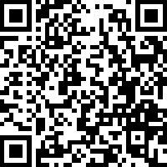

How to Connect with Us!
Website: www.ILTTACenter.org
Request training and / or technical assistance (expert help for your organization): fill out a form on our website to let us know how we can help.
Call: 406-243-5300 and someone will get back to you as soon as we can.
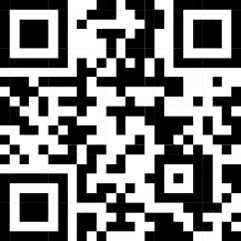
Sign-Up for Events & Announcements:
Visit our website to sign up for updates about live training, group technical assistance, new publications, and other happenings around the Center.

IL T&TA Center Attribution

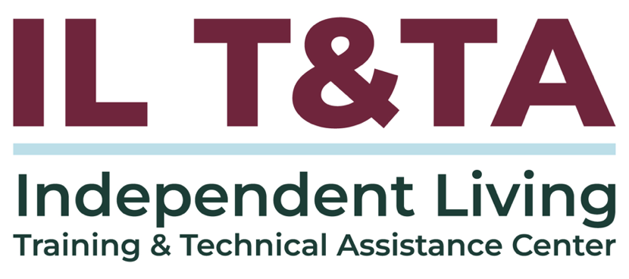
This project is on assignment through contract with the Administration on Disabilities, Administration for Community Living, Health and Human Services.

About the IL T& TA Center
The Independent Living Training and Technical Assistance Center (IL T&TA Center) is available to you through a contract with the US Department of Health and Human Services.
The IL T&TA Center provides expert training and technical assistance to CILs, SILCs, and DSEs.
The Center is operated by the University of Montana's Rural Institute for Inclusive Communities.
