Emotional Wellness & Elevated Engagement Cohort: Week 1

September 2, 2026

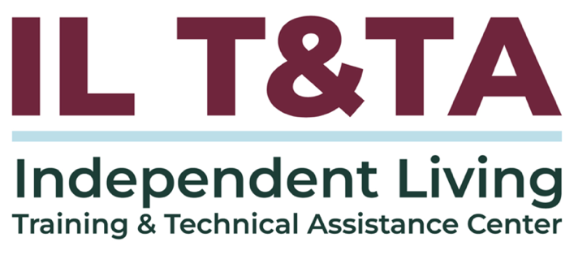

Before We Begin
ASL & Spanish Interpreters are available and labeled.
Access Closed Captioning by clicking the CC button located at the bottom of your Zoom window.
Use Zoom's Raise Hand or Chat features to ask questions.
Use the Q&A box to send us your questions at any time.
Remember to state your name and organization before speaking.
Message our IL T&TA team using the Chat feature if you have difficulties with today's call.
Please complete the survey at the end of today's training.

Cohort Learning Objectives –

Week One: Staying Grounded – Practical Safety Strategies for IL Team/Staff
- Understand how history, bias, policies, and systems impact decision-making and outcomes.
- Make informed decisions that balance safety with dignity of risk and consumer choice.
- Recognize safety risks and use situational awareness to respond in changing environments

Week Two: Turning Down the Heat – De-escalation Skills for Challenging Situations

Week Three: Sustaining the Work – Taking Care of Yourself in Our Movement
Cohort Overview:
- Dates: September 2, 9, 16, 2026
- Flow: 60 minutes of learning + 30 minutes of peer discussion and application
- Approach: Interactive • Peer-driven • Conversational

How We’ll Learn Together:
- Be Present — Participate in the way that works for you.
- Share the Space — Make room for different voices and experiences.
- Stay Curious — We’re here to learn with and from one another.
- Honor Trust — Take the learning with you; leave personal stories in the room.
- Respect the Time — Help us keep the conversation moving
Presenter
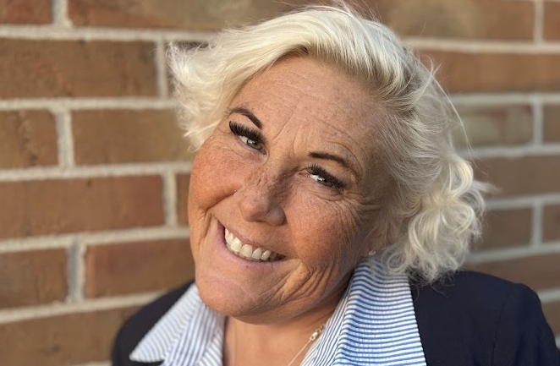
Kristina “KK” Kapp
Executive Director
The Center for disABILITY Empowerment (CIL)
kkapp@disabilityempowerment.net


About Your Presenter
Kristina “KK” Kapp has transformed a life marked by adversity into a masterpiece of possibility. A first-generation American with a rich, global upbringing, she reframes disability and trauma as catalysts for growth. For 24 years she has been a dedicated disability rights and justice advocate. A survivor of ECT, she founded Beliefactory in 2020 to empower others. She is President & CEO of MindFreedom International, Vice President of NARPA, co-founder of SAFE 4 Recovery, an ADA Watch National Advisory Board member, and Executive Director of The Center for disABILITY Empowerment (CIL) in Columbus, Ohio.
BELIEVE IT… BECOME IT… BE IT…

Setting the Stage: Safety & Independent Living
- Week 1 is about what happens before we respond: ground yourself, then assess.
- “Safety” means different things to different people — and can quietly slide into control.
- Our aim: hold real safety concerns and a person’s right to direct their own life at the same time.

Ground → Assess → Decide

IL Foundation: Independence, Self-Determination & Interdependence
- Independence = self-determination — the right to make your own decisions — not doing everything alone.
- We are all interdependent: asking for and offering support is a strength, not a failure.
- Support is not control: Our role is to inform and stand with people, not to take over.

History Shapes How We Think About Safety
- For generations, institutionalization separated people with disabilities from their communities and placed decisions about their lives in the hands of others.
- Ideas about protection, safety, and risk have often been used to justify limiting choice and self-determination.
- Those histories can still influence policies, practices, and our instincts about when to step in.
- Moving from institution to community also means shifting from deciding for people to supporting people to direct their own lives.
History → Practice → Decisions Today

Ableism, Bias & the Assumptions We Carry
- Ableism and bias shapes what we notice, what we fear, and what we label “risky” or “unsafe”.
- Our own history, identity, role, experiences, and interactions with systems can influence how we interpret the same situation.
- A behavior or choice that makes us uncomfortable is not automatically a safety concern.
- Recognizing our assumptions helps us separate what we're observing from what we're interpreting
Pause • Notice • Question the assumption

Dignity of Risk: The Right to Reasonable Risk
The right to take reasonable risks is essential to growth, dignity, and self-determination – Robert Perske
- Overprotection can cause harm — it can communicate, “I don't believe in your ability.”
- Informed choice means sharing what we know, exploring options, and honoring the person's decision.
- Risk does not automatically mean danger — and discomfort does not automatically mean something is unsafe.
- Supporting dignity of risk means holding choice and legitimate safety concerns together.

Balancing Choice, Safety & Staff Responsibility
Sometimes choice, staff responsibility, and safety can feel in tension.
Both/and, not either/or — safety and dignity can be held together.
- Before moving into action, ask:
  - What is the actual risk — and what am I assuming?
  - Whose decision is this?
  - What is my responsibility or obligation?
  - What information, options, or support can I offer?
  - How do I support without unnecessarily overriding choice?
Safety and dignity, together


Let’s Pause & Reflect:
Recording has stopped.
- On the phone with a consumer expressing frustration with a situation, such as housing?
  - How would you validate someone without assumptions?
  - How do you interact with the consumer’s system’s representative?

Ways to Engage:
- Raise your hand to be spotlighted to speak
- Turn on your camera if you're comfortable
- Use the chat to share insights, questions, resources, or tools
- React, reflect, or build on what others say

Introducing Compassionate Presence Model
An Independent Living–grounded approach to emotional wellness, engagement, and de-escalation.
It brings together:
  - Independent Living values
  - Emotional CPR - eCPR
  - Whole Health Action Management - WHAM
  - Peer and recovery engagement
  - Peer Prevention/Mental Health Advance Directives Workbook
  - Peer Support Resources Guide

Grounded in G·R·A·C·E.

The Compassionate Presence Model
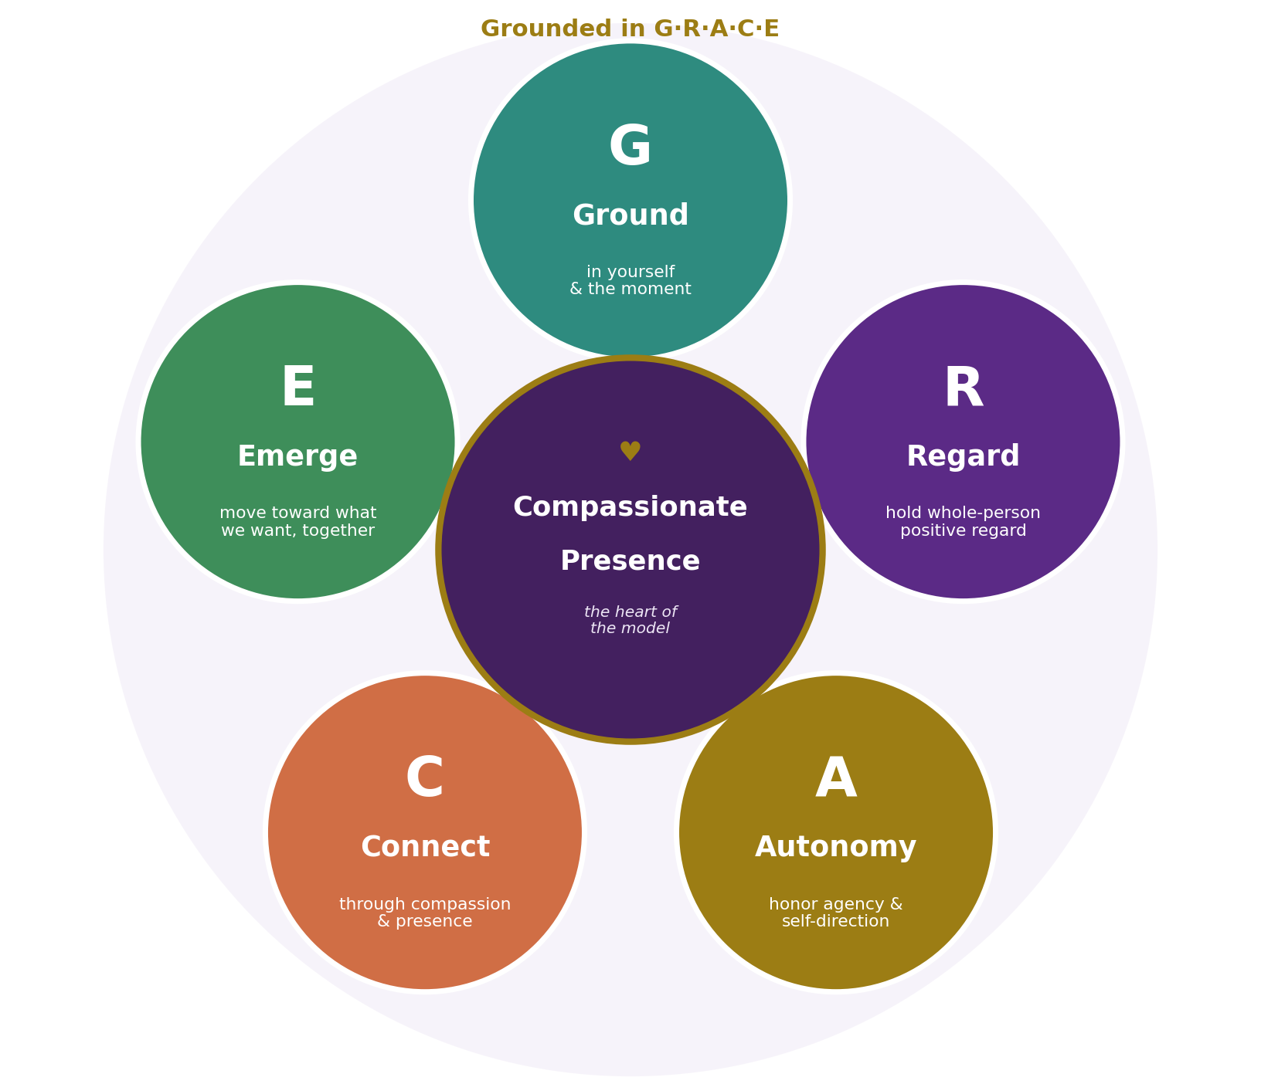

GRACE at a Glance
Pocket Card
G — Ground
Steady yourself and come into the moment.
R — Regard
See the whole person with curiosity and positive regard.
A — Autonomy
Honor agency, choice, and self-direction.
C — Connect
Lead with compassion and presence rather than control.
E — Emerge
Move toward what the person wants, together.
Compassionate Presence sits at the center — GRACE helps us put it into practice.

GRACE Across the Cohort
All five elements of GRACE work together.
Across the three weeks, we'll spend more time with different parts of the model.
Week 1 — Staying Grounded
Ground • Regard • Autonomy
Ground yourself, see the whole person, and honor choice.
Week 2 — Turning Down the Heat
Connect
Build connection and respond when emotions escalate.
Week 3 — Sustaining the Work
Emerge
Move toward recovery, support, and sustainable next steps.
Autonomy and Compassionate Presence carry throughout.

Putting It into Practice
For week 1, we’ll spend more time putting three parts of GRACE into practice:

These practices help us assess what is happening and make thoughtful decisions about what comes next.

GROUND

Start With Yourself
Before responding, be self-aware and mindful of your:
- Body: What is happening in me right now?
- Environment: What is happening around us?
- Reaction: Am I feeling urgency, fear, frustration, or the need to “fix”?
- Intention: What does this person need from me in this moment?

Relaxation Response – WHAM:
- Slow the breath
- Make the exhale longer
- Rest on one word or the breath

Ground yourself before you support – your calm is contagious - eCPR

Situational Awareness

Person + Environment
- Take in the whole picture — the person and the environment.
- Notice what may affect your safety or the consumer's safety: who is present, positioning, exits, communication, and what has changed.
  - Changes may include: communication, behavior, who is present, the environment, new information, or your own response.
- Separate what you are observing from what you may be assuming.
- Distinguish discomfort or uncertainty from a genuine safety concern.
- Stay grounded enough to assess before responding.
Notice • Assess • Respond thoughtfully

REGARD

Seeing the Whole Person
- See the person – value them as your peer
  - Not for complying, but for being human
  - Compassion first – for the person, and for yourself
- Separate what you're observing from what you're assuming.
- Stay curious about what may be happening beneath the surface.
  - Peer engagement: How did they come to know what they know?
Make the shift from assumptions and ask:
- “Help me understand what this is like for you.”
- “What matters most to you here?”
- “What I hear you say is…”

Person, Power & Perspective
Who is in the room matters.
- Disability, race, culture, communication, trauma history, and role/power can shape how both staff and consumers experience and interpret a situation.
- Our identities and experiences can influence what we notice, how we communicate, and what feels safe or unsafe.
- The same response or intervention may land differently for different people.
- Get curious, ask: What does safety mean to this person right now?
- Consider how your role, assumptions, and available response options may affect what happens next.

AUTONOMY

Honor Agency & Self-Direction
Be clear about your role and responsibilities as a peer to support informed decision-making.
- Offer options rather than answers.
- Give information rather than instructions.
- Ask what support the person wants or needs.
- Honor dignity of risk and informed choice.
- Support the person's voice in decisions that affect them, they are the expert.

Support choice – don’t assume control

Autonomy in Practice

Instead of | Try:
“Here's what you need to do.” | “We could do A or B — or something you have in mind. What feels right to you?”
Moving directly into advice or action. | “Would it be okay if I shared something that might help?”

Ask → Offer → Inform → Support
From GRACE to Implementation
GRACE helps us approach the moment thoughtfully. Now we use what we’ve noticed to assess what is actually happening.
GROUND
Am I steady enough to see the situation clearly?
REGARD
What am I actually observing — and what might I be assuming?
AUTONOMY
What does the person want, and whose decision is this?

SELF-COMPASSION TOOL
What is changing? Is there an actual safety concern? What support, responsibility, or response may be needed?

What Are We Actually Implementing?
Before deciding what comes next:
- What changed? What am I actually observing or experiencing?
- Is there a genuine and / or immediate safety concern? Or is this discomfort, uncertainty, or disagreement?
- What does the person say they need?
- What supports are already available?
- What responsibility or obligation do I have?
- What is the least intrusive response the situation allows?
Observe → Clarify → Assess → Decide
As the situation changes, reassess — new information may change what comes next.

Making an
Informed Decision

Recognize and Understand Your Role & Responsibilities

Policies, Reporting & Requirements
- Be aware of policies and any mandated reporting duties that may conflict or infringe upon IL philosophy, values, principles.
- Uphold consumer choice being transparent about the limits of confidentiality and any actions you may be required to take.
  - However, choice and autonomy should exist at all levels of IL – consumer, staff, organization.
  - Know who you can consult when uncertain.
- When action is required, consider how the consumer can remain informed and involved in what happens next.
- Good decisions start with being well informed and knowing what options are available before the moment arrives.

Know Your Options & Their Impact
There may be more than one pathway or alternative option available.
- Ask what path or alternative option the person wants whenever possible.
- Consider the spectrum of options and supports, especially those rooted in IL: natural, peer, organizational, community, and wholistic supports / options.
- Consider how involving outside systems (law enforcement/crisis intervention) may affect the gravity of a situation and pose risks:
  - Risk of (re)traumatization
  - Risk of institutionalization
- Depending on the situation, options may include already existing trusted supports, peer support, a warmline, or mobile crisis, behavioral-health crisis response, or emergency services.

Get Informed – Then Take Action
Create an IL-focused local response-planning quick reference that includes 988, mobile crisis, warmlines, peer and community support, non-emergency contacts, and other local options. Contacting law enforcement should be only be done as a last resort.

Know:
- What might happen when I call?
- Who might respond?
- Can I request a particular crisis response?
- What accessibility/communication supports are available?
- What information will responders ask for?
- What are our CIL/SILC procedures for different levels of concern?

Scenario: Put GRACE into Practice
A consumer makes a choice that worries you; emotions are rising, and the environment is shifting.
G — GROUND: What do you need to notice in yourself and the environment? Keep breathing.
R — REGARD: What are you actually observing or experiencing? What assumptions might you be making in this moment?
What matters most to the consumer right now?
A — AUTONOMY: What does the consumer want? Whose decision is this? How can you offer information, options, support or guidance?
What comes next? Based on what you've encountered, do you have a responsibility or requirement to respond a particular way that must be considered?

Key Takeaways
Ground yourself: Notice what's happening in you and around you.
See the whole person: Separate observation from assumptions (recognize / limit bias).
Honor autonomy: Choice and safety can coexist even in difficult or tense moments and situations.
Know before acting: Identify genuine concerns, your responsibilities, and the spectrum of available supports.
Consider impact: Use the most supportive response the situation will allow in order to minimize trauma and institutionalization.

Coming Up Next –Week 2: Turning Down the Heat: De-escalation Skills for Challenging Situations on September 9, 2026!

Resources for Additional Guidance
- Emotional CPR (eCPR)
- The Compassionate Presence Model (Grounded in GRACE) – Kristina Kapp
  - Diagram
  - Pocket Card
  - Practical Application, Role-Plays & Logic Model Toolkit
- Whole Health Action Management (WHAM)
- Working Definition of Recovery - Substance Abuse and Mental Health Services Administration (SAMHSA)
- 988 Lifeline
- The Link Center - ACL

Additional cohort resources will be shared
throughout this three-week learning series!

Your Experience Matters
Recording has stopped.
As we open the conversation:
- Take the learning with you; leave personal stories and identifying details in the room.
- Share only what you're comfortable sharing.
- Different experiences and perspectives are welcome — stay curious and respectful.
Ways to Engage:
- Raise your hand to be spotlighted to speak
- Turn on your camera if you're comfortable
- Use the chat to share insights, questions, resources, or tools
- React, reflect, or build on what others say
- Share real challenges or successes
Let’s turn ideas into action — your experience is an important part of the learning.
Evaluation
Thank you for participating in today's Learn and Share.
Your feedback is important and helps us plan future training.
Please use the link in the chat to share your feedback.
Evaluation Link:


How to Connect with Us!

Website: www.ILTTACenter.org
Request training and / or technical assistance (expert help for your organization): fill out a form on our website to let us know how we can help.
Call: 406-243-5300 and someone will get back to you as soon as we can.
Sign-Up for Events & Announcements:

Visit our website to sign up for updates about live training, group technical assistance, new publications, and other happenings around the Center.

IL T&TA Center Attribution

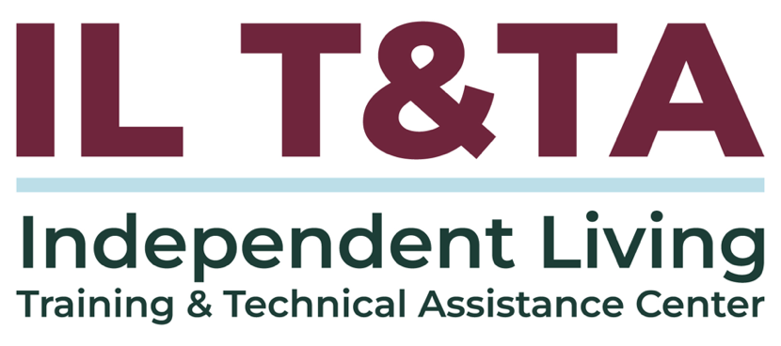
This project is on assignment through contract with the Administration on Disabilities, Administration for Community Living, Health and Human Services.

About the IL T& TA Center
The Independent Living Training and Technical Assistance Center (IL T&TA Center) is available to you through a contract with the US Department of Health and Human Services.
The IL T&TA Center provides expert training and technical assistance to CILs, SILCs, and DSEs.
The Center is operated by the University of Montana's Rural Institute for Inclusive Communities.


